Docker:

By Amir Mustafa. D.O.S – 06/02/2022

Private and Confidential

[amirengg15@gmail.com](mailto:amirengg15@gmail.com) +918170954991 [LinkedIn](https://www.linkedin.com/in/amirmustafa1/) [Twitter](https://twitter.com/amir__mustafa) [GitHub](https://github.com/AmirMustafa) [YouTube](https://www.youtube.com/channel/UCiRv7SECTSF3-tXQM1IoMTw)

What is Docker and why?

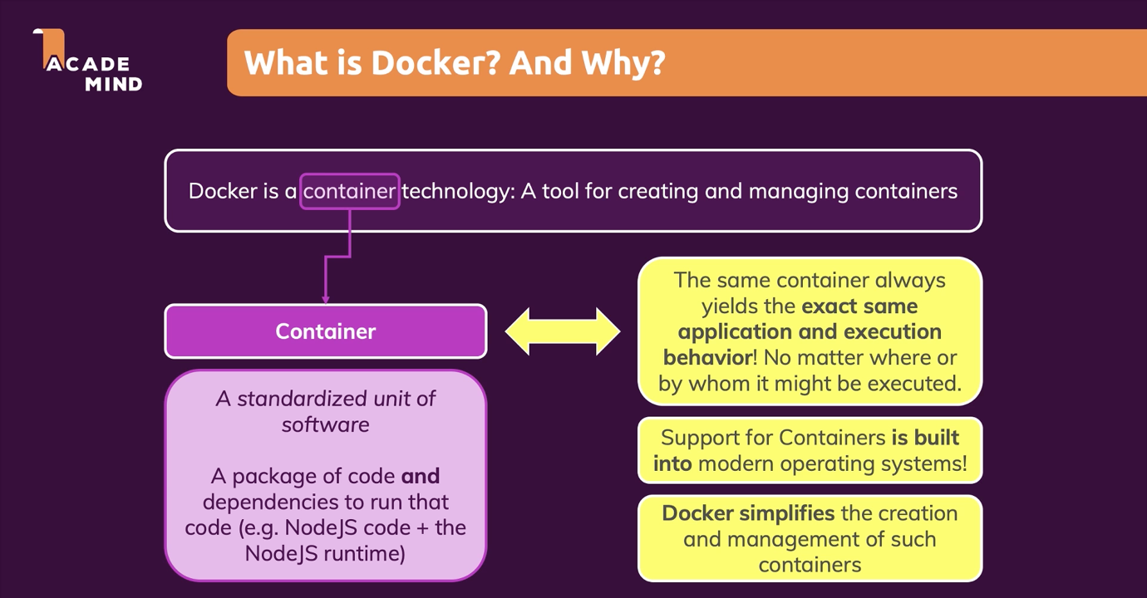

🡪 Consider this equivalent to picnic containers (All required thing in one)

‘



Why Containers?

🡪 When work in team, some code supports Node v14.3 only and not v12 await

🡪 For that we need to update or install new version.

Case A: Even if we do locally remote (or production might have older version).

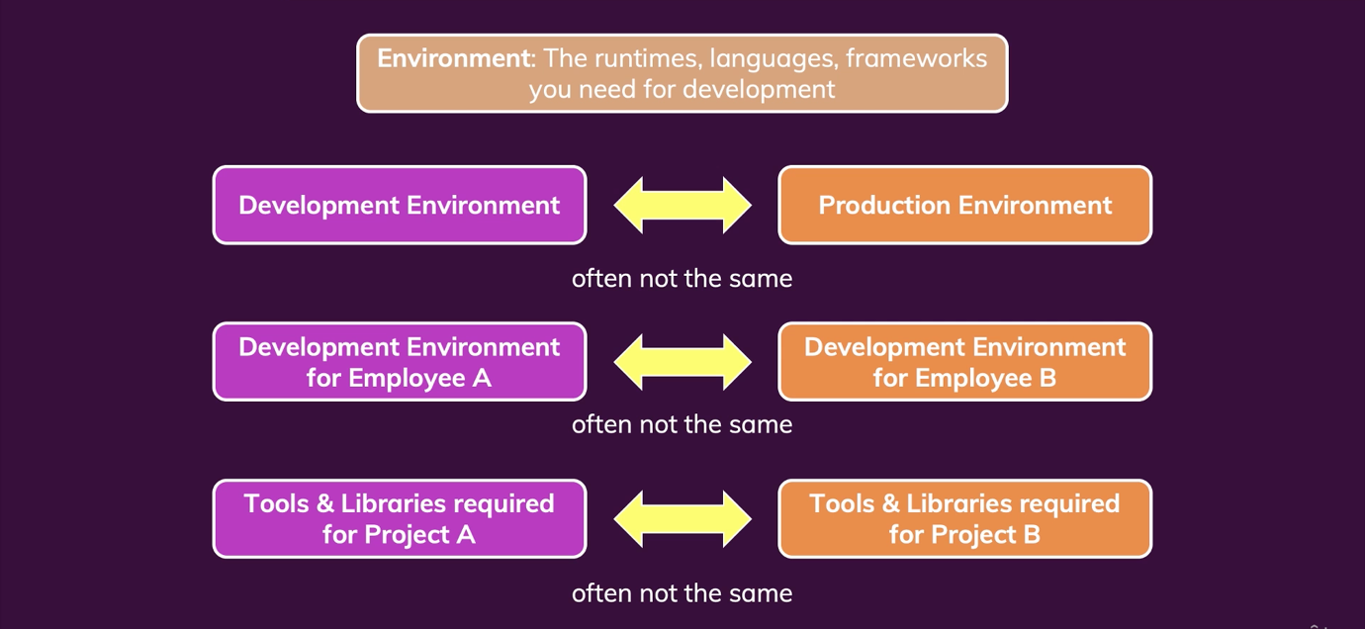

Case B: If we are not in a tech for some time (say Node) after months we return to our project. Our node.js version might be older but our colleagues version is update.

Some code might crash

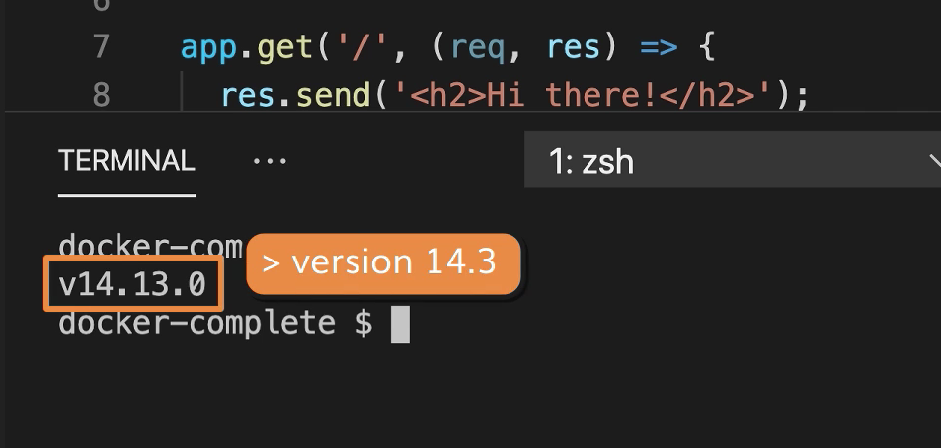

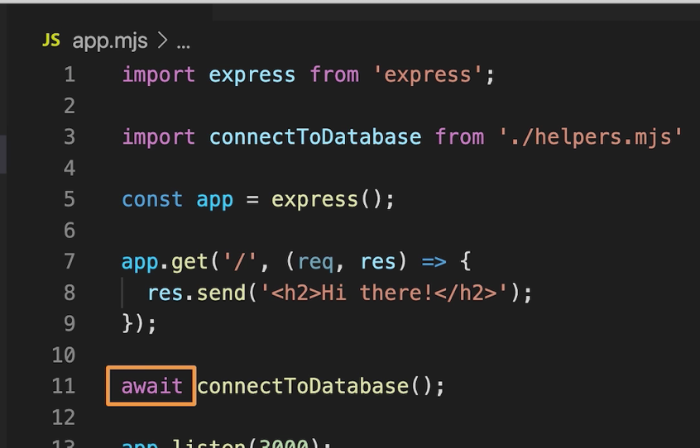

🡪 Throws error in node.js version 12

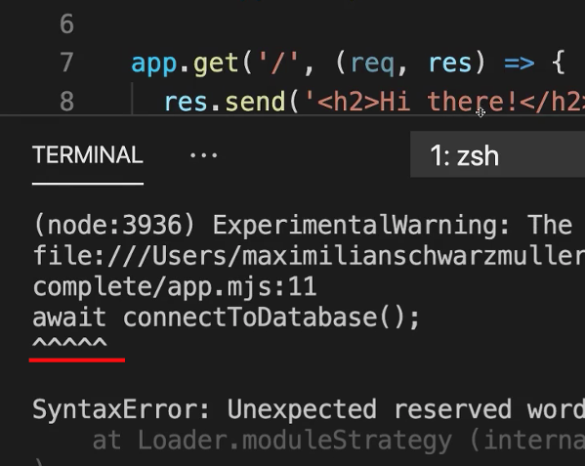

Case C: If we in independent project and have multiple applications. Say one project require Node.js 12 and other v14.3. It would hassle to update software package most time

Case D: Consider a project need have lots of dependent package and consider 15 apps version is old and need to update in local and production

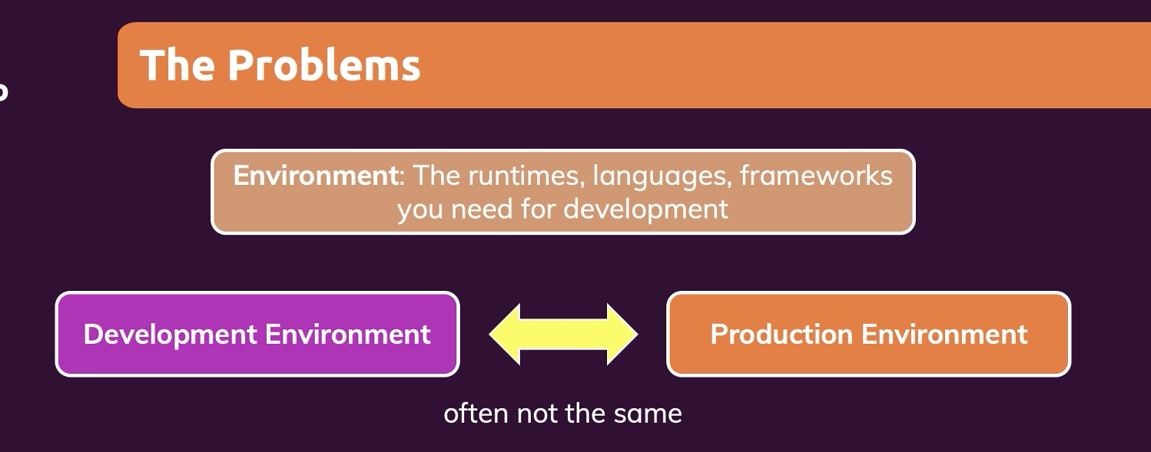

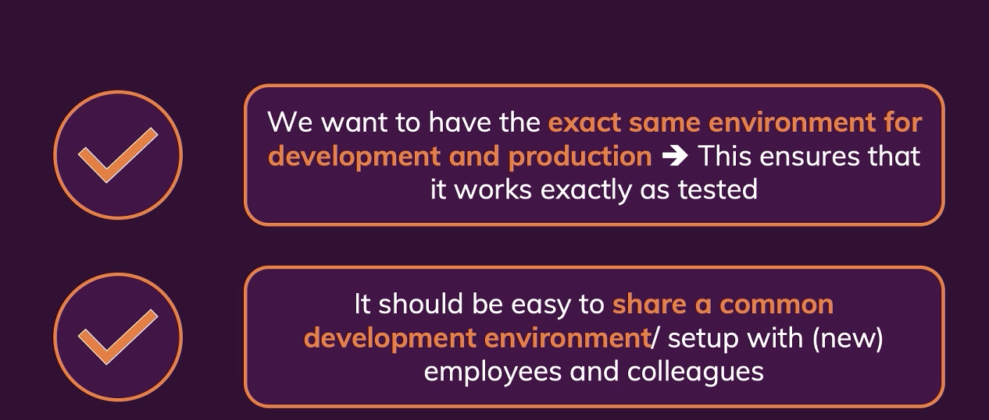

🡪 So we lock versions in docker container and every project has its own containers

🡪 If we switch projects, it work just like that. We do not need to uninstall and reinstall packages because it is all in the container.

Switching projects means 🡪 launching a new container

Can Virtual Machine a solution for Docker?

It can be as all app can encapsulate separately

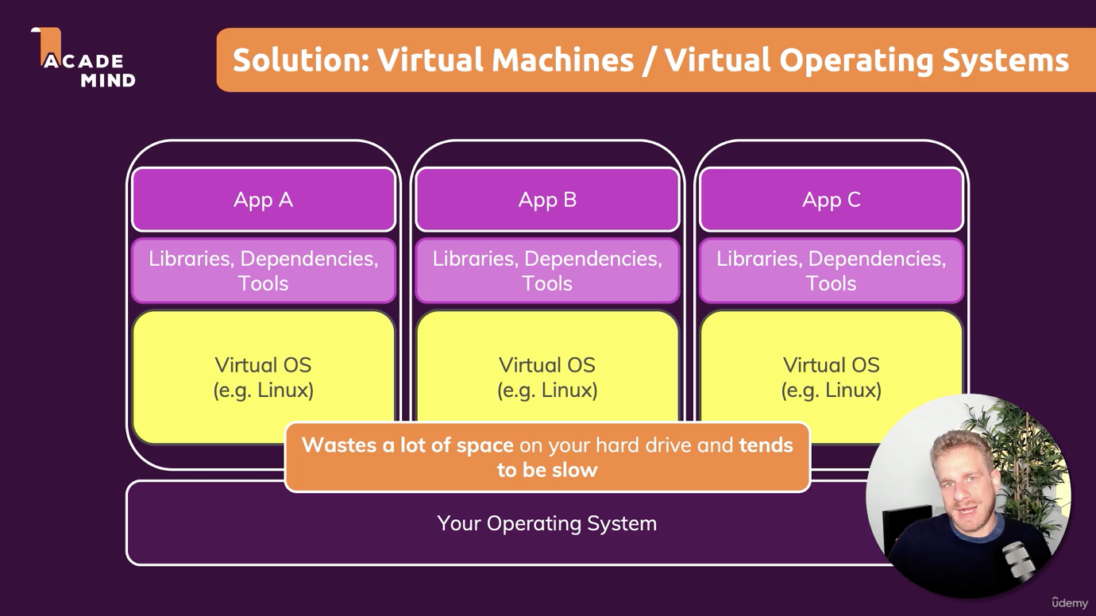

🡪 The problem is every time we install VM, we install a brand virtual new computer 🡪 Lots of space wastage 🡪 system will be slow

Pros and Cons:

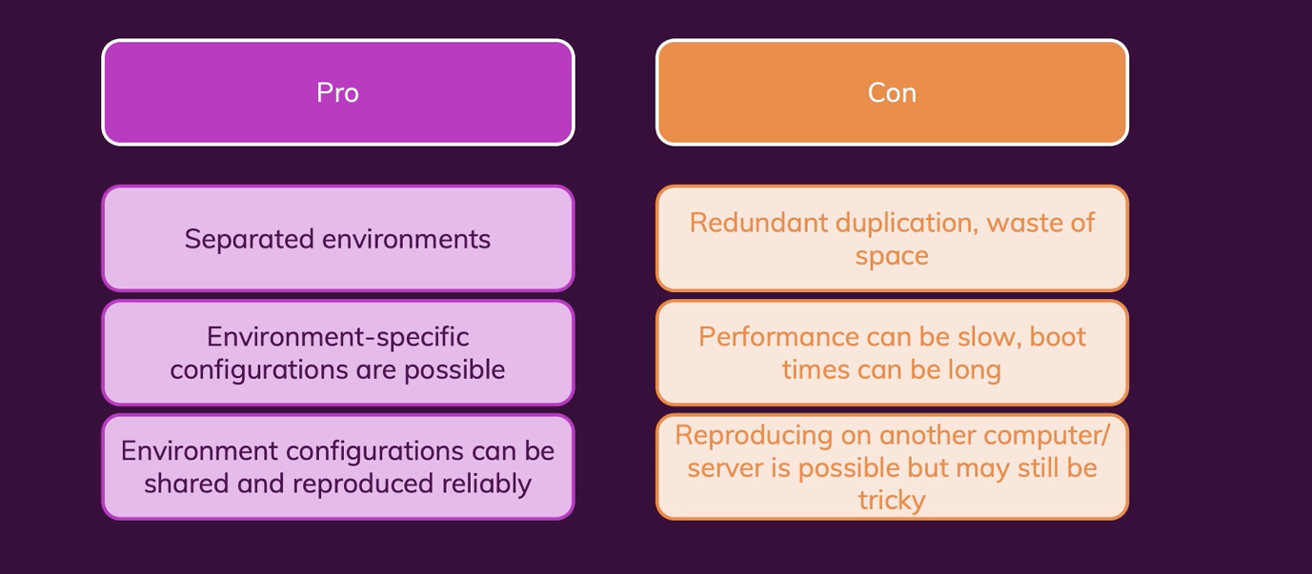

🡪 Containers solves our problem using Docker tool

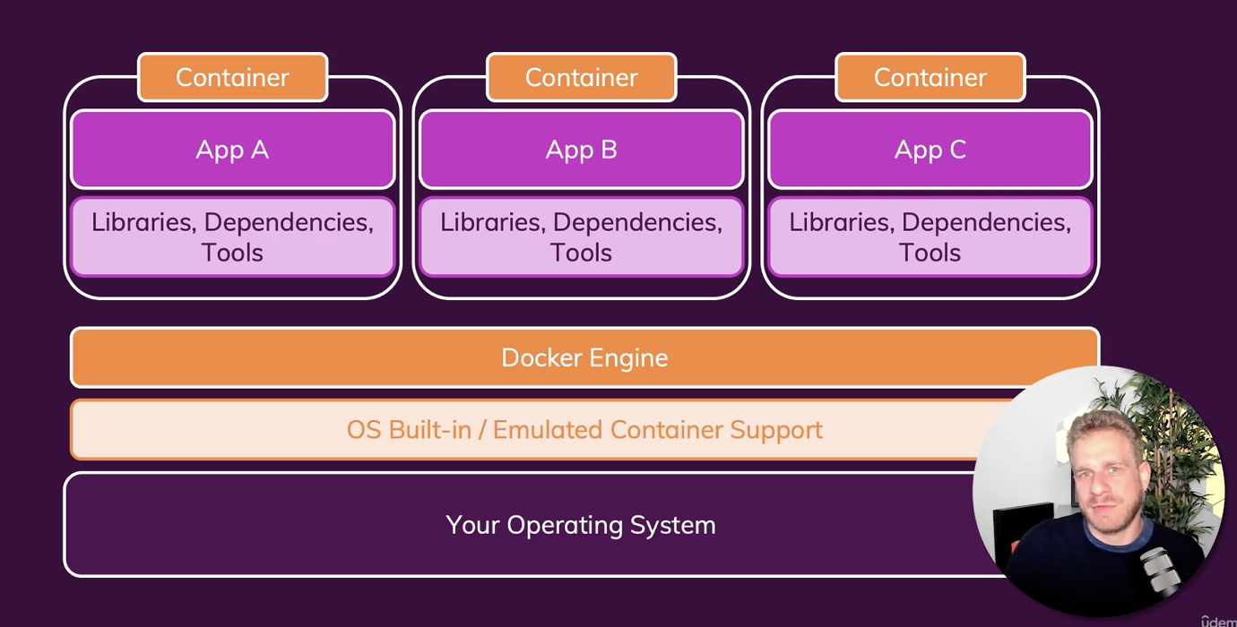

🡪 Here we have docker engine, that will easily switch between containers

🡪 Another cool feature is we have a docker configuration file in app, that we can share with our colleagues and create similar software/application environment

Difference:

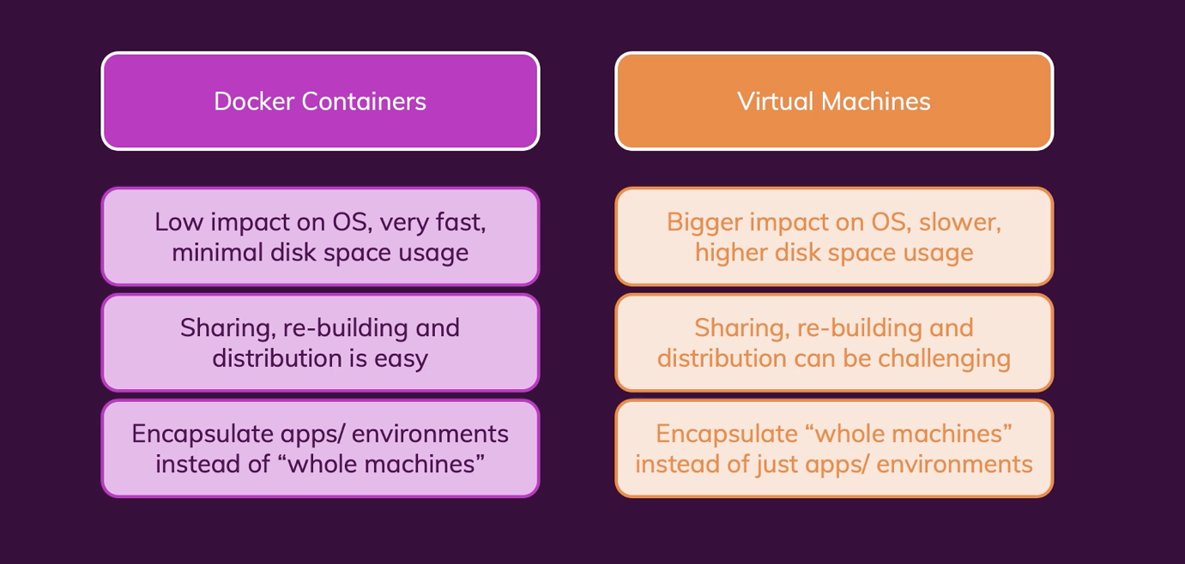

Docker Play ground:

Try online docker, if there is some error in desktop versions

<https://labs.play-with-docker.com/>

Docker Tools and Building Blocks:

🡪 If we install docker in mac, windows or linux or Docker toolbox 🡪 We are actually installing docker engine.

🡪 Daemon server runs always

🡪 Docker Hub: Once we have worked in local with Docker, to deploy containers in cloud, we use this

🡪 Docker Compose: Stand alone section, here we will handle complex containers

🡪 Kubernetes:

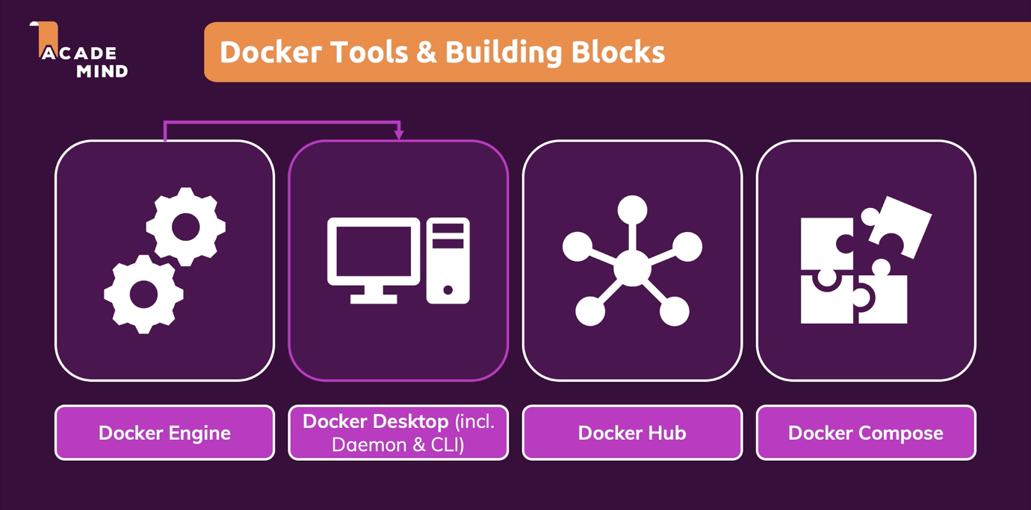

Create first Dockerized application:

STEP1: Pick any code base say Node.js 14

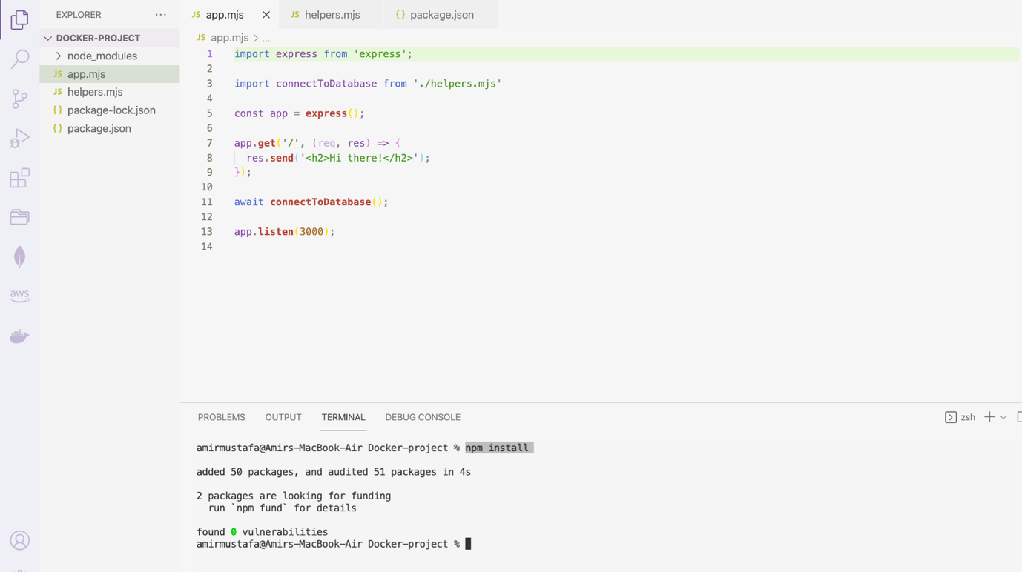

STEP2: Create Dockerfile (without extension)

FROM **node**:14

WORKDIR /app

COPY package.json .

RUN npm install

COPY . .

EXPOSE 3000

CMD ["node", "app.mjs"]

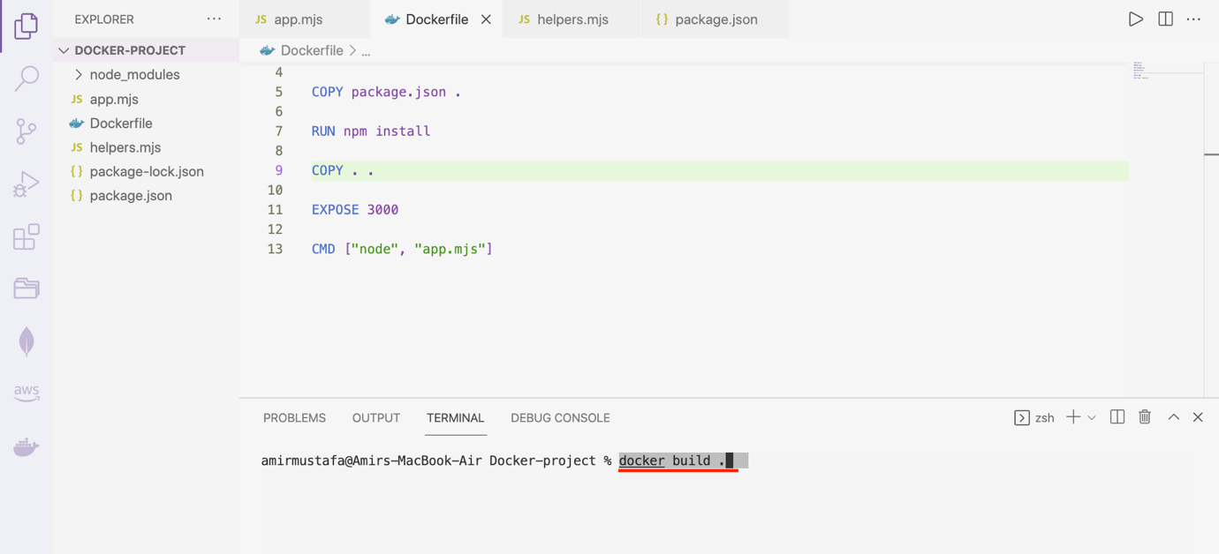

Run: docker build .

🡪 This will execute our Dockerfile image and create environment

🡪 We should make sure Docker is running in the application, we get ID in the end

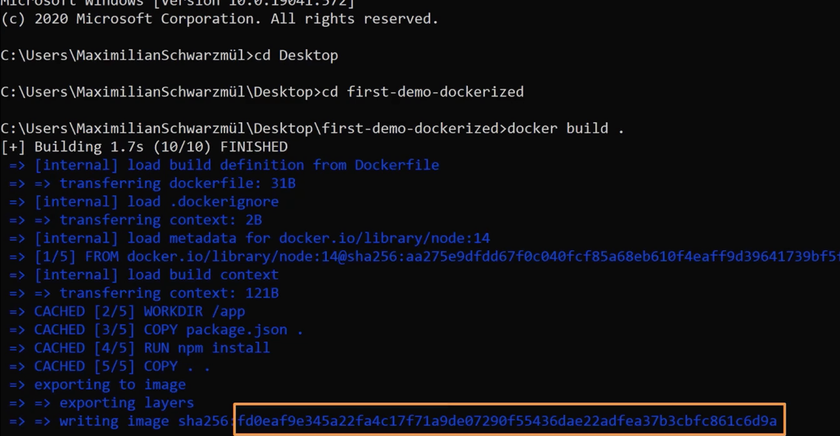

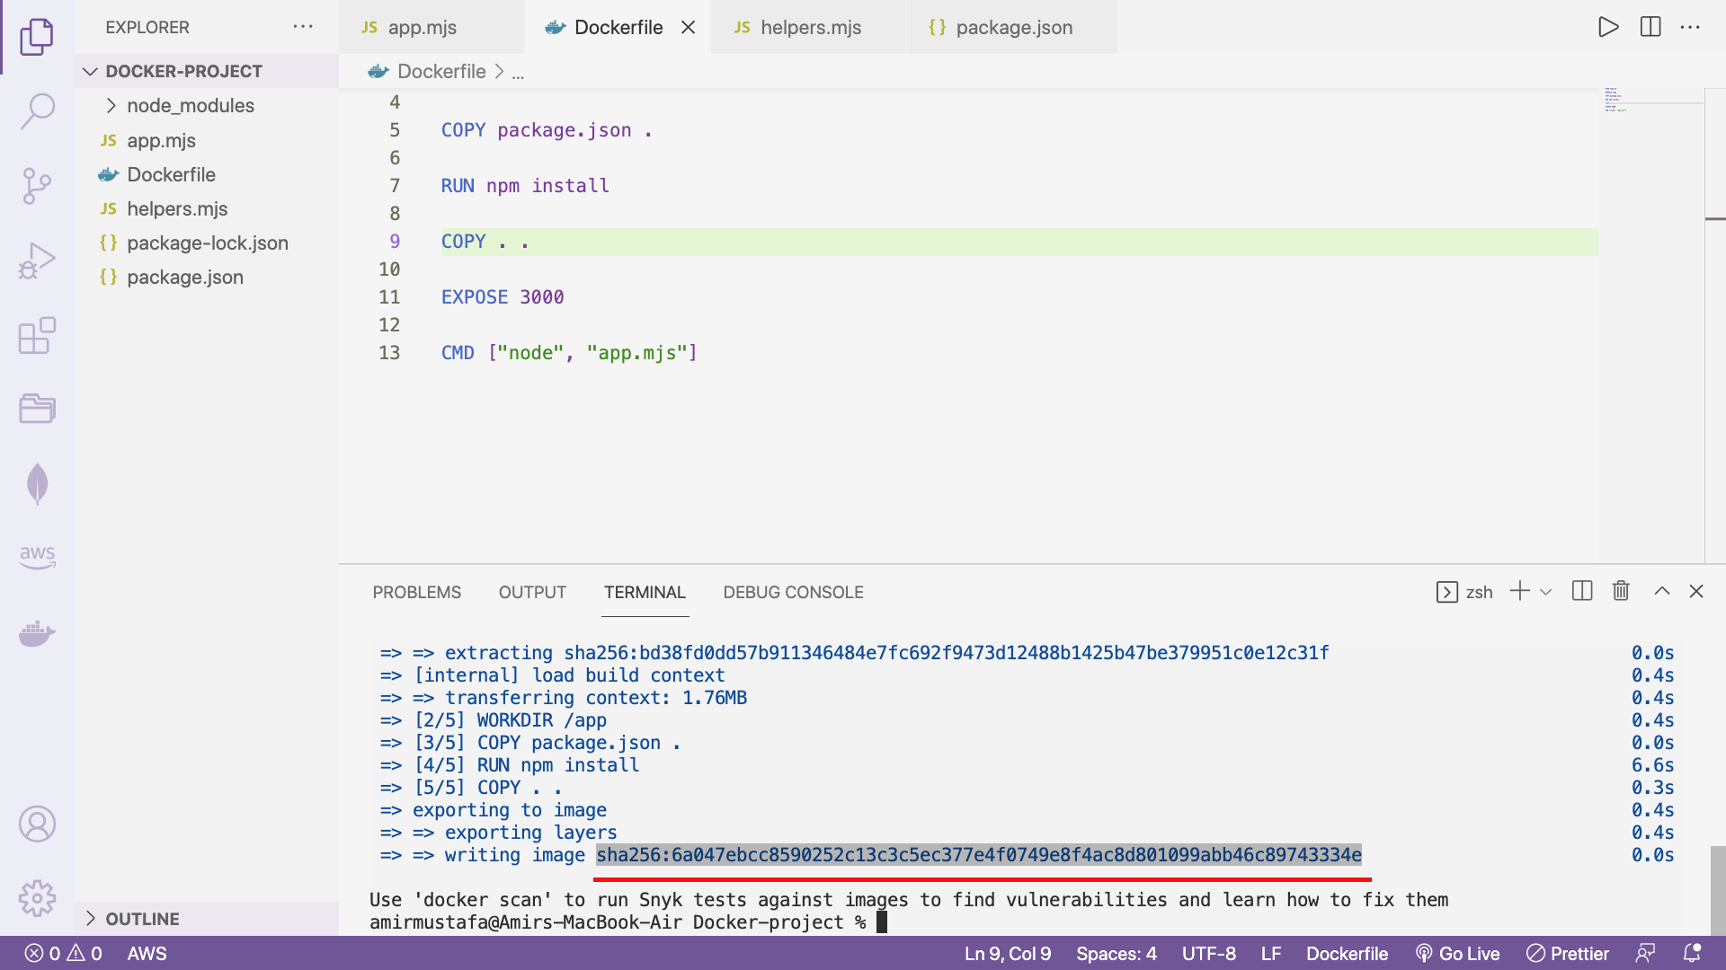

🡪 To create docker server:

Run

docker run imageId

eg Node listens to port 3000, hence publishing port 3000 to outside world

docker run -p 3000:3000 6a047ebcc8590252c13c3c5ec377e4f0749e8f4ac8d801099abb46c89743334e

hit enter

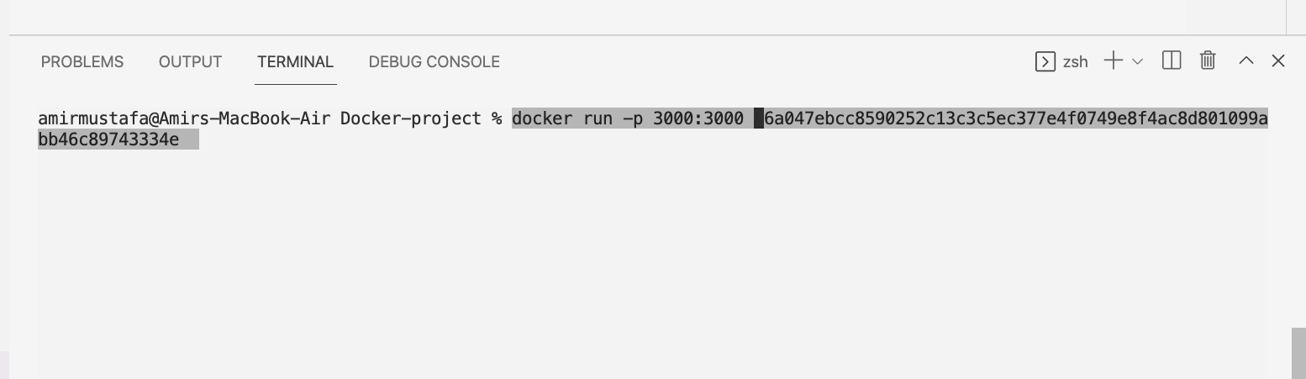

🡪 We now see our server is running

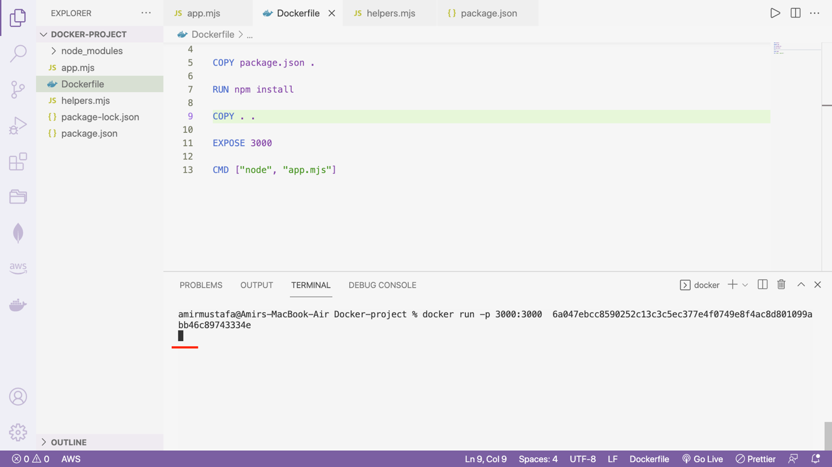

Go to browser:

<http://localhost:3000>

page will run

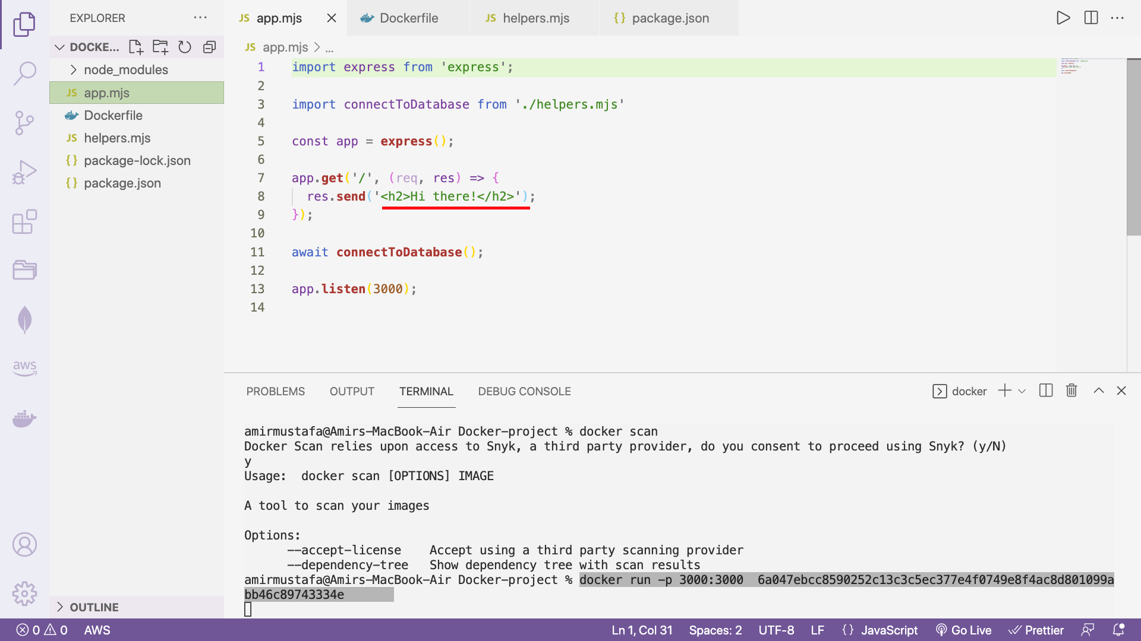

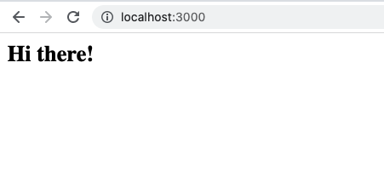

Check all running containers:

docker ps

Docker assigns random name

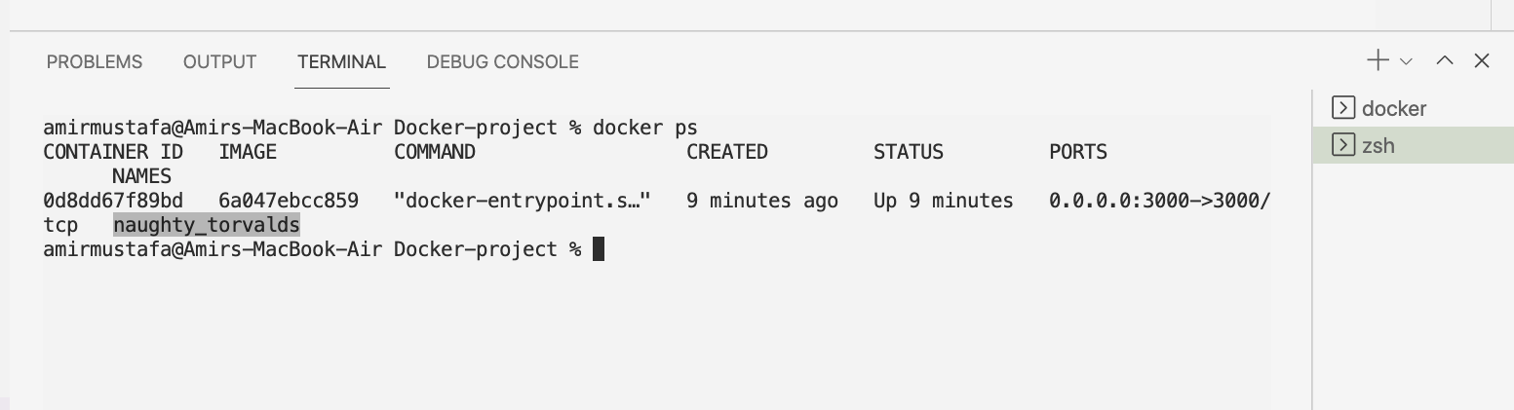

Stop the container:

Docker stop <image name>

Eg, docker stop naughty_torvald

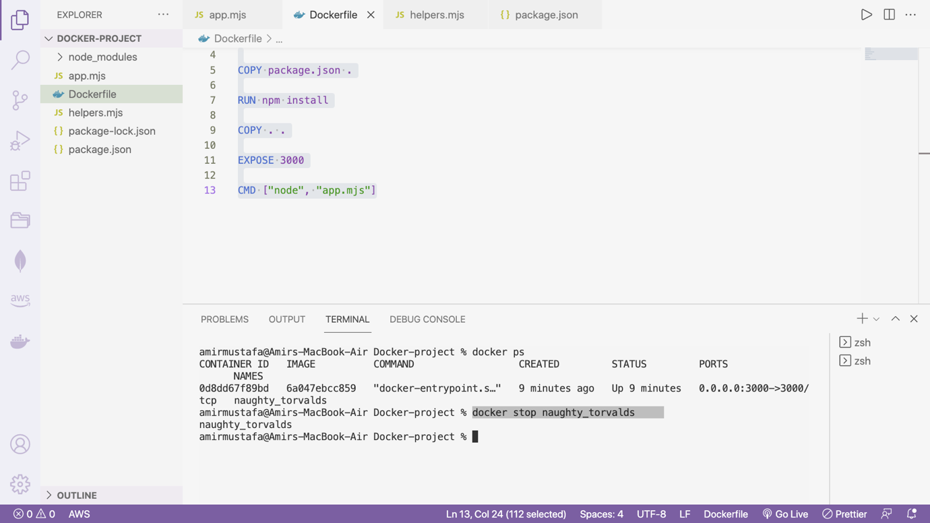

🡪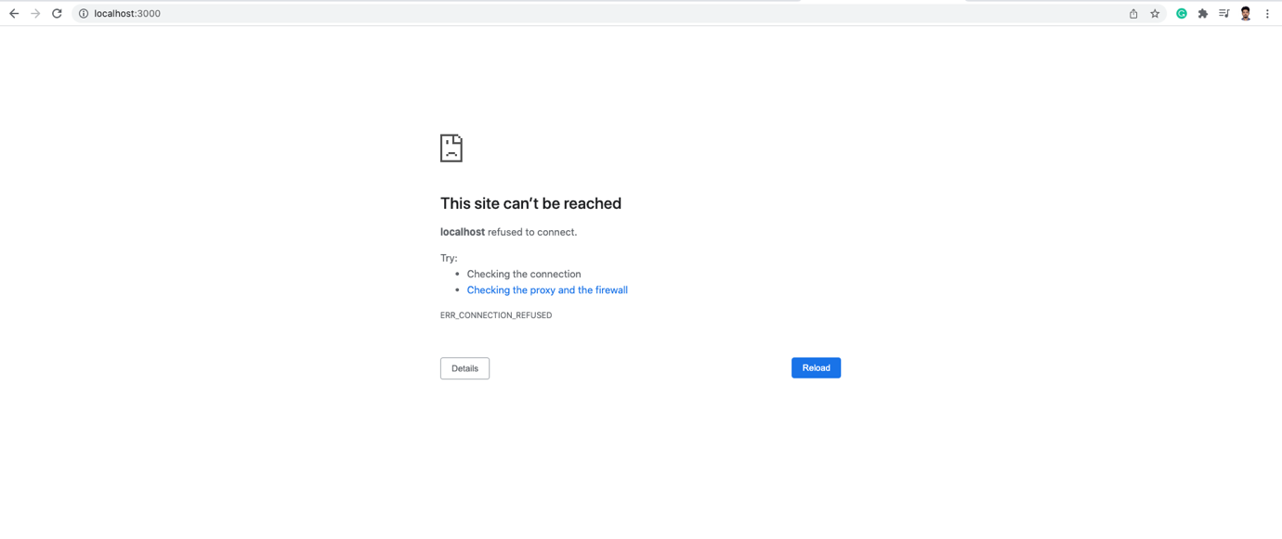

🡪 So even without installing npm install, we get our node.js server running

Course Outline:

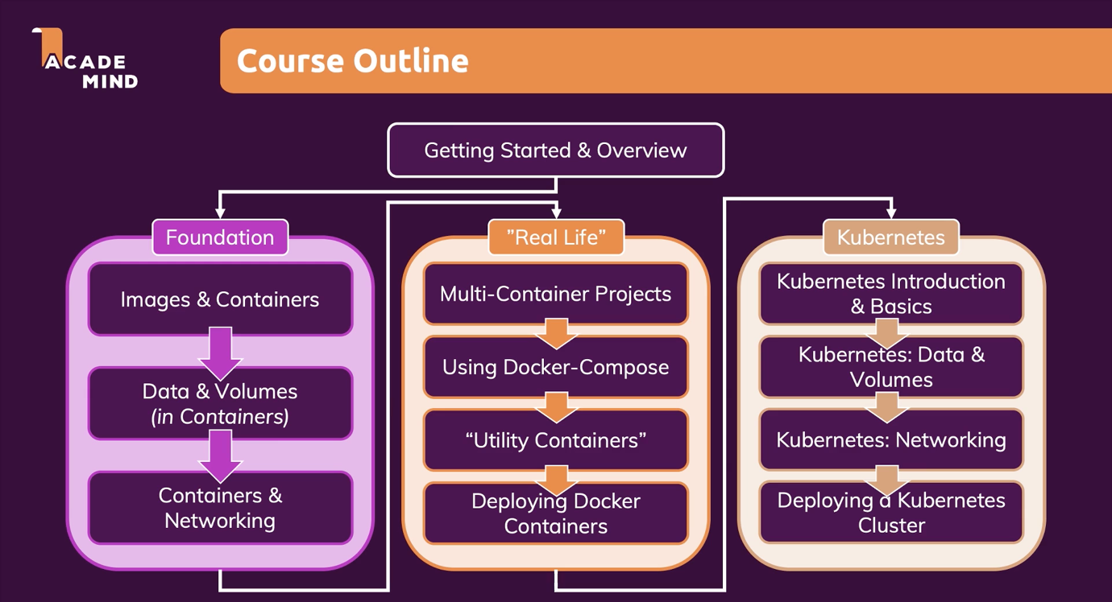

SECTION2: Working with Images and Containers:

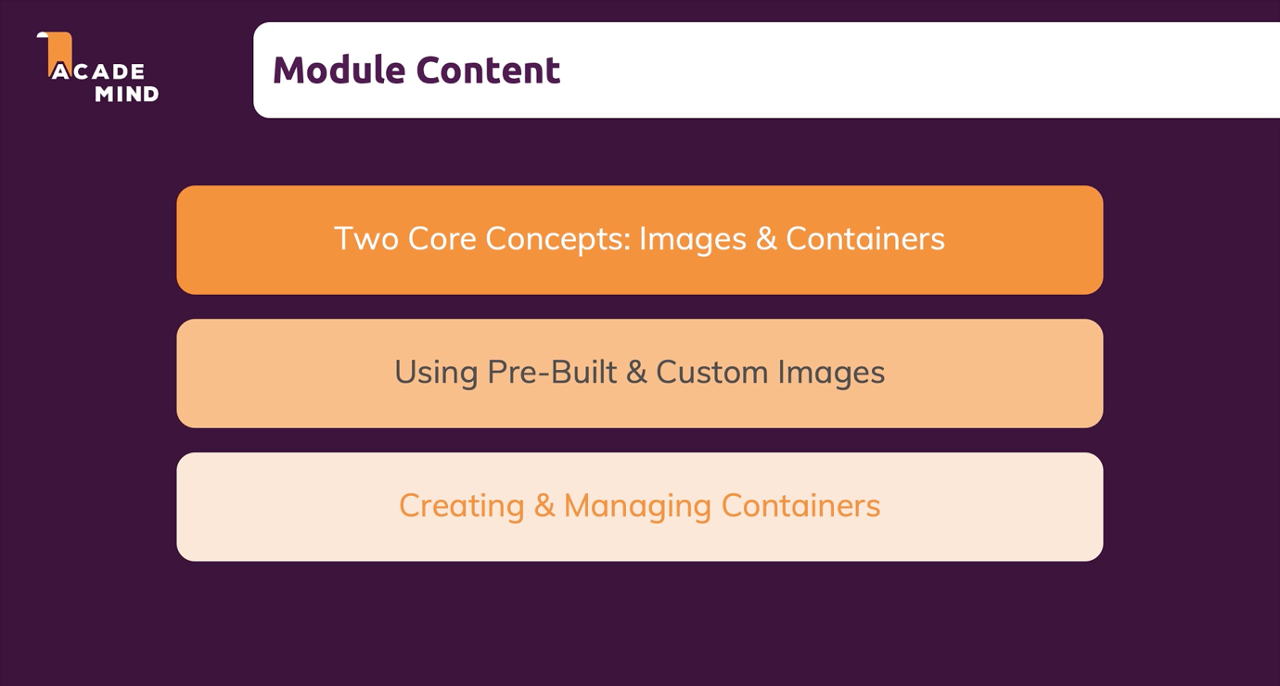

Image vs Containers:

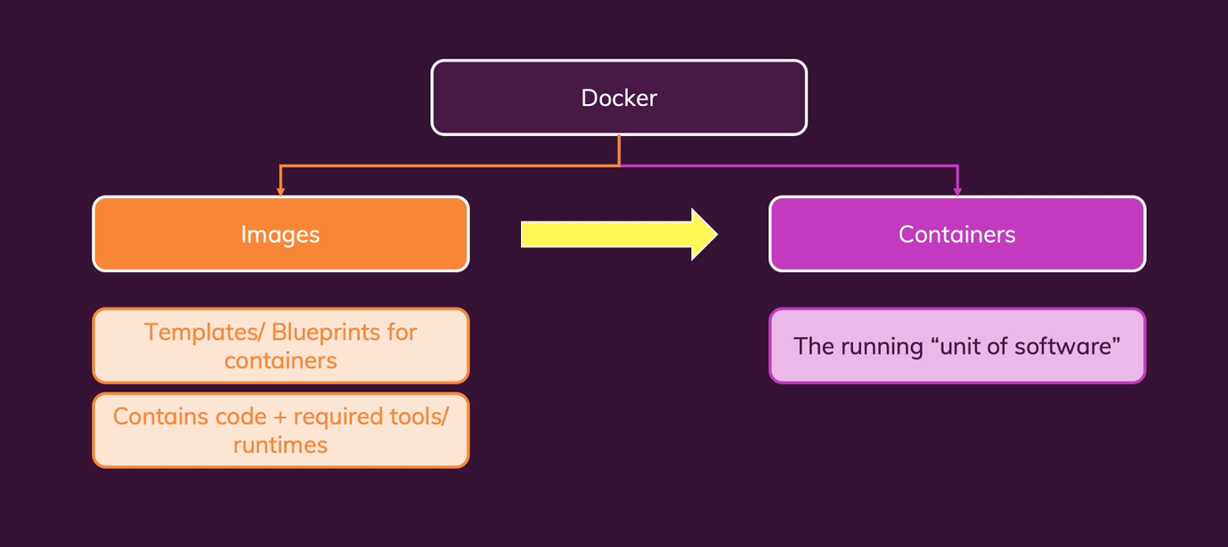

🡪 Containers: Here software is always running i.e. containers are running instances of images.

Images: Code + template (Eg: node.js + node packages )

🡪 There can be one image (Say Node.js environment + App code) 🡪 It can run in multiple containers

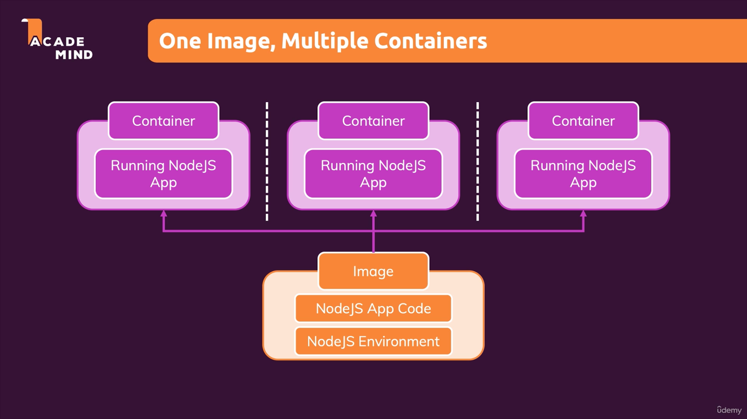

Getting Pre-built image:

Docker Hub: <https://hub.docker.com/>

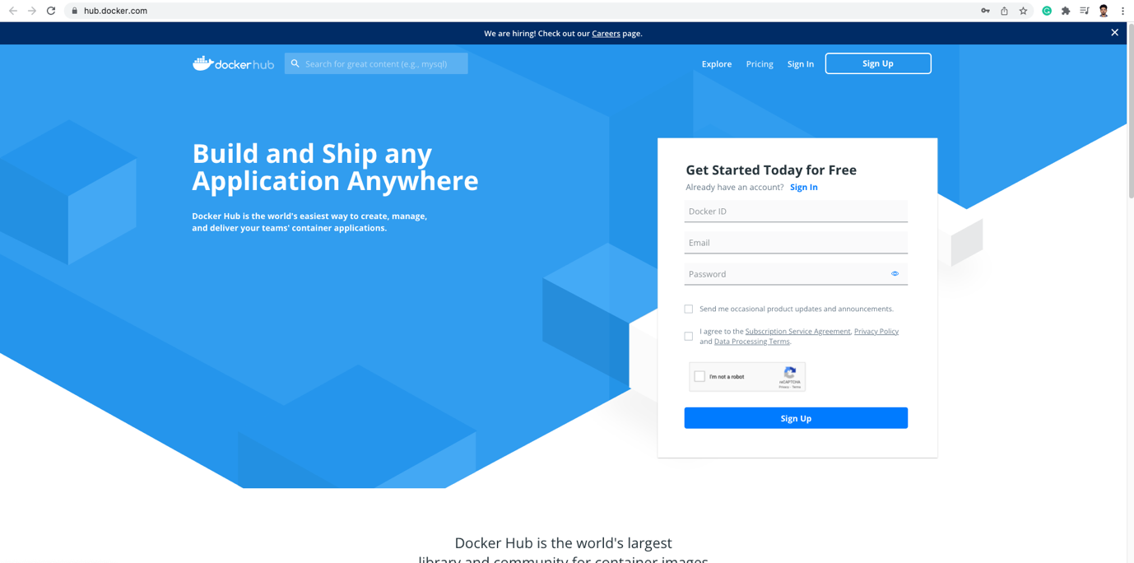

Search your favorite technology:

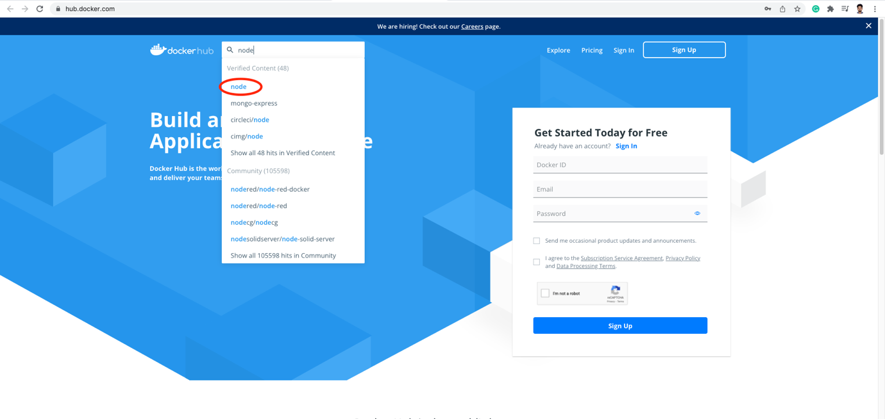

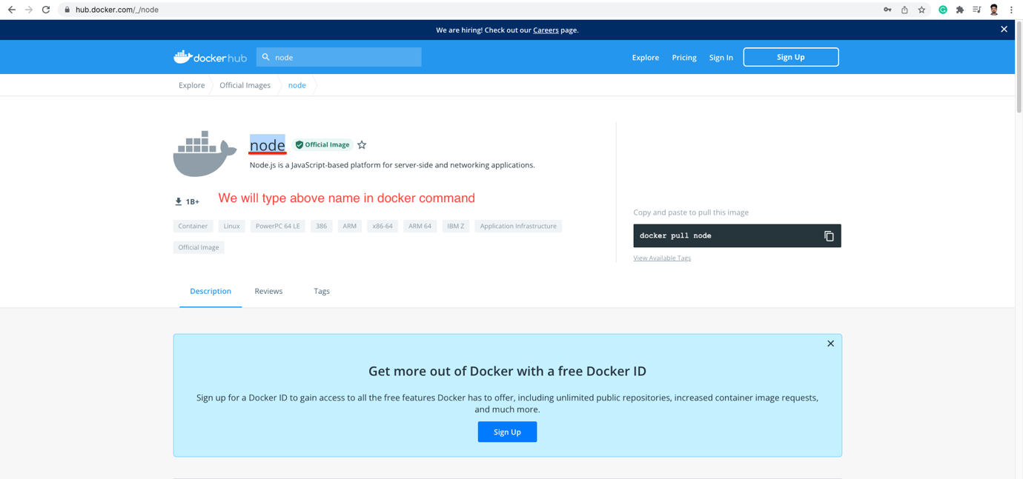

Check available containers locally: docker ps -a

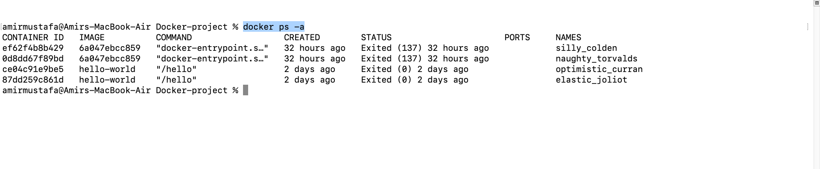

🡪 Here we see list of containers in local

🡪 Let us now import Node environment

Docker run <package-name – same name we found in docker hub>

Eg. Import a container: docker run node

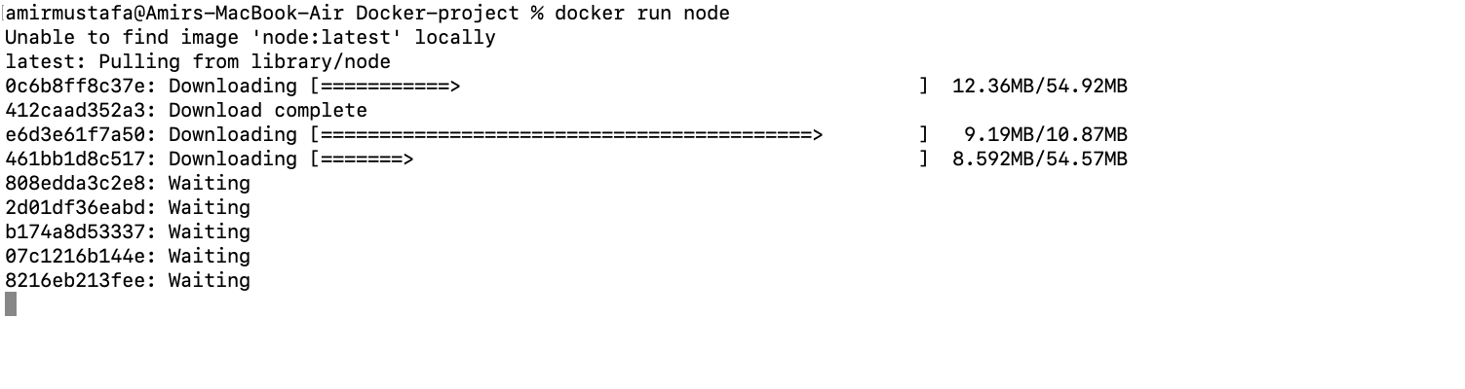

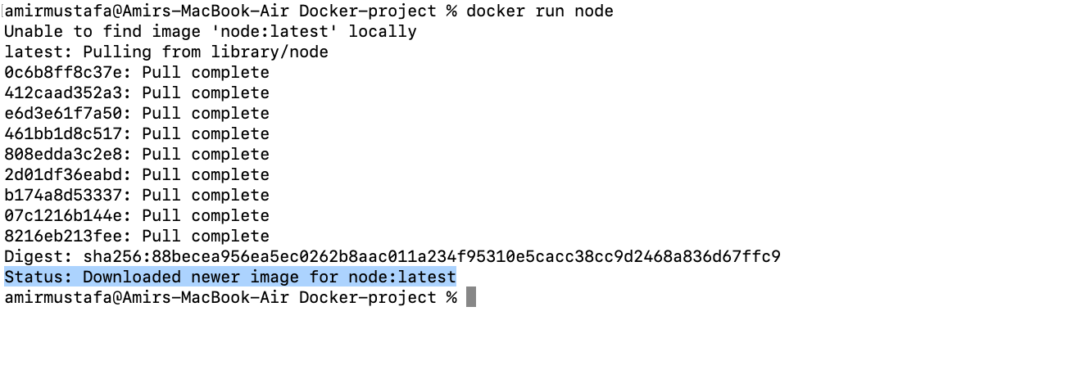

🡪 Let us re-run the command get list of containers:

docker ps -a

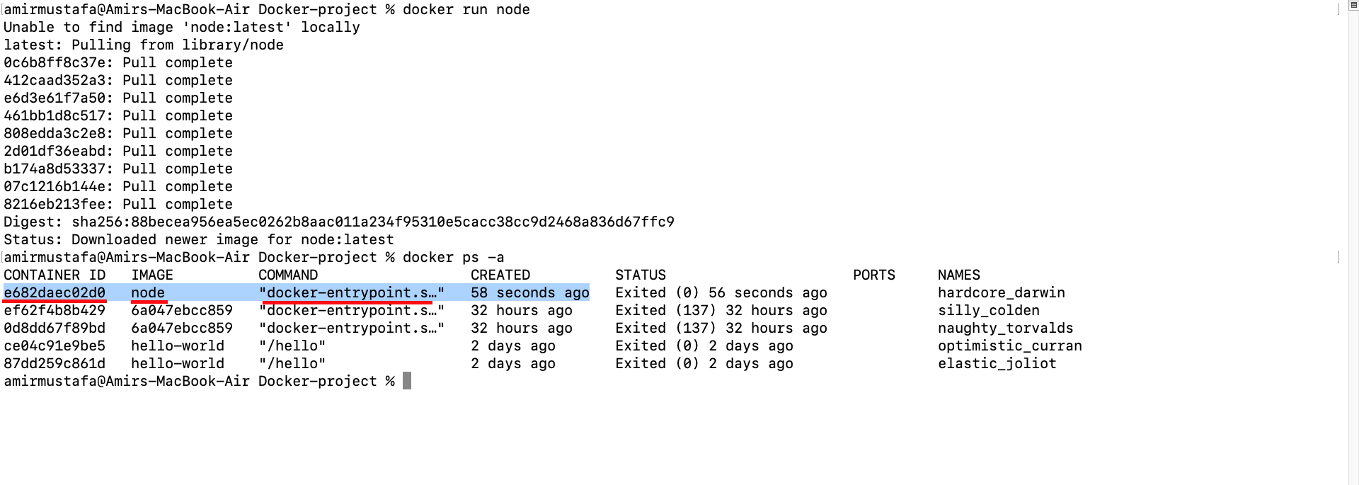

🡪 This time we see a new node image is created and ready to be used. Also we see automatically received names to image

🡪 To get the image + run in container

docker run -it <package-name>. (i.e. container interactive mode)

eg. docker run it node

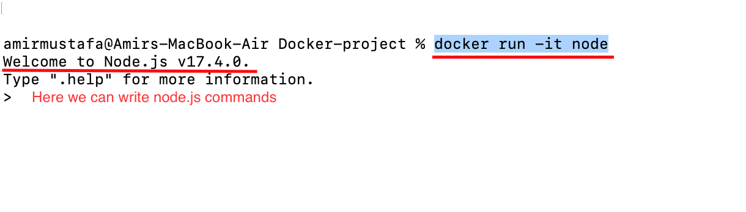

Eg. 1 +1

2

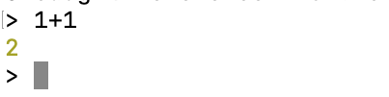

**Exit from node:** Ctrl + C (Press twice)

Observation:

🡪 Node image running in docker is not from local. Here’s how we can check

🡪 Try running node version from local and docker container

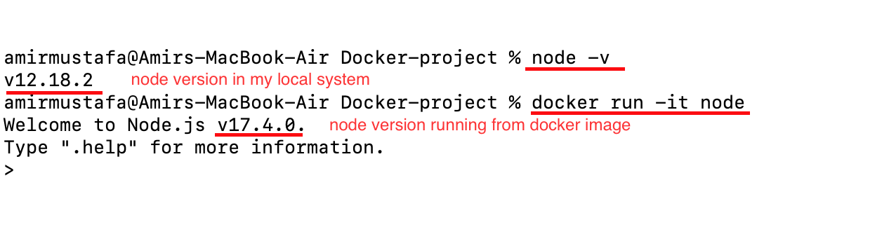

🡪 We do not need node.js (or technology that we are using) to be installed in our system at all

🡪 Images run behind the scene containers (logics/code that need behind the scene)

🡪 If we run the command again

We see multiple containers of same image is running.

This is the concept multiple contains to one image

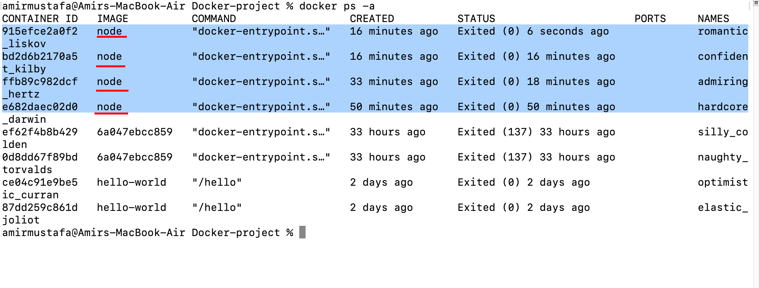

Running Node.js App

1. Regular way (without Docker):

Step1: Suppose we have a basic code with package.json file

Step2: run npm install (node_modules directory is created)

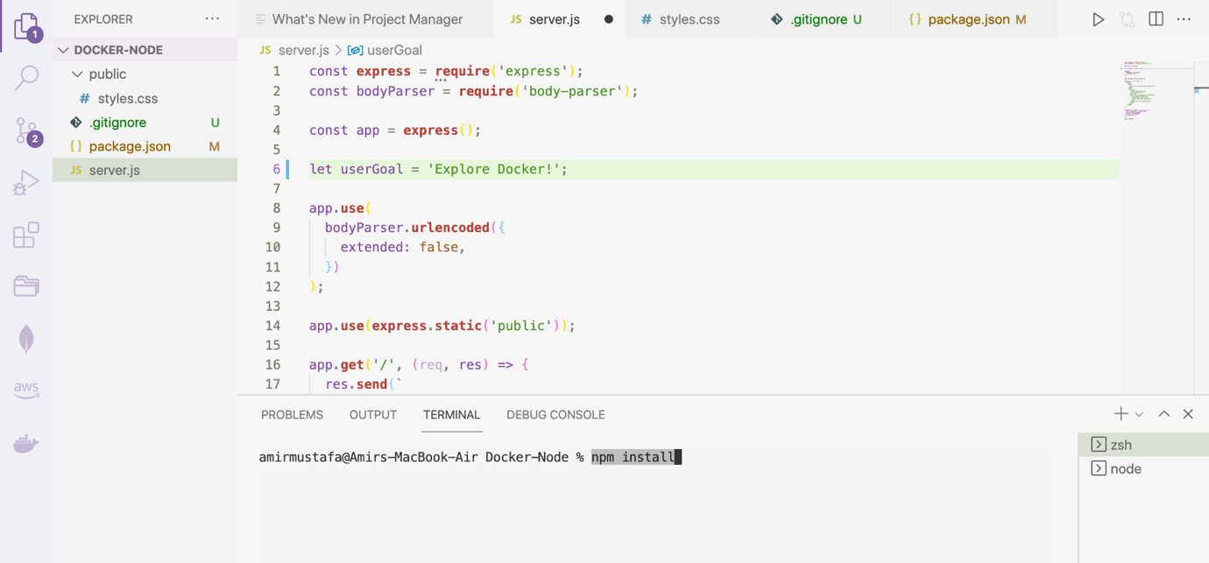

Step3: In separate terminal, run node server

<http://localhost:80>

Our Node.js app is up

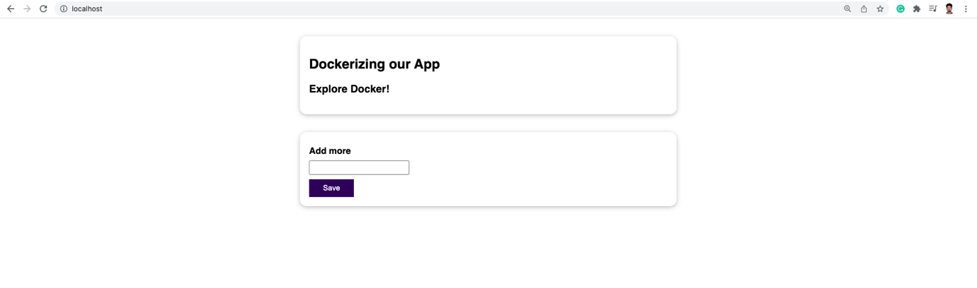

1. Building our own Image with Docker file:

Step1: Delete node_modules ( if any )

Step2: Create dockerfile in the directory

Dockerfile

FROM **node // Use base image from Docker Hub**

WORKDIR /app // Inside containers run node in /app directory

COPY . /app // first parameter= copy all file from current directory, paste inside container’s /app directory

RUN npm install. // run npm install. (in container)

EXPOSE 80. // Use port 80

CMD ["node", "server"]. // Run node server (in container and not image)

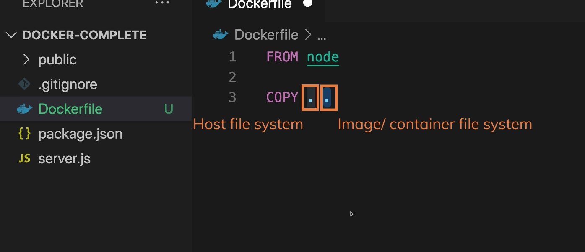

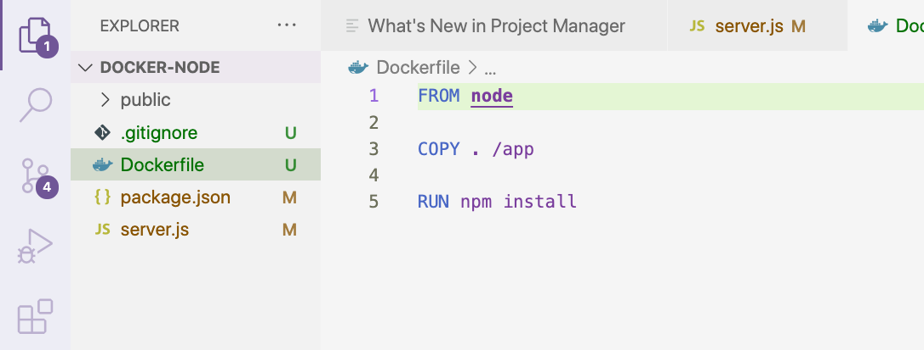

Relative Path - for pasting in container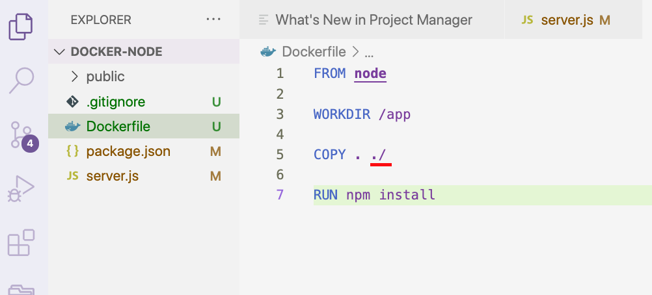

Actual Path – for pasting in container

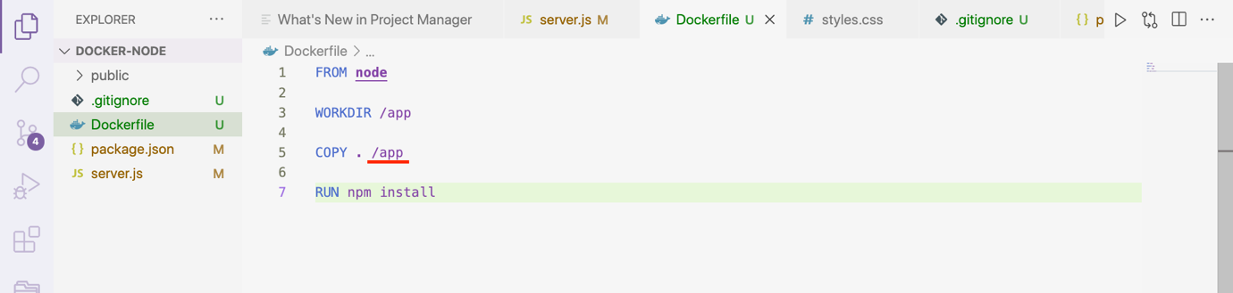

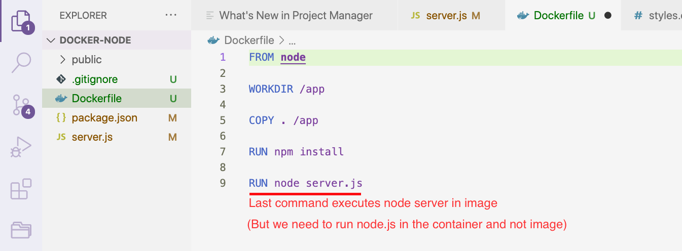

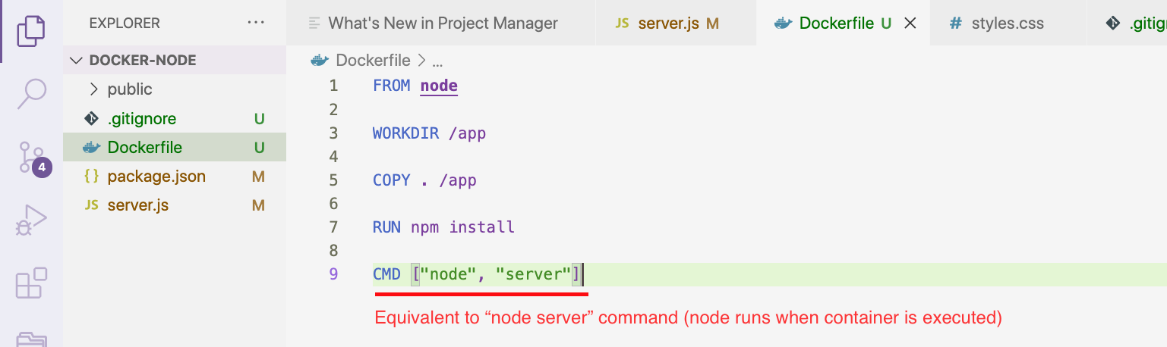

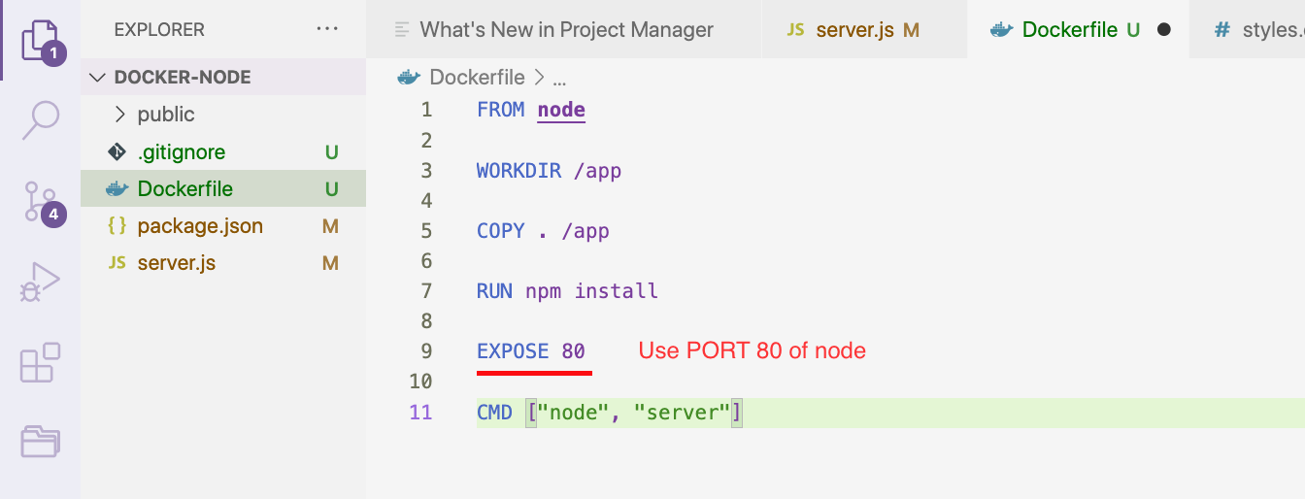

Create/Build Image

🡪 For this we use

docker build .

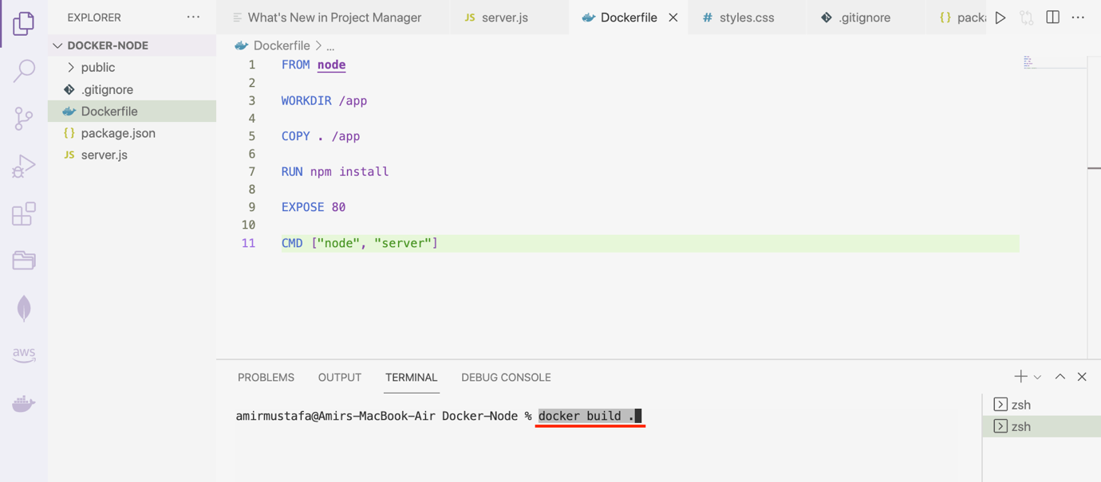

We get image ID in the end

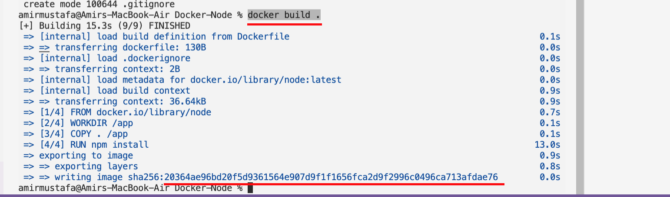

Run Container using image

docker run <image ID>

eg. docker run 0364ae96bd20f5d9361564e907d9f1f1656fca2d9f2996c0496ca713afdae76

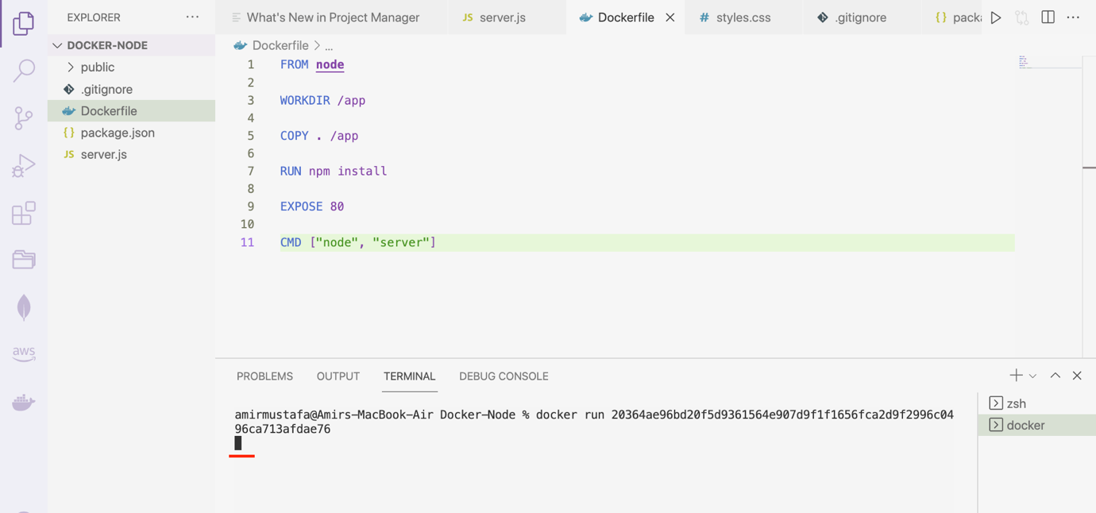

🡪 We see server is running, but when we hit

http://localhost:80, we see our node app not running

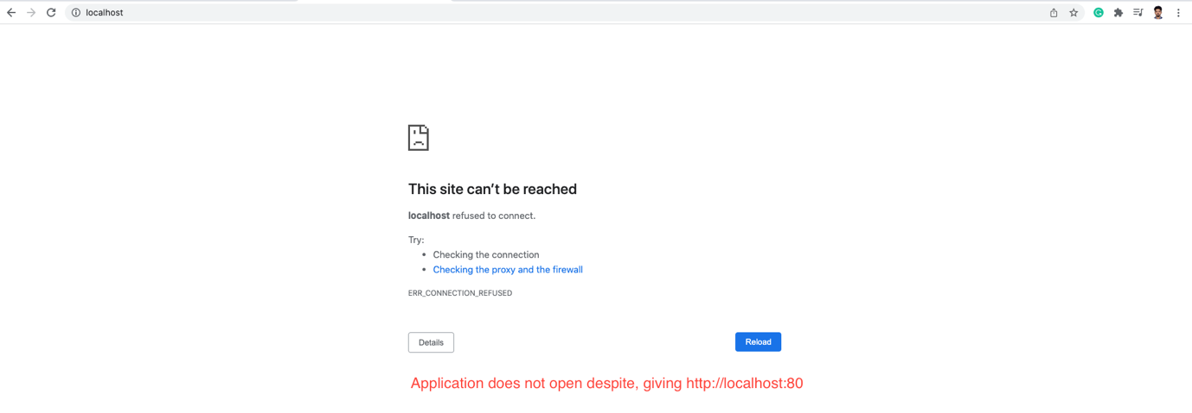

🡪 To fix this issue, we need to first run

docker ps // checks our running containers

NOTE: docker ps -a // checks our running containers

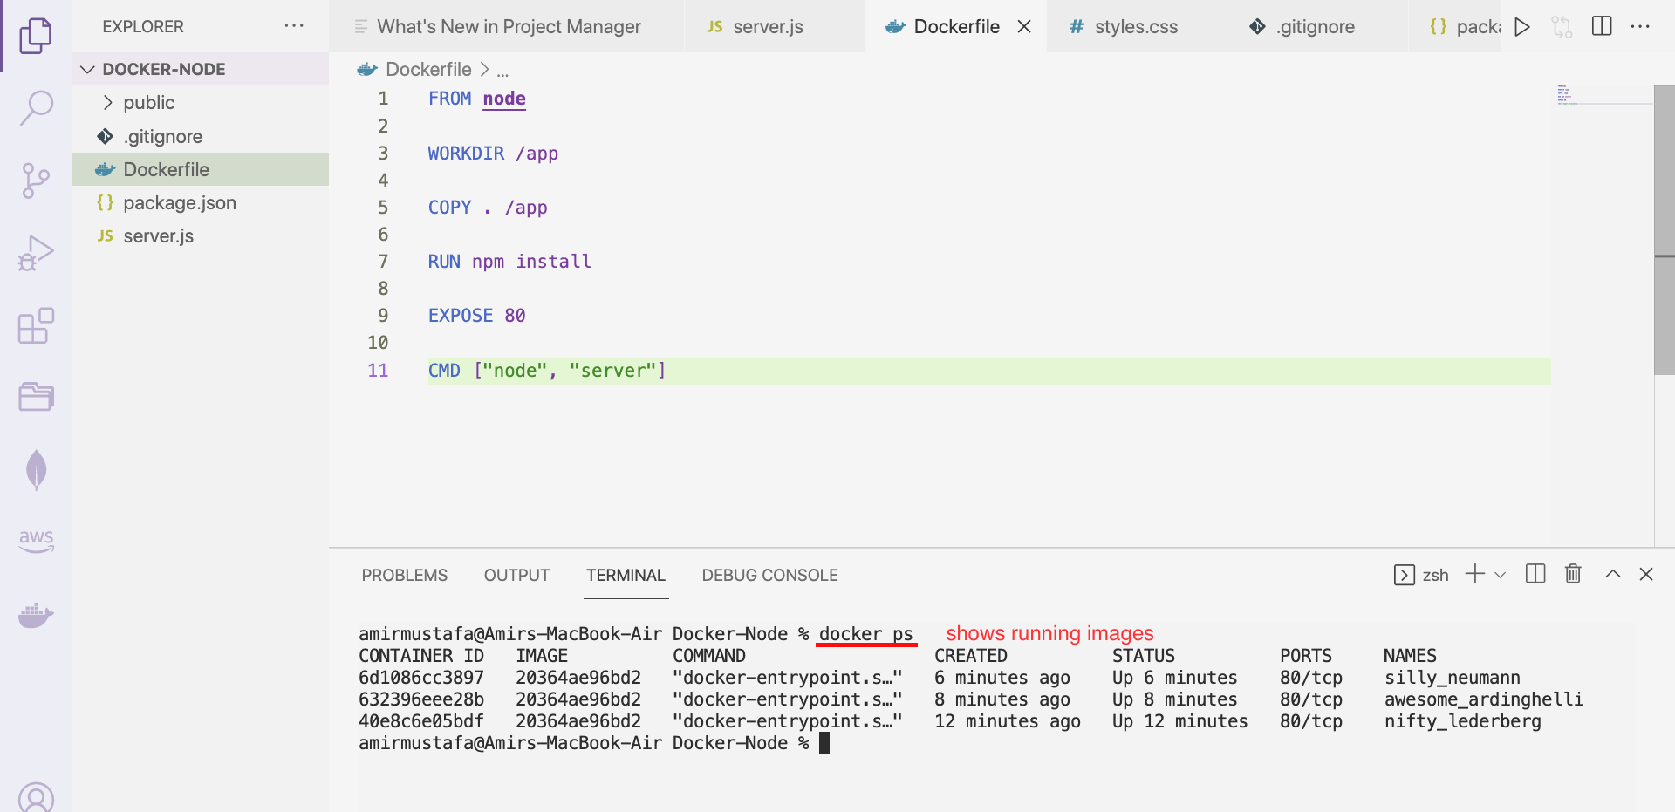

🡪 To stop all three containers

docker stop <image assigned name>

docker stop silly_neumann awesome_ardinghelli nifty_lederberg

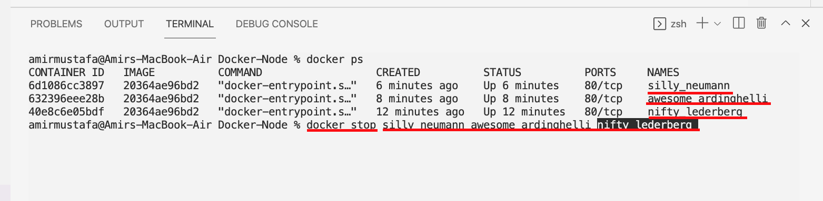

🡪 Run again command docker ps, we see no containers running

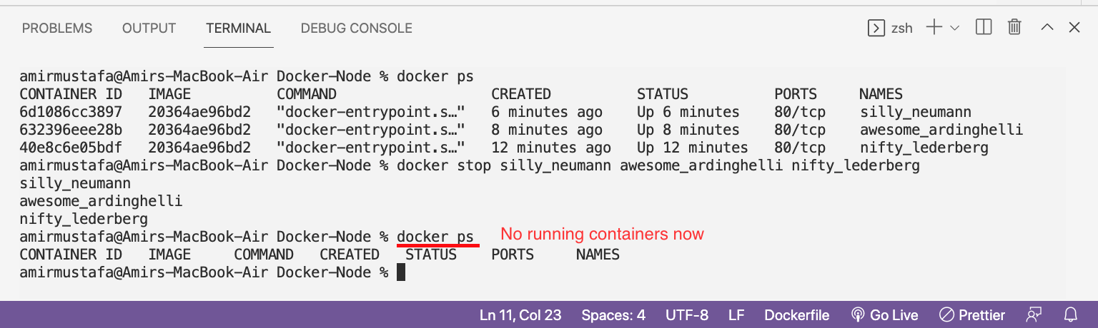

STEP2: We will execute docker with port

docker -p <localport:dockerport> <image_id>

eg. docker run -p 3000:80 20364ae96bd20f5d9361564e907d9f1f1656fca2d9f2996c0496ca713afdae76

🡪 Run localhost:3000 in browser

🡪 Our node.js app is running

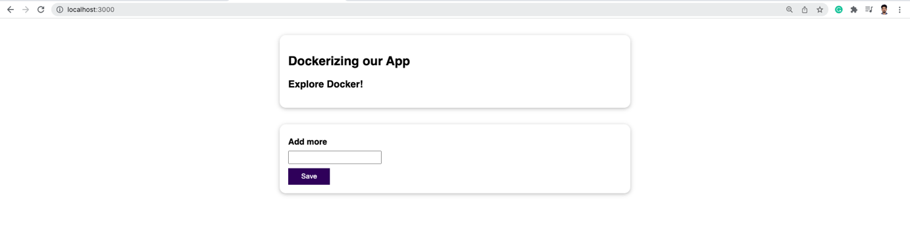

NOTE:

It is important to note, we did not run npm install in our browser, docker handles it

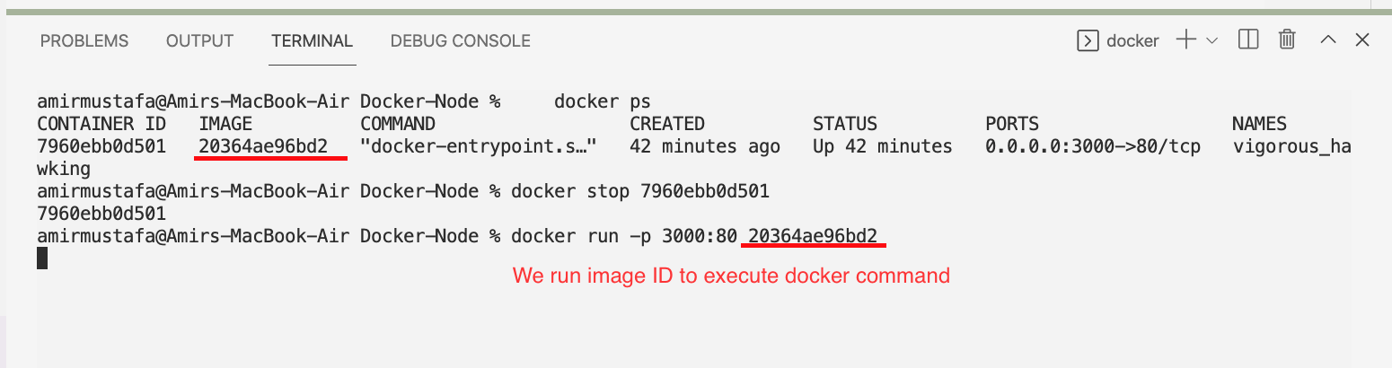

NOTE:

As an additional**quick side-note**: For **all docker commands** where an **ID** can be used, we **don't always have to copy** / write out the **full id.**

We can also**just use the first (few) character(s)** - just enough to have a unique identifier.

So instead of

docker run abcdefg

we could also run

docker run abc

or, if there's no other image ID starting with "a", we could even run just:

docker run a

This applies to all Docker command where ID is needed.

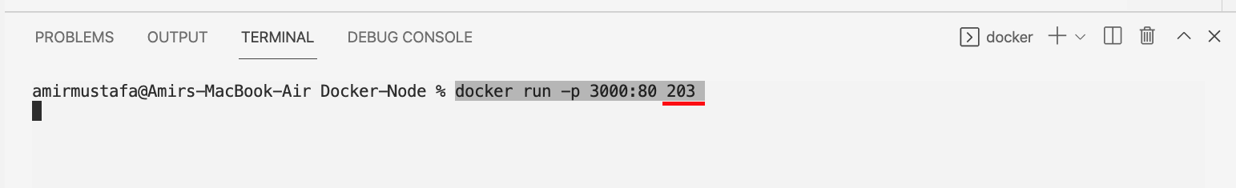

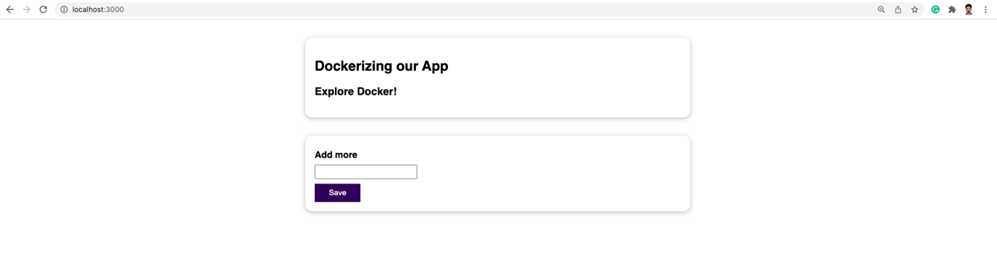

Images are Read-only

🡪 Suppose we have edited in our code

🡪 If we stop the docker server and restart it, we will observe our latest code is not rendered

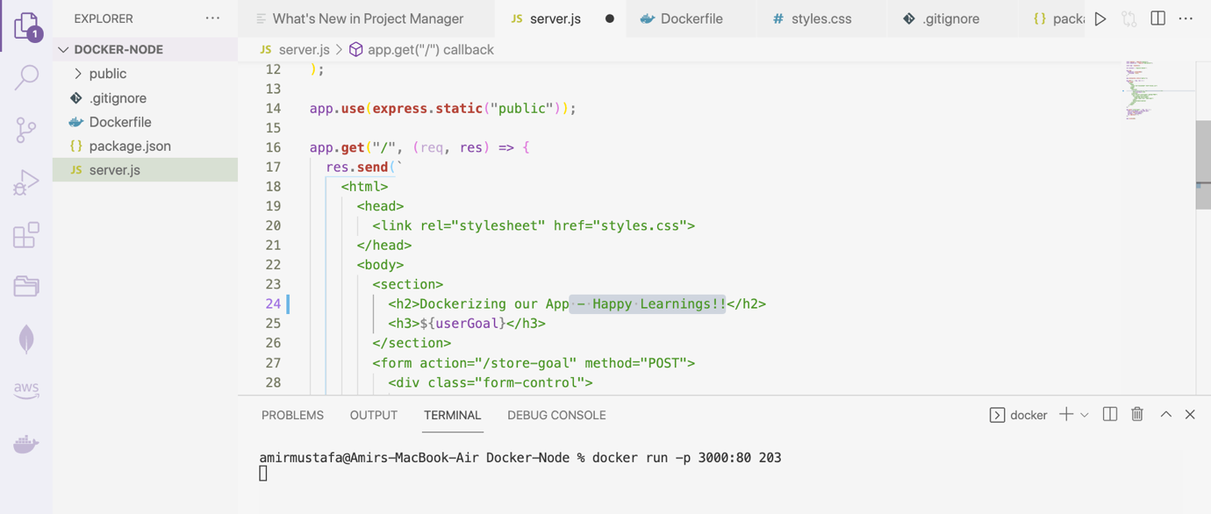

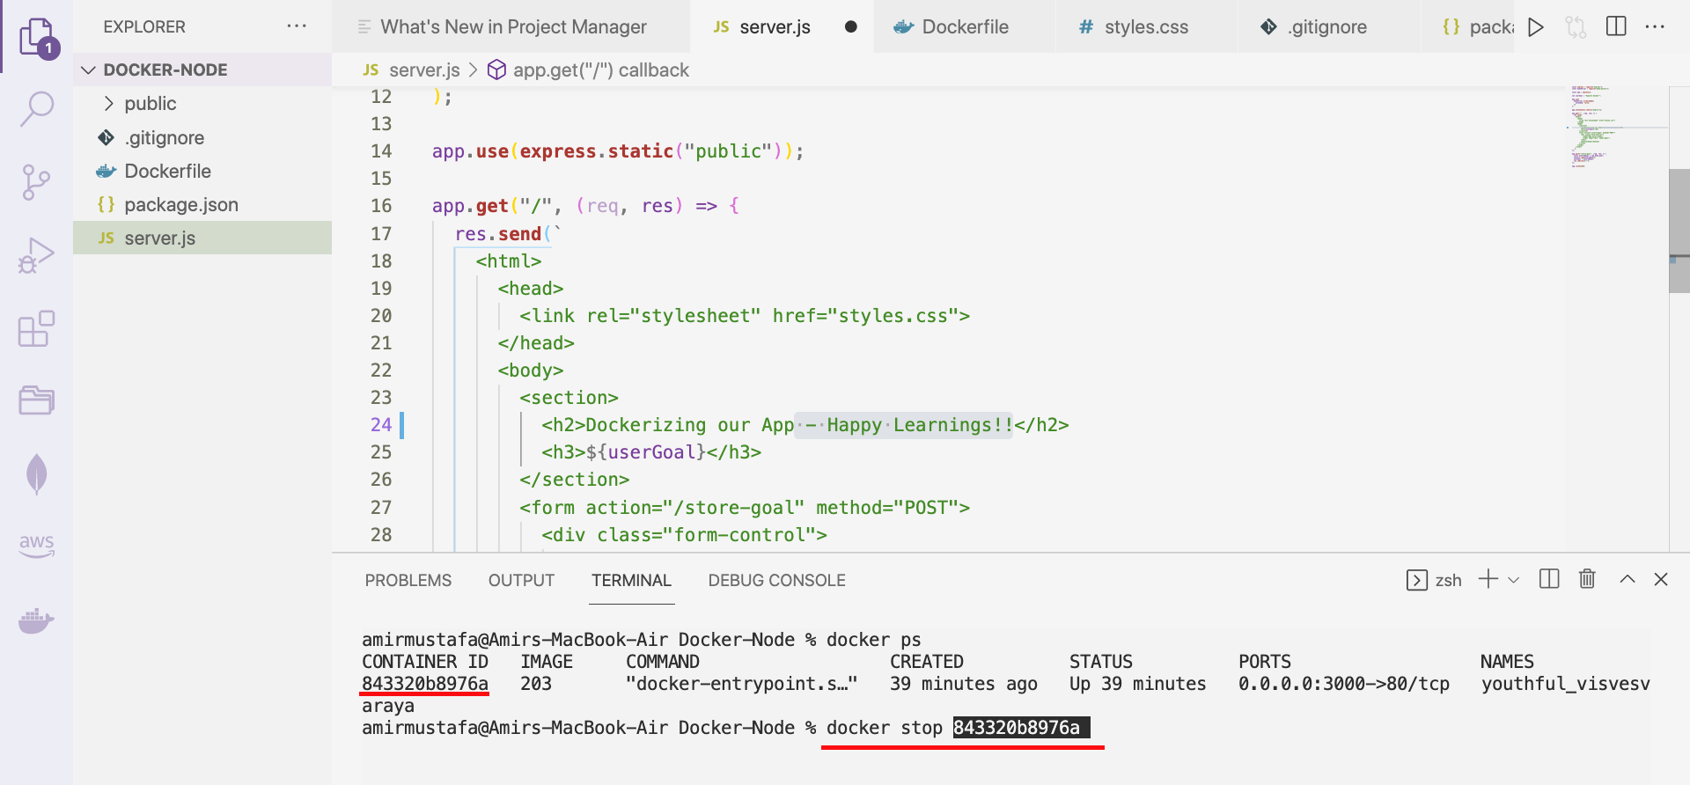

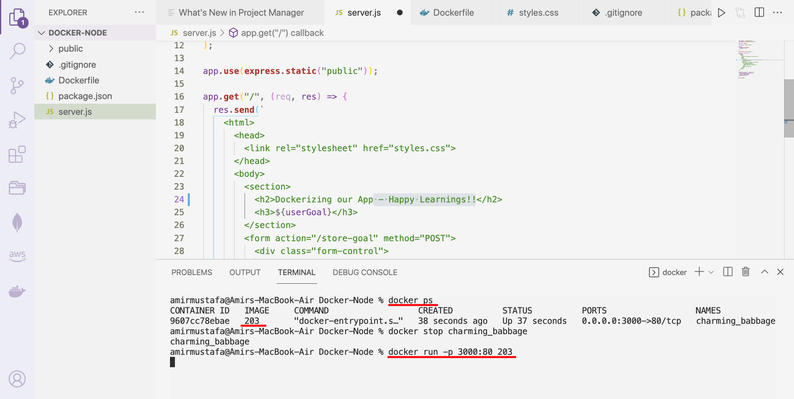

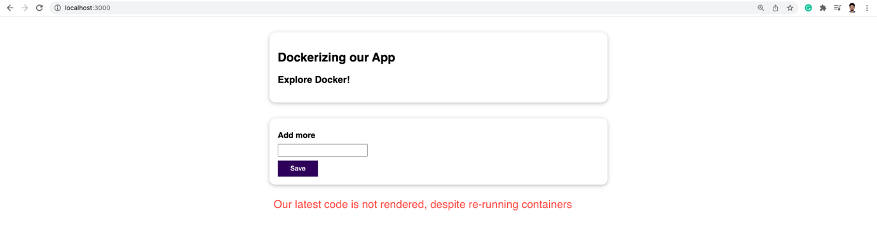

Q. So why does it happen?

Mainly when we run Dockerfile, the code is executed and is locked and cannot be changed.

Solution – Everytime code changes, we need to build again

docker build .

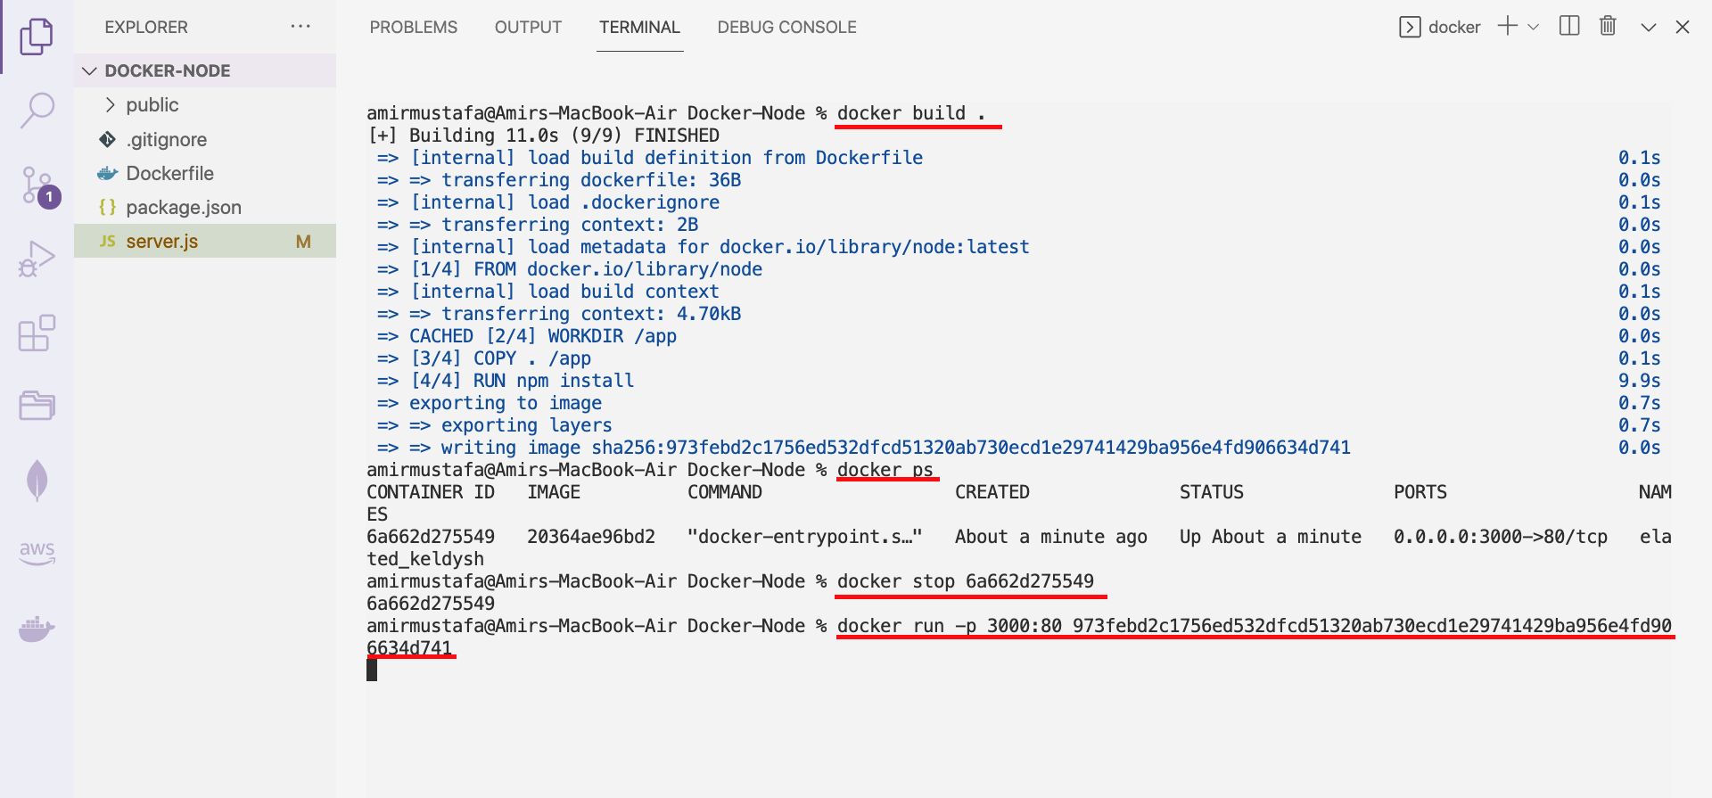

🡪 Finally, our image is rendered

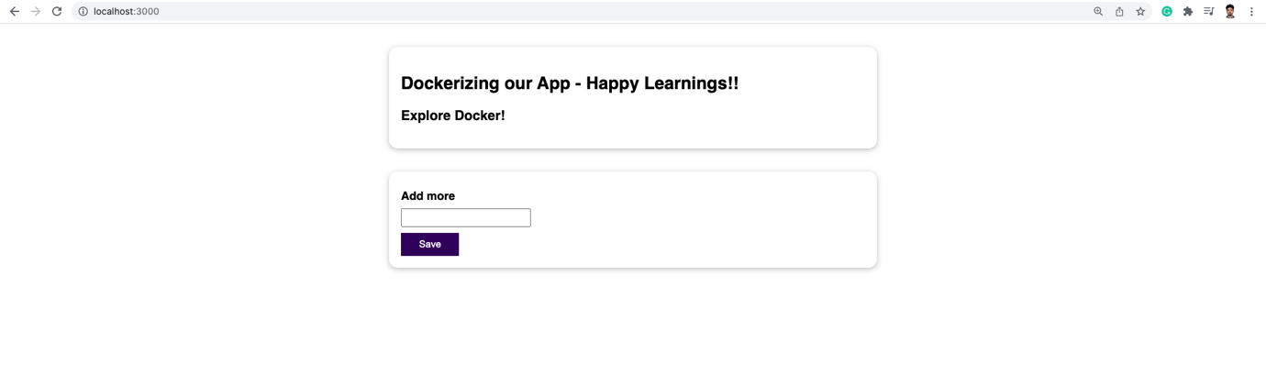

Understanding Image Layers

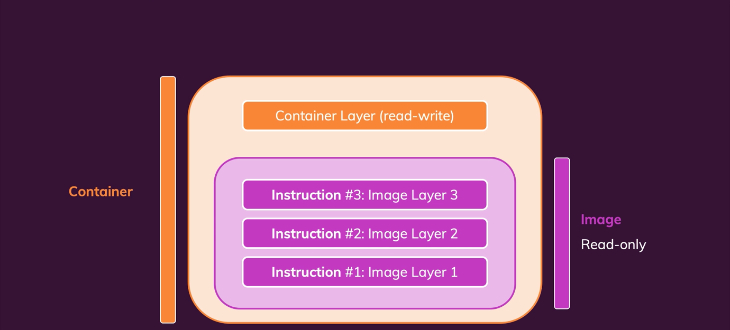

If build is done and see our docker application running

Case 1: If we edit the code and rebuild docker latest code will be created

Case 2: If we without doing any change we run build command again, this time it will be very fast. Docker caches the data

🡪 All the command run in Dockerfile have different image layers

🡪 Image is build in multiple layers based on instruction.

🡪 If we do make change, layers after specific command layer will be re-executed again

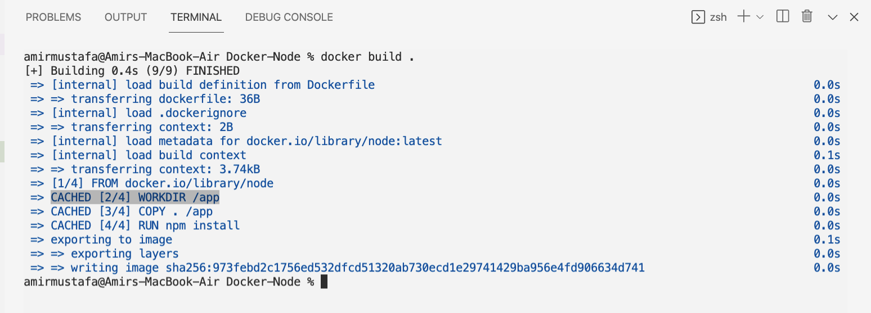

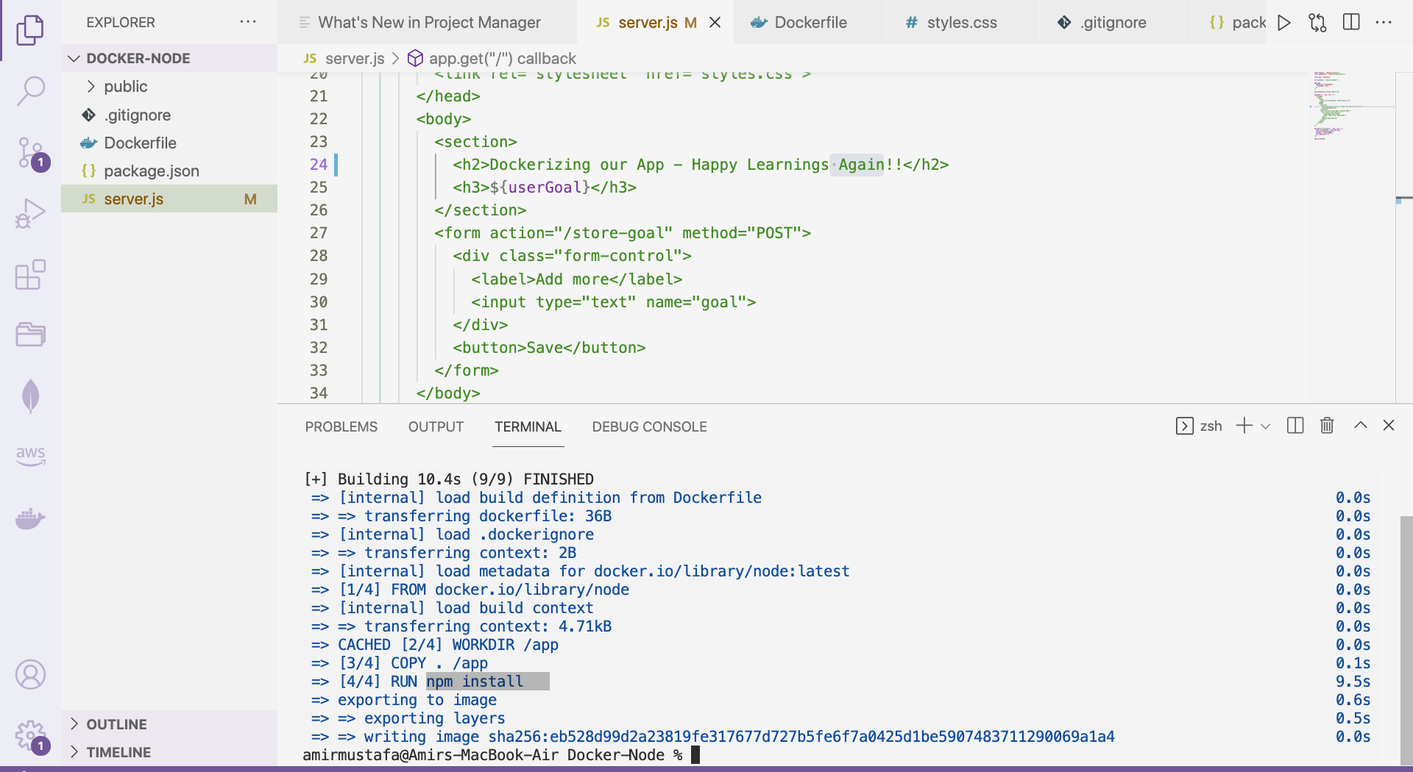

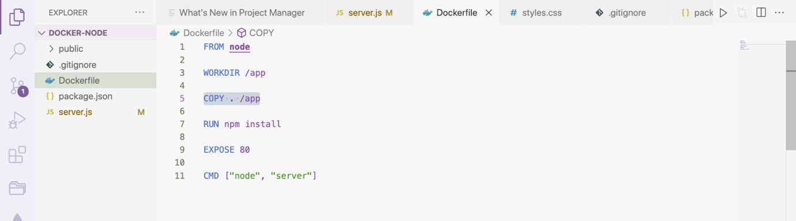

🡪 We observe our npm install is again running all layers. Because layers after COPY code re-runs

**Solution:**

We will copy package.json first 🡪 then npm install 🡪 then remaining files

🡪 So when we edit code, and build again npm install will not run. Only when we make changes in package.json file npm run will run

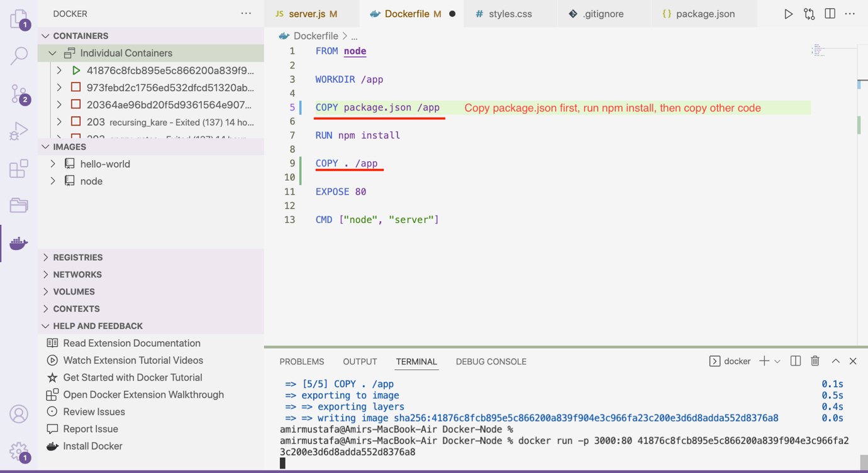

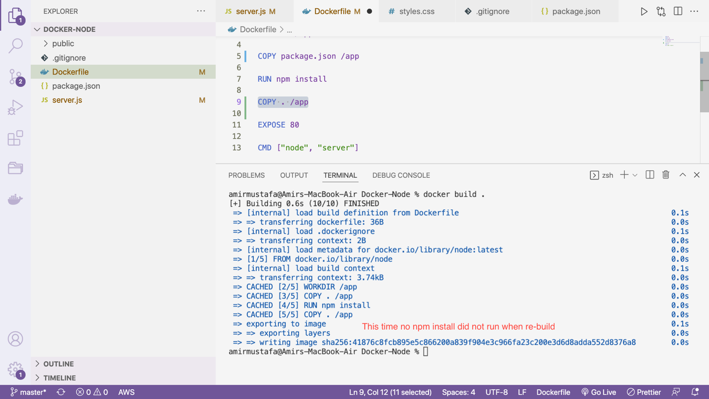

Summary:

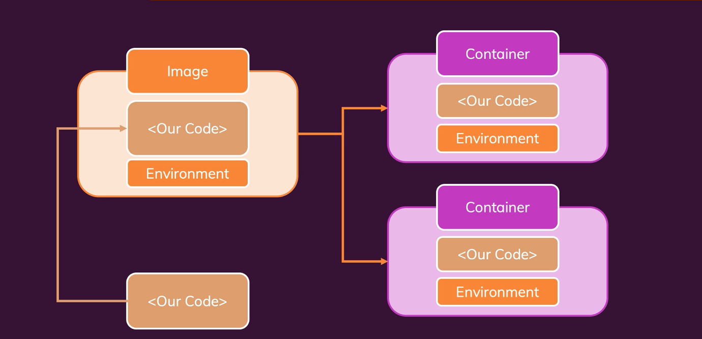

🡪 We create image from Docker file

🡪 Image contains App code + Environment (dependencies for node)

🡪 Docker is all about container, image is the building block

🡪 When running container is running, code is not copied, extra layer is on top of image. There can be multiple containers running independent of each other

🡪 New changes in code, add on the container

Q. What are "Images" (when working with Docker)?

A. Images are blueprints for containerswhich then are running instances with read and write access

Q2. What are "Layers" in the context of images?

1. Every instruction in an image creates a cacheble layer – layers help with image re-building and sharing

Managing Images and container:

🡪 Till now we have seen how we can build a docker, start and stop a container

🡪 There more options with which we can play

HINT: Always –help after any docker command – very handy

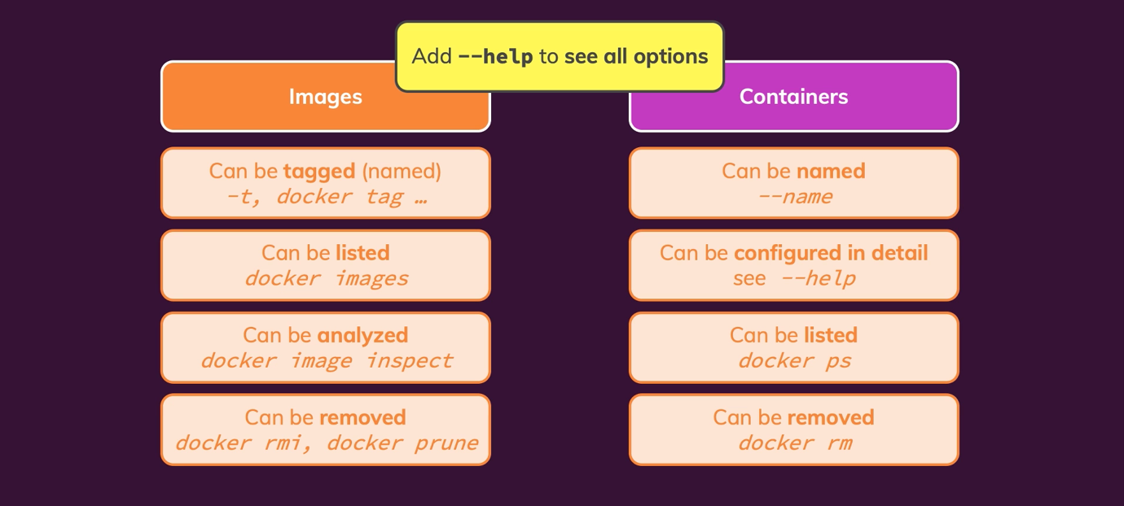

Stopping and Restarting containers:

1. docker –help. // list of command with its use

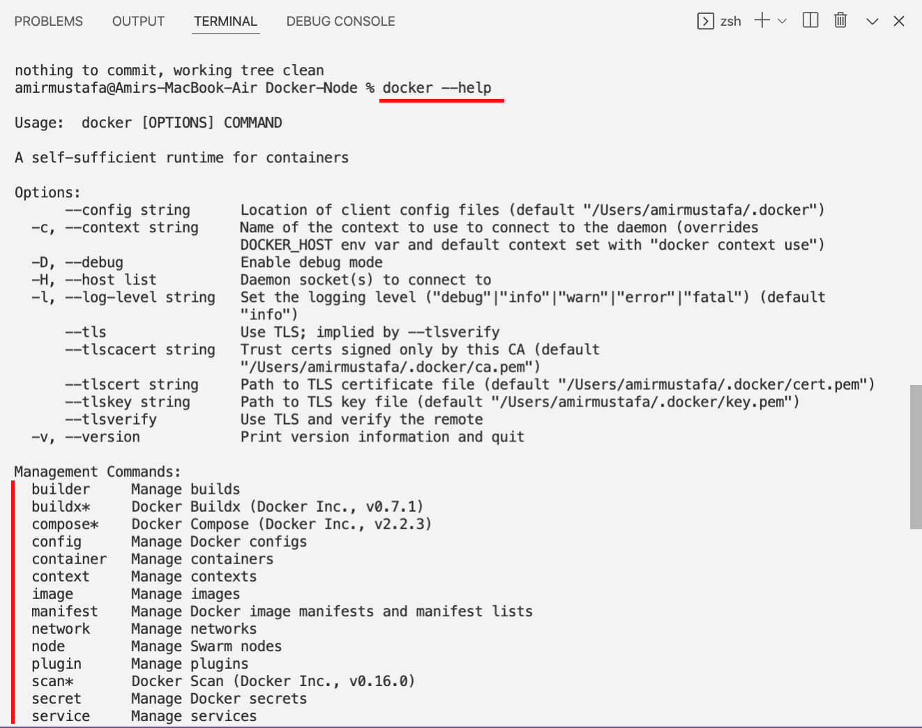

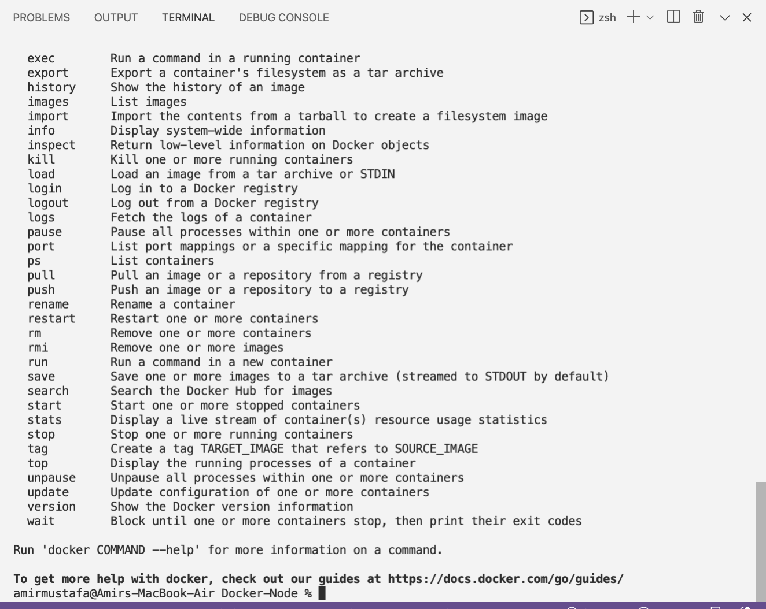

1. docker ps // Lists all running containers

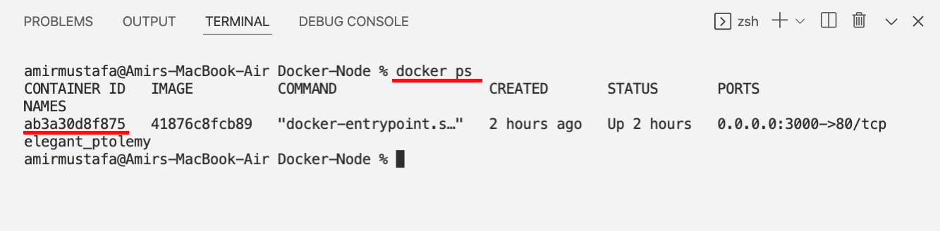

1. docker ps -a. // All the containers (including stopped containers)

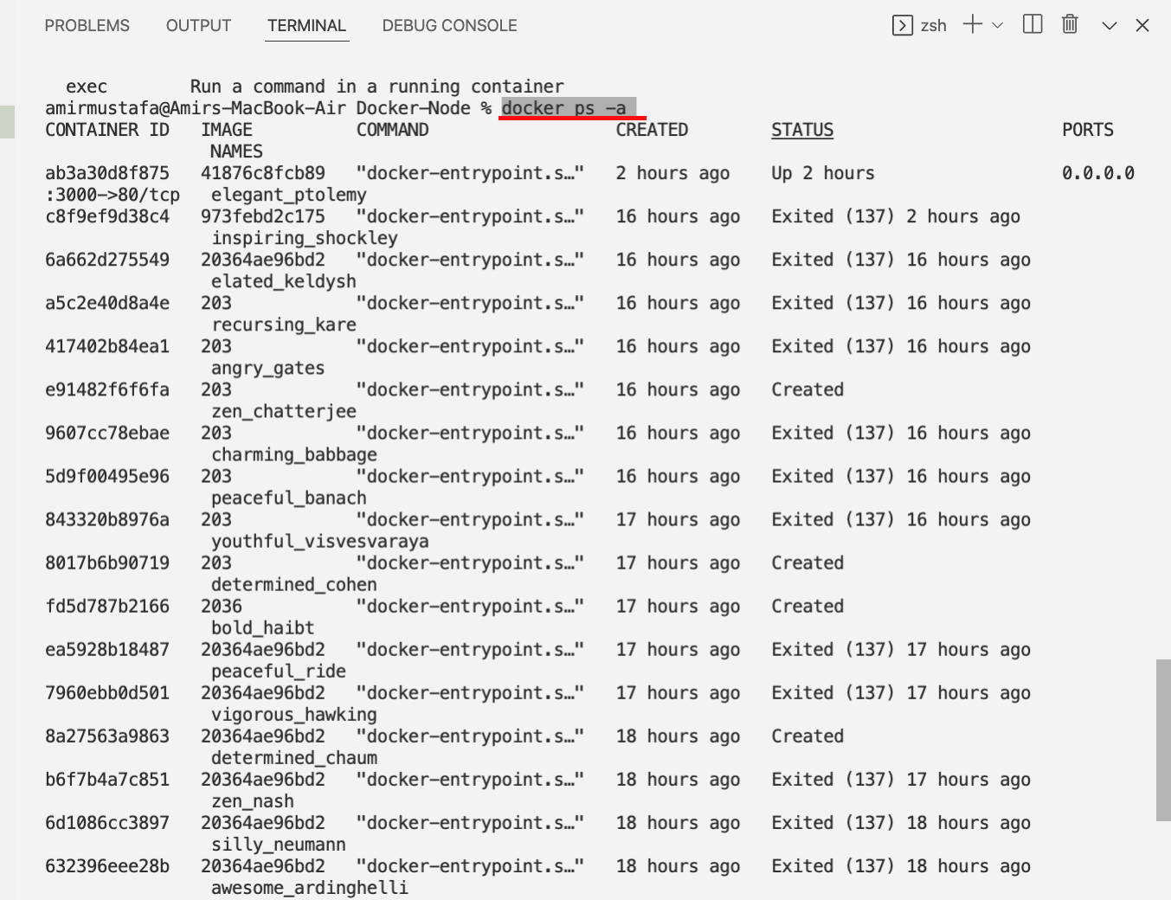

1. docker ps –help // for all ps related configs

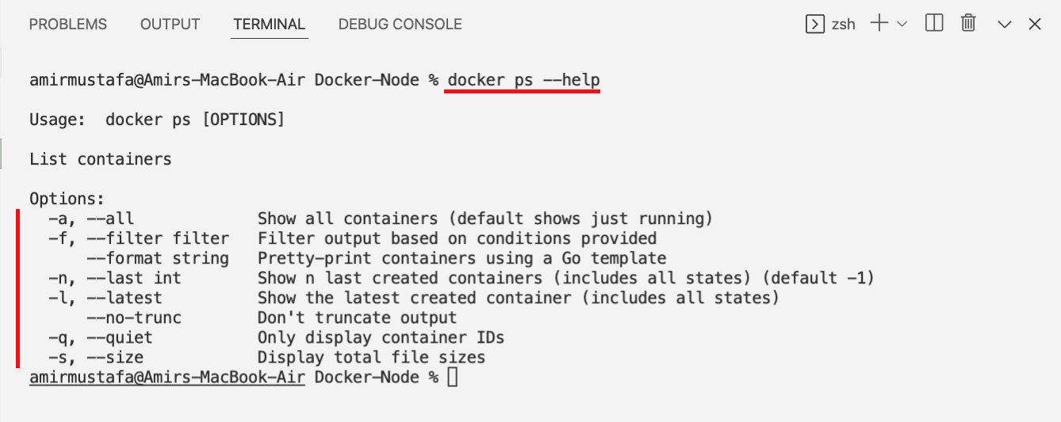

1. Restarting a container

🡪 If we have not made any changes we do not create a new container by docker run command

Method 1:

🡪 first we check container to restart – copy ID or name of container

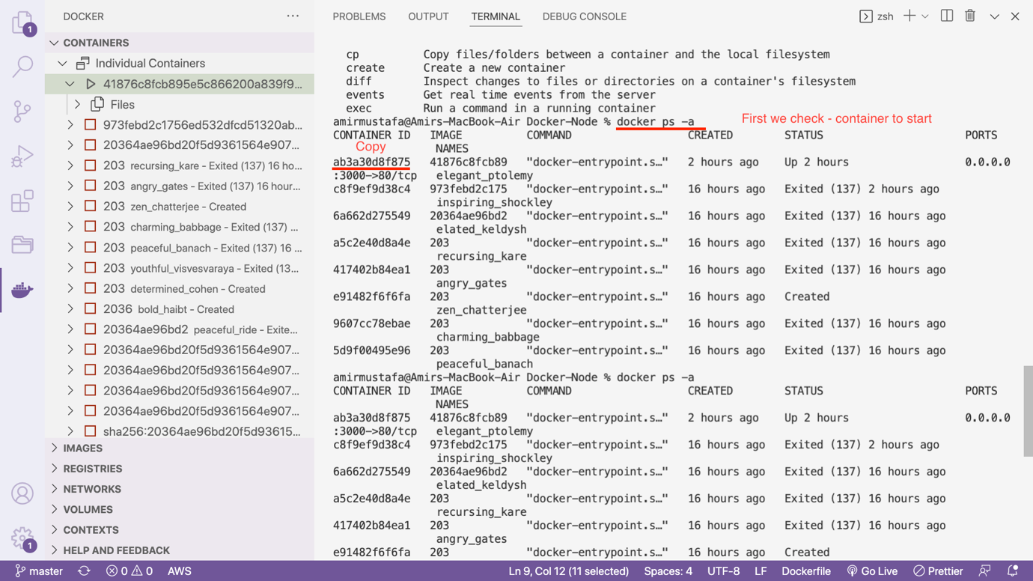

docker start <container ID or name>

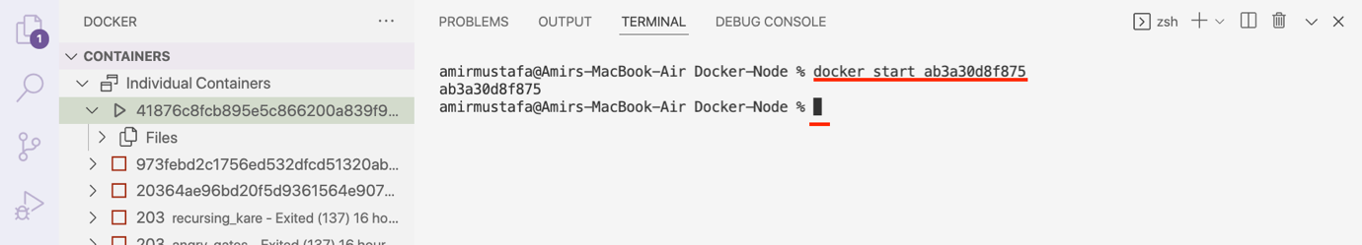

Containers runs in background (we check by docker ps)

Method2: If we have updated VS Code:

Step1:Go to docker section

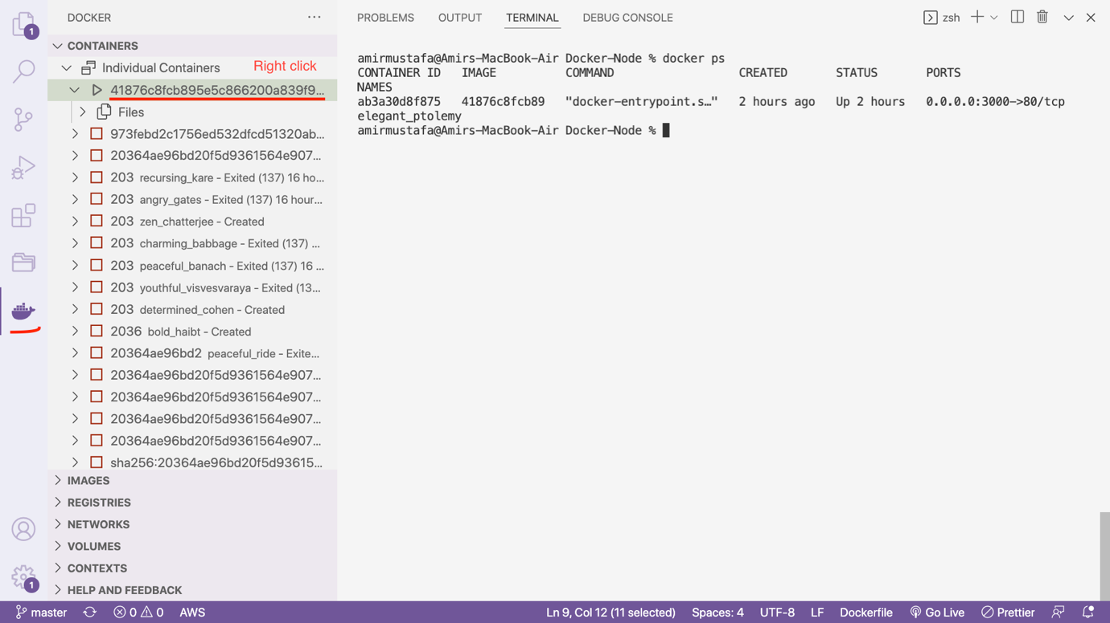

Step2: Right click Restart

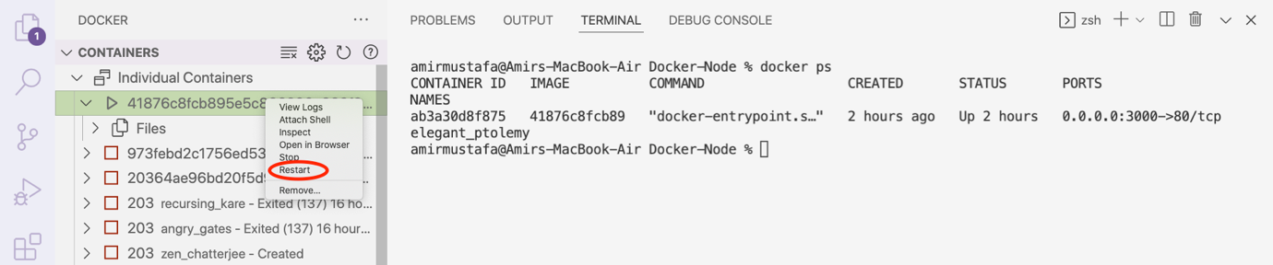

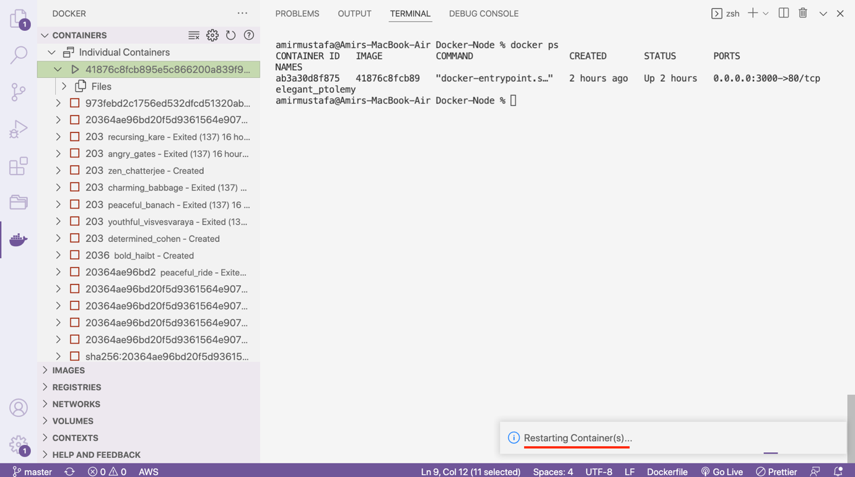

Understanding Attached and Detached Containers:

1. On Creating the container:

🡪 When we create a container by default, terminal will be in attached mode

🡪 Attached mode means terminal is running, consoles logs will also print if we write in our code

docker run -p 8000:80 <docker-image-id>

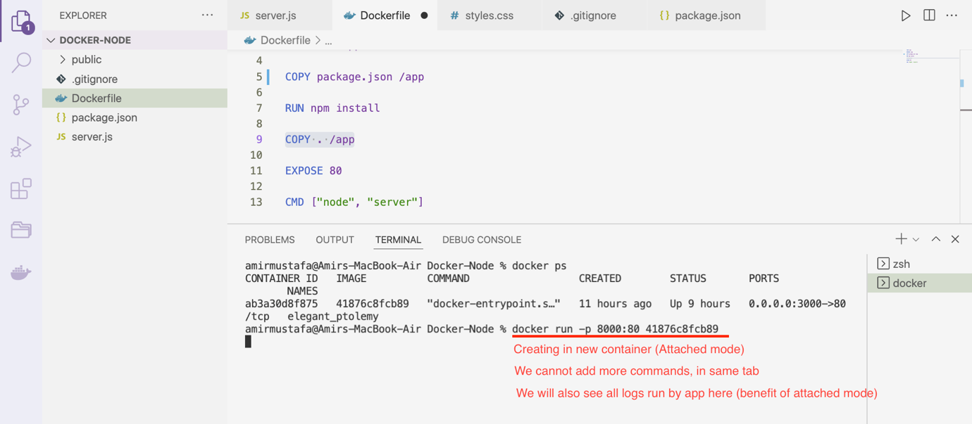

1. On Restarting the container:

🡪 When we restart the container by default, terminal will be in detached mode

🡪 Detached mode means container is running background, no log will print

🡪 We can write more commands, terminal is unblocked

docker start <docker-container-id-or-name>

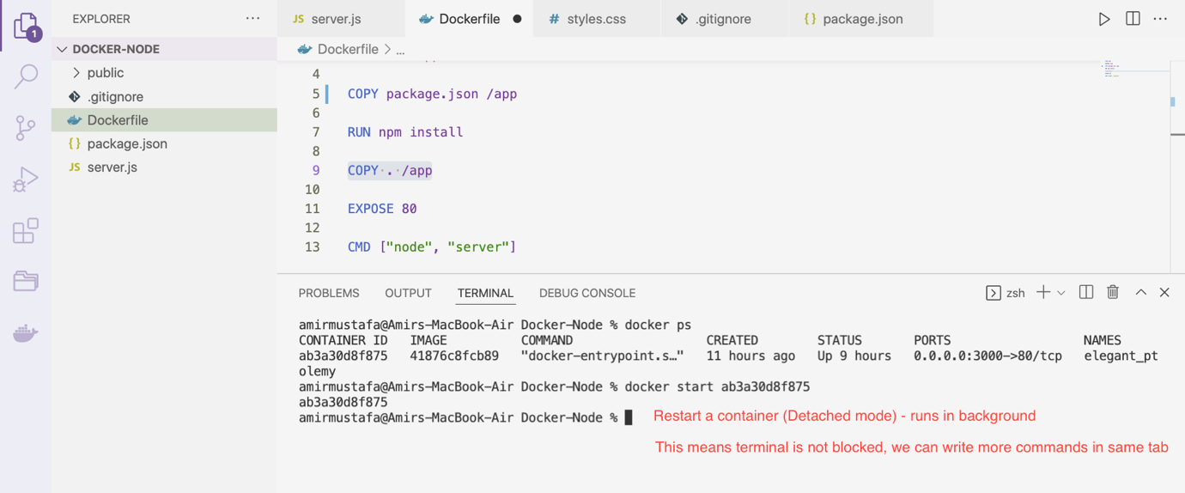

🡪 We created containers in 8000 PORT and restarted container in 3000 PORT

🡪 There are two ways to see running containers:

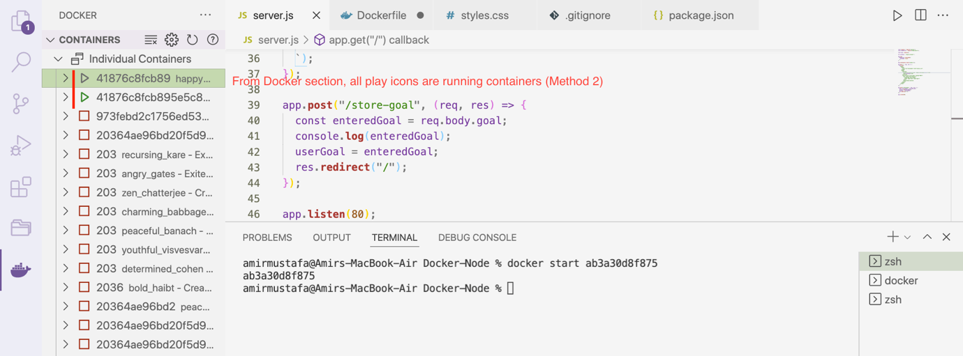

🡪 Let us print console in both 8000 and 3000 PORTS:

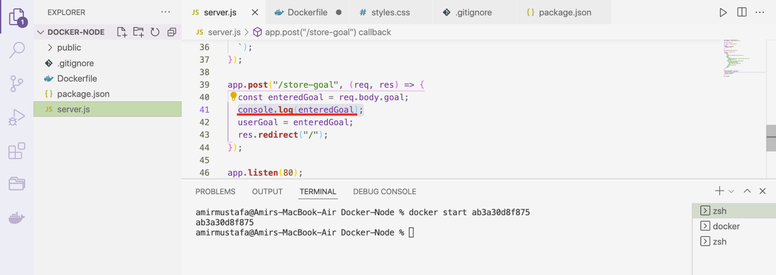

1. 3000 PORT (Detached mode – default restart container case):

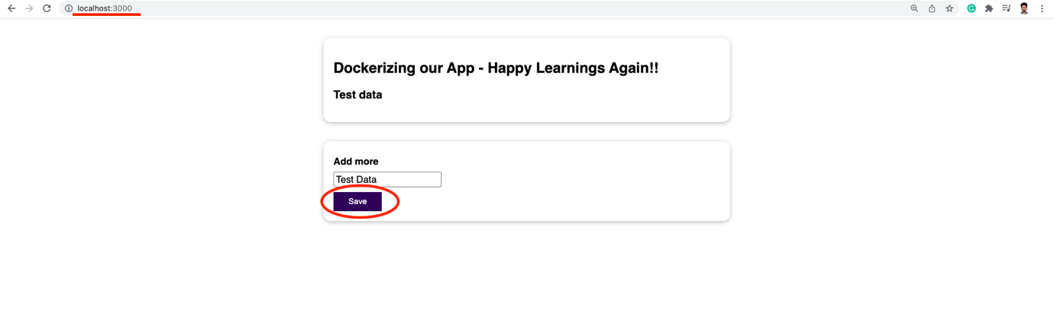

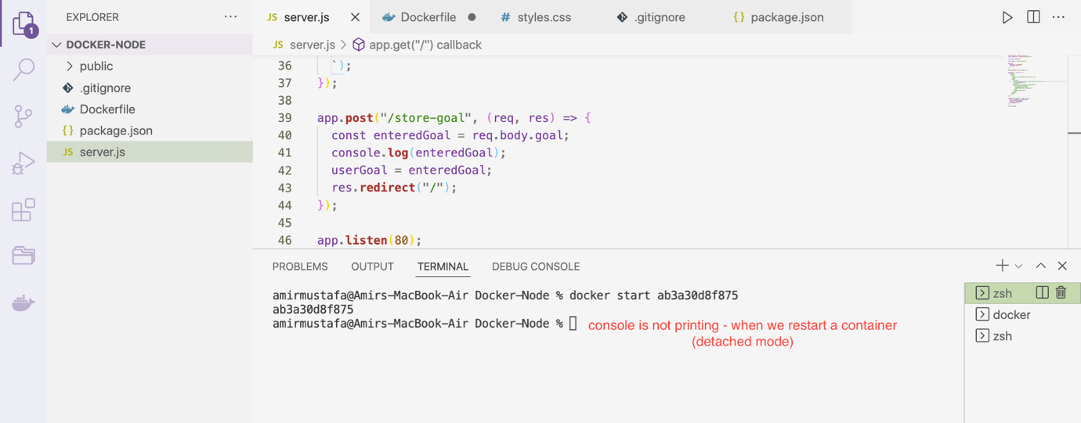

1. 8000 PORT (Attached mode – default create container case):

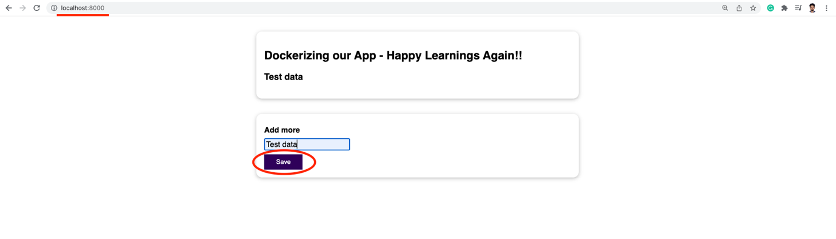

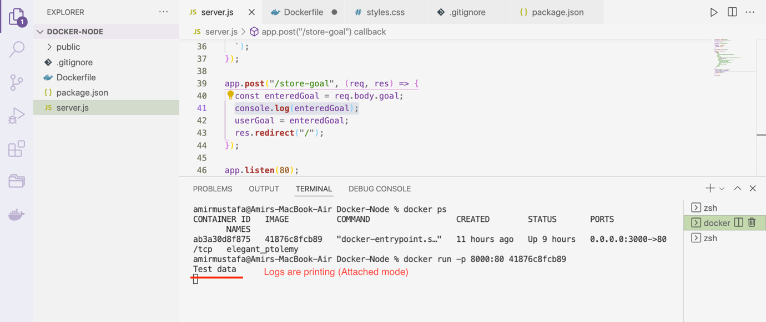

🡪 It is possible to open both cases in attached or detached mode:

-a flag for attached

-d flag for detached

Creating containers (opposite case of default)

We explicitly used -d flag



🡪 Restarting containers (opposite case of default):

We explicitly used -a flag

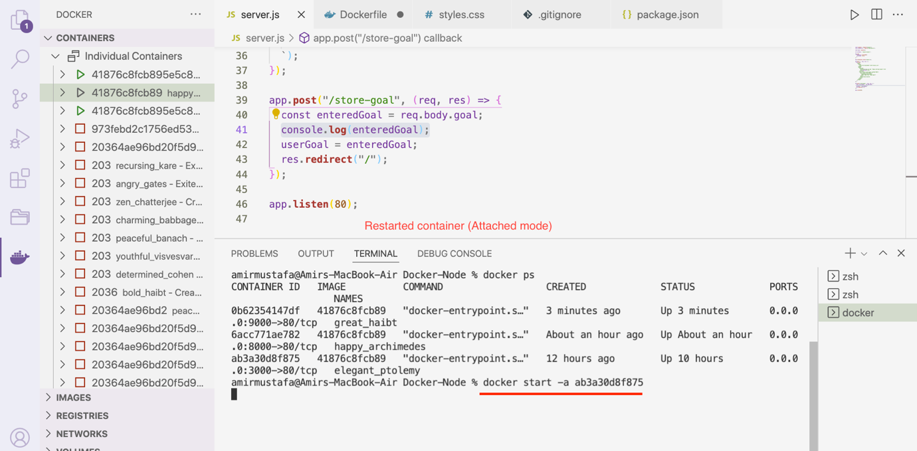

NOTE: If in both cases we are in detach mode

We can write docker attach <container> to convert in attach mode

View logs of containers:

Method1: docker logs <docker-container-id-or-name>

If we add. -f flag follow, we will be able to see future logs as well

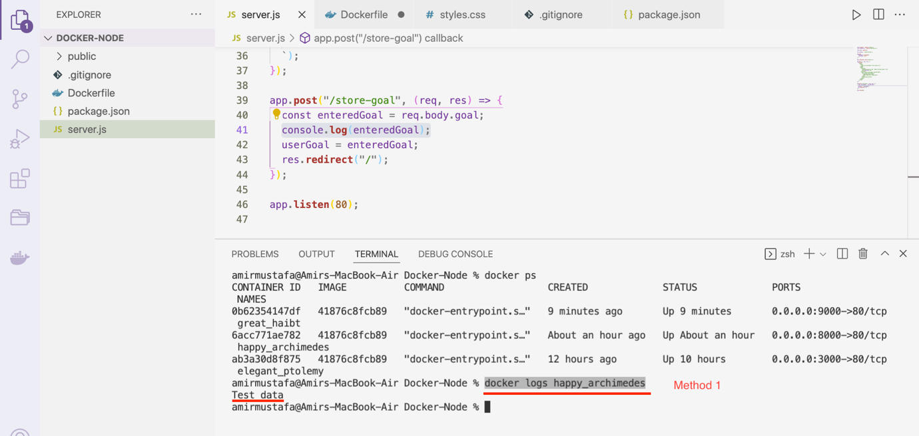

Method 2: From Docker section:

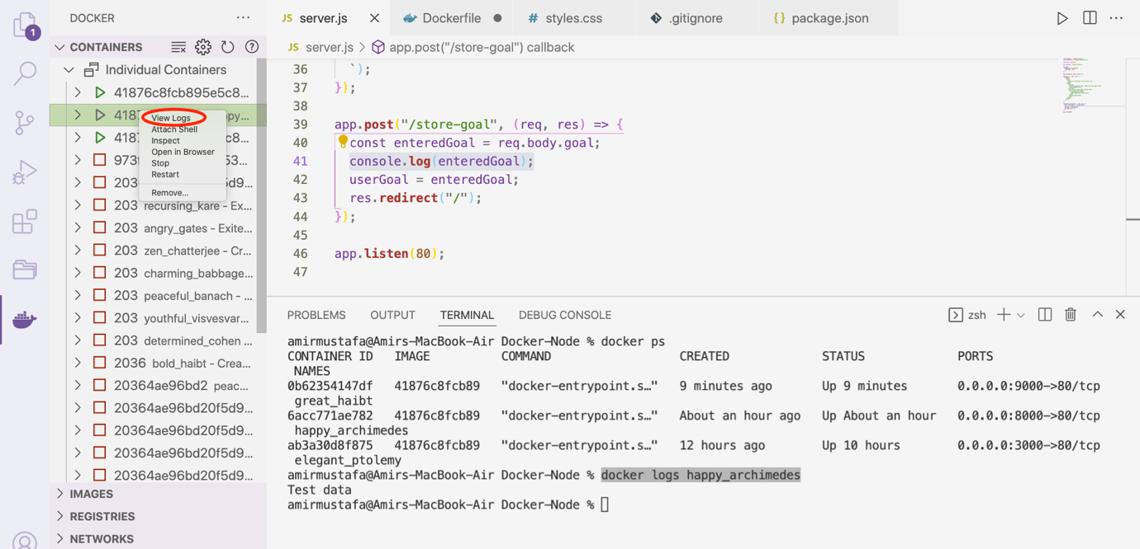

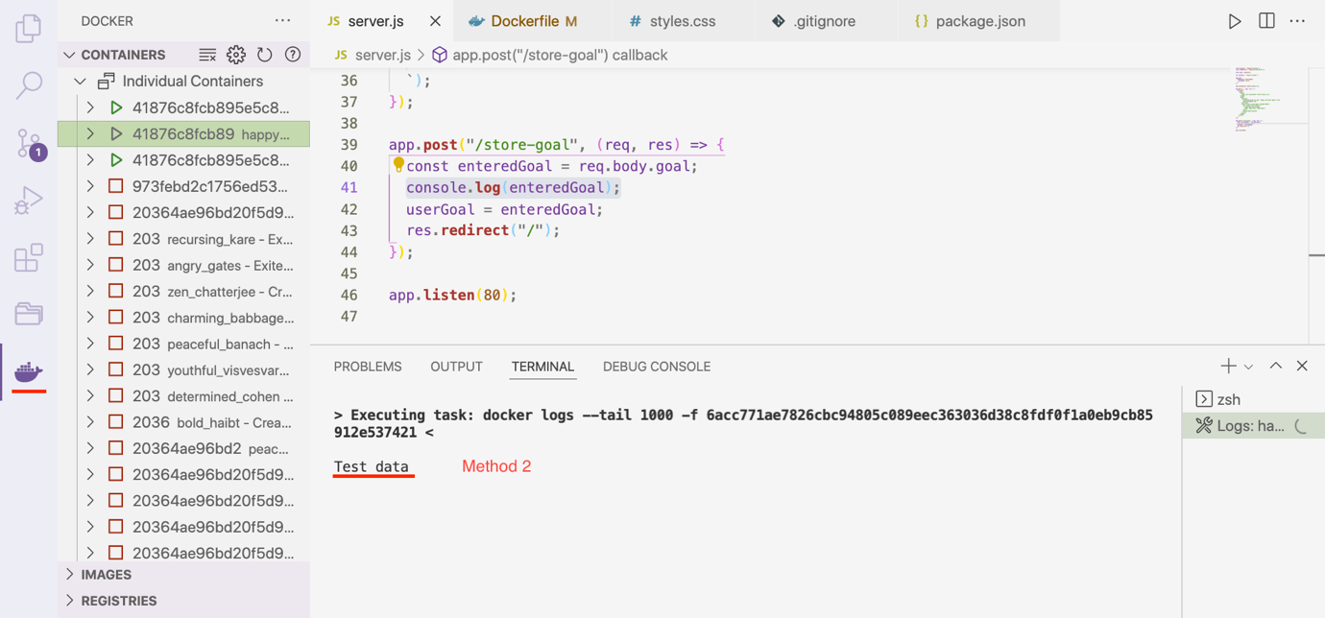

Entering Interactive Mode:

🡪 For this let us use Python as the base image

rng.py

from random import randint

min_number = int(**input**('Please enter the min number: '))

max_number = int(**input**('Please enter the max number: '))

if (max_number < min_number):

**print**('Invalid input - shutting down...')

else:

rnd_number = randint(min_number, max_number)

**print**(rnd_number)

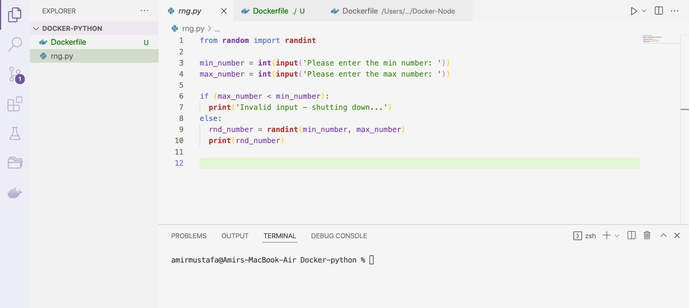

🡪 The above is a basic python code that accepts two numbers – min and max and output generates

🡪 Here we do not need package file as we are not rendering on web page

🡪 The terminal asks two numbers and gives random result in terminal itself

🡪 Let us create Dockerfile. We will be using python as the base image

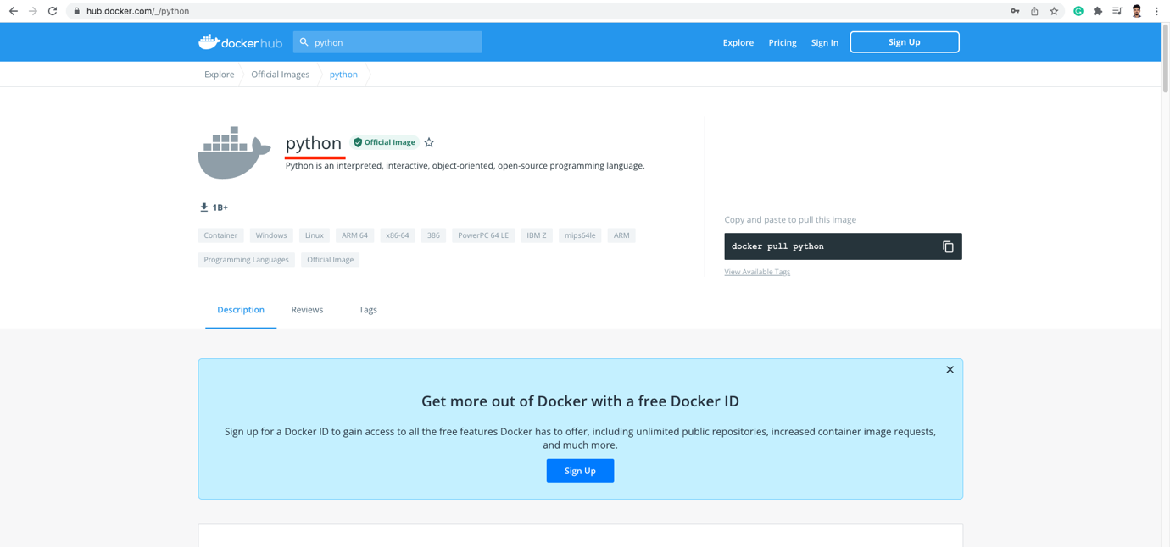

Dockerfile

FROM **python**

WORKDIR /app

COPY . /app

CMD ["python", "rng.py"]

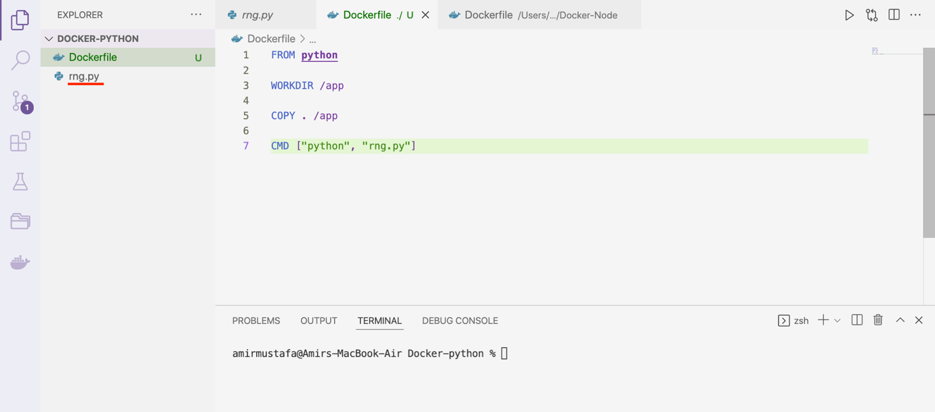

RUN: docker build .

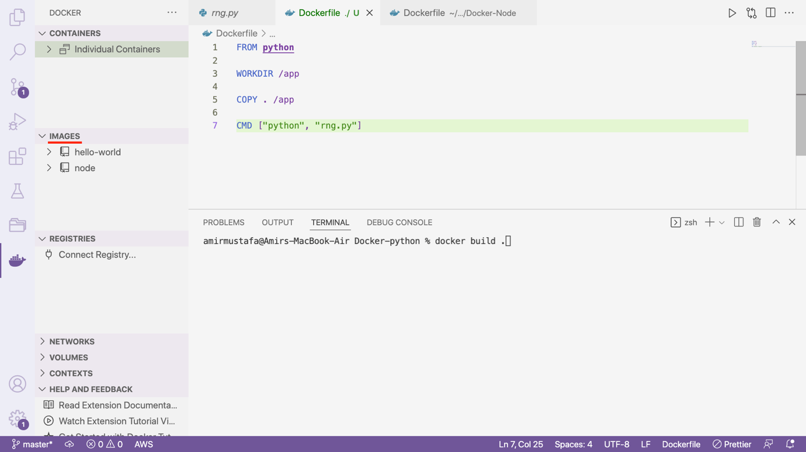

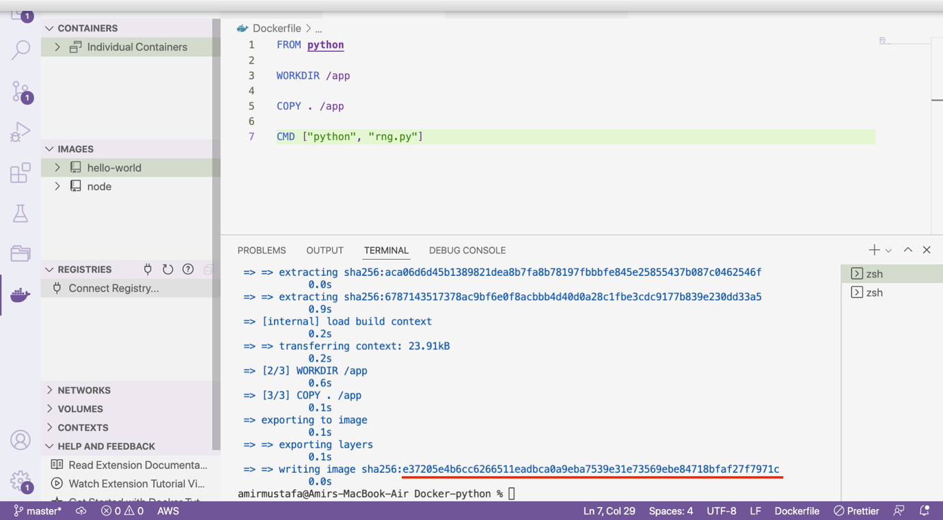

🡪 We do not need to publish to any port so -p 3000:80 is not required.

🡪 Everything is observed in terminal itself.

🡪 If we run image, as we did for node

docker run <python-image-id>

we will see our app will crash. As it does not have capabilities to accept data from terminal

Solution: -i and -t flag or -it flag as combined (interactive terminal)

Type: docker run –help to see all run related configurations

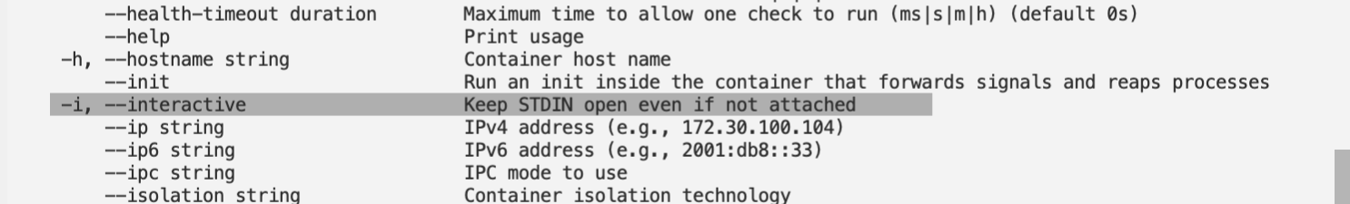

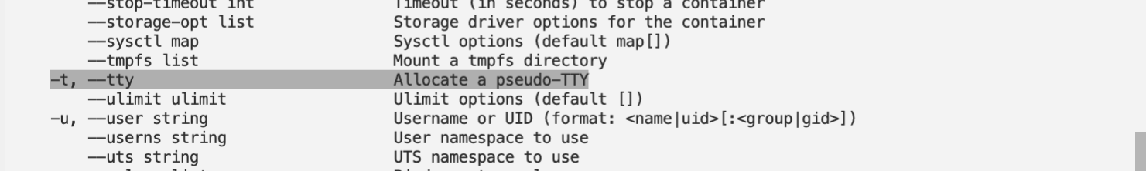

Docker –

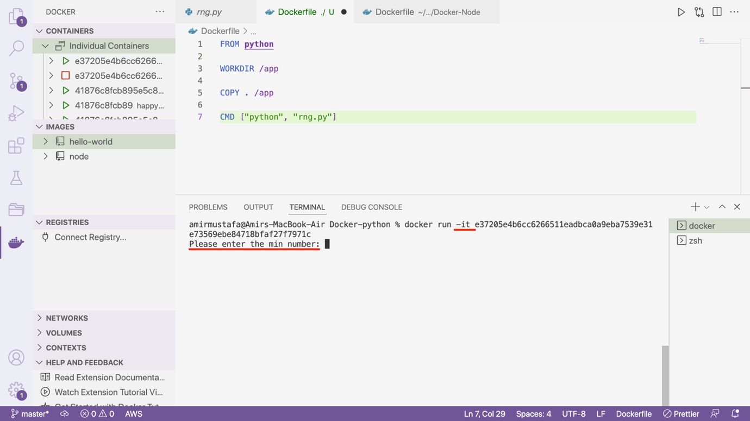

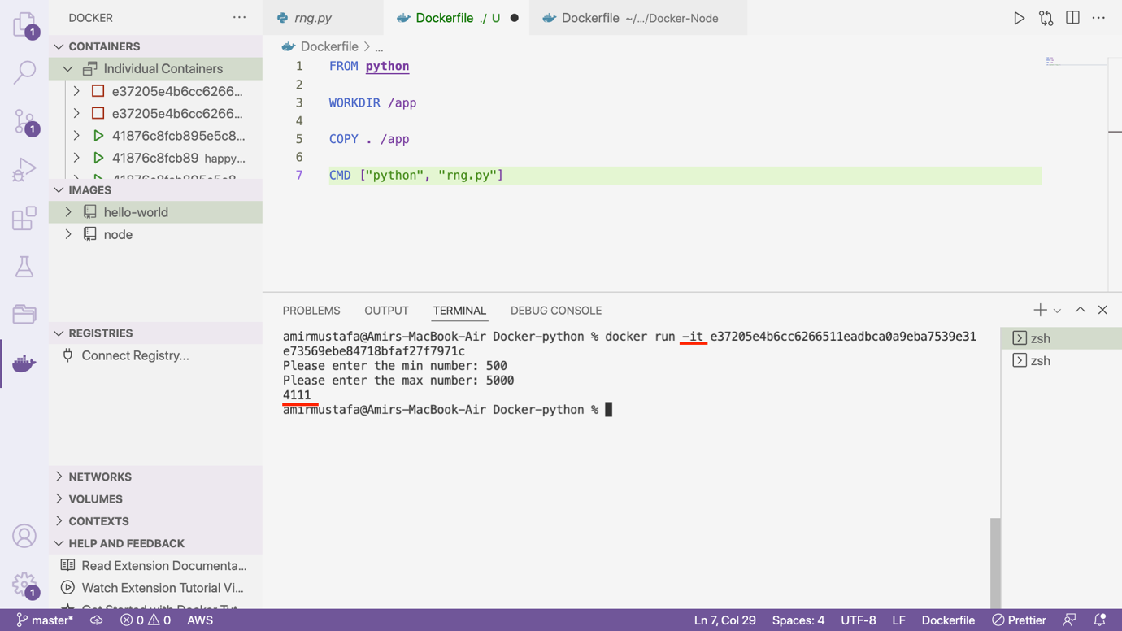

🡪 This time our app did not crash

🡪 We see running containers with docker ps -a

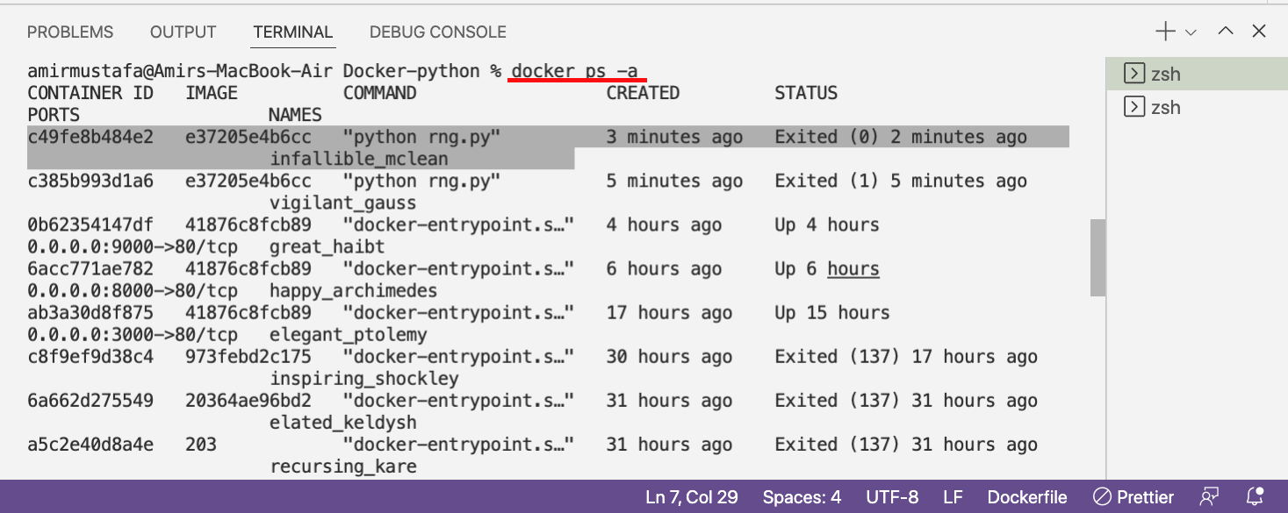

🡪 Now we will have problem when we restart the container, as terminal will not be able to ask in

docker start <image ID>. (will crash as containers opens in detached mode)

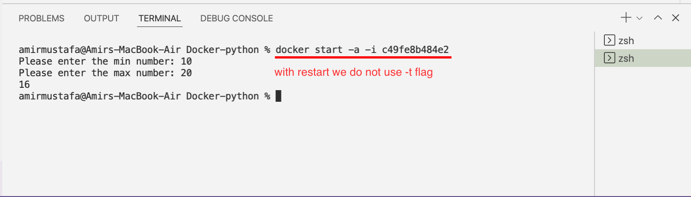

🡪 with restart we do not use t flag. Only attach mode + interactive mode

docker start -a -I <image ID>



🡪 Docker is not only for web application, it can also be used with simple utility tool like this

Deleting Images and Containers:

1. Deleting Containers:

🡪 We can delete docker containers

docker rm <container-id-1> <container-id-2> <container-id-3>

🡪 We get container id from

docker ps -a command

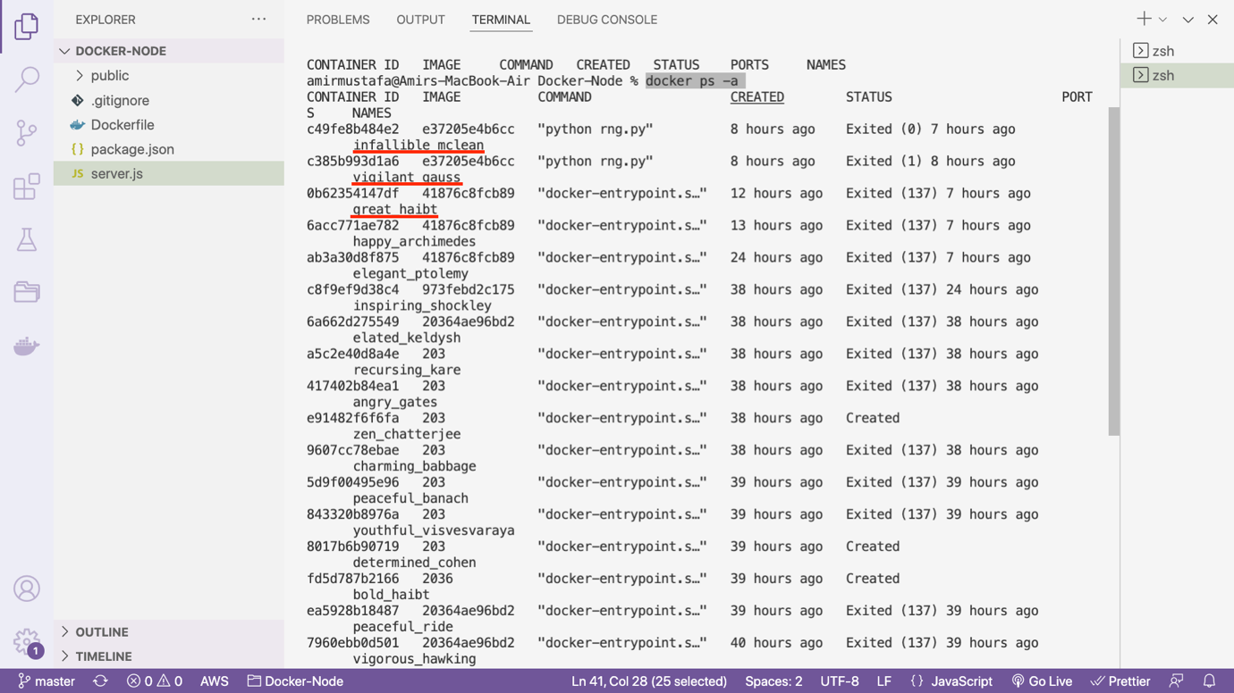

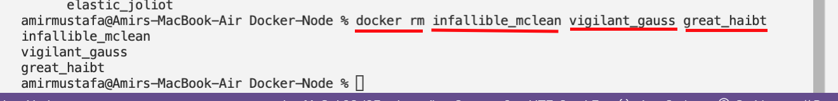

NOTE:

We cannot delete running containers

STEP1: Check docker ps -a

STEP2: Docker stop <container-ID>

STEP3: Docker rm <container-ID>

NOTE2:

If we want to delete all containers at once: docker container prune

Method2: From Docker section:

Right click on container 🡪 Remove

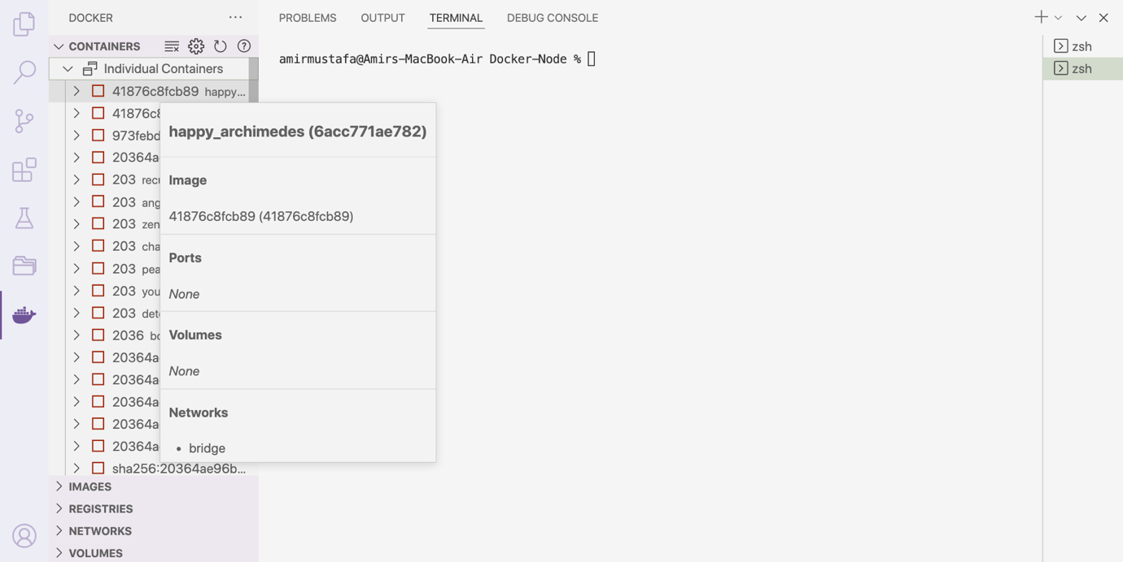

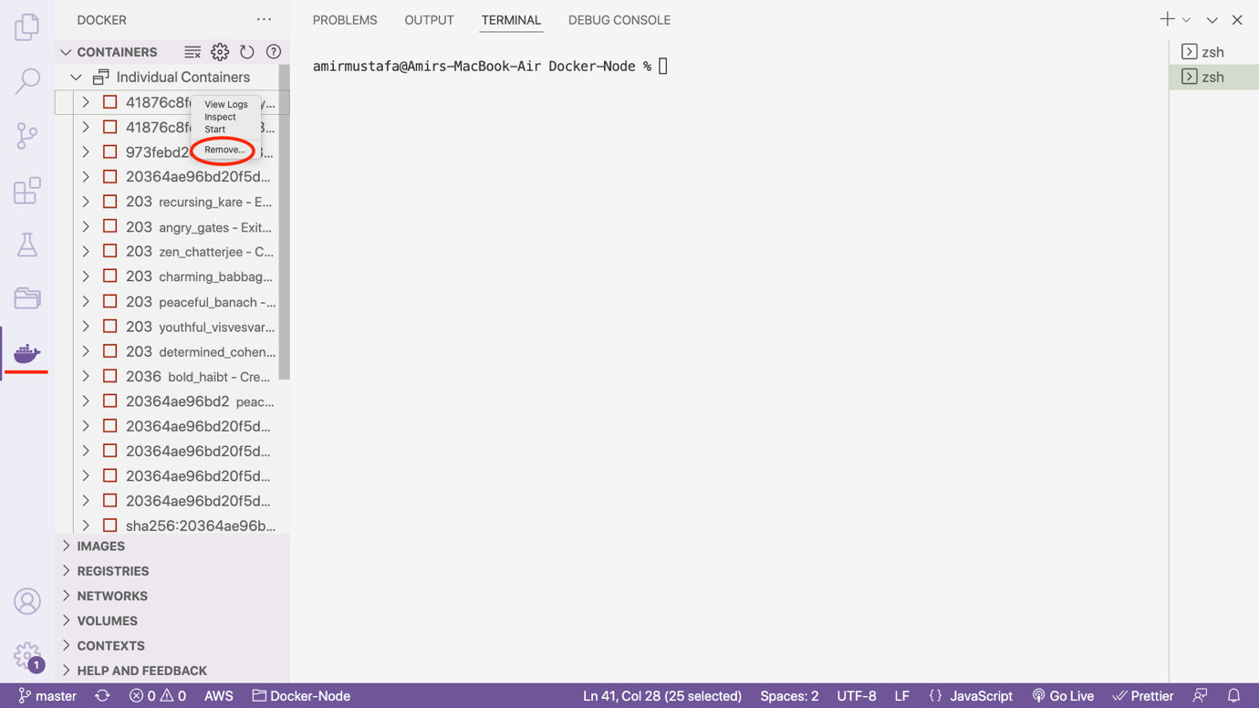

1. Deleteing Images:

Method 1:

Get List of images: docker images

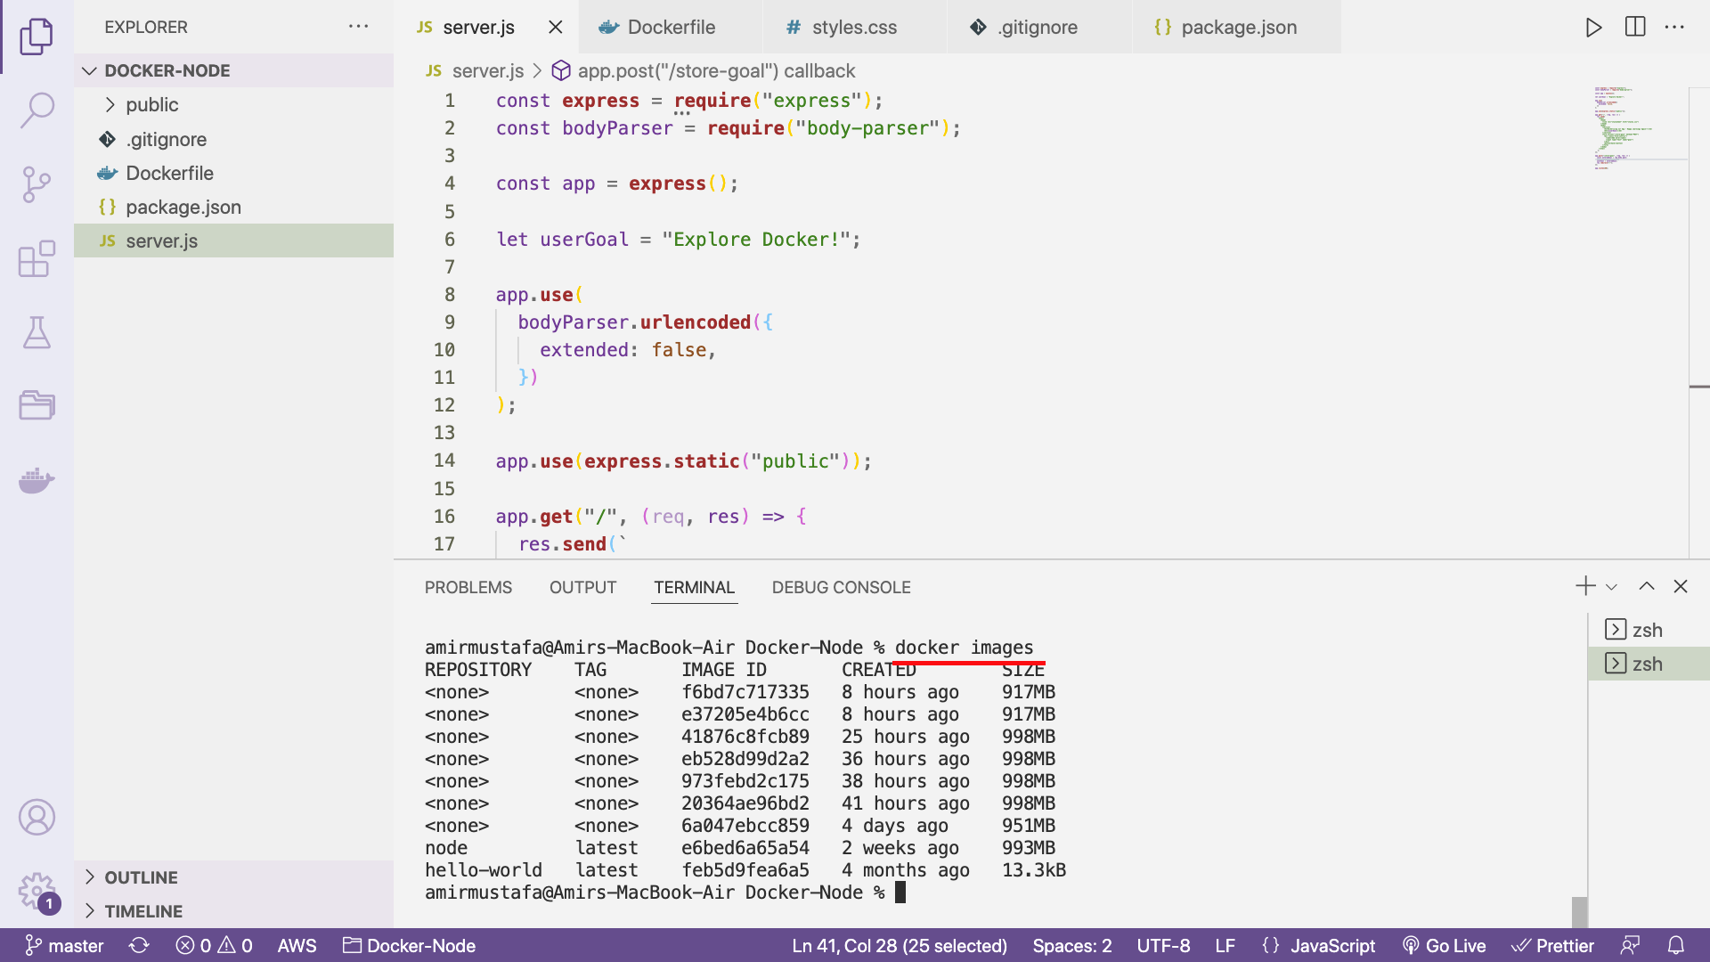

Delete the image

docker rmi <image-ID>

or

Docker rmi <image-ID-1> <image-ID-2> <image-ID-3>

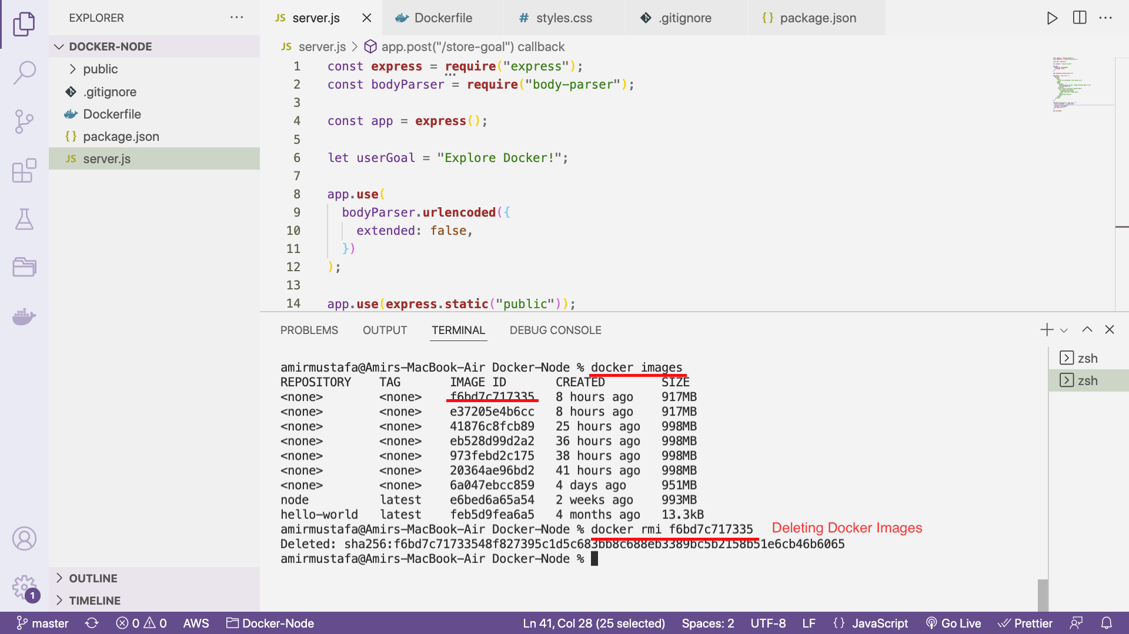

Method2: From Docker:

STEP1: Right click on image 🡪 remove

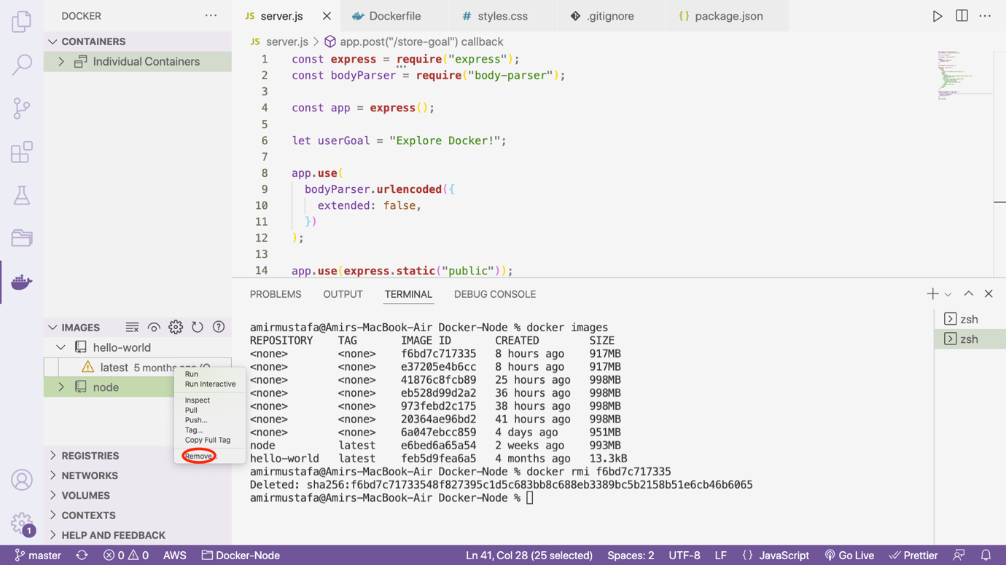

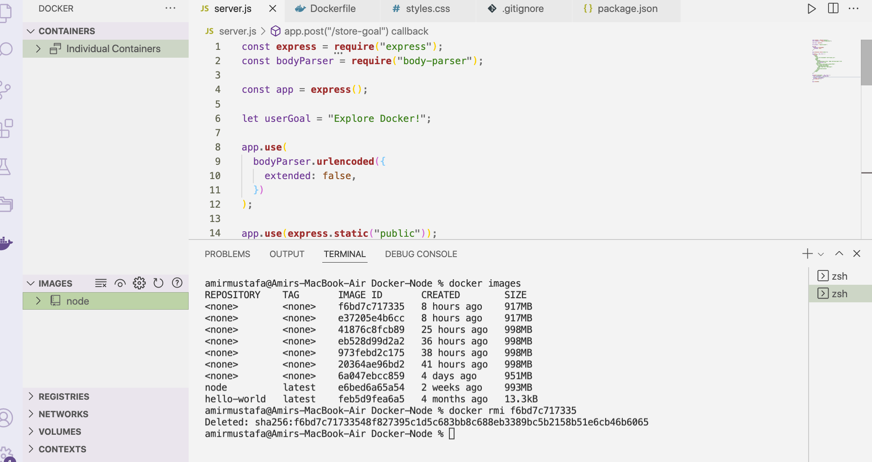

**NOTE:**

We need to **remove** container first before image (if is being used – includes stopped)

**NOTE2:**

Remove all unused images: docker image prune

Automatically remove unused containers (--rm flag)

docker build . 🡪 get image ID

docker run =p 3000:80 -d –rm <image id>

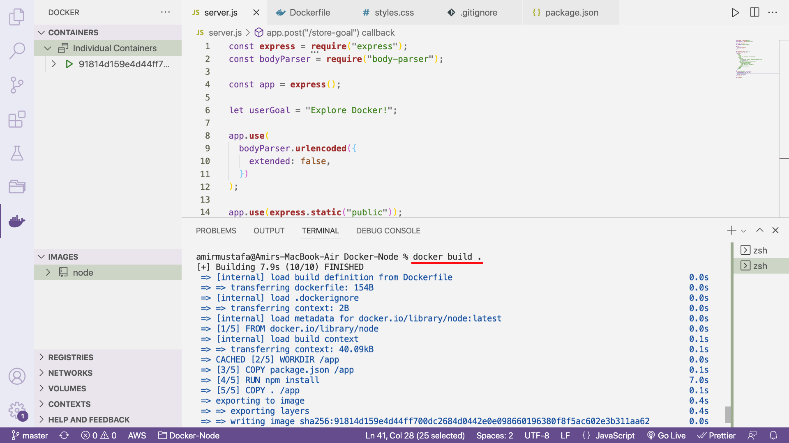

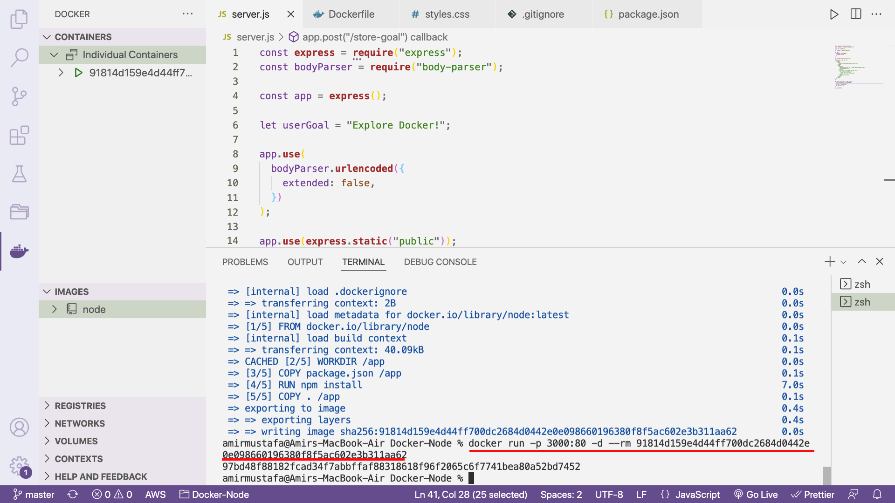

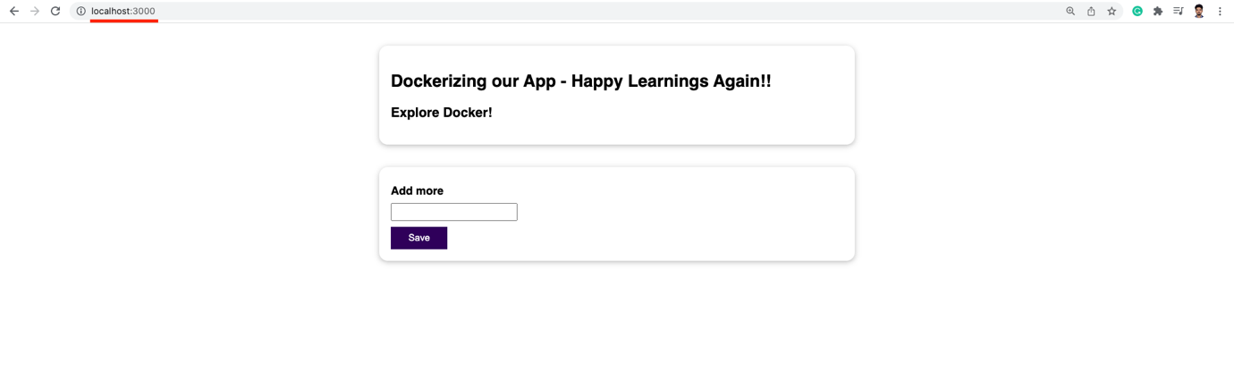

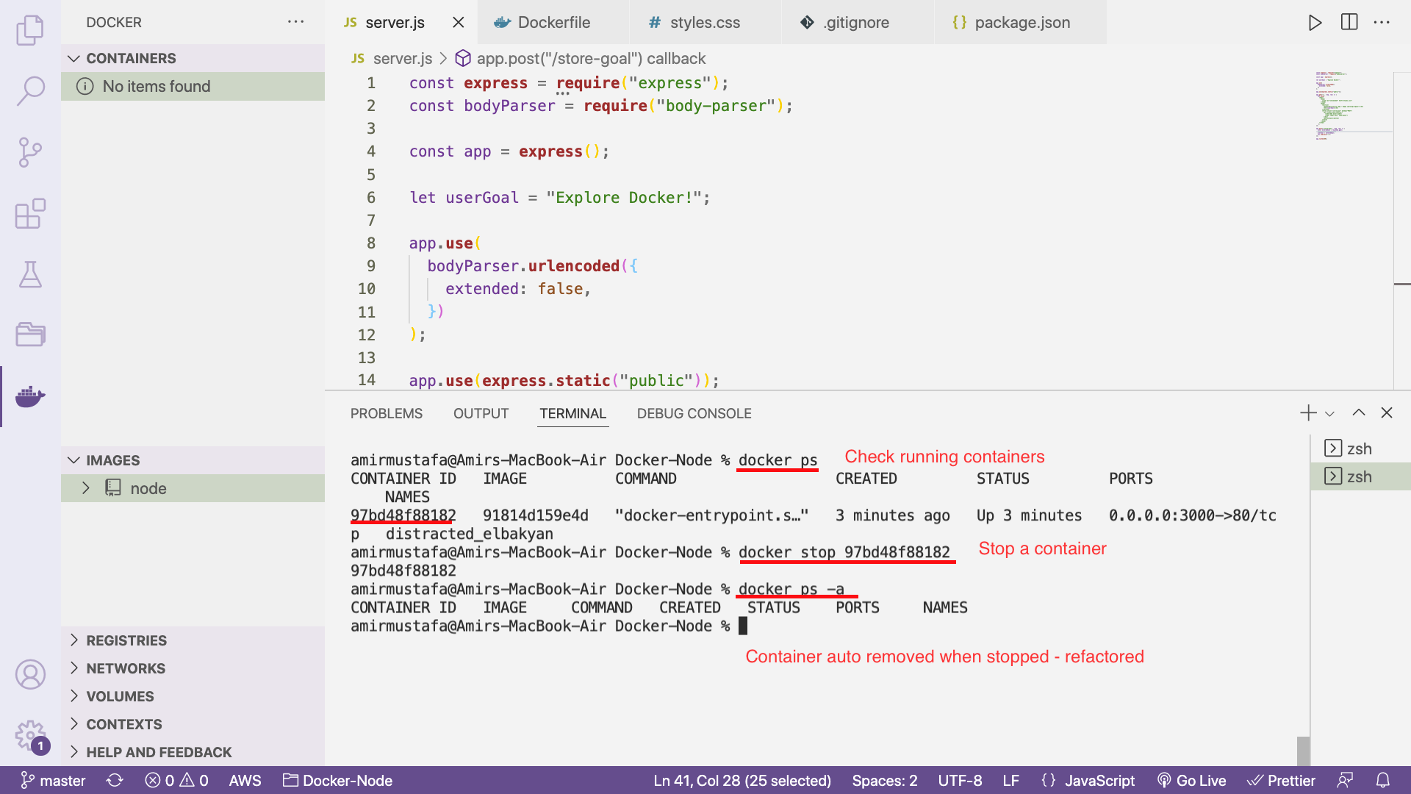

🡪 For starting the container,we need to build first – docker build . (get container ID)

docker -p 3000:80 -d –rm <container-id>

Inspecting image:

STEP1: Get image ID

docker images

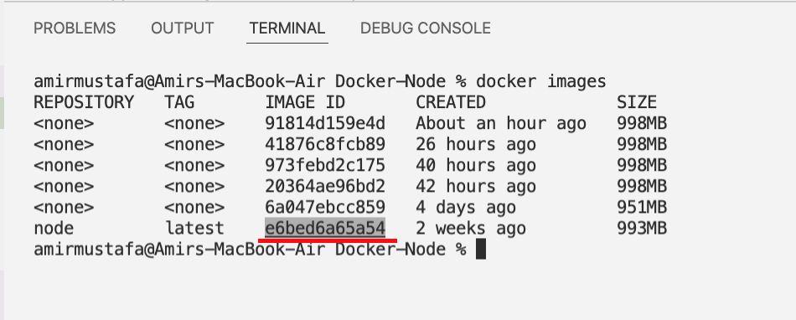

NOTE: base node image is 993 MB

The containers with say 951 size is 998-993 = 5 MB (code is not copied). Extra layers are created

STEP2: docker image inspect <image-id>

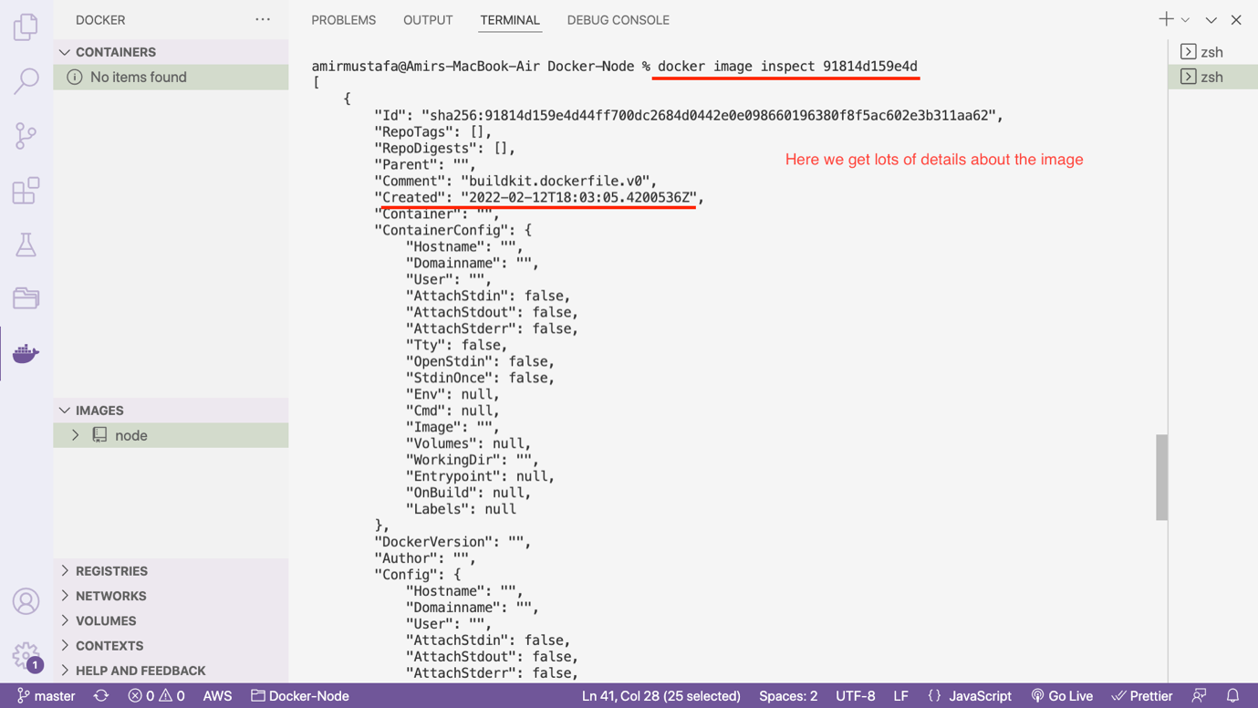

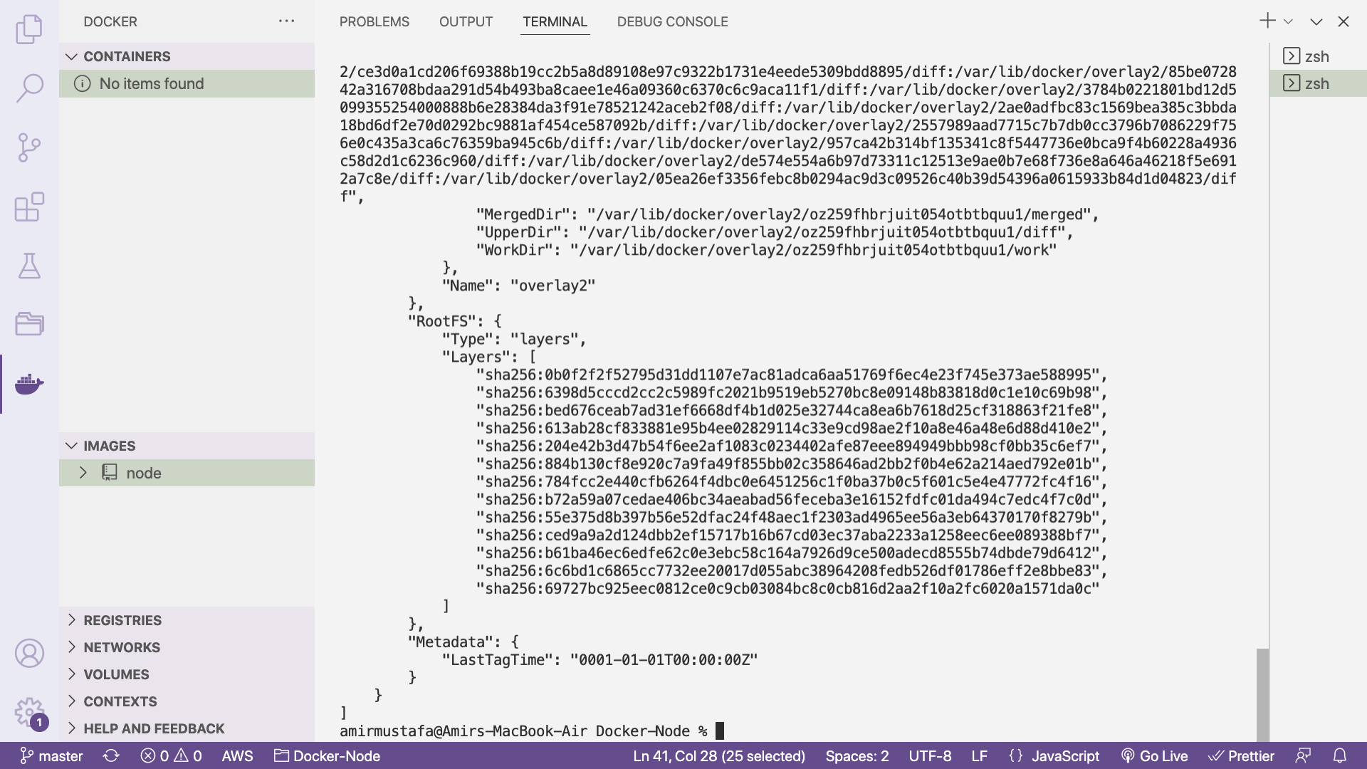

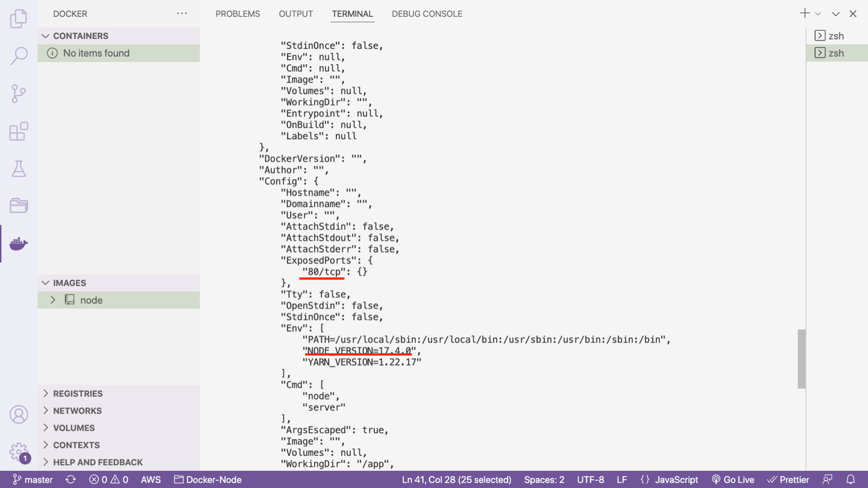

OS – Linux

🡪 We see different layers of image – docker file layers + node base image internal layers

Copying files into and from a container:

1. Create files to copy:

🡪 Let us create a file in our project to copy (say test/test-file-1.js)

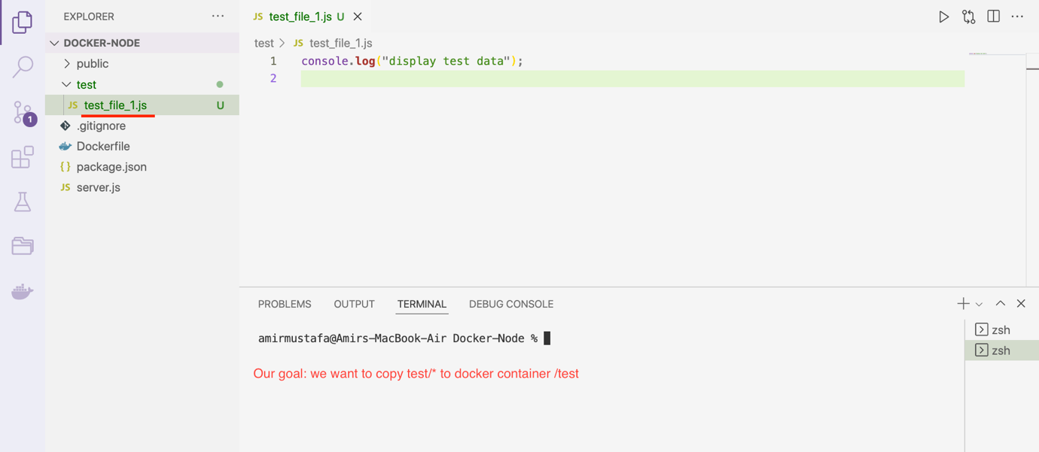

🡪 For this we need a container

Check using – docker ps -a

🡪 If no containers are showing let us create the container

Step1: docker build . (we get image ID)

Step2: docker run -p 3000:80 -d –rm <image-ID>

Step3: docker ps -a. (Copy container ID or name)

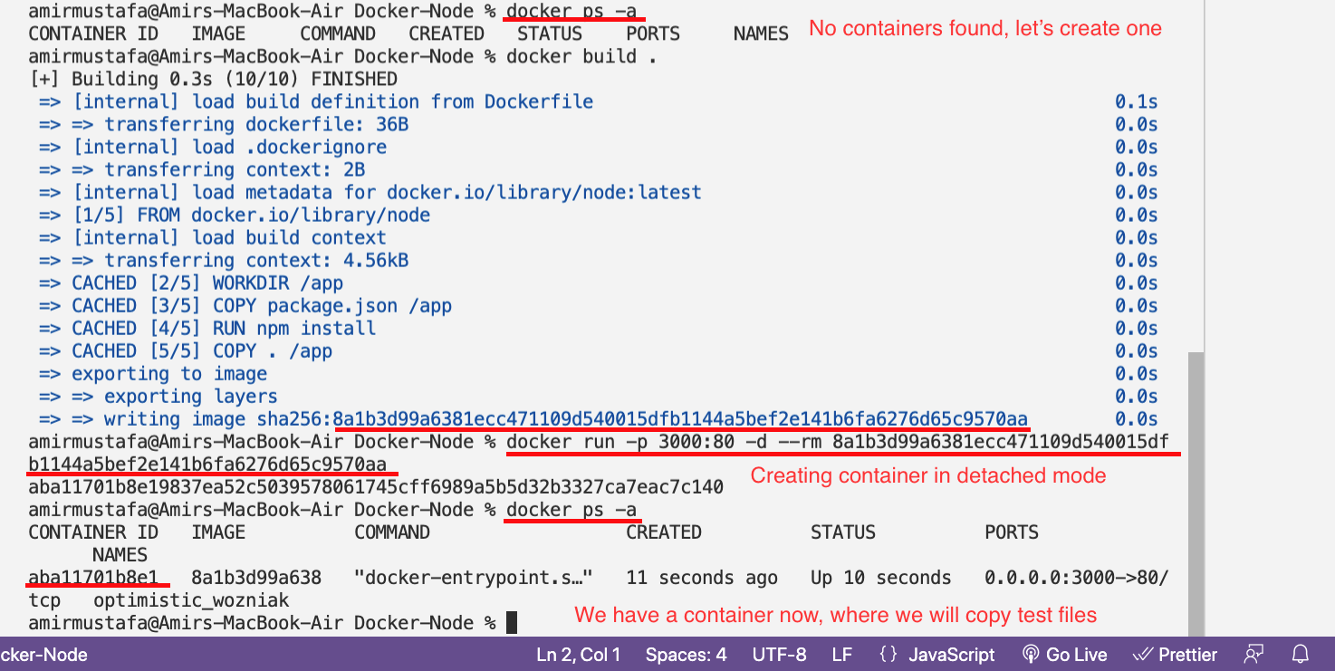

1. Copying from Project to specific docker container

Step4: docker cp <source_file> <container-id-or-name>:/<directory-to-paste>

Eg

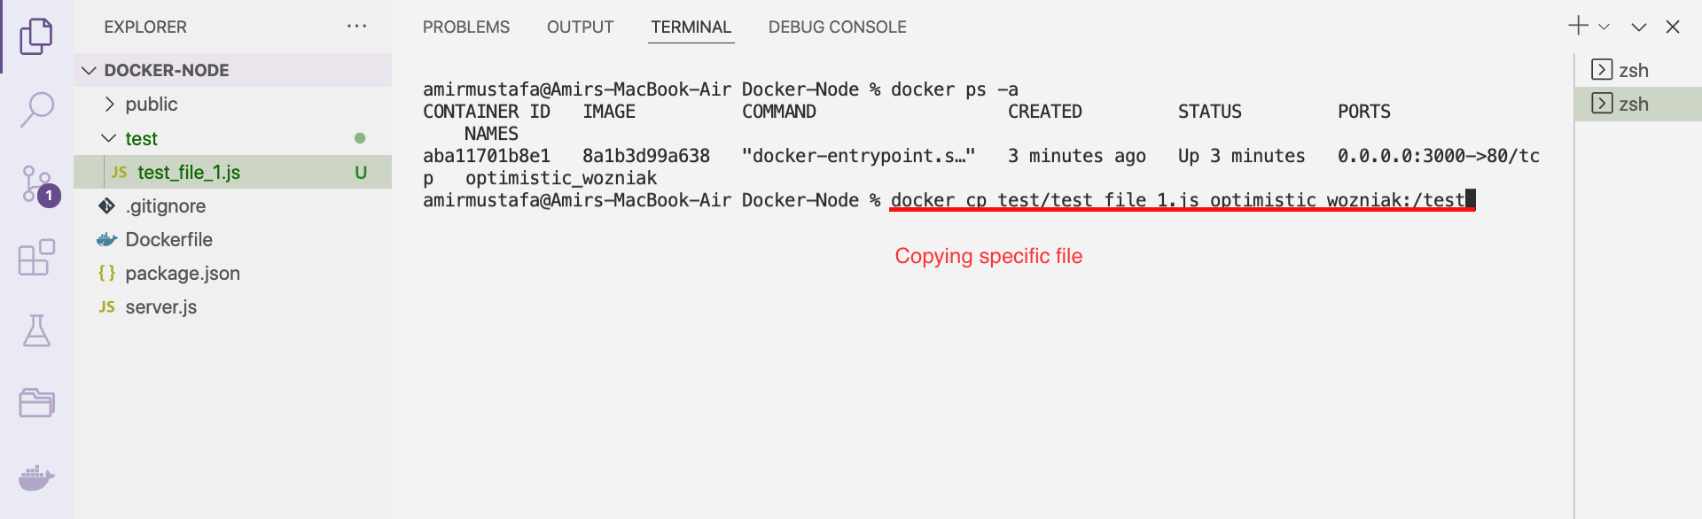

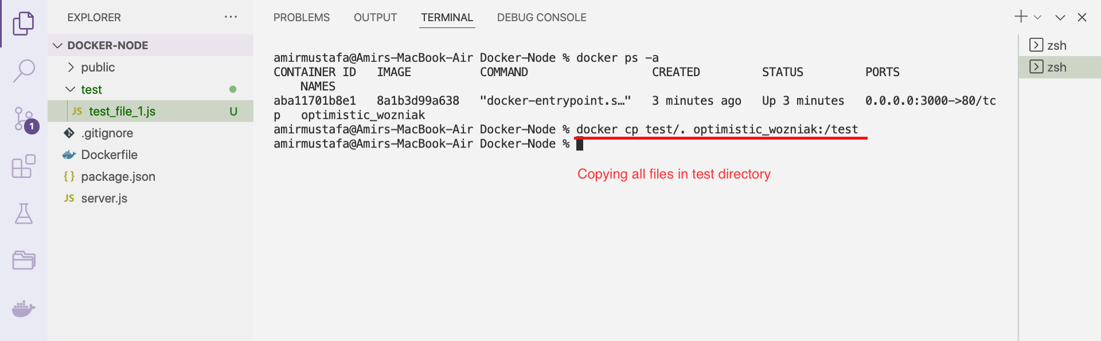

TRICK to check inside docker container:

🡪 For this we go to docker section 🡪 expand our container

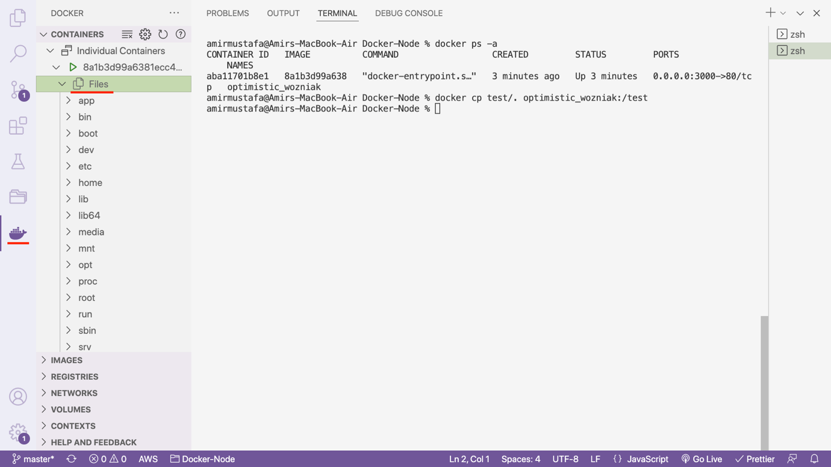

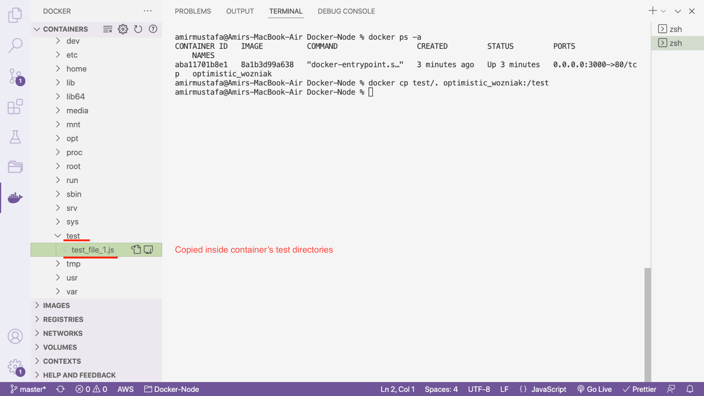

1. Copying from Project to specific docker container

Step4: docker cp <source_file> <container-id-or-name>:/<directory-to-paste>

Let is now delete test directory from project

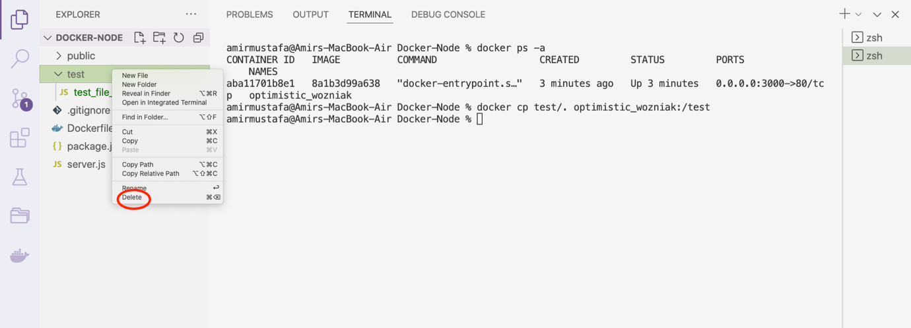

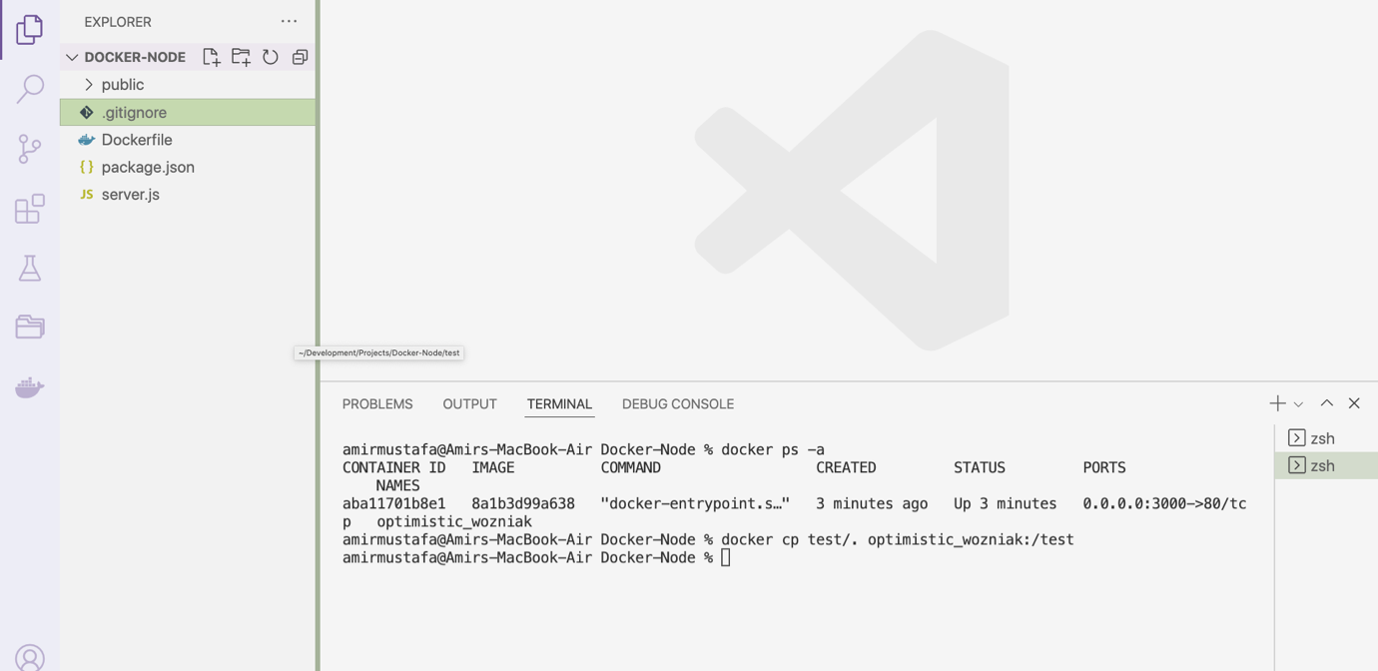

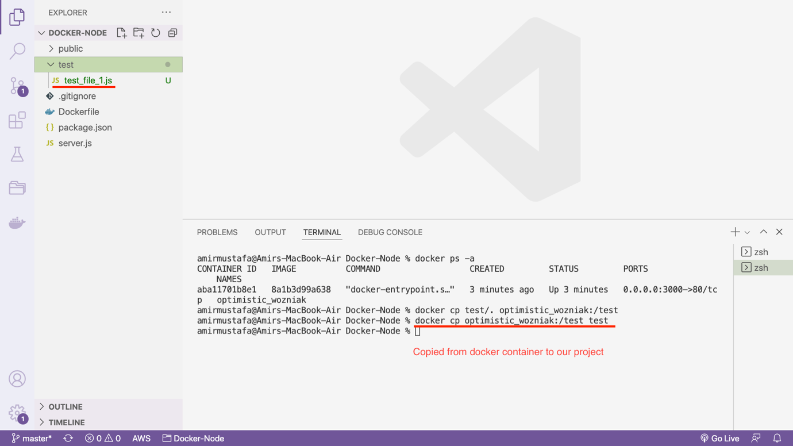

🡪 of course we could have copied a specific file from docker container

docker cp <container-id-or-name>:/test/test-files-1.js test

🡪 Suppose we are working in a project, we have made frequent edits in our application

🡪 building image again, copy-paste always in docker is the good solution always, chances are there our app might be broken in container

🡪 Instead we will be learning update soon.

Realtime Scenario: When we run app from docker, sometimes docker logs file in containers which we can **copy from docker to project** and read them

Hence transparent to read in from editor

Naming and tagging Images and Containers:

🡪 Default Image Name: When create image, only ID is assigned

docker images

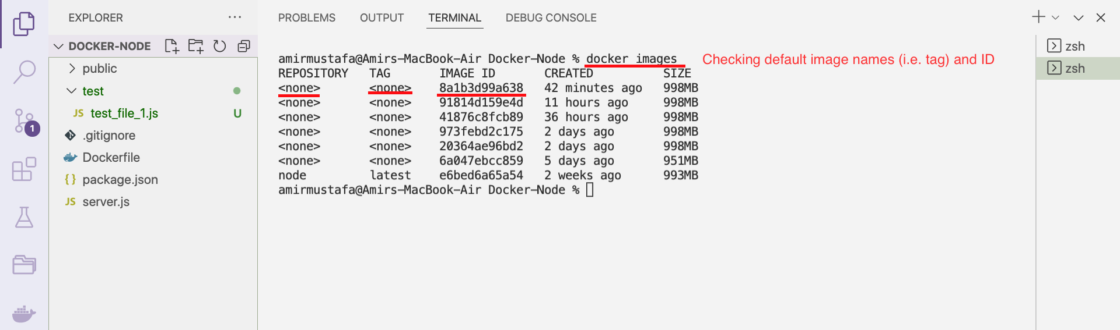

Default container: When we create container, random name is assigned + ID

docker ps -a

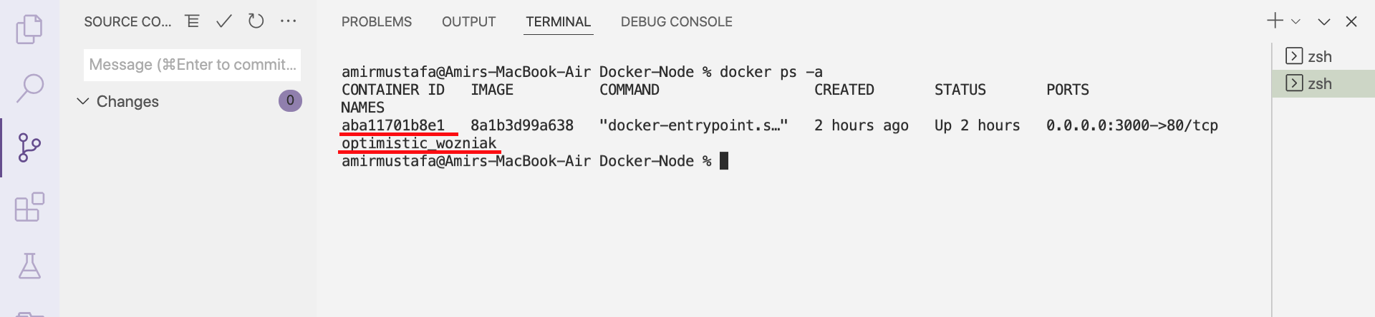

🡪 It would be great if we could assign names ourself, we then don’t have to get ID or name from the list, we would remember it

🡪 we add extra –name <docker-name> attribute

docker run build -d –rm –name docker-feb-2022 <container ID>

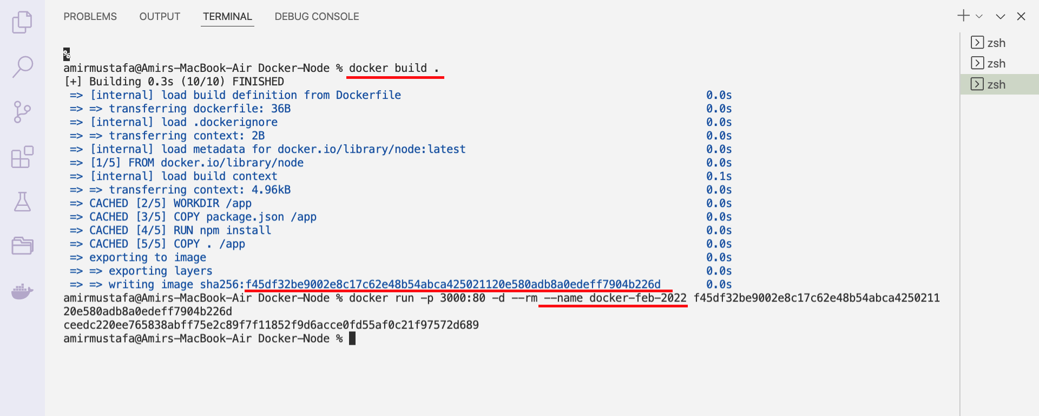

docker ps -a

🡪 We check container listing:

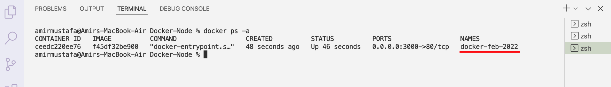

🡪 The beauty of naming convention is we do not need to check the id or random name now

We can directly start/stop the container with our assigned

Naming the Image:

🡪 In the name, it is possible to name the image

🡪 For image naming case – we have two attributes – name (unique name) + tag (from tagging in group)

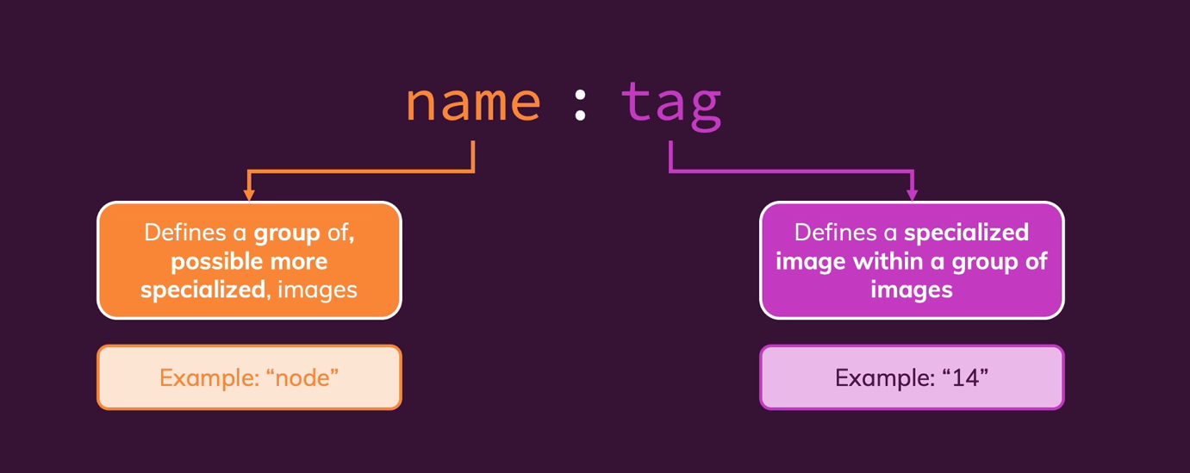

Go to hub.docker.com. Chose your image technology

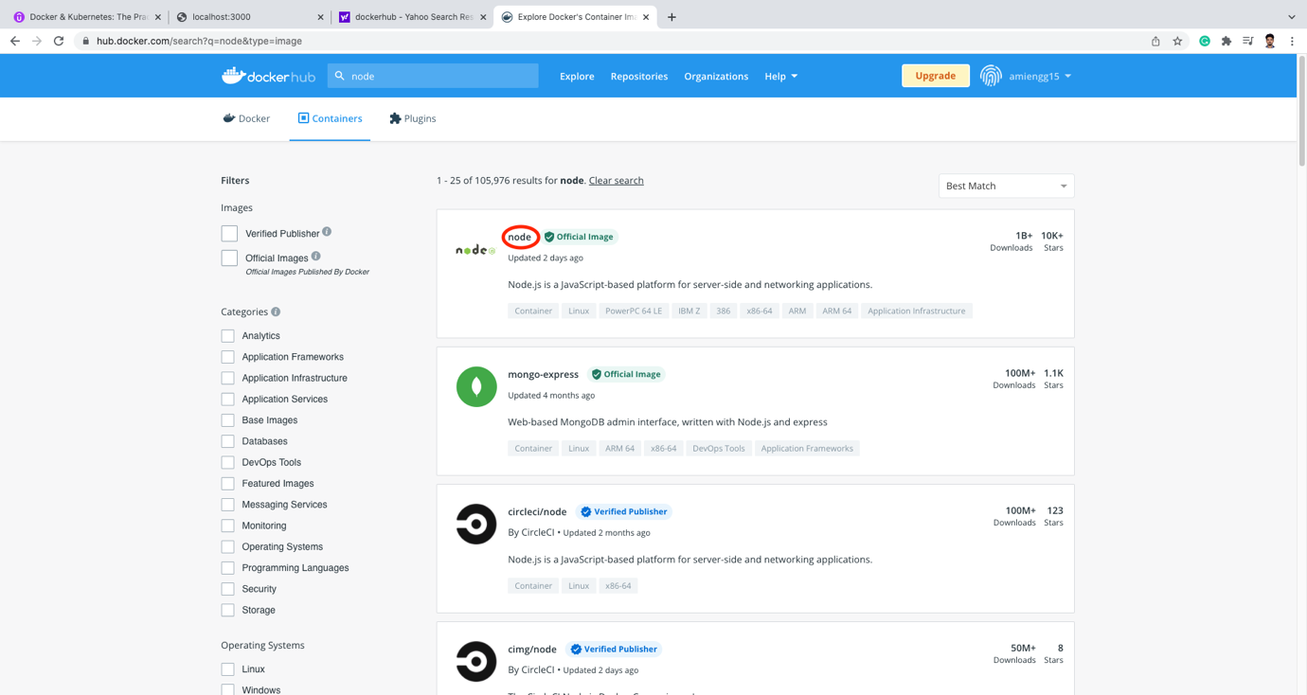

🡪 If we will scroll down – we see all possible versions of node

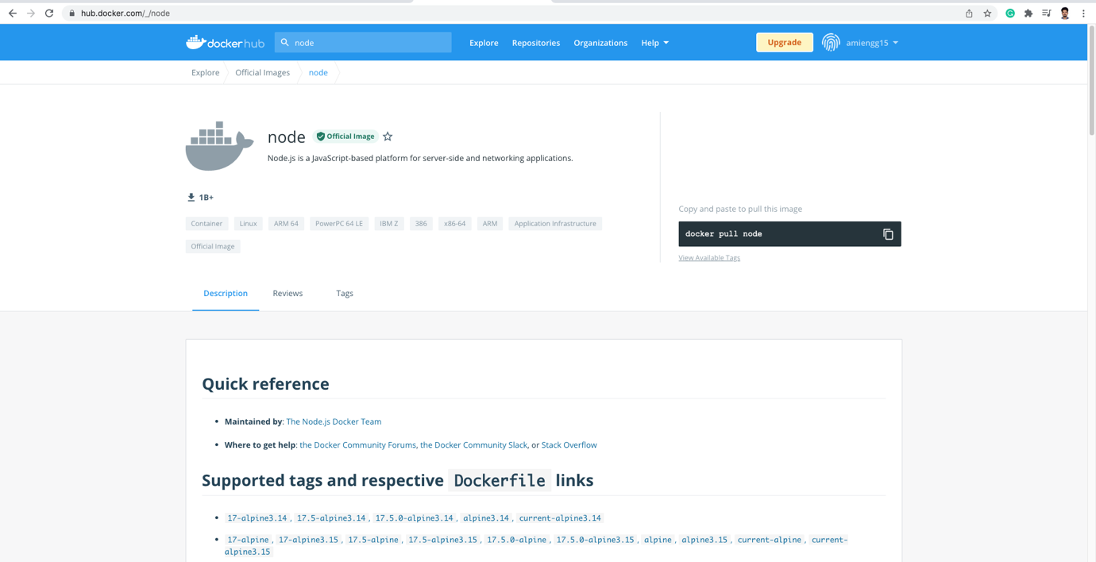

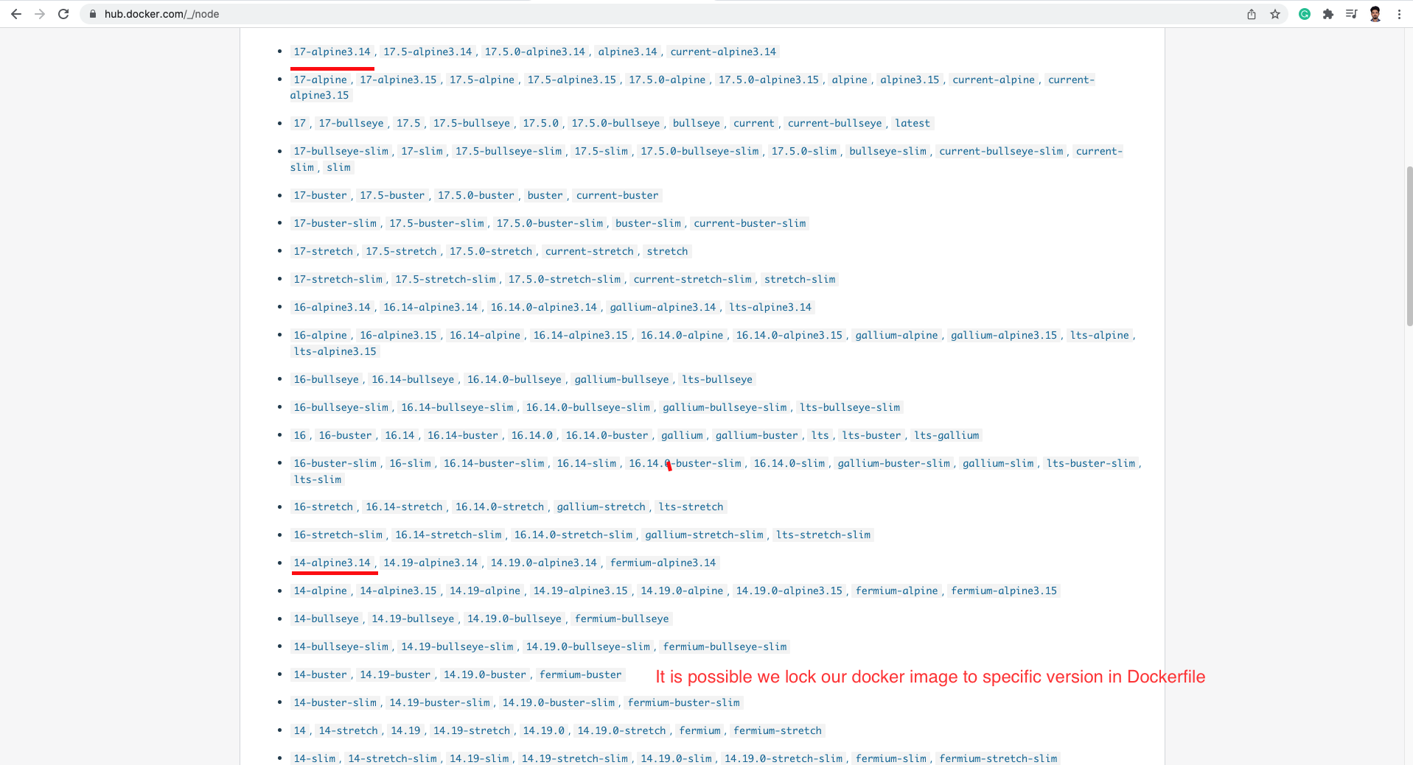

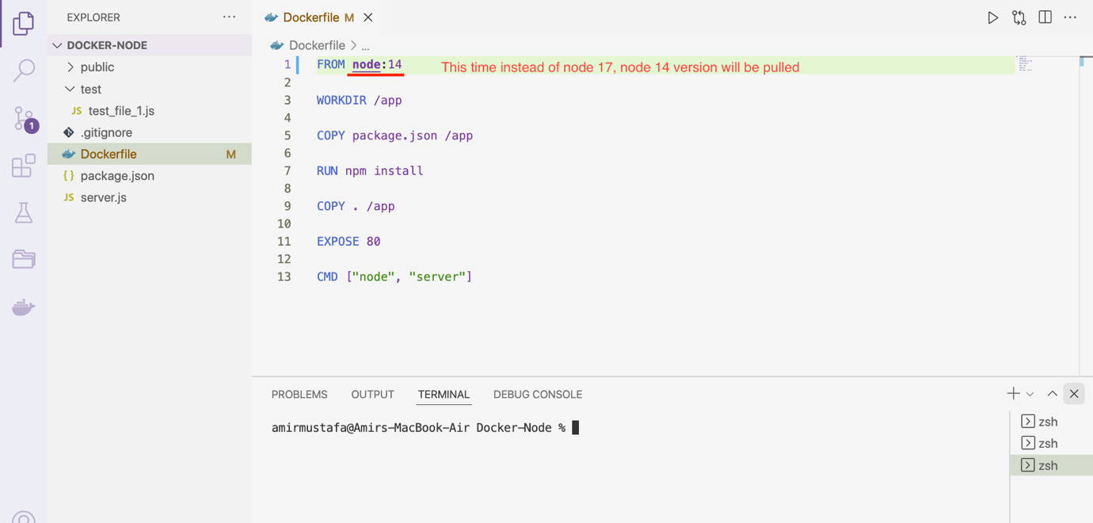

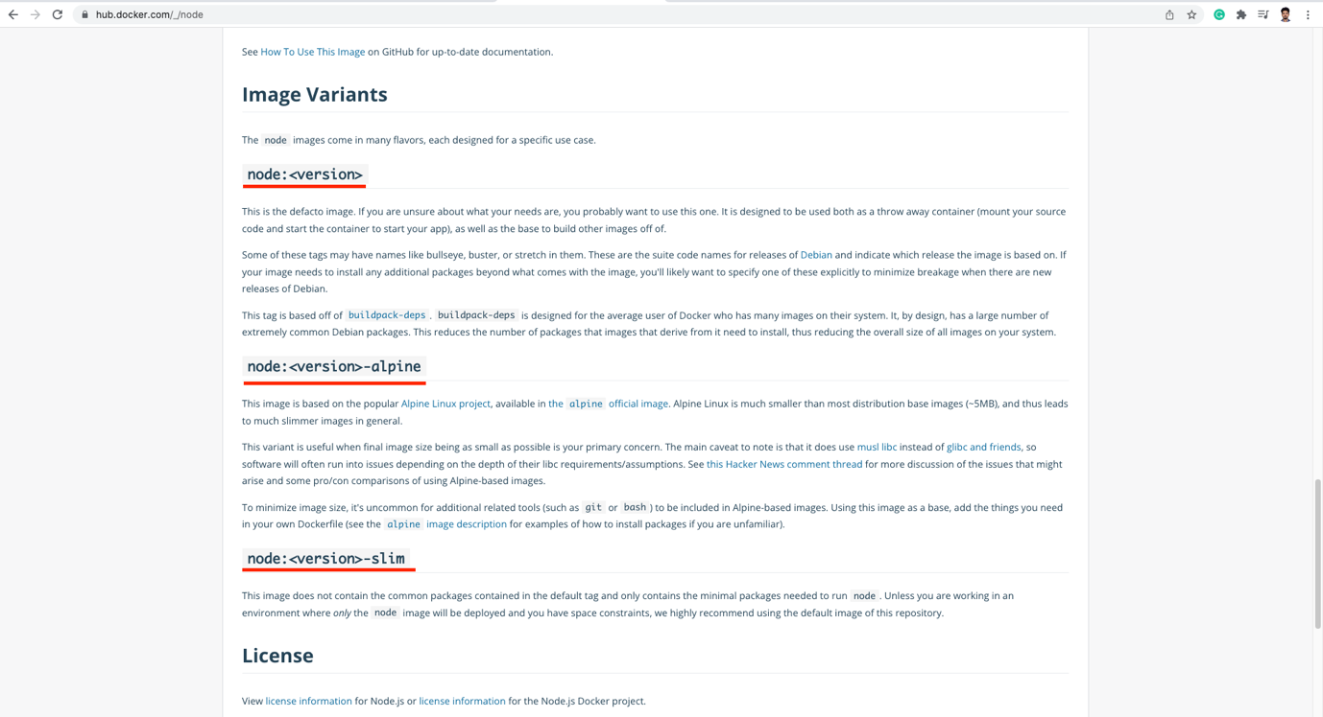

Node:14

Here

name = node

tag = 14 (specialized tag)

🡪 The same is possible for custom image build as well

🡪 tag can be number, string

🡪 Let us now lock to Node version 14 instead of 17

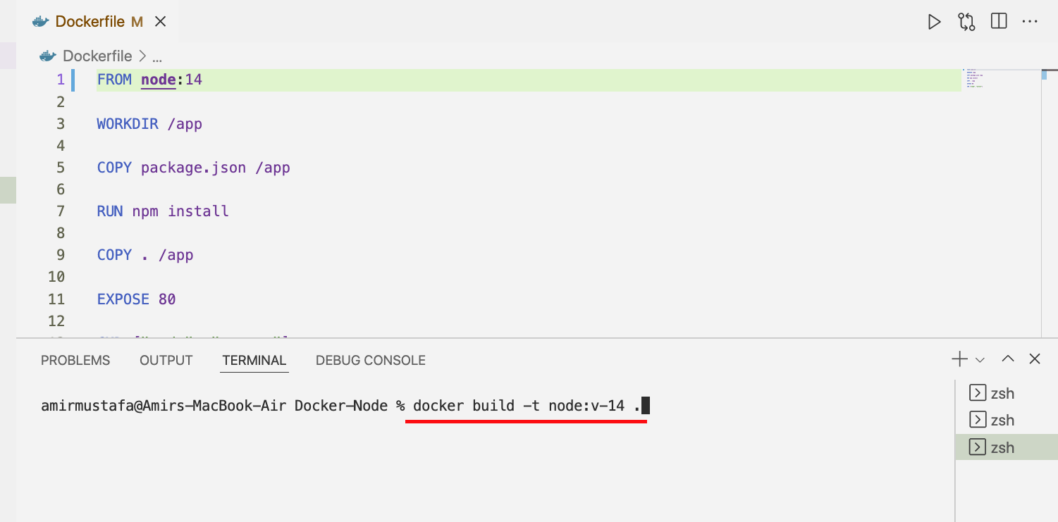

Or

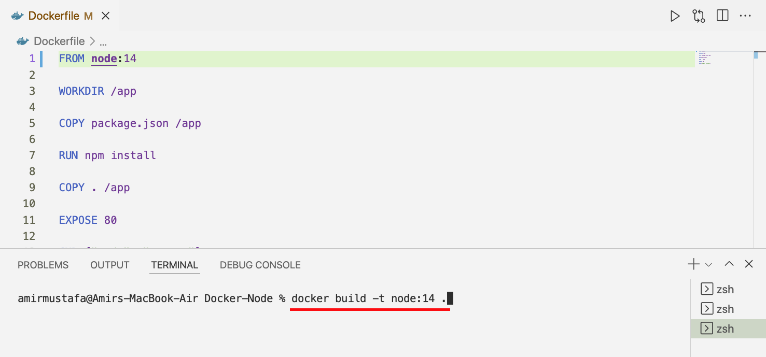

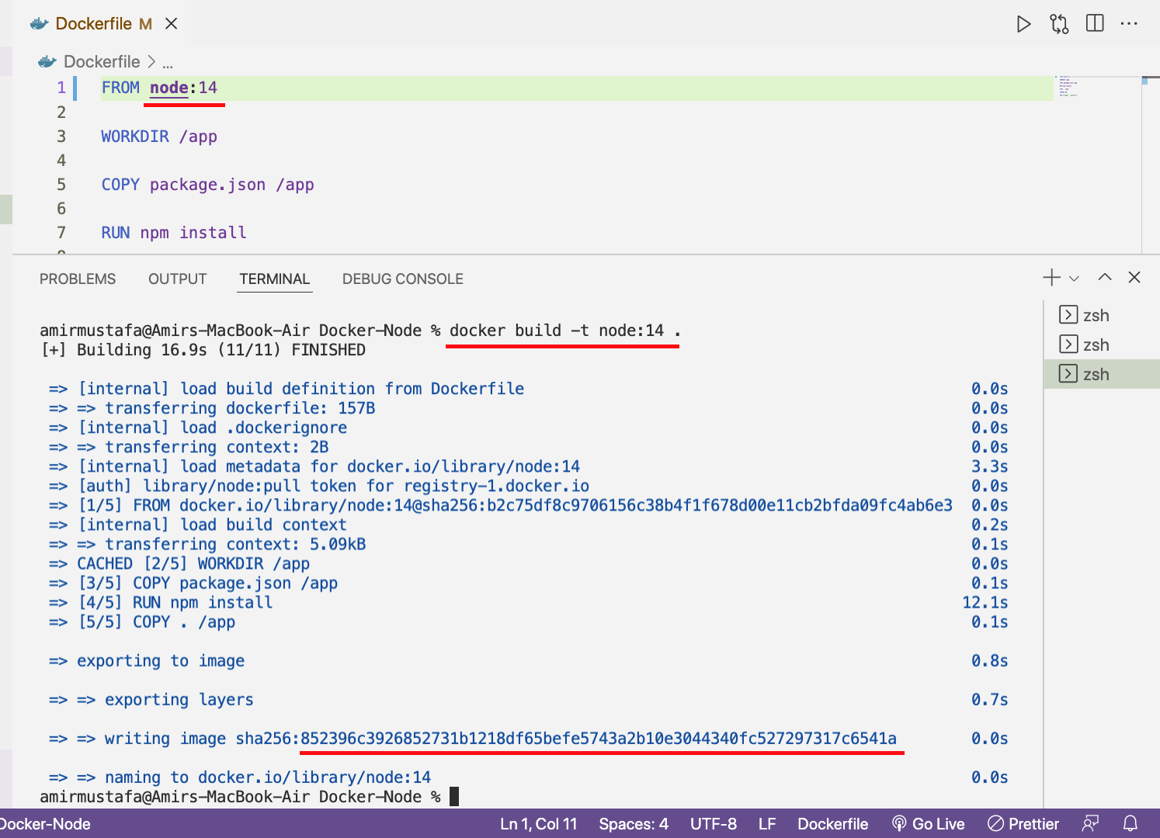

🡪 There are two ways we can check images:

1. docker images

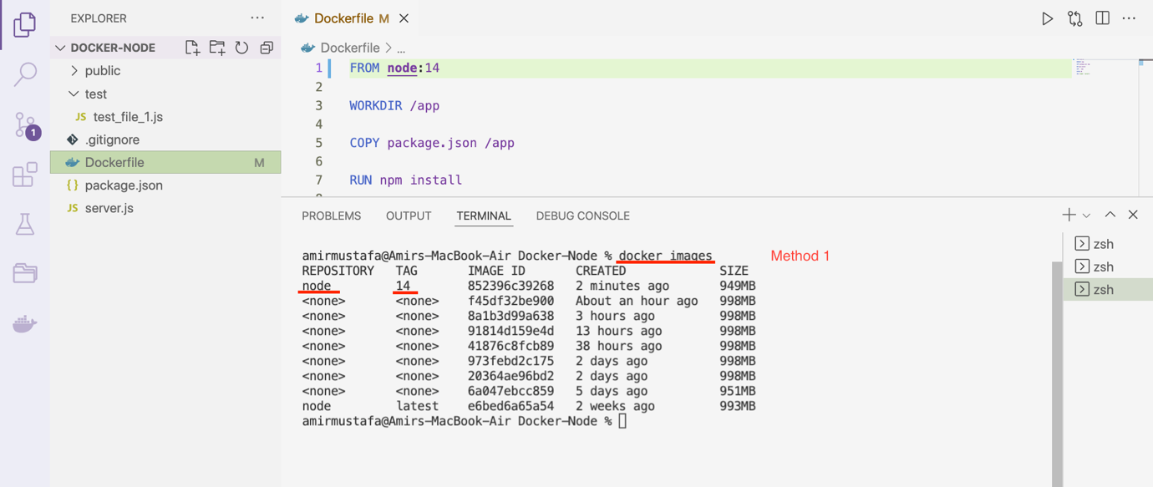

1. From docker section:

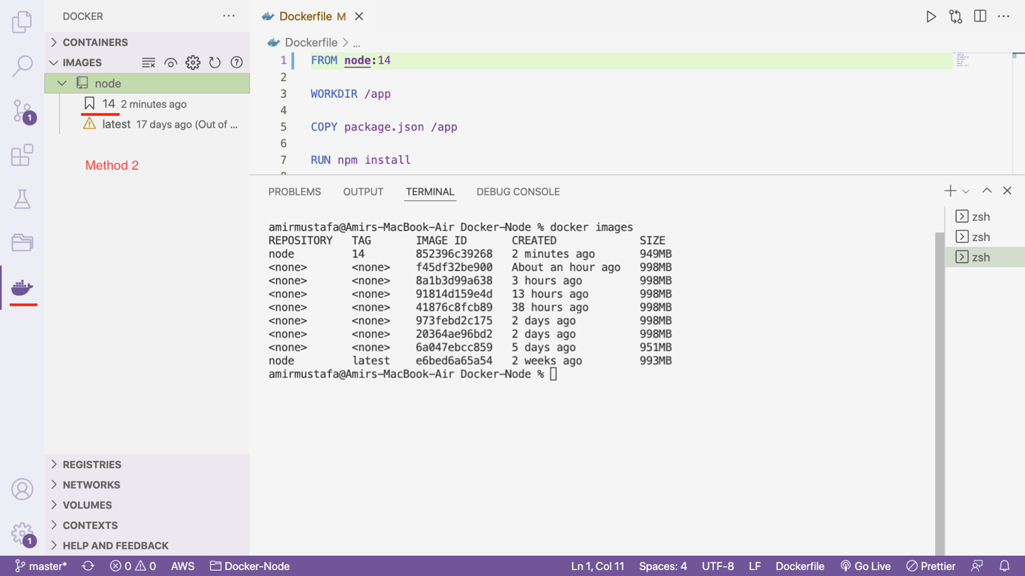

Removing all images including tagged ones:

docker image prune -a

Sharing Images and Containers:

🡪 Till we have seen advantage of docker, we do not need to install npm install

🡪 The other benefit is we can share images or containers and reuse’

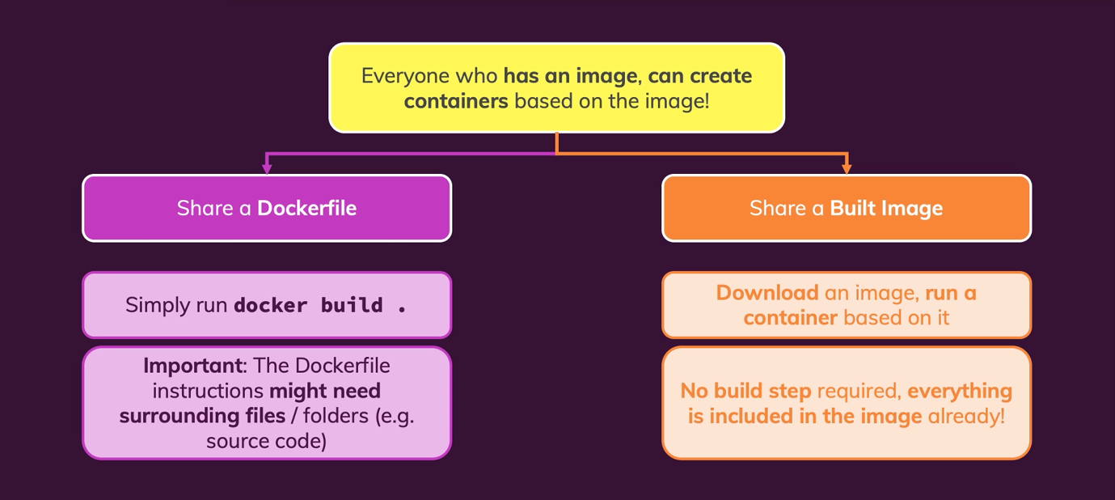

1. Method 1:

🡪 Share Dockerfile + app source code with team, they can then create images and containers

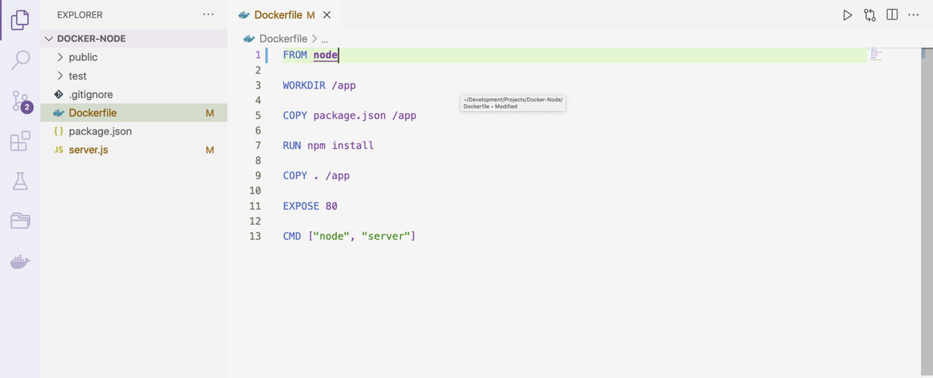

🡪 This can be some work for the recipient

1. Image directly

Image = environment (i.e. all packages) + app code

🡪 No code is required, recipient user can create containers instantly

🡪 Normally when we should share image files with team member or when deploying the app and not the raw docker file

🡪 Sharing images can be done in two ways:

1. Docker Hub: <https://hub.docker.com/>
2. Private Repositories (any other docker container managing application)

DockerHub is free



Latest pricing plans in Docker Hub



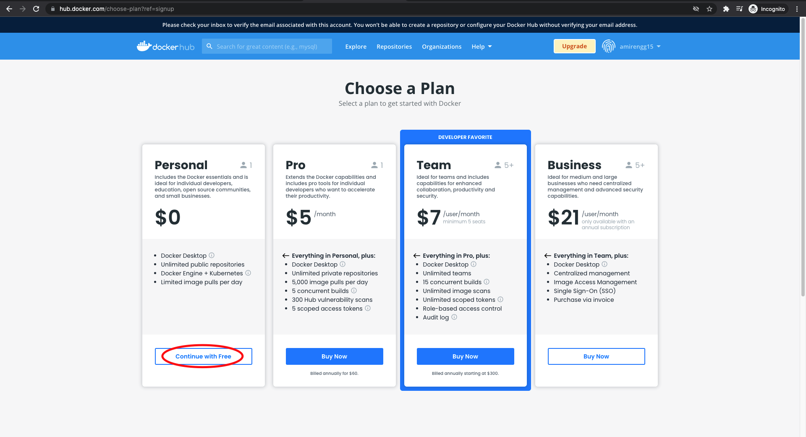

1. Pushing Image in Docker Hub

🡪 We will be sharing using DockerHub. Click Sign in button

🡪 For fresh register we should click, Sign up button and do a basic signup,

🡪 For login enter username 🡪 Click Continue

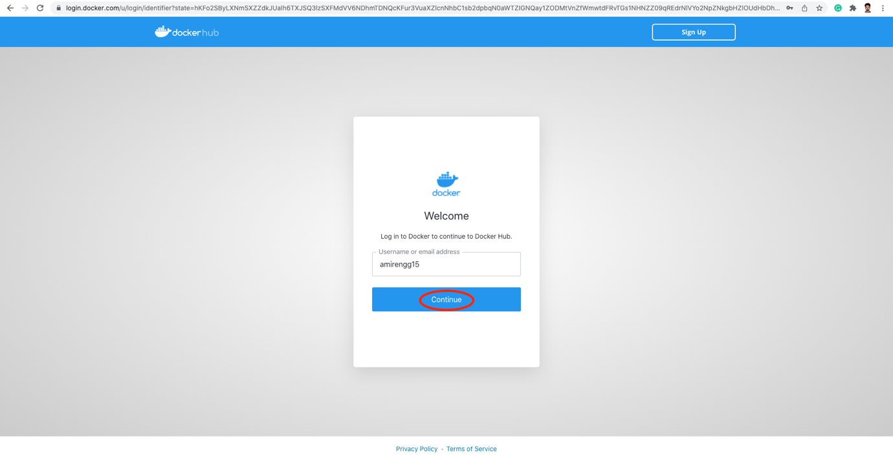

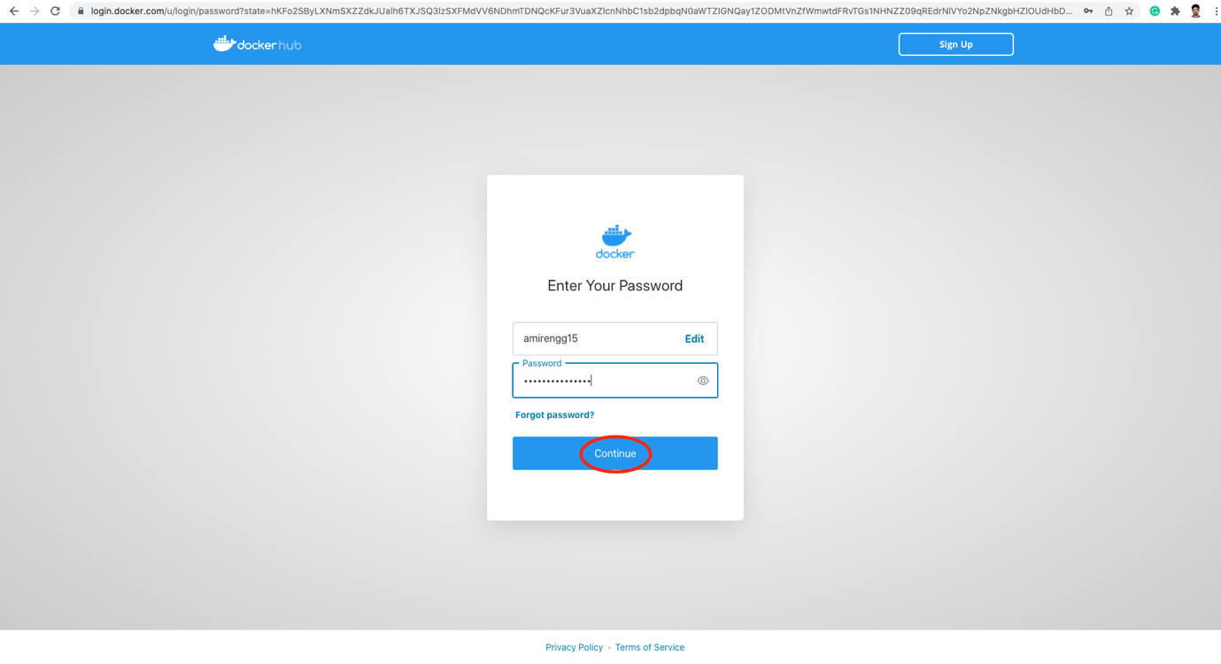

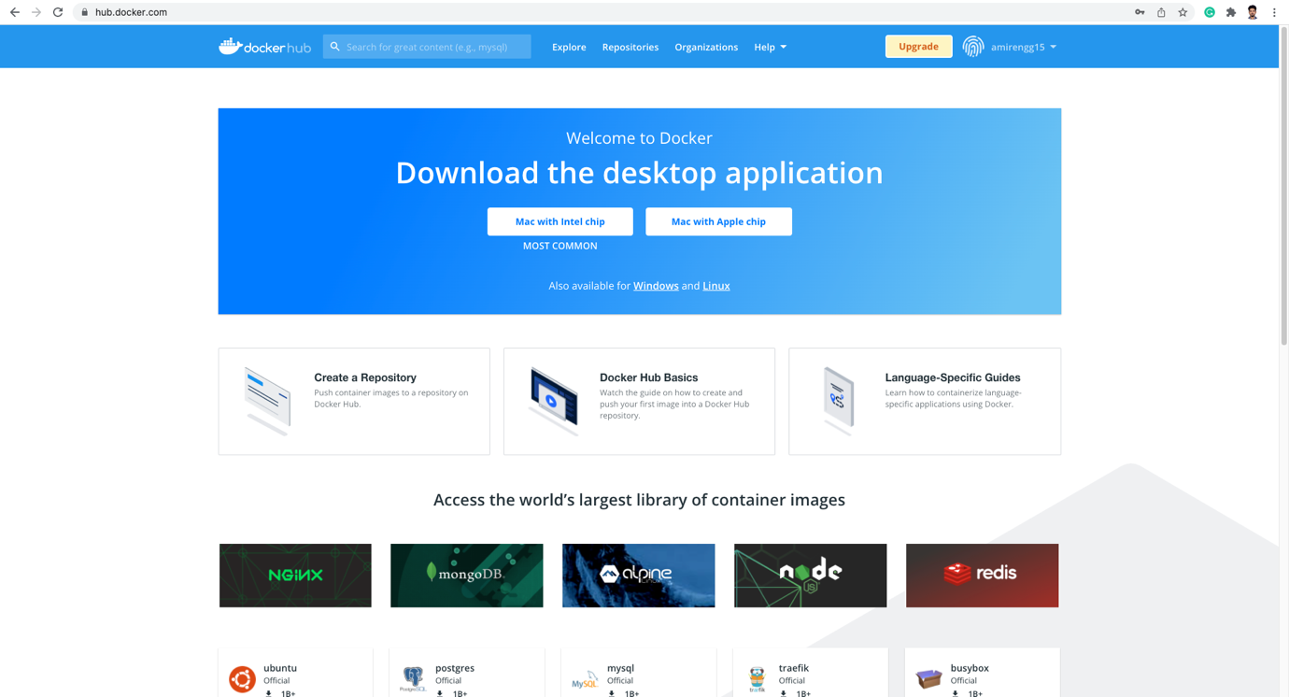

STEP1: Create a repository in docker hub. Click Repositories

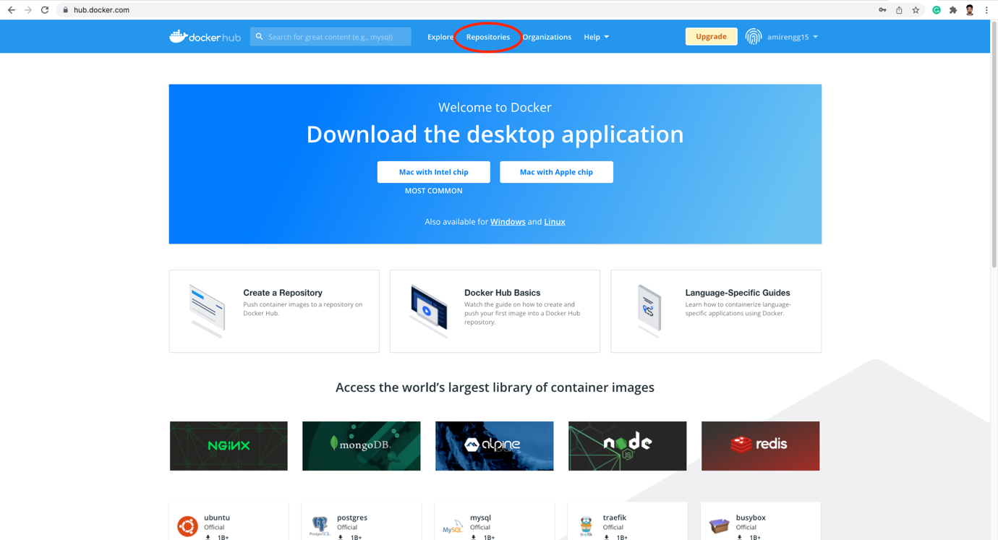

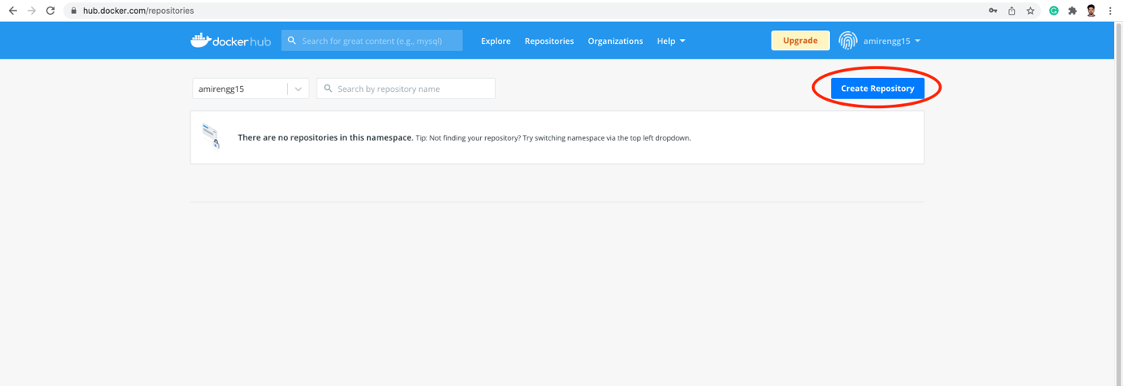

🡪 We can choose type of repository – Public (visible to all) or private (only visible to us).

🡪 Enter repository name

Eg. node-product. It will be stored as

amirengg15/node-product

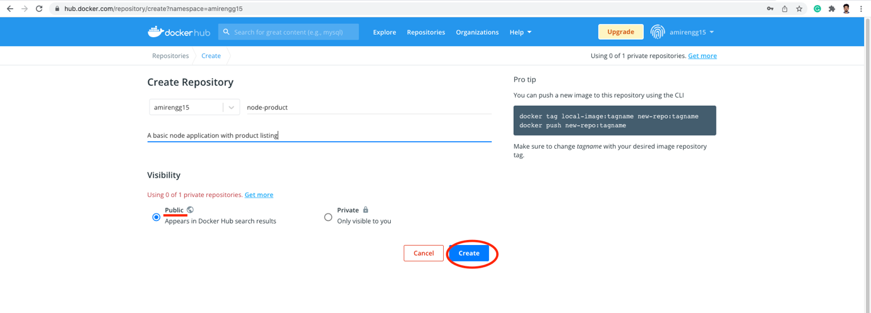

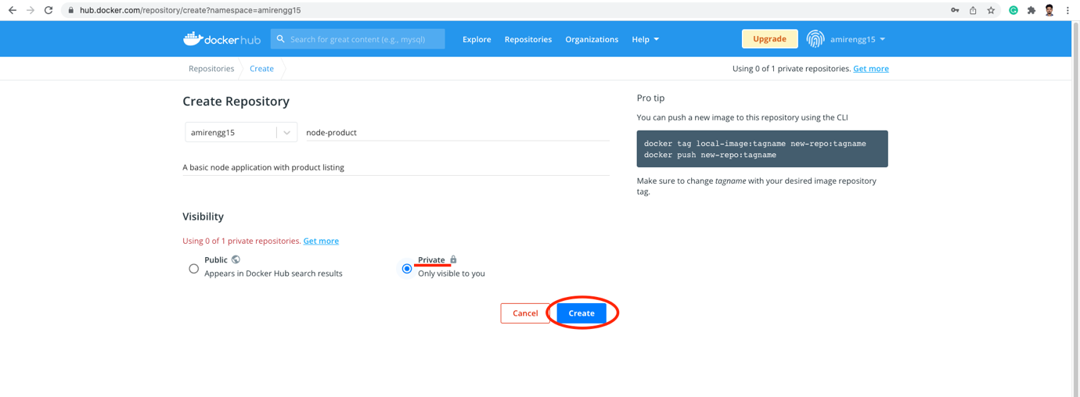

Click Create

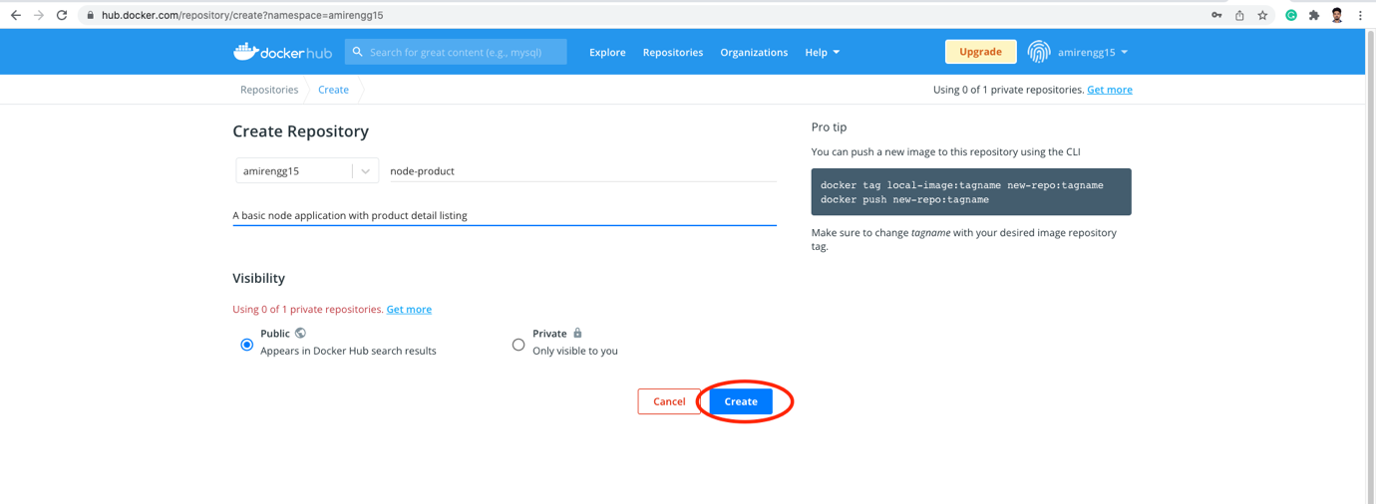

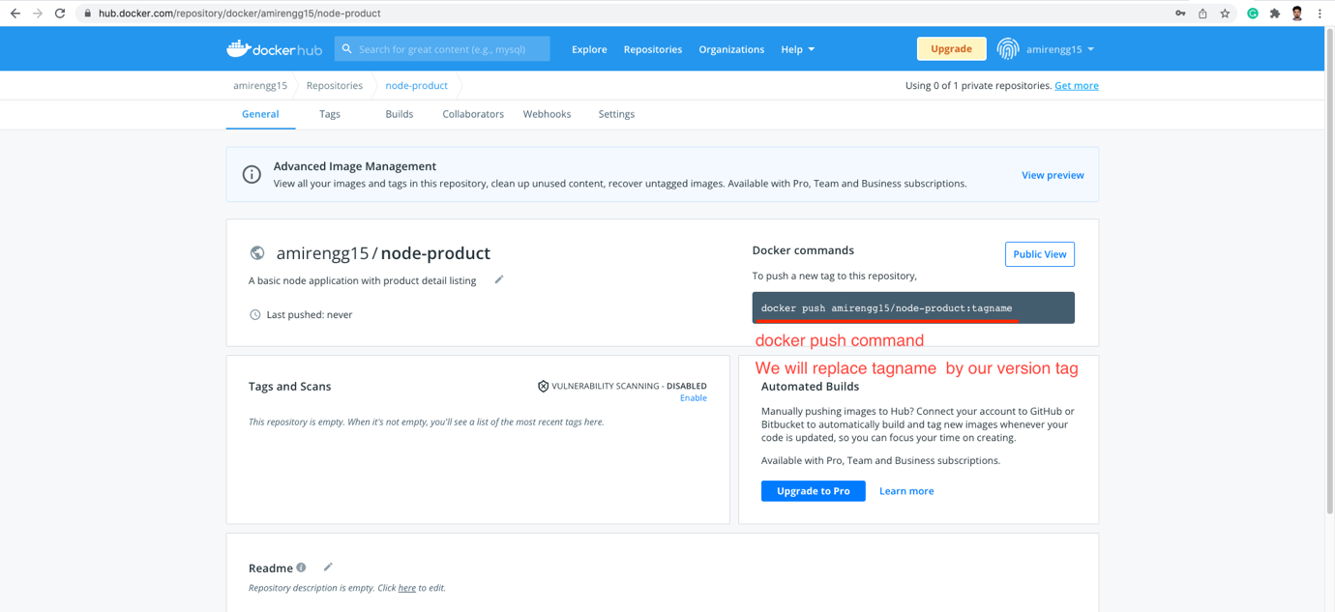

Copy the docker command

docker push amirengg15/node-product:tagname

Replace tagname by our version

STEP2: Create the image (Same name as docker repo)

Build the image with same name

docker build -t amirengg15/node-product:v1 .

NOTE: If we will not provide the tag (i.e. :v1), latest will be by default

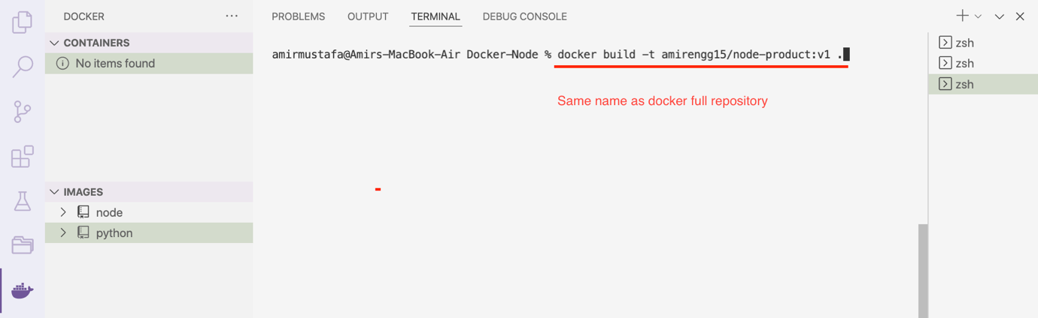

🡪 Image created successfully

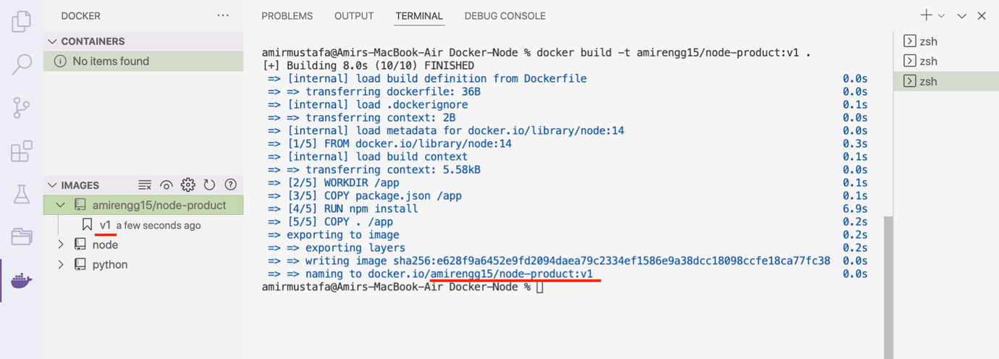

🡪 When we push the command, we observe we get unauthorized error. This is expected because how will docker know which account to push

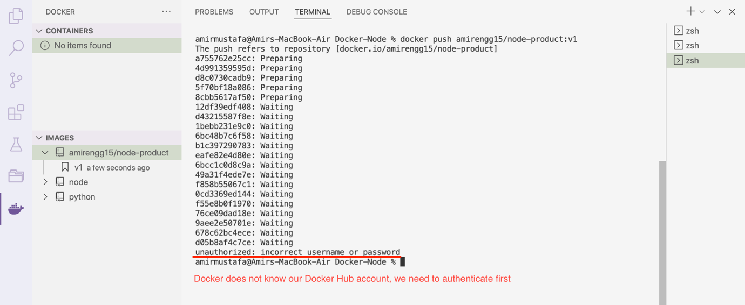

Docker login command:

docker login – terminal will remain login after auth

docker logout – explicitly want to logout from terminal

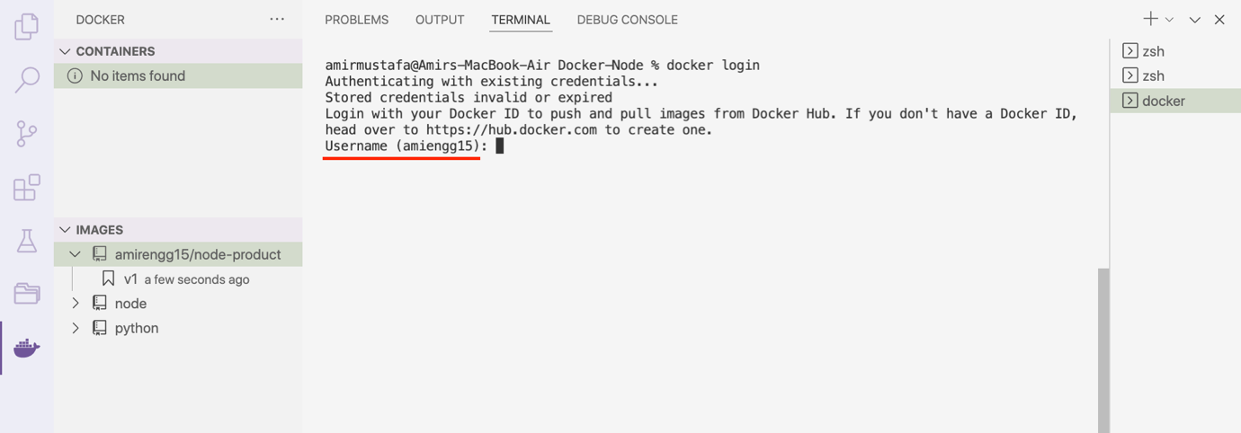

🡪 We enter our DockerHub login-password and click enter

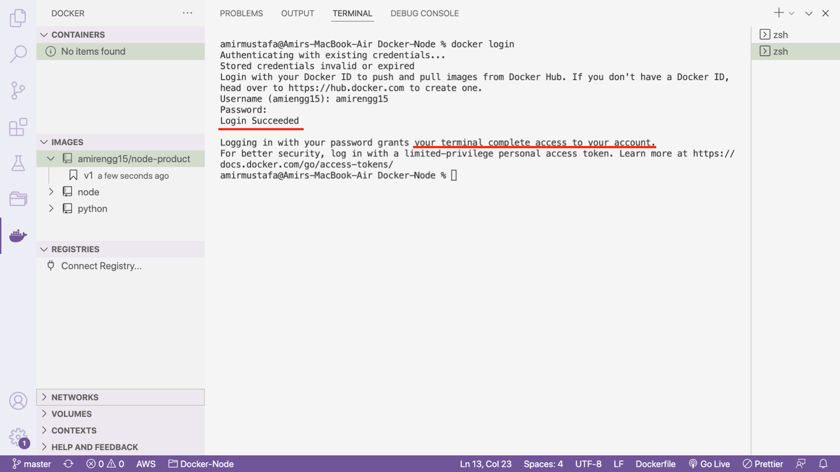

🡪 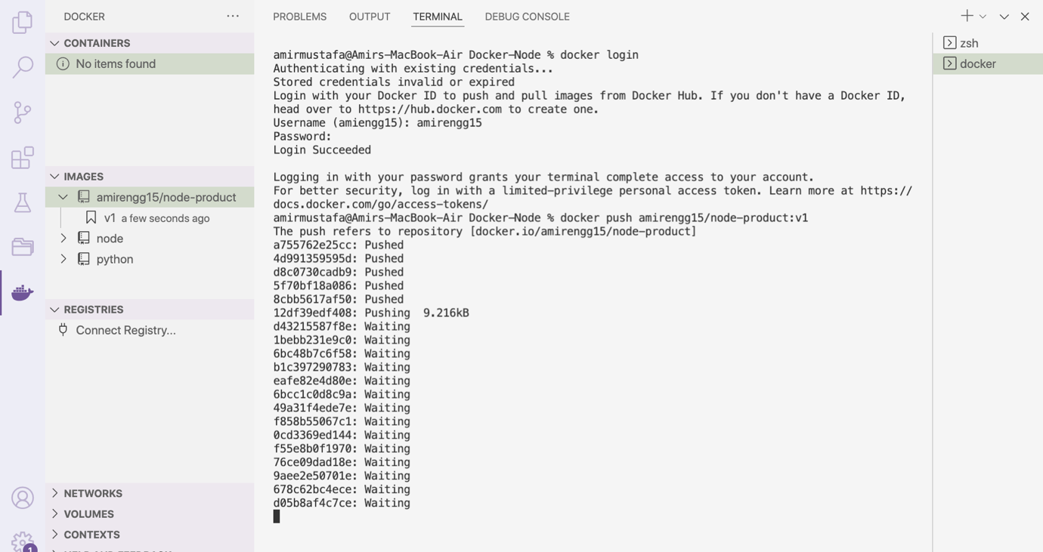

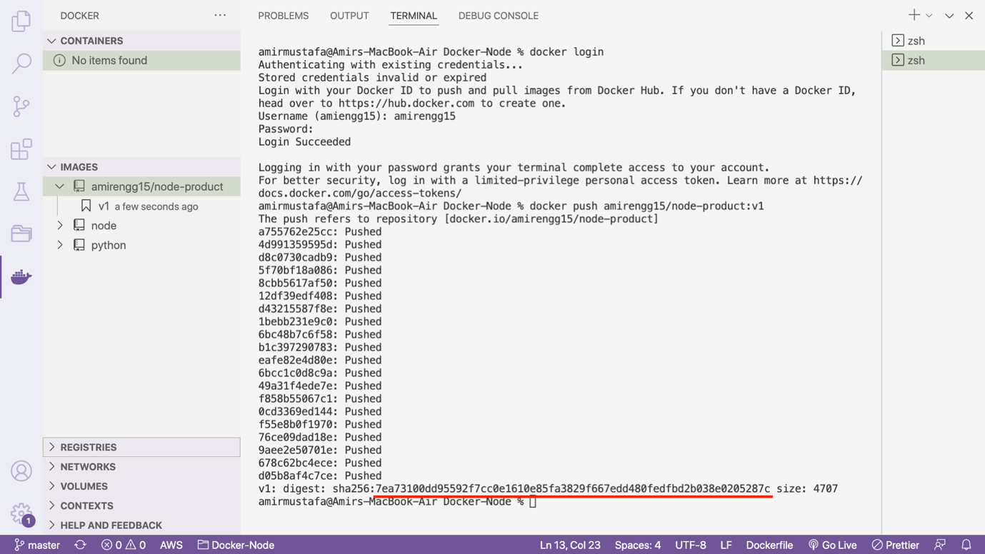

🡪 Pushing is successful. Let us check Docker Hub repository

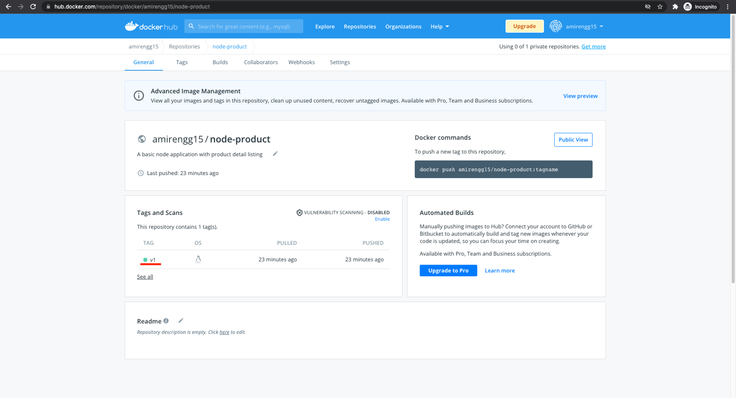

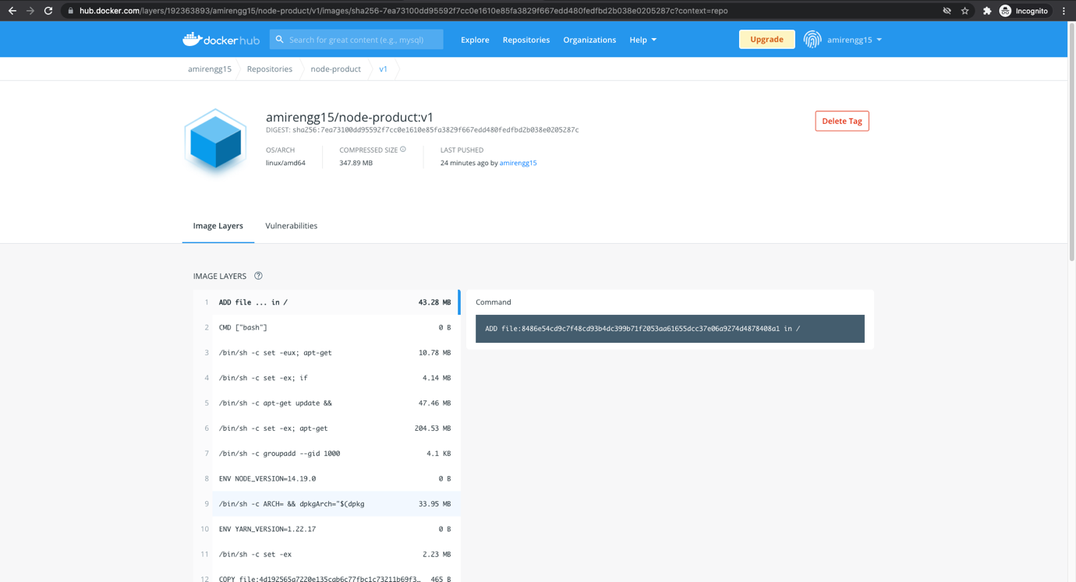

1. Pulling Image from Docker Hub and using it:

🡪 For pulling the image we use docker pull command

🡪 Let us logout first

docker logout

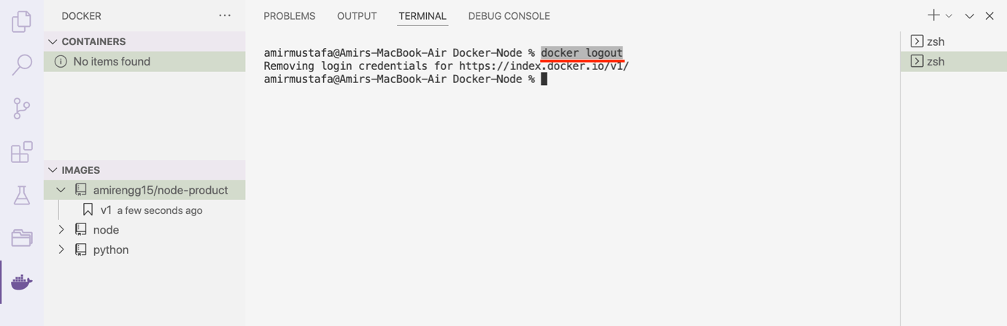

🡪 We first delete our local image that we will pull from docker hub

docker rmi amirengg15/node-product:v1

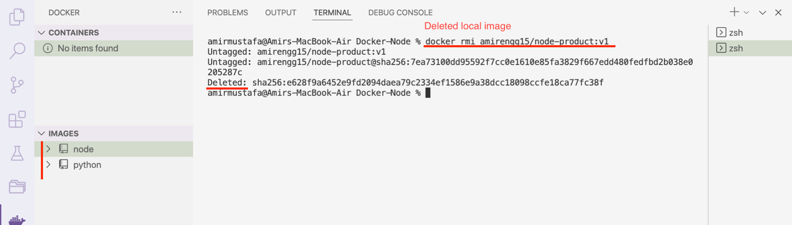

🡪 Now let us go to the docker hub search your image to pull

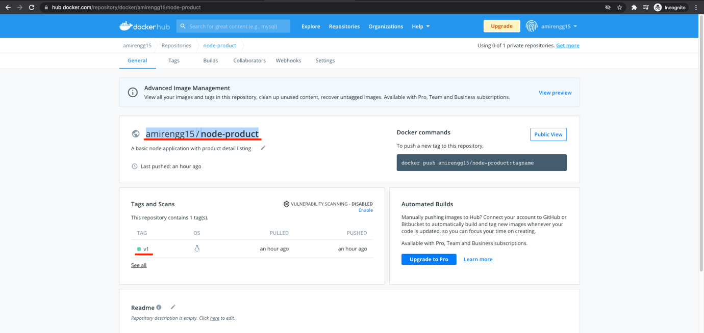

docker pull <docker-image-fullname>:tag. // we mention tag

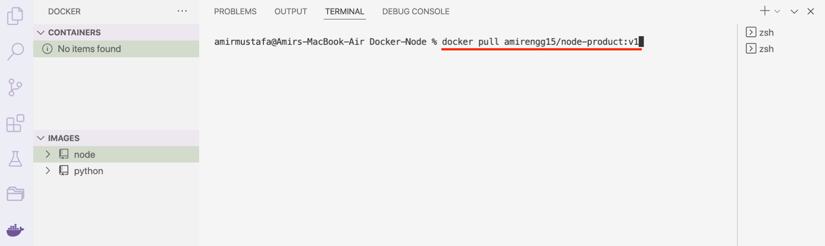

🡪 Successfully pulled:

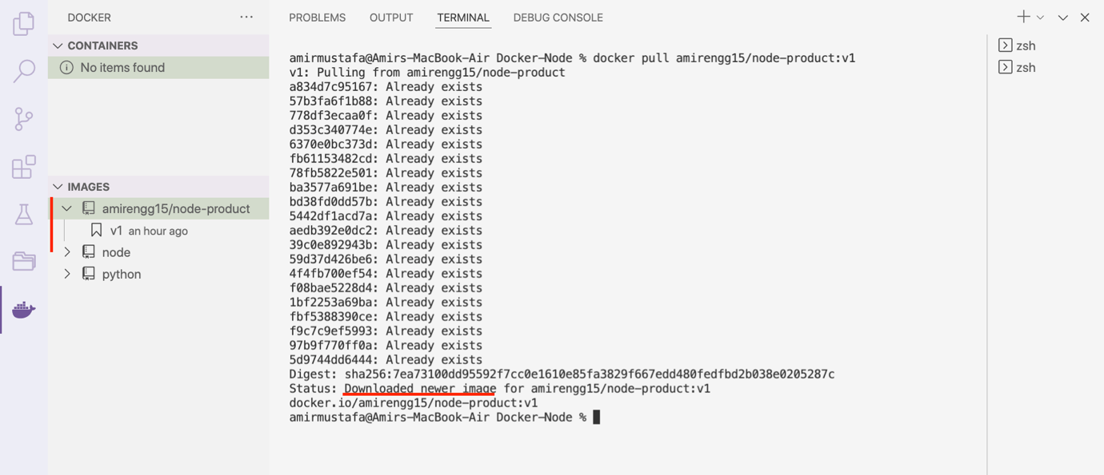

🡪 So if we want to share images, docker Hub can be used

🡪 Docker Hub has many features like deployment of the image (we will understand soon)

Points to note:

🡪 If we have removed image from local and run the command, docker will automatically pull and run

What docker will not do is check for updates i.e. latest version. Better to give tag always

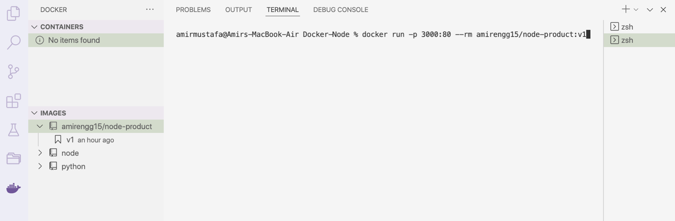

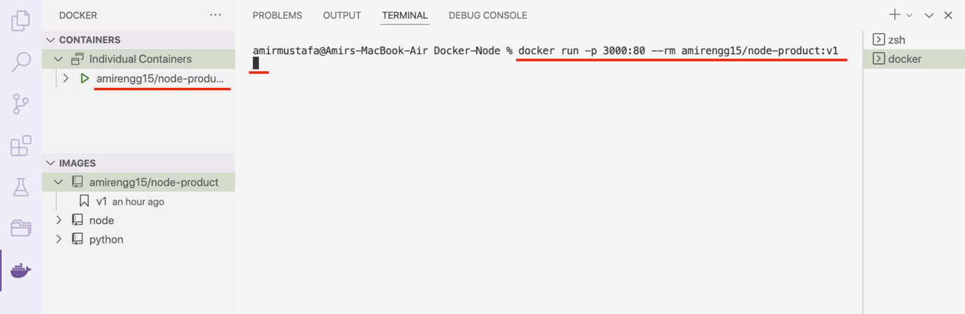

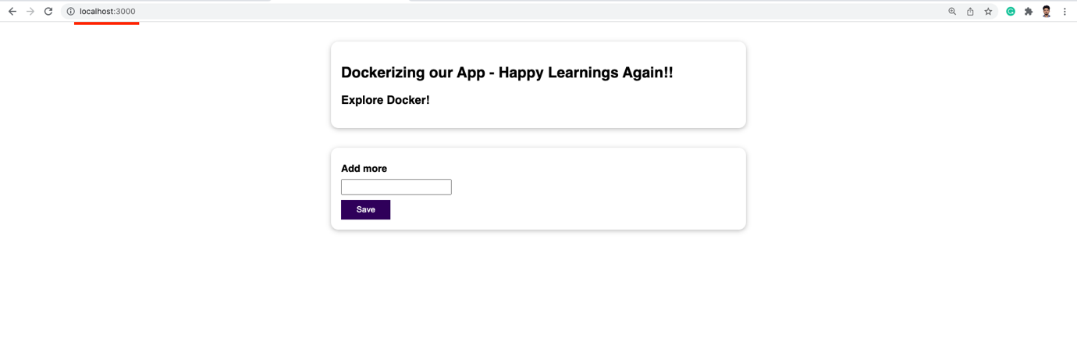

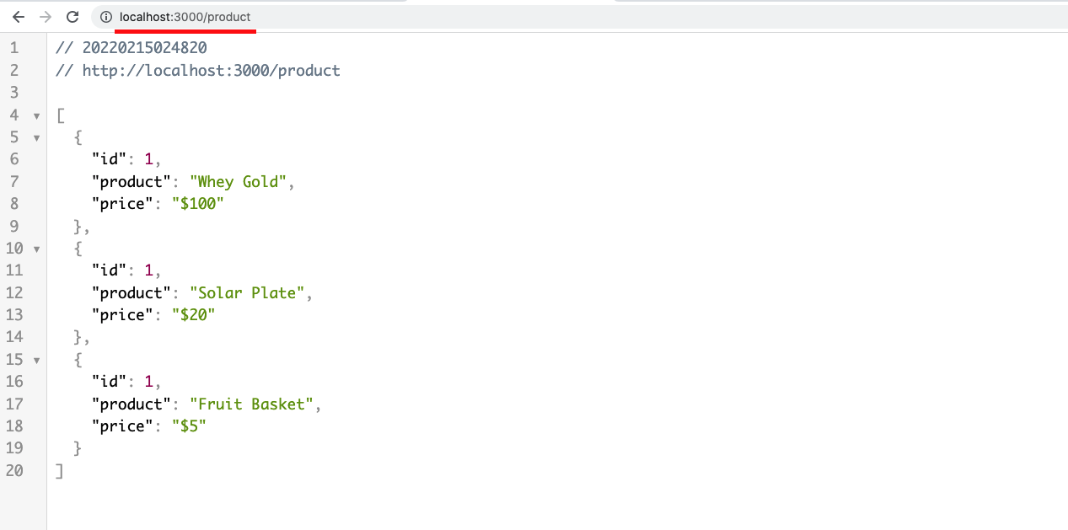

Module Summary:

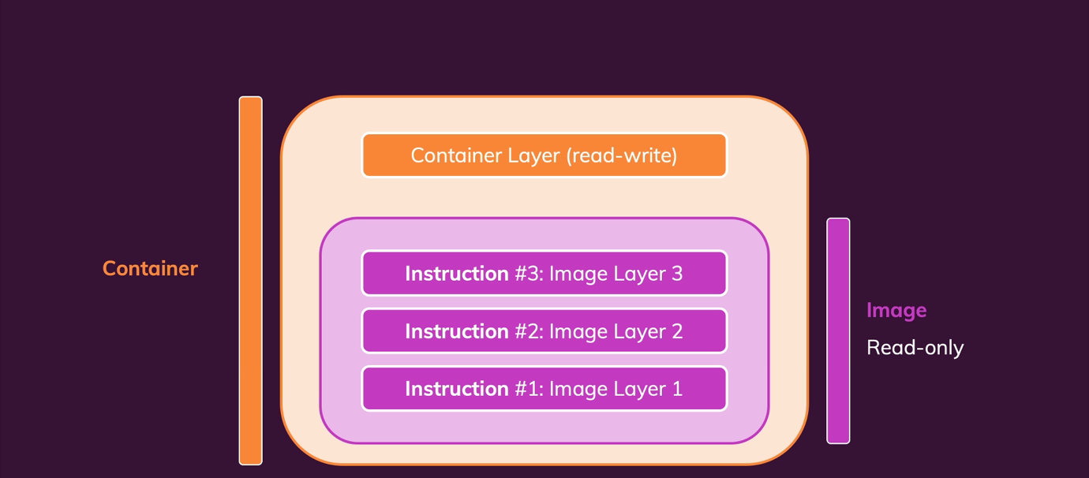

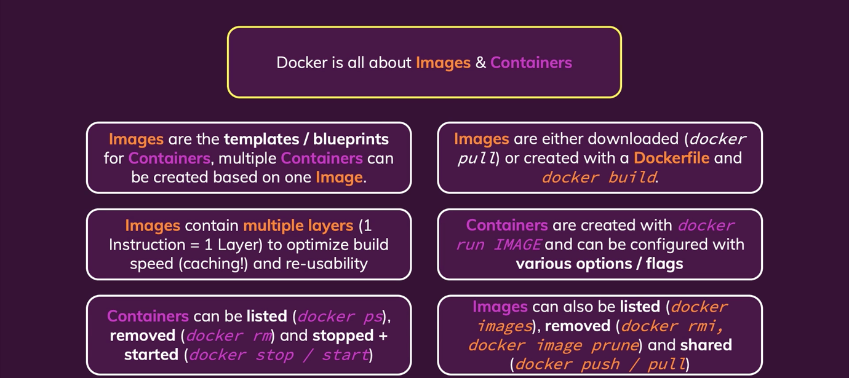

Basics, Core concepts, managing images & containers

Section 2: Managing Data and Working With Volumes:





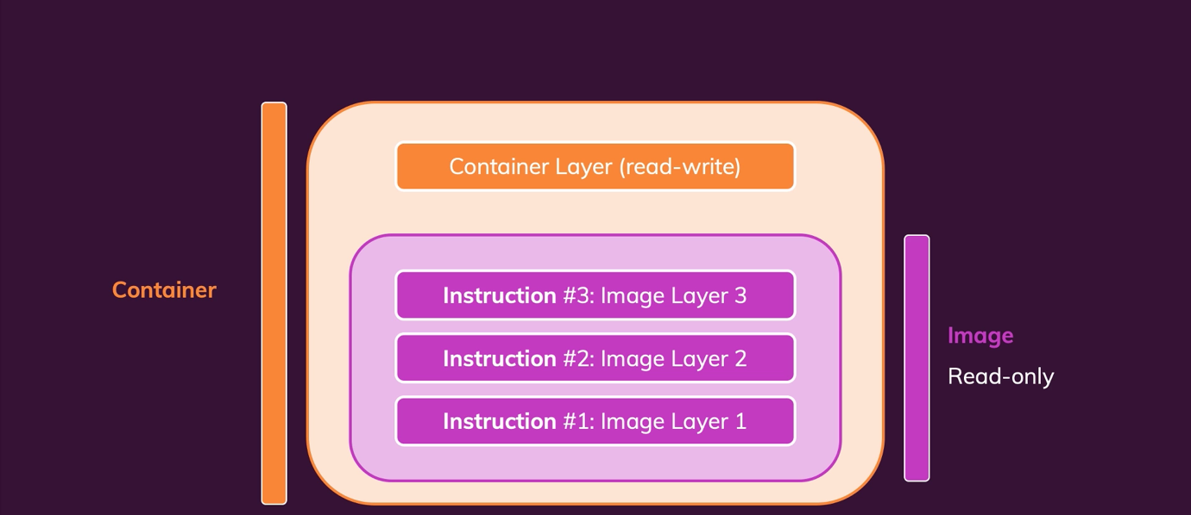

🡪 There are three types of Data

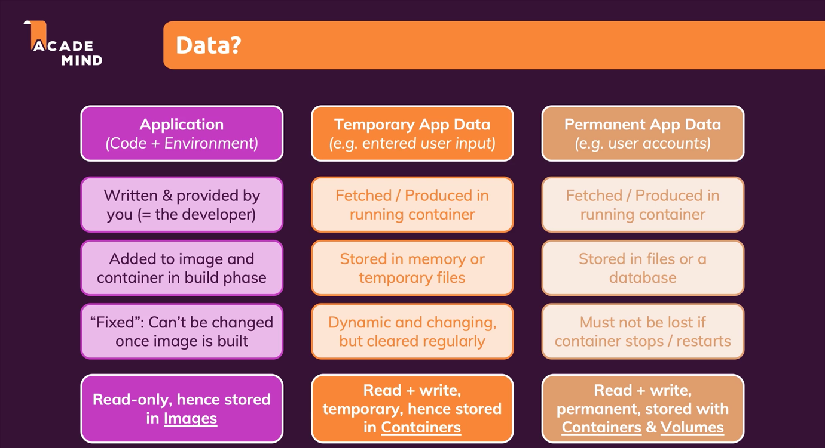

1. Application (Code + Environment): These are the data we discussed in last section (Read-only)
2. Temporary App Data: These data are generated in real-time (form data keeping temporary files) (Read + Write)
3. Permanent App Data: These data are stored in files or database (Read + Write)

Analysing a Realtime App

🡪 We have a basic node.js app. The key of the app is it take feedback from user and save in temp and feedback directory

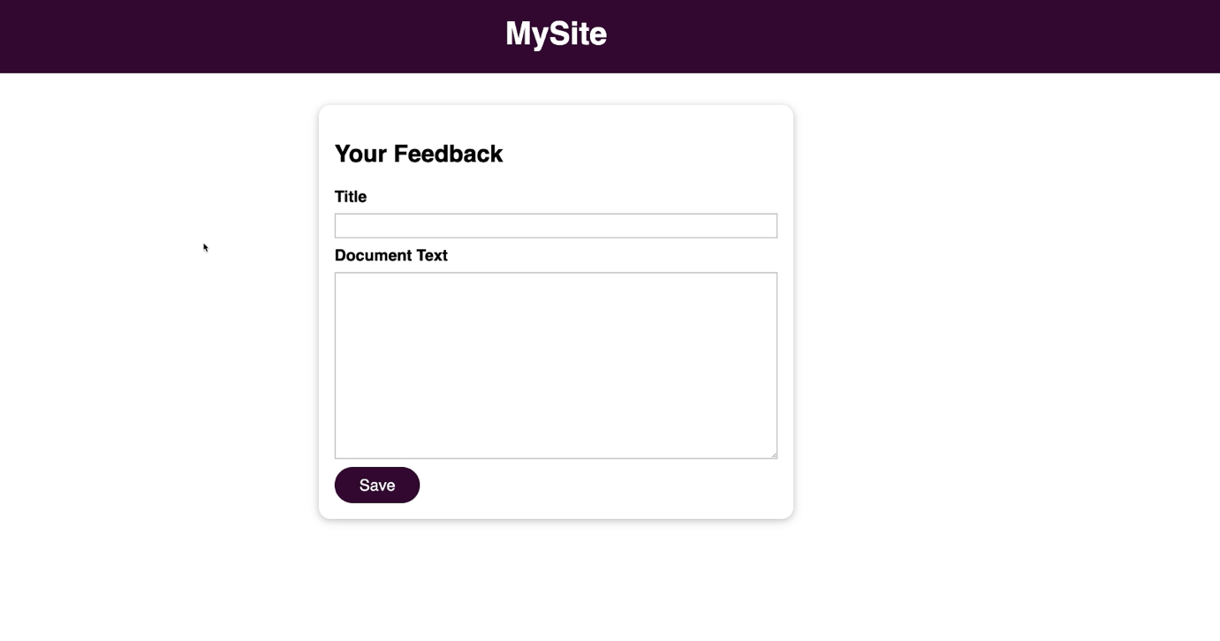

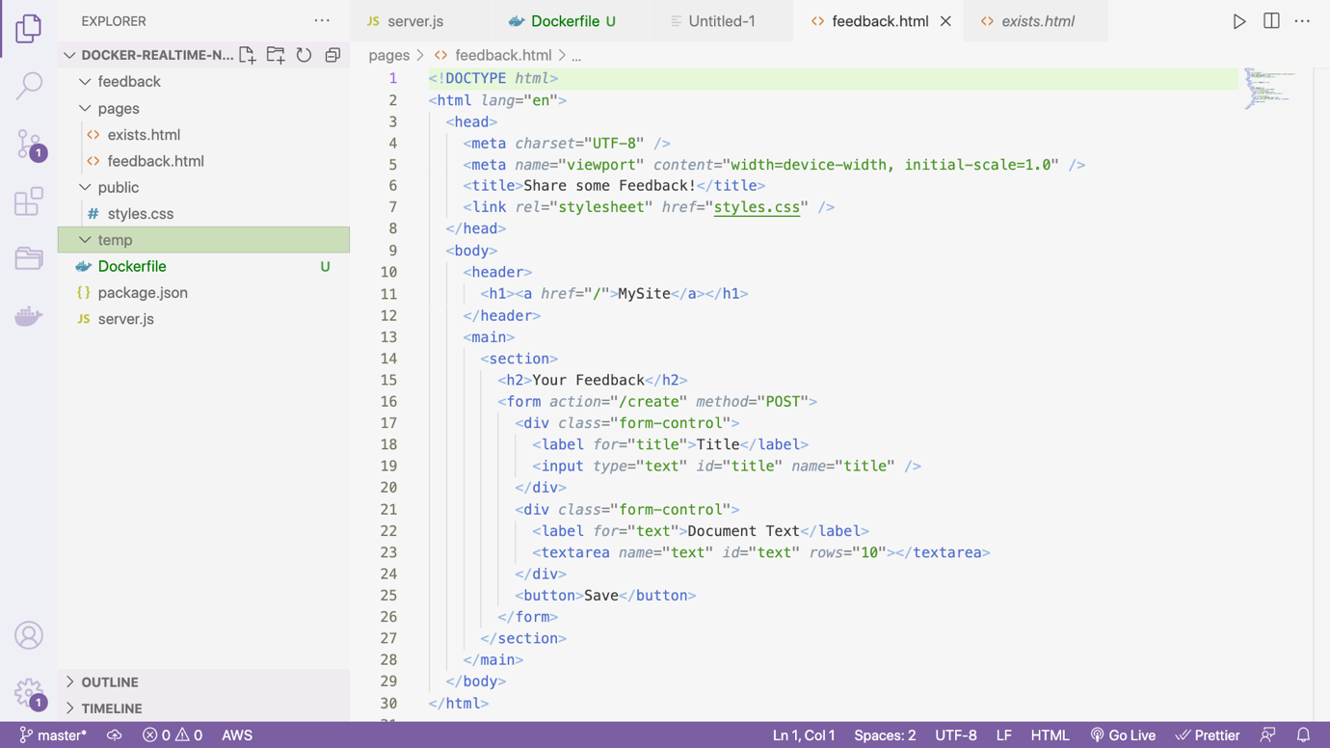

🡪 At present we have feedback and temp file empty. When user submits the feedback, temp file will be saved in these directories

🡪 As we see these data are temp data (second type of data)

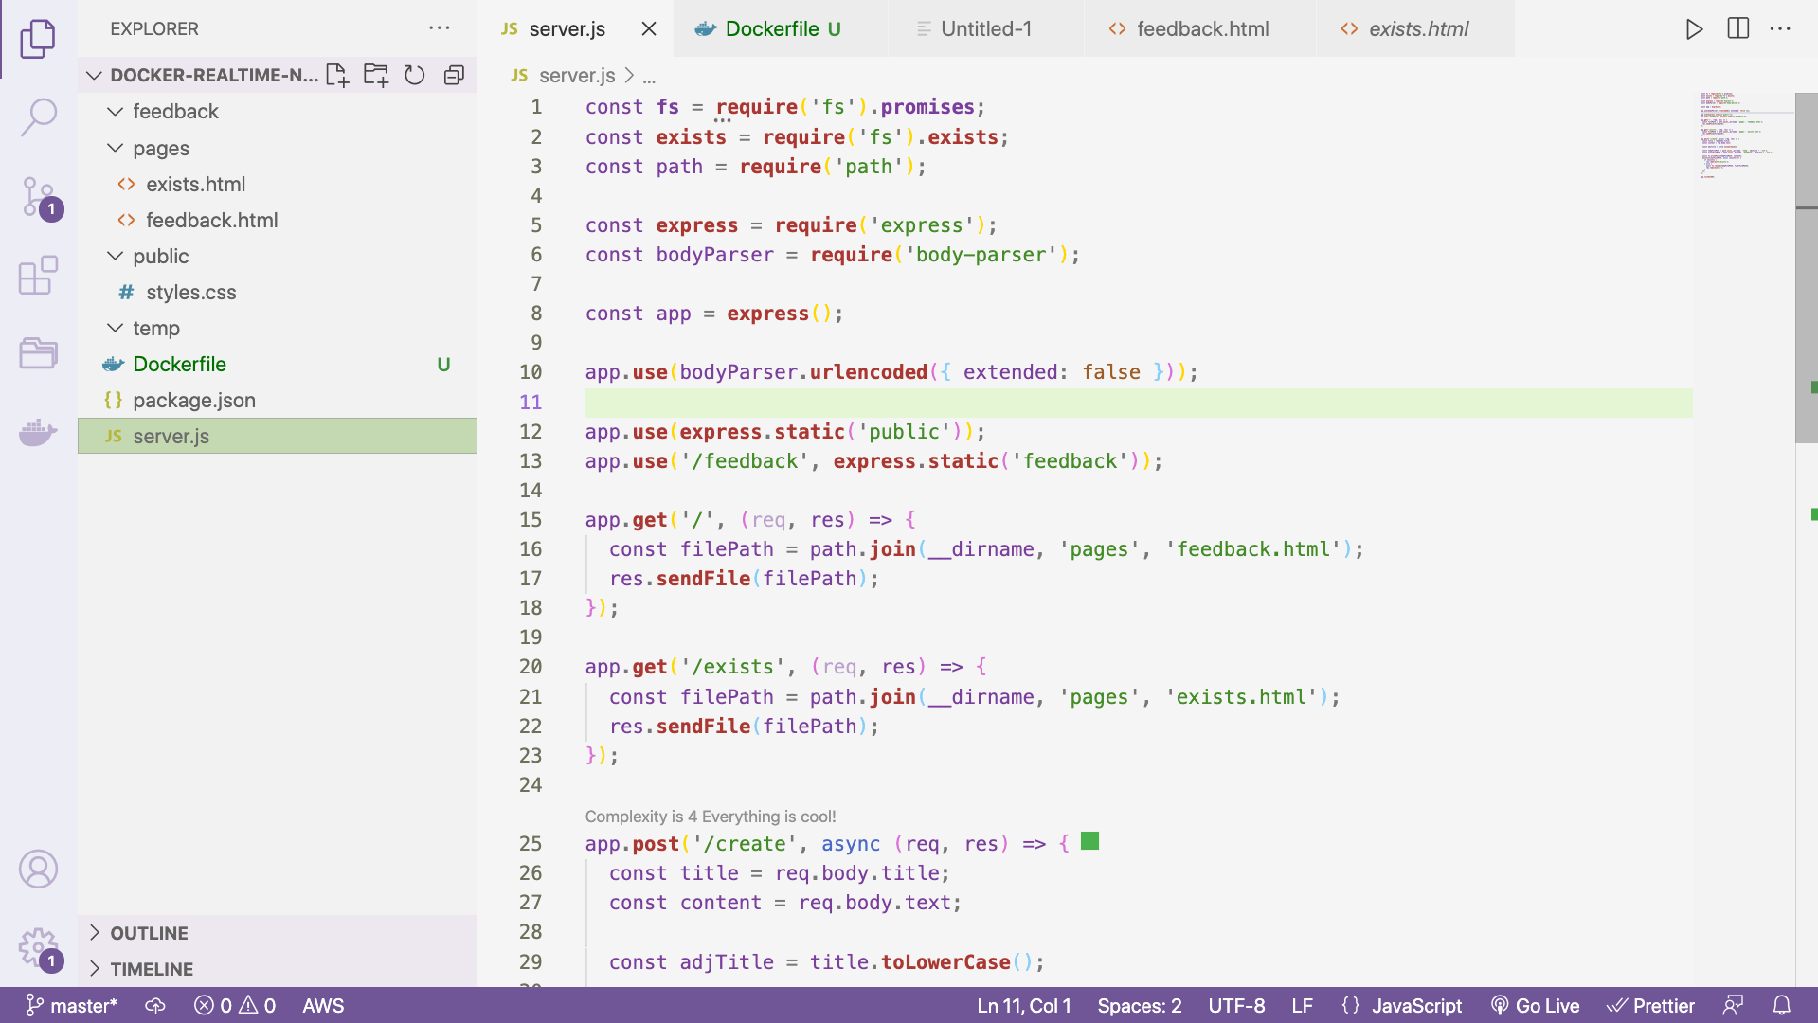

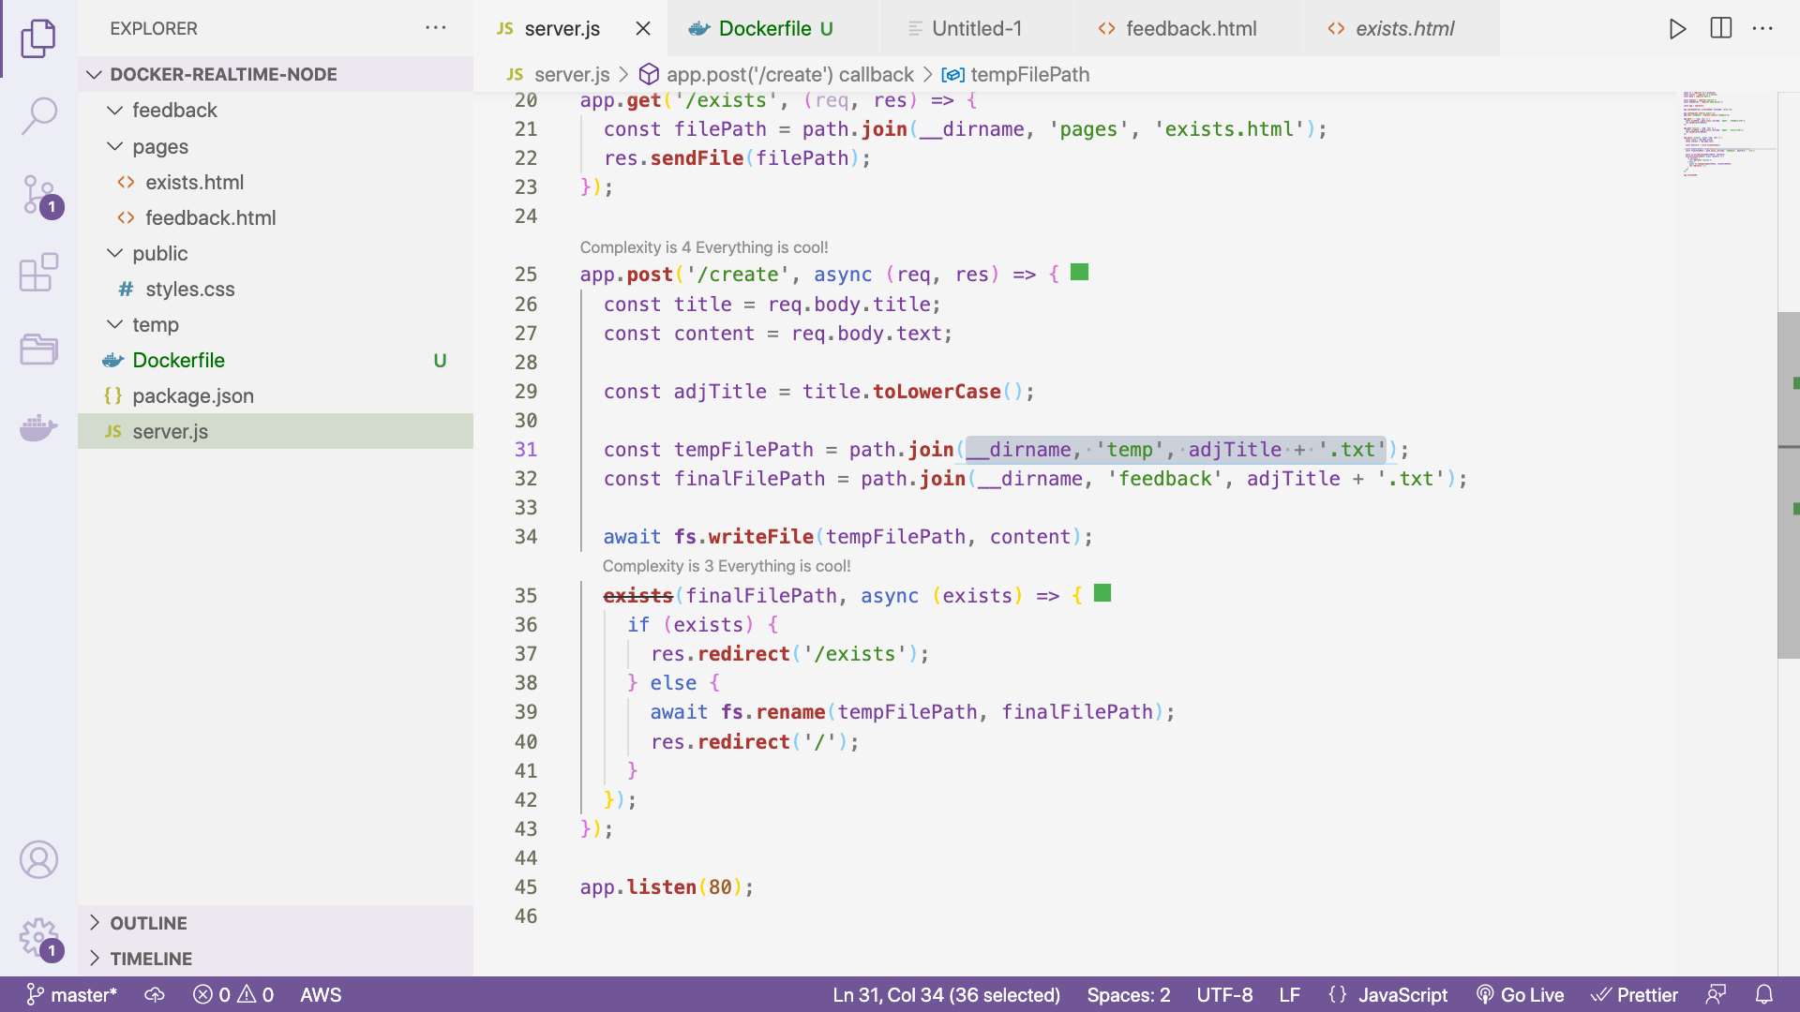

🡪 Here we have basic server file with some routes

🡪 Here we are copying in two paths – temp path (**tempFilePath**) and finally to one final path (**finalFilePath**)

LOGIC: If file exists redirect to exist, otherwise over to final path

🡪 Generated file simply contains feedback that was submitted

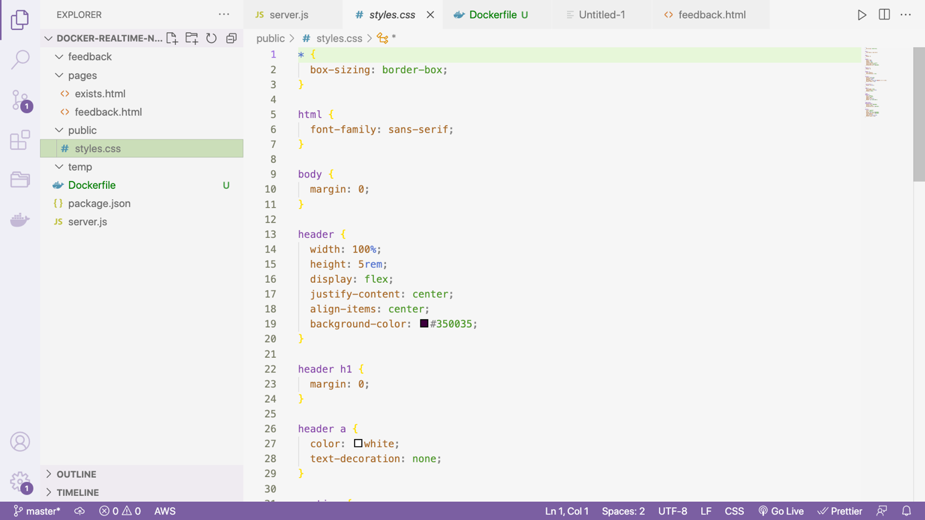

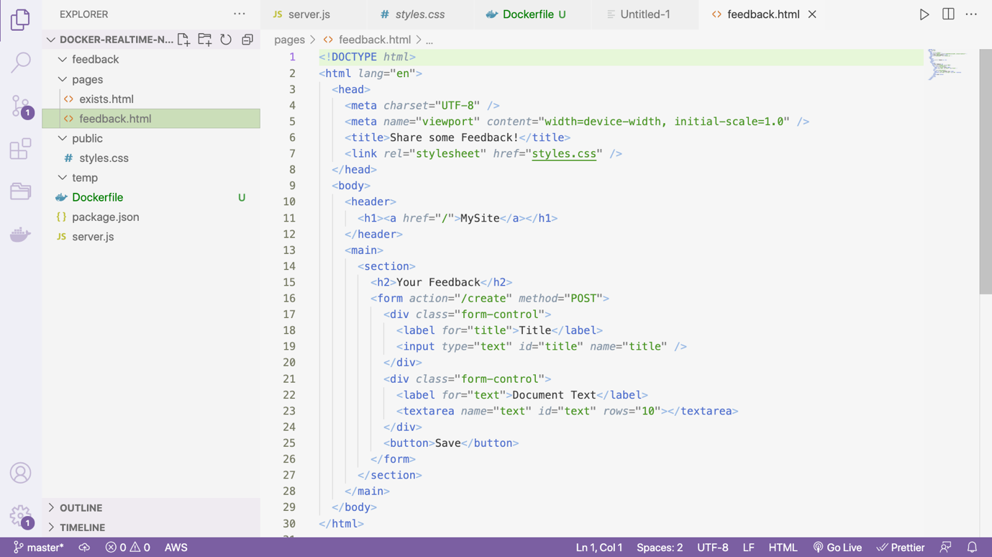

🡪 Here we have all three kind of data in action

Application – source code data

Temp – temporary data (file which we are okay with losing)

feedback – final path data (permanent storage)

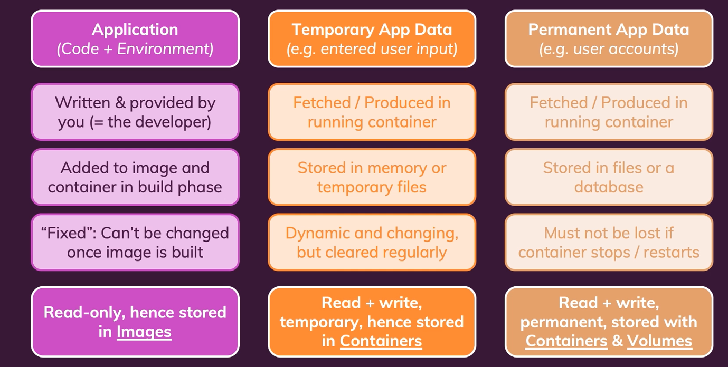

Dockerizing above app:

STEP1: Create Dockerfile

FROM **node**:17

WORKDIR /app

COPY package.json .

RUN npm install

COPY . .

EXPOSE 80

CMD ["node", "server.js"]

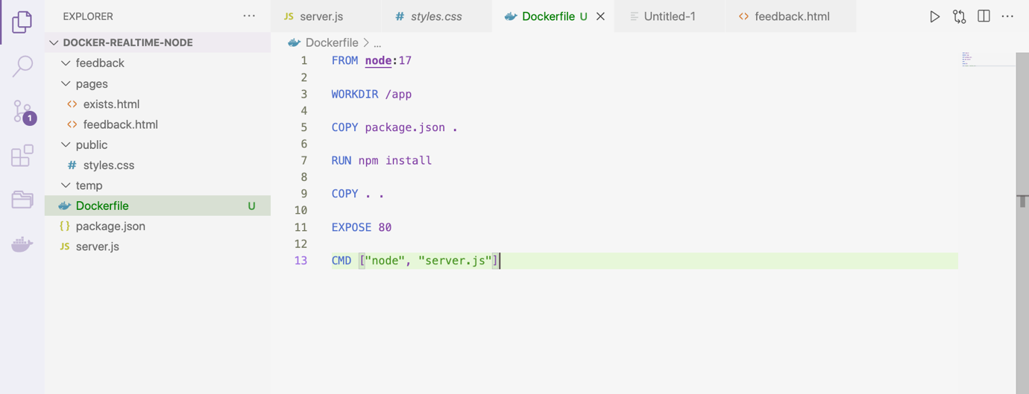

STEP2: Run below command

docker build . // default image command

or

docker build -t feedback-node . // naming the image

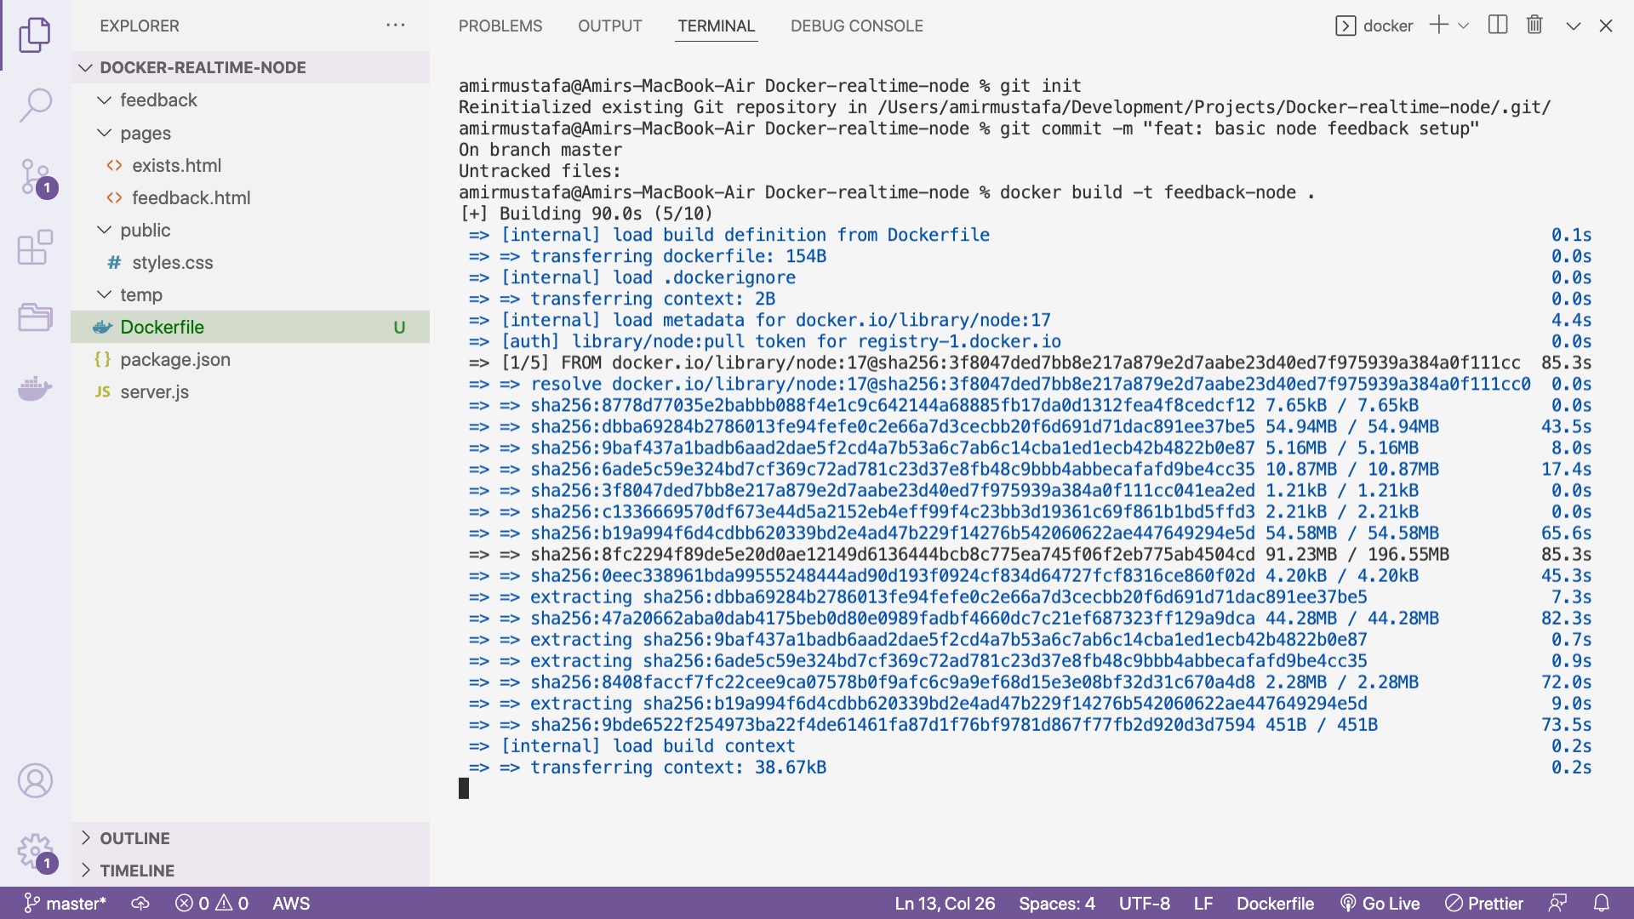

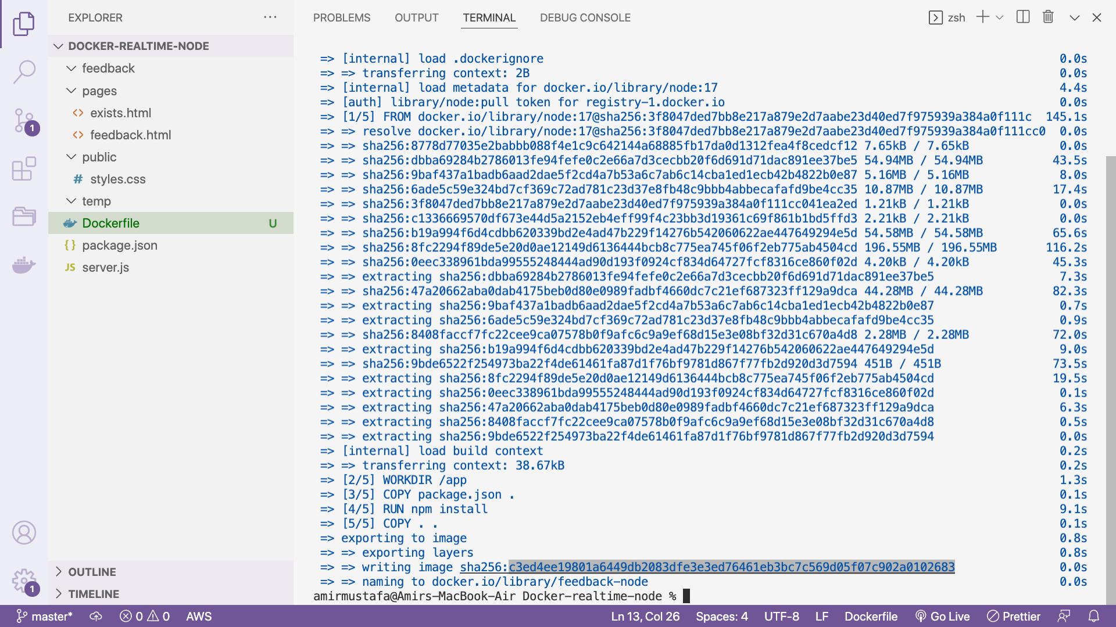

🡪 We got the image ID

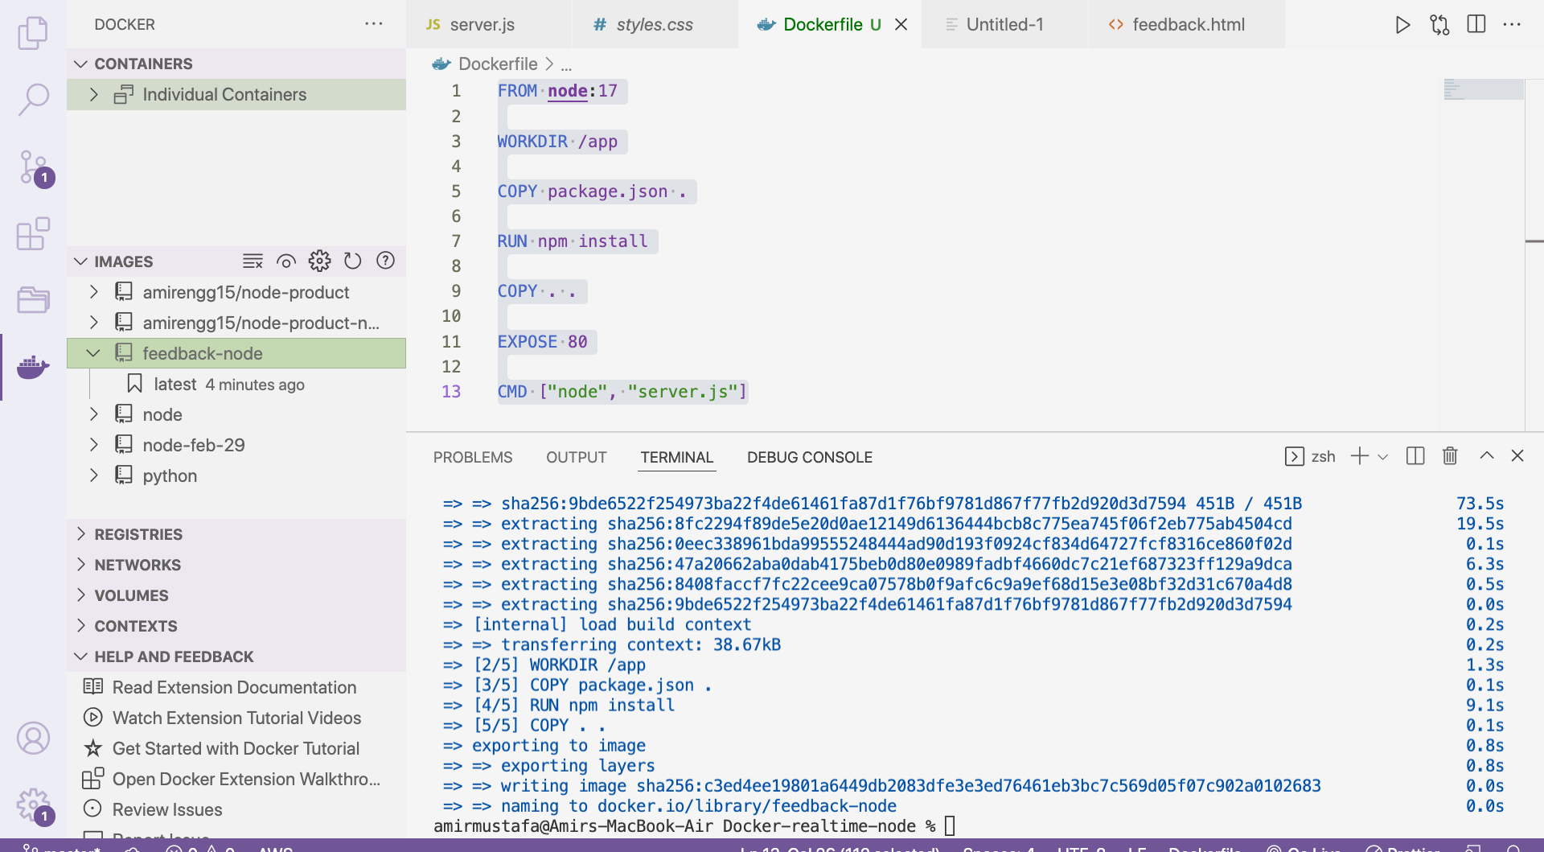

🡪 STEP3: Creating container out of this image

docker run -p 3000:80 -d –name feedback-app –rm feedback-node

// port 3000, detached mode, named the container, remove the container once closed

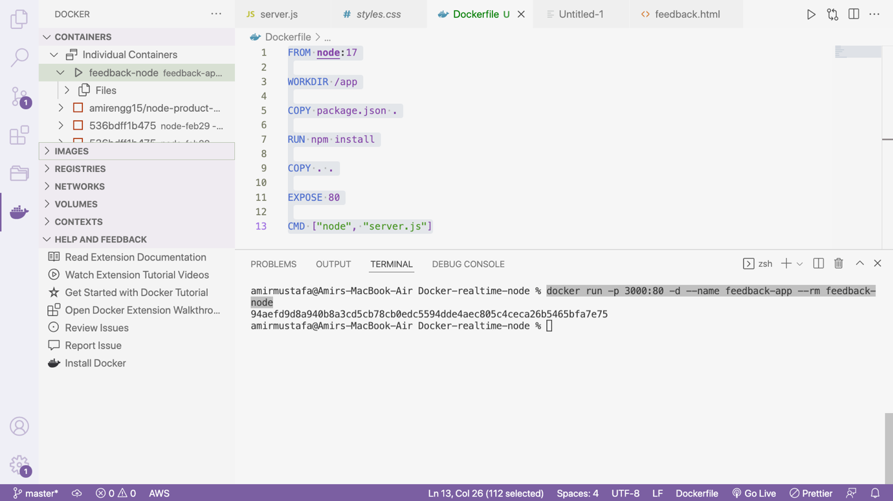

STEP4: Let us enter a feedback. Click Save button

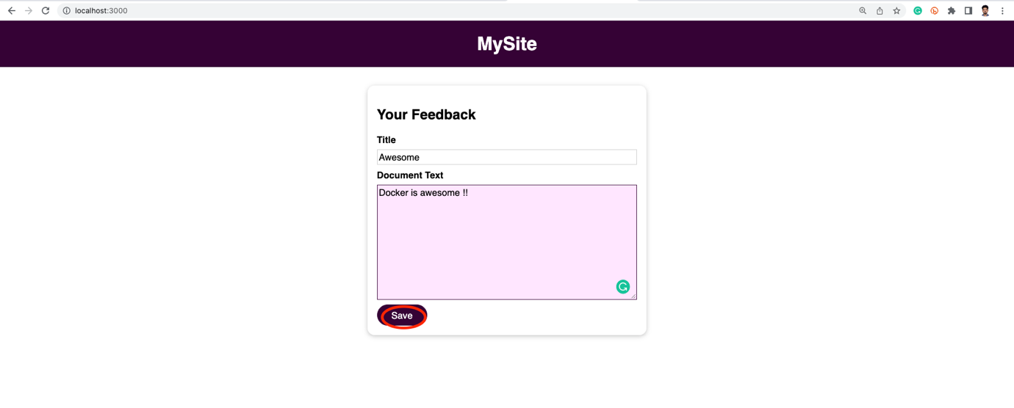

🡪 The feedback is saved. Its title lowercase is the file name

/feedback/lowercase(Title Entered)

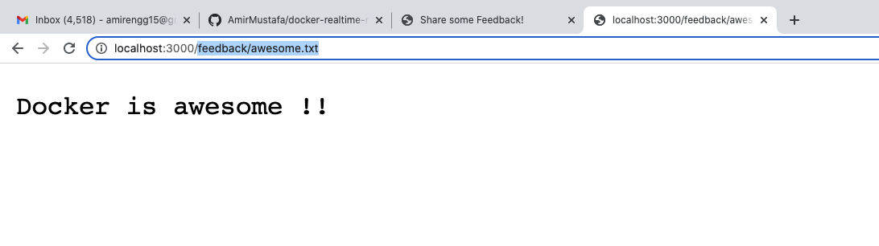

🡪 On a side note if we will try to view inside feedback of the local app. File will not be there

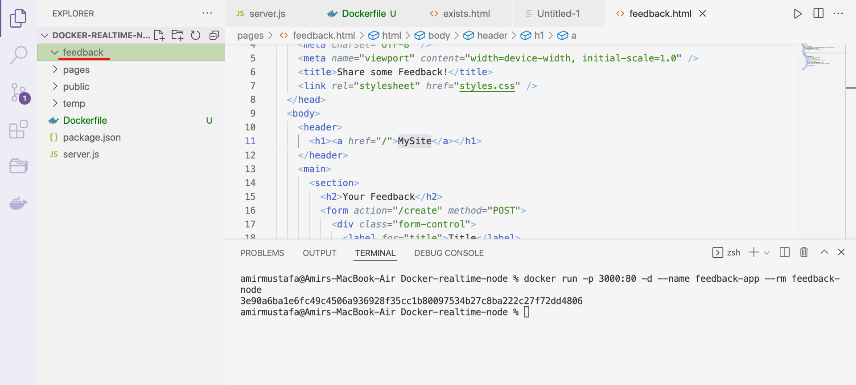

🡪 This is because. It is only inside the docker/app/feedback/awesome.txt from where it is rendering in the app

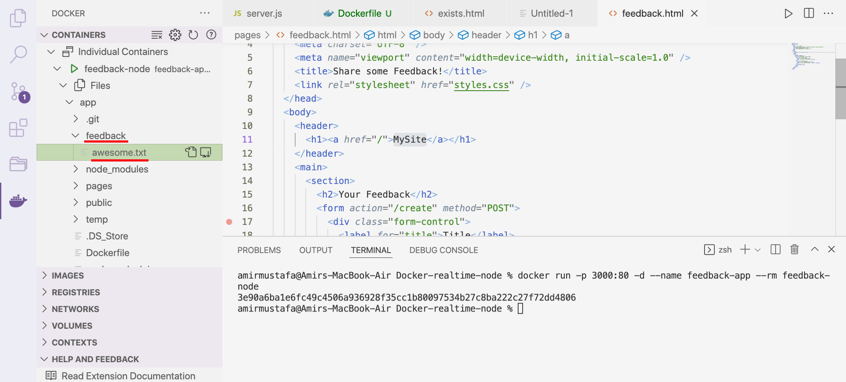

🡪 The reason is we copy the local code in the image and container in based on the image.

COPY . . command in Dockerfile

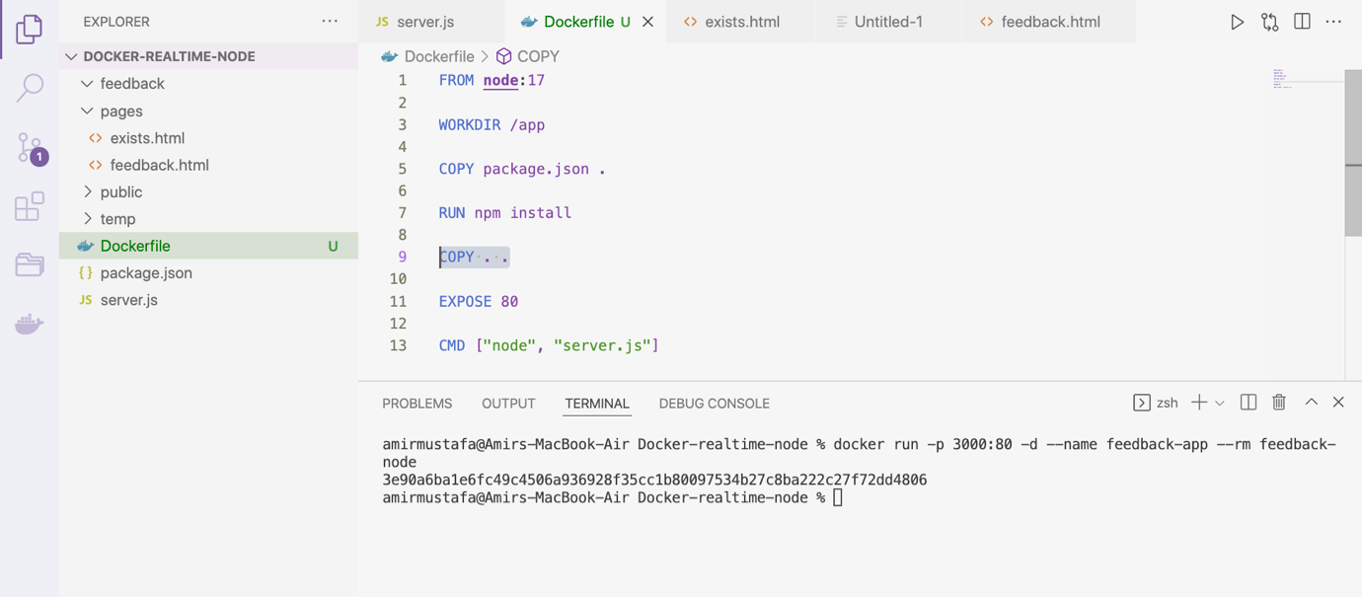

🡪 But after copy there is no connection between local and container, unless we create new image.

🡪 And that is how it should work container should be isolated after all.

🡪 If we have done change in the code locally, we have to rebuild the image, and then the code is reflected in browser.

🡪 If we now try to run the same feedback again (mean same title), system will ask for a new feedback

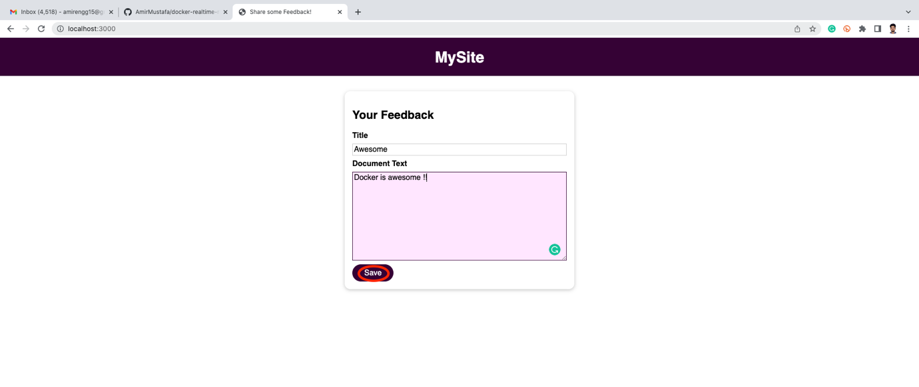

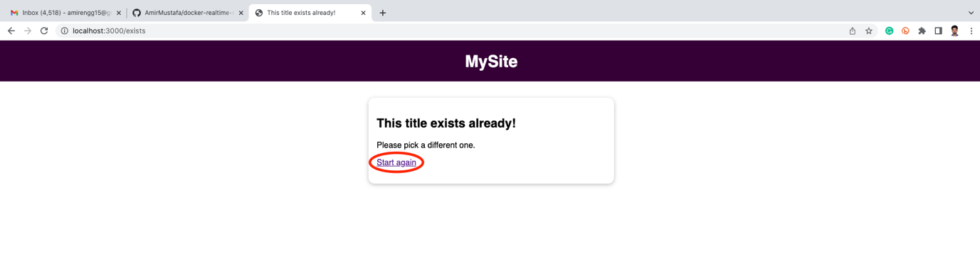

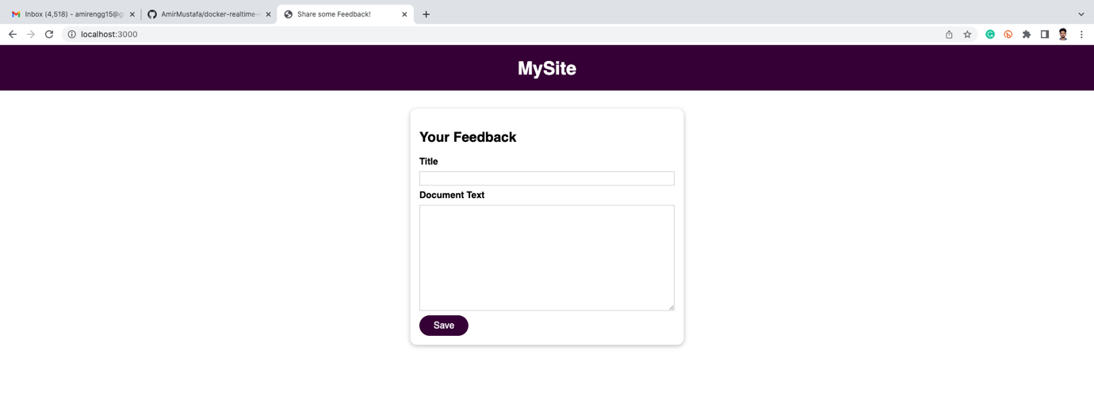

Reason: We implemented with this logic

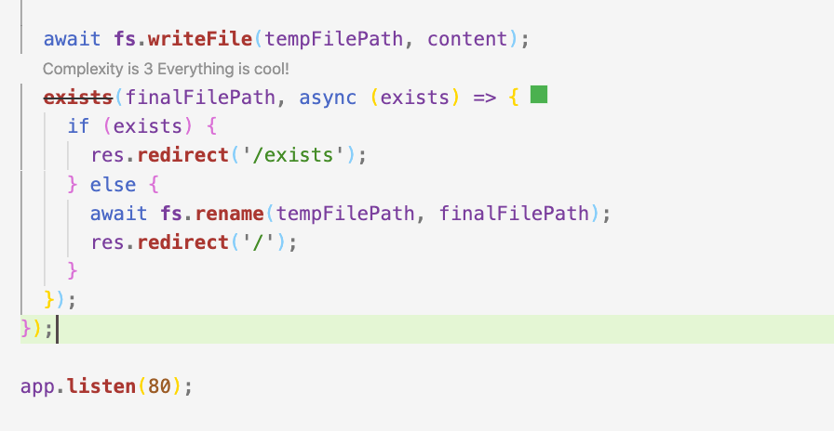

Understanding the Problem

**Understanding the Problem:**

### Docker. Ep 15 - Docker Volumes, Anonymous Volume

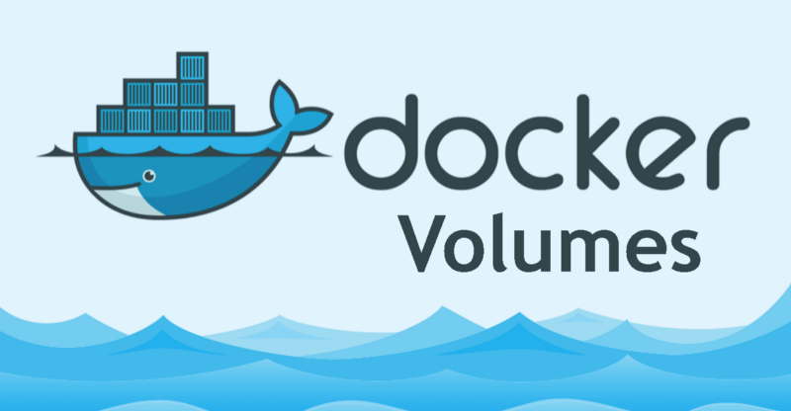

### Understanding the Problem:

 → In the previous article, we dockerized the application and everything was working fine.

 → When creating a container, our application asked for feedback and it was saved inside the container.

 → The problem is if **we delete the container** and **create a new instance of the container** from the same image, **all previous feedback data is lost**.

 → This problem is for any files we have saved in a container. Once the container is deleted, all files of the previous containers are lost.

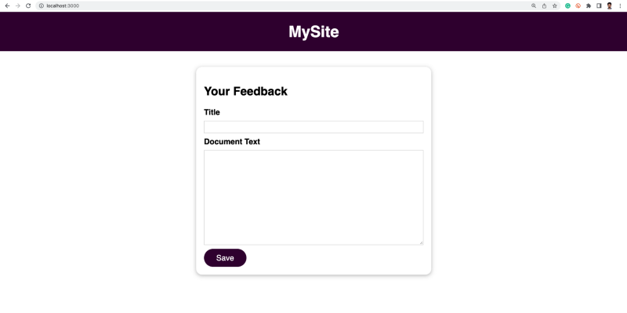

 → We would have a comparable scenario if we have a user account or with product data submitted by users or any other type of data which shouldn’t be disappearing suddenly. It should survive.

 → In reality, this problem will come quite often. We will be changing in code and rebuilding the image and containers. Files will be lost

### Docker Volumes:



 → Now we know the problem. How can we solve this problem

 → Docker has a built-in feature called **volumes**.

 → Volumes help in **persisting data** and **solving the above problem**.

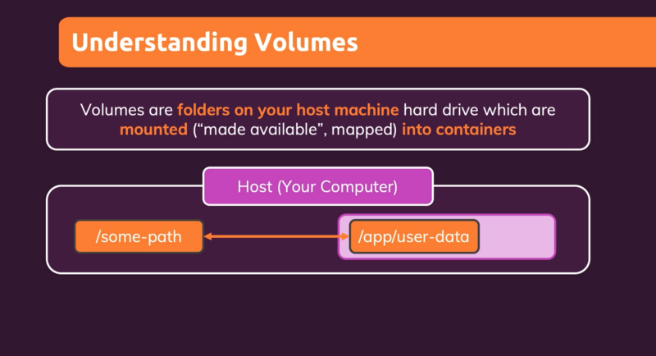

 → Volumes are folders in our computer that we make Docker aware of and are then mapped to a folder inside the Docker container.

 → Here we can connect the host machine path and container path.

 → Changes in one will be reflected in the other one i.e.

a. If we add a file to the host machine, it is accessible inside a container.

 b. If the container adds a file inside the mapped path it is available outside of the container inside the host machine as well.

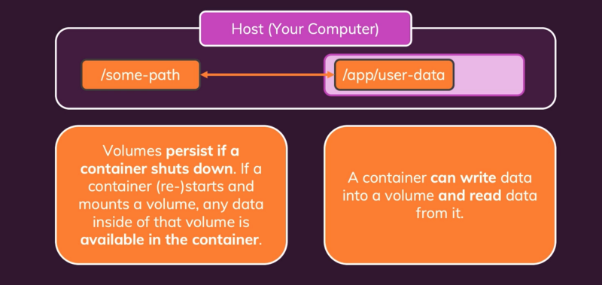

 → Volumes persist data even if the container is deleted

### First Try — Anonymous Volumes:

**STEP1: Adding Volume instruction in Dockerfile**

 → For creating Anonymous Volumes, we go to Dockerfile in the codebase.

 → By Anonymous, we mean only the docker path is given. Docker itself will create some path in the host computer which we do not need to know.

VOLUME ["/app/feedback"]

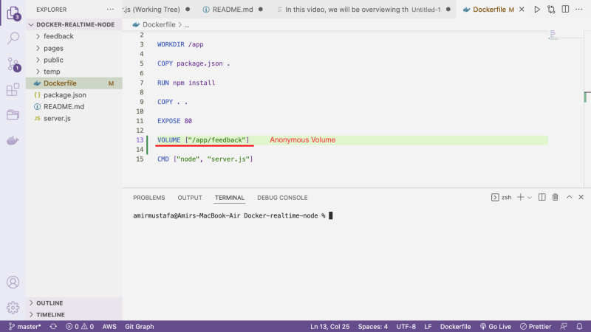

 → If we check the server.js file, the temp path should not be stored, whereas feedback path files should be stored

const tempFilePath = path.**join**(__dirname, "temp", adjTitle + ".txt"); // Need not to be stored, temporary data

const finalFilePath = path.**join**(__dirname, "feedback", adjTitle + ".txt"); // Must be stored

await fs.**writeFile**(tempFilePath, content);

**exists**(finalFilePath, async (exists) => {

if (exists) {

res.**redirect**("/exists");

} else {

await fs.**copyFile**(tempFilePath, finalFilePath);

await fs.**unlink**(tempFilePath);

res.**redirect**("/");

}

});

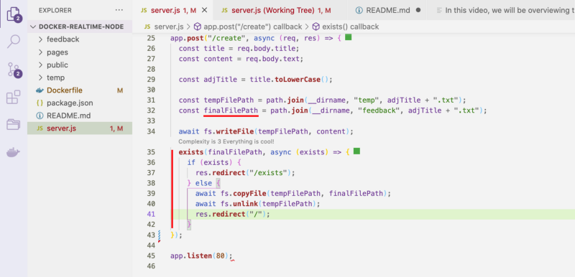

**STEP 2: Building the Image:**

docker build -t <docker-image-name>:<tag> .

eg: docker build -t feedback-node:volumes .

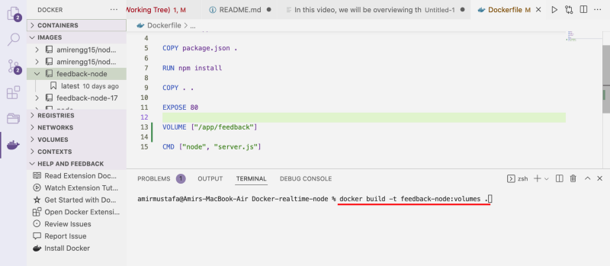

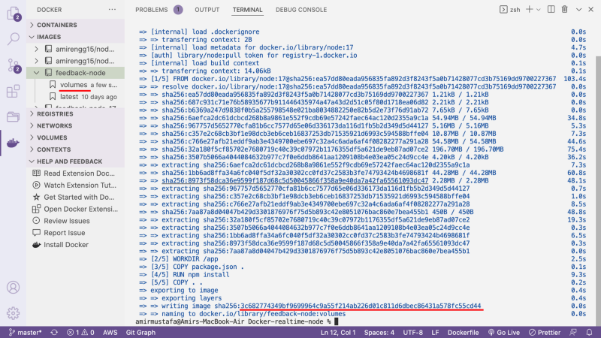

**STEP 3: Creating Container on the above image:**

docker run -d -p <browser-port>:<docker-port> -rm --name <docker-container-name> <docker-image>

eg. docker run -d -p 3000:80 -rm --name feedback-app feedback-node:volumes

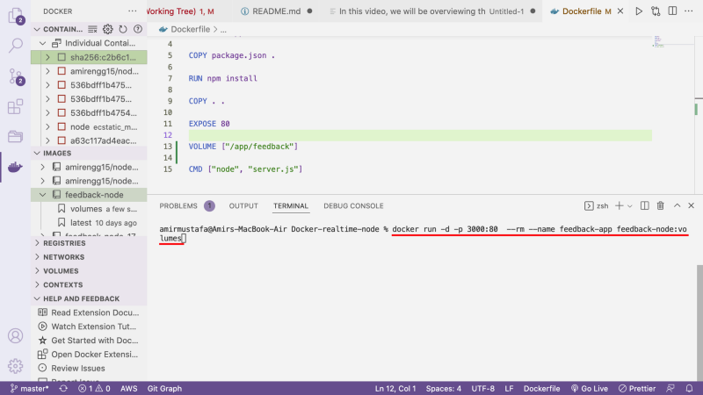

 → A container is created.

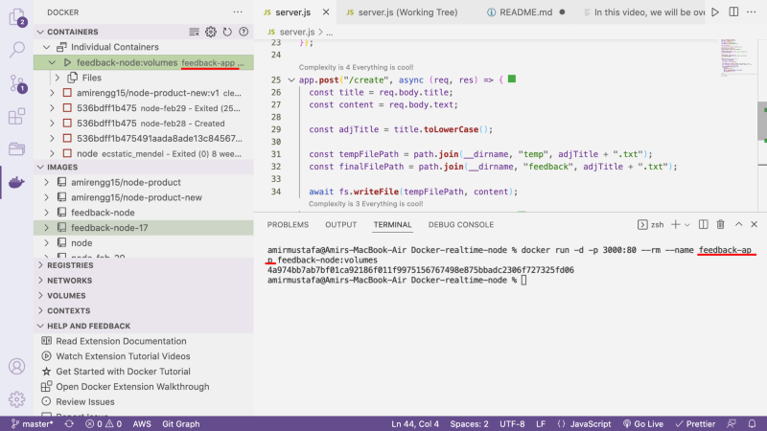

 → Let us now run our node.js application and fill in feedback. Click Save.

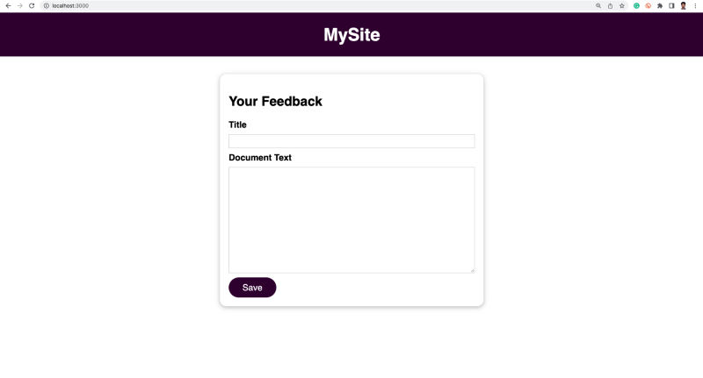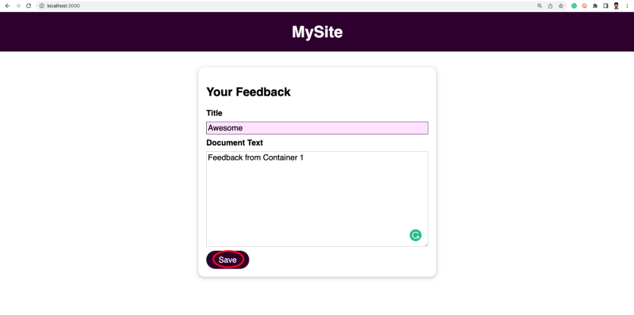

 → Let us try to access the feedback file.

 → We are **able to access it**. Which was also working previously

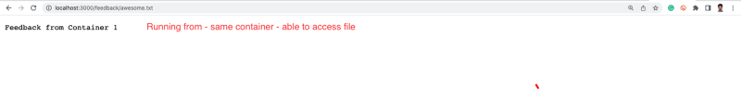

 → The problem is when **we delete this container** and **create a new container.** The **file should be accessible**.

**STEP 4: Delete Current container:**

docker stop <container-name>  
eg. docker stop feedback-node

(as we are using --rm flag container is auto deleted on stopping)

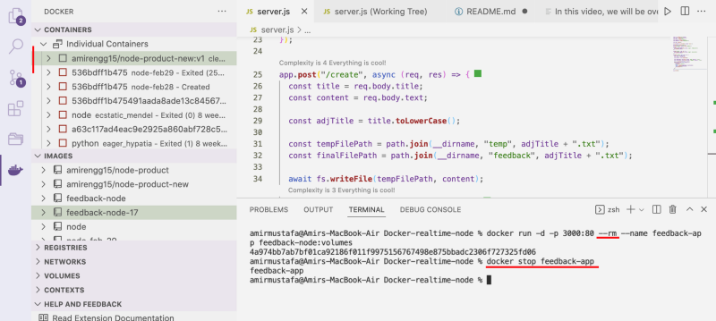

**STEP 5: Re-create container:**

docker run -d -p <browser-port>:<docker-port> -rm --name <docker-container-name> <docker-image>

eg. docker run -d -p 3000:80 -rm --name feedback-app feedback-node:volumes

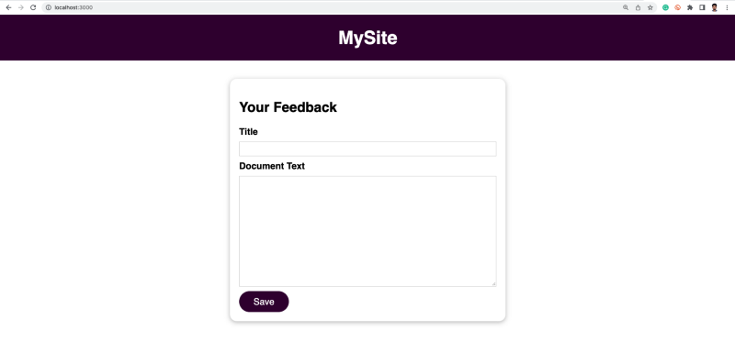

 → Let us try to access the feedback file, without adding new feedback

→ We get a file not reachable error 😧 😵

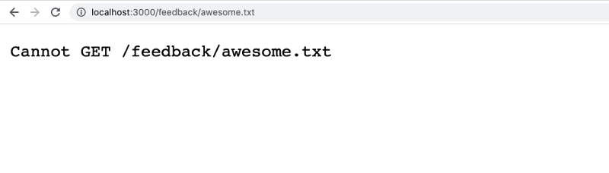

Named Volumes

# Docker Ep 16: Named Volumes

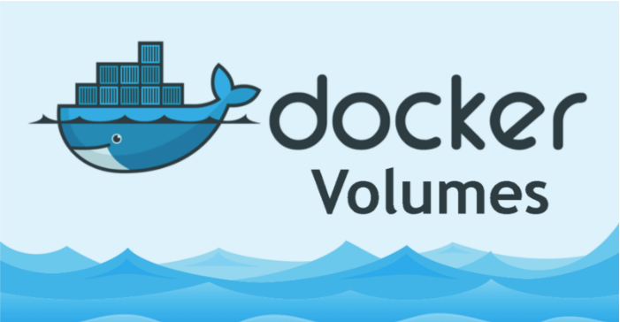

→ Docker has two types of external data storage mechanisms:

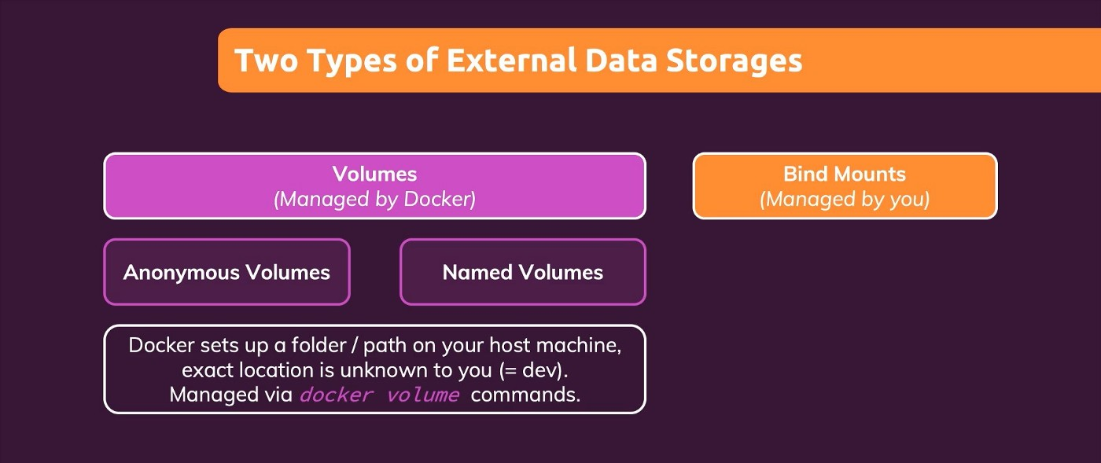

a. Volumes — Anonymous Volume and Named Volume

b. Bind Mounts

→ In this article, we will dockerize the node.js application using **Named Volume.**

→ Volumes are managed by docker.

→ By this we mean, docker keeps **someplace in the host machine** the path which is mapped with the **path inside Docker container**

## Docker Volume Commands:

1. Helper volume commands:

docker volume --help

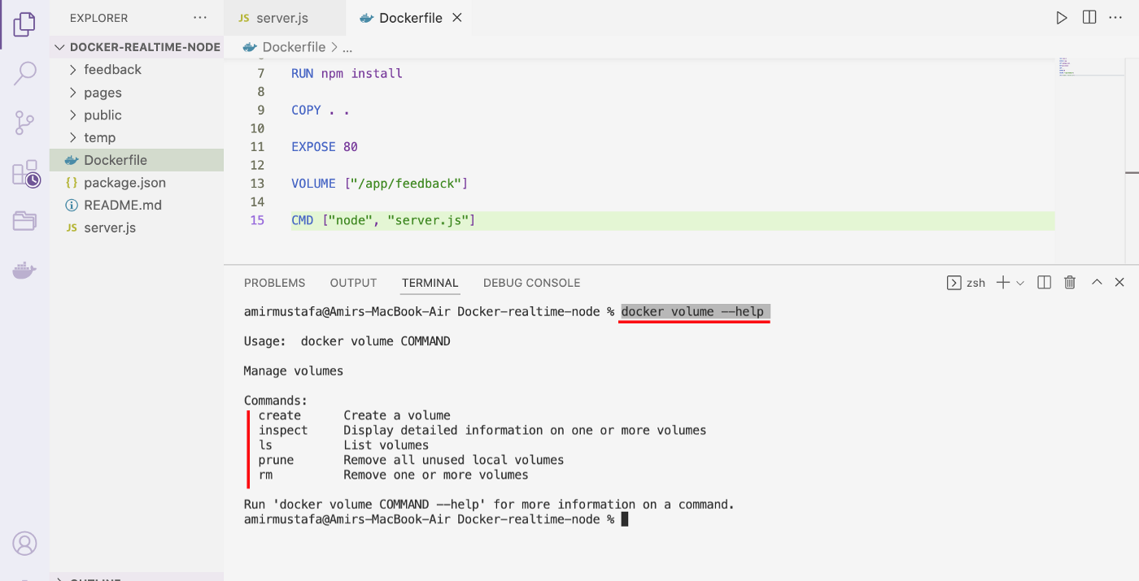

2. Get the list of Volumes

**Method 1:** Command

docker volume ls

**Method 2:** Directly through **Microsoft’s Docker extension** as shown in the image below:

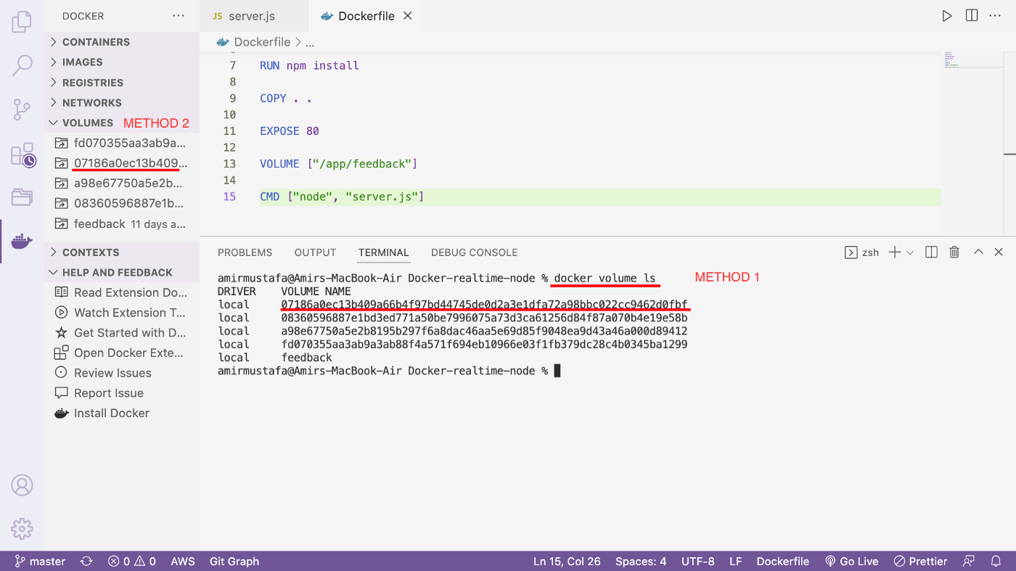

3. Remove all volume at once

docker volume prune

4. Remove specific volume:

docker rm <volume-name-or-id>

# Introduction to Docker Named Volume:

→ Till now we have seen volume in the listing command give random IDs. This is because it was anonymous volumes, we did not assign any names.

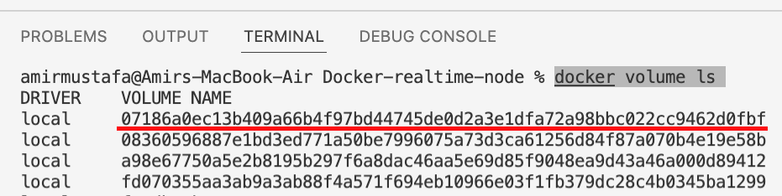

*TRICK: If we stop the anonymous container and we inspect it again. This volume is lost and cannot be retrieved*

→ STEP 1: Suppose an anonymous container is running. It is initiated with — rm flag. It means when we stop the container, it is deleted

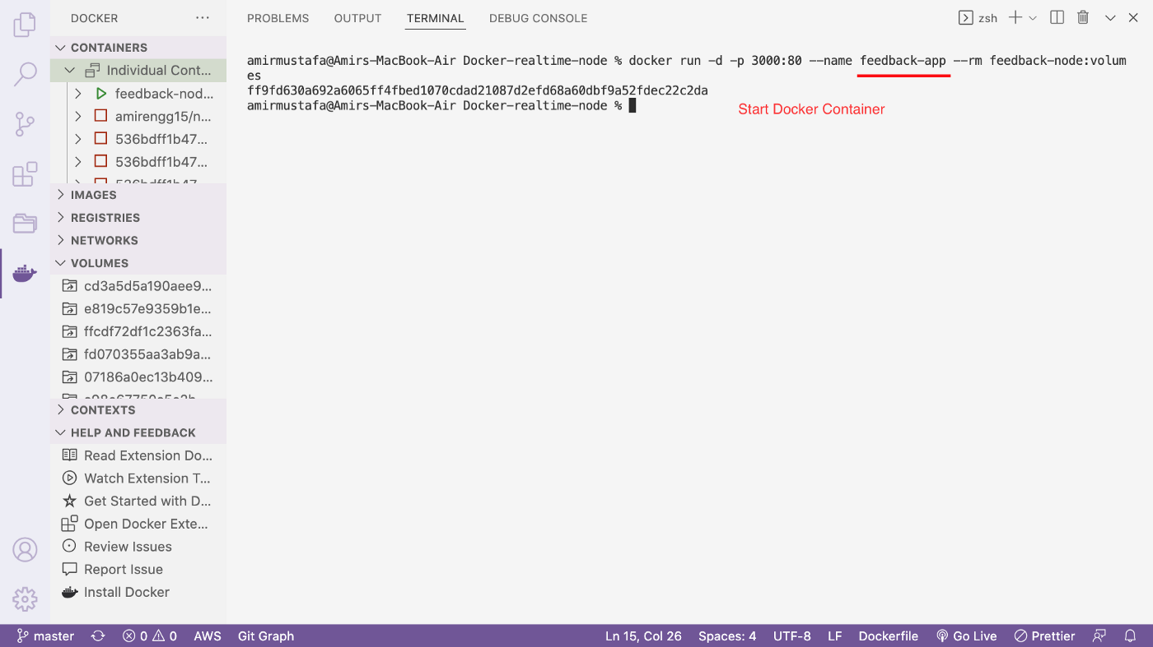

→ STEP 2: Checking volume. We can check volumes either of the two ways

docker volume ls

or from Microsoft’s docker extension as shown in the screen below:

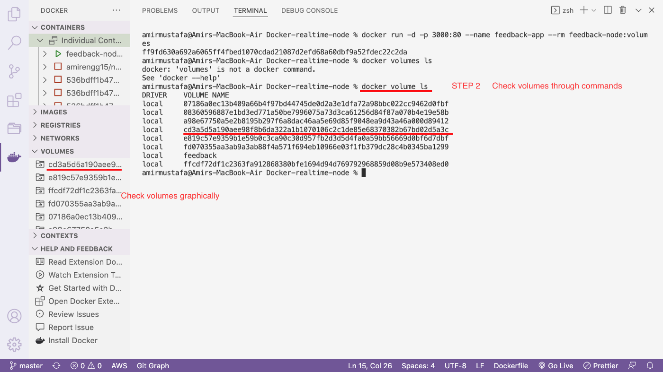

→ STEP 3: Stopping the container. This will delete the container. This is the **demerit of Anonymous container**.

The Anonymous volume is gone and does not exist anymore.

Deleting Anonymous Volume Container = Deleting Volume created with it = Data loss

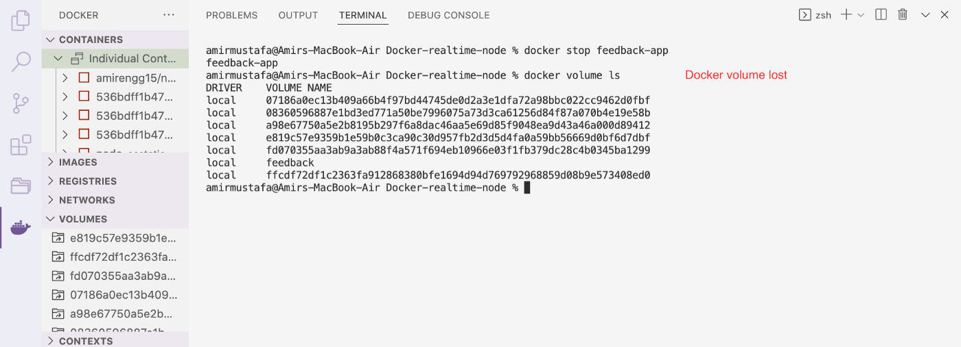

→ With **Named volume**container will **survive volume** when container’s shutdown ✅

→ Folders in hard drive will survive, hence creating new container will not affect the previous data 😀

*NOTE:* ***Data is available in Named volume****.* ***It cannot be edited directly*** *because we do not really have access to this host machine (i.e. managed by Docker) 💡*

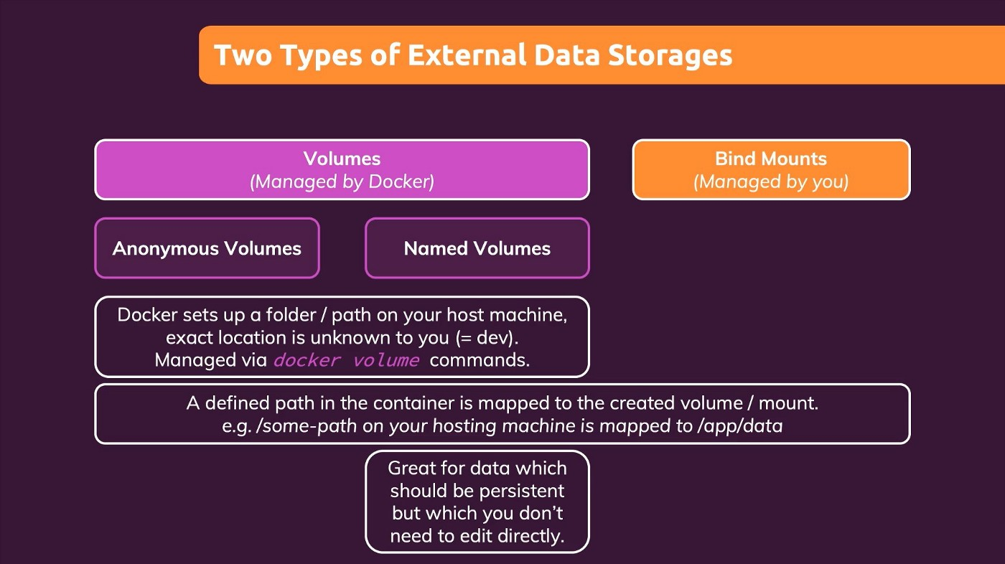

→ It is hidden somewhere by the docker in the host machine and managed by Docker and it is not meant to be edited by.

## Dockerizing Node.js App with Named Volume:

—> We cannot write named volume instruction inside Docker file.Hence we can remove the volume instruction from Docker File. check code [here](https://github.com/AmirMustafa/docker-realtime-node/commit/158c6dbea4fbfbf3b809cb70ecc8c1d8b8ae6793).

VOLUME ["app/feedback"] // Remove this line - used by Anonymous Volume

→ We will add named volume from Docker command. Let us follow below steps:

**STEP 1: Delete previous image (if any)**

docker rmi <image-name:tag>  
eg. docker rmi feedback-node:volumes

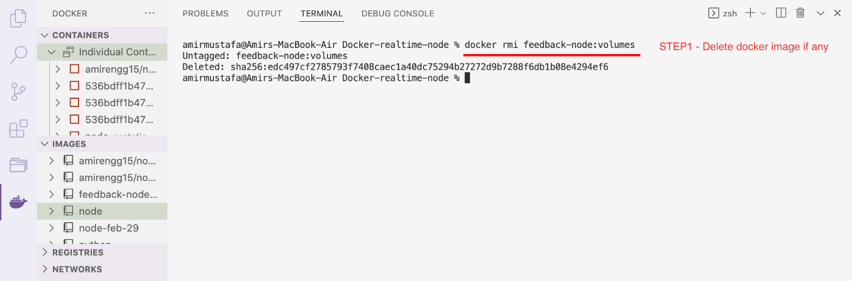

**STEP 2: Build a new docker image**

*Important to note, we should delete VOLUME instruction from Dockerfile (it is only for Anonymous volumes)*

docker build -t <image-name>:<tag> .  
eg. docker build -t feedback-node:volumes .

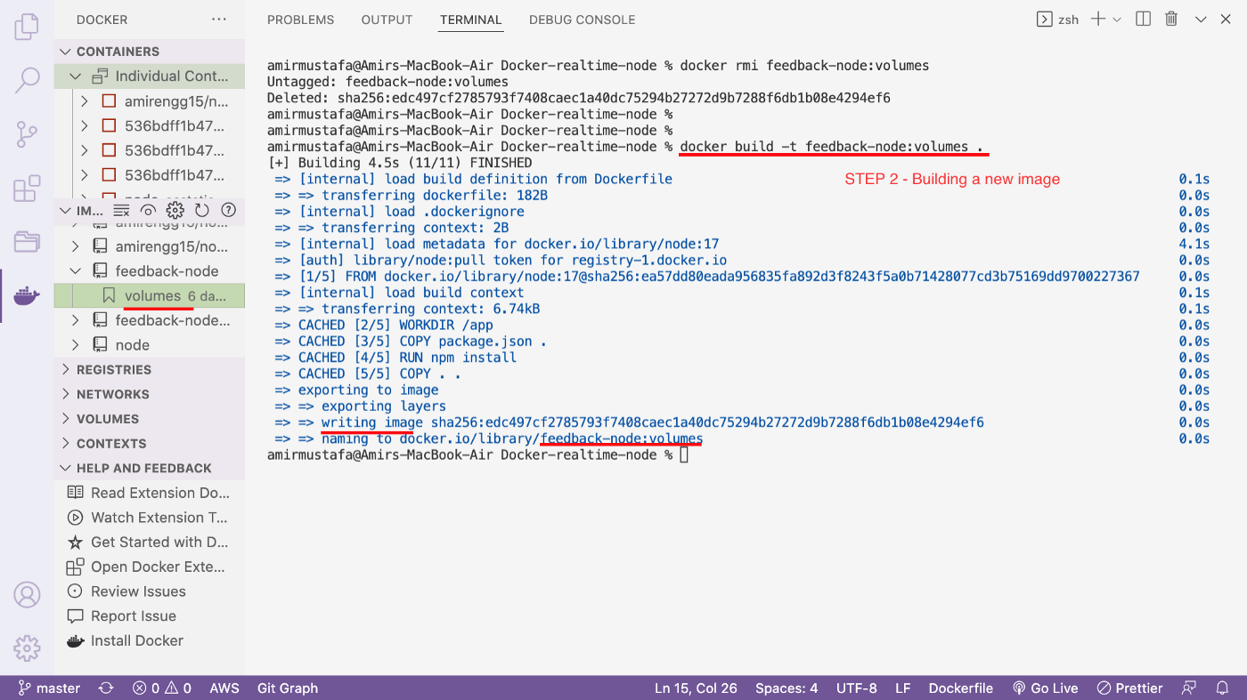

**STEP 3: Create a Named Volume container**

→ Command is same as previous a new flag is to be added with volume name and path

-v <volume-name>:<volume-path> // ADDITIONAL FLAG docker run -d -p 3000:80 --rm --name <container-name> -v <volume-name>:<volume-path> <image-name>eg. docker run -d -p 3000:80 --rm --name feedback-app -v feedback-may2022:/app/feedback feedback-node:volumes

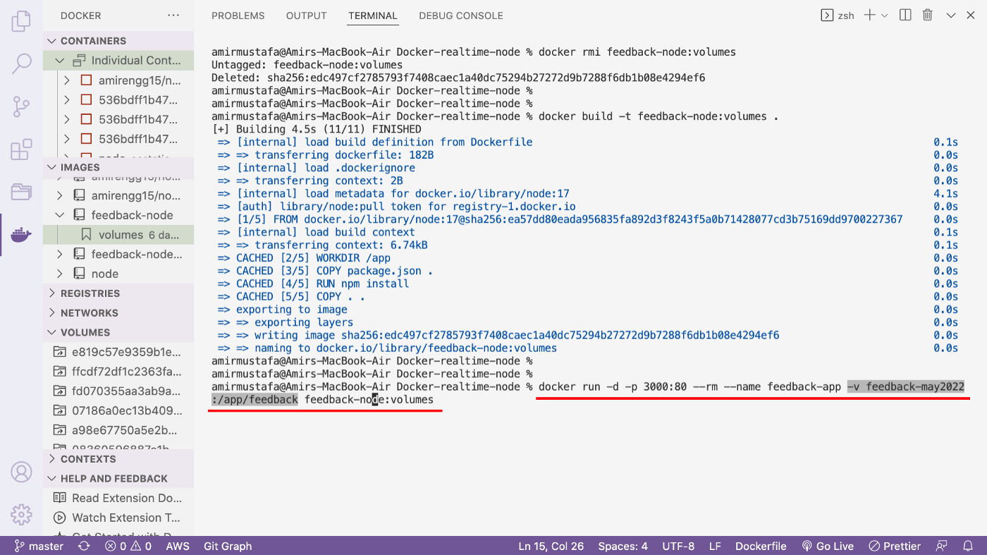

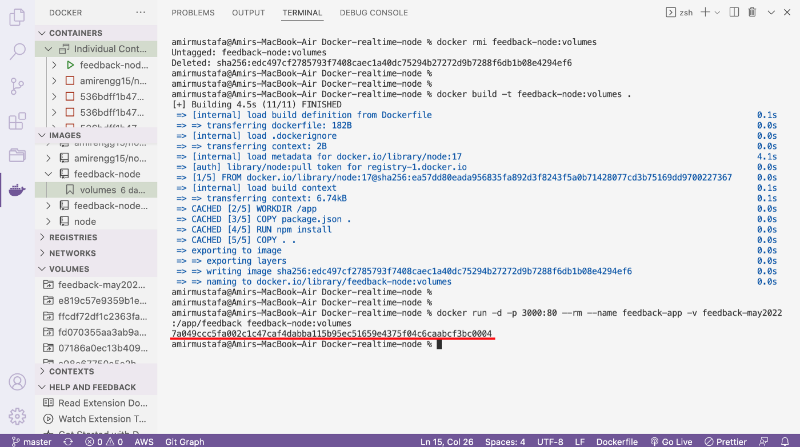

**STEP 4: Let us check list of docker volumes.** This can be done in one of the two ways:

a. docker command:

docker volume ls

b. Microsoft’ extension graphical view, both can be seen from below

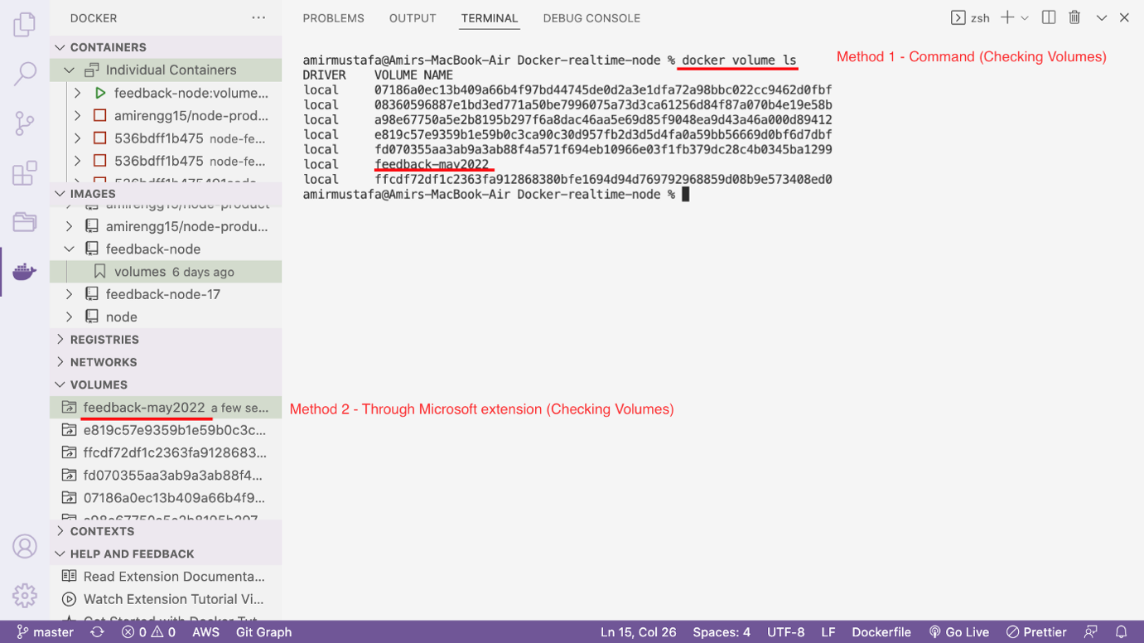

→ Finally we have created a named volume.

*Time to test, whether this can persist data*

**STEP 5: Open Node.js application in browser**. It is a feedback form that saved data inside app/feedback/<name>.

<http://localhost:3000/>

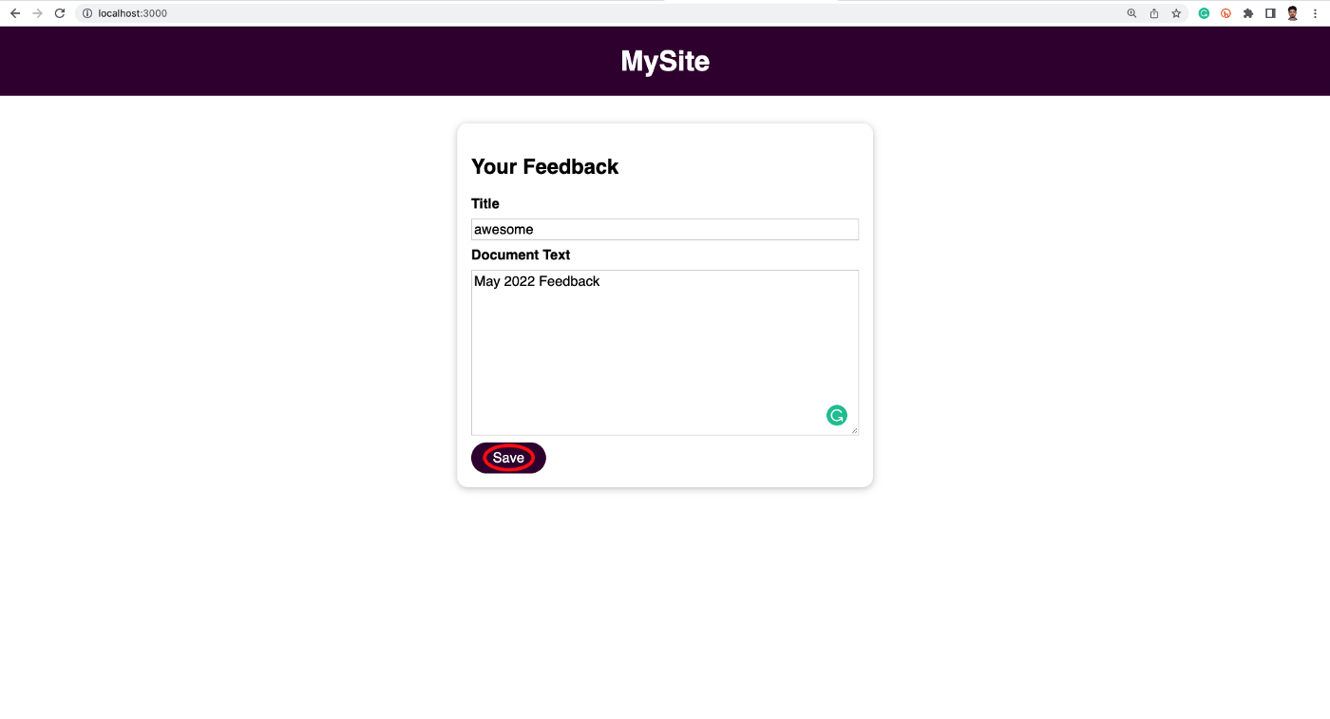

→ Enter some feedback. Click save.

→ Let us check the file path. Feedback exist.

<http://localhost:3000/feedback/awesome.txt>

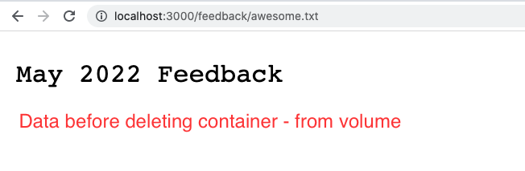

→ Till here was working in [Anonymous Volume](https://amirmustafaofficial.medium.com/docker-ep-15-docker-volumes-anonymous-volume-b2171ddeeecc?source=your_stories_page-------------------------------------). When we delete this container and recreate it data loss was happening.

→ Let us check same with Named Volume

**STEP 6: Stop the container**

→ As the container was created using — rm flag. Stopping the container will delete it. Let us see in below image

docker stop <container-name>  
i.e. docker stop feeback-app

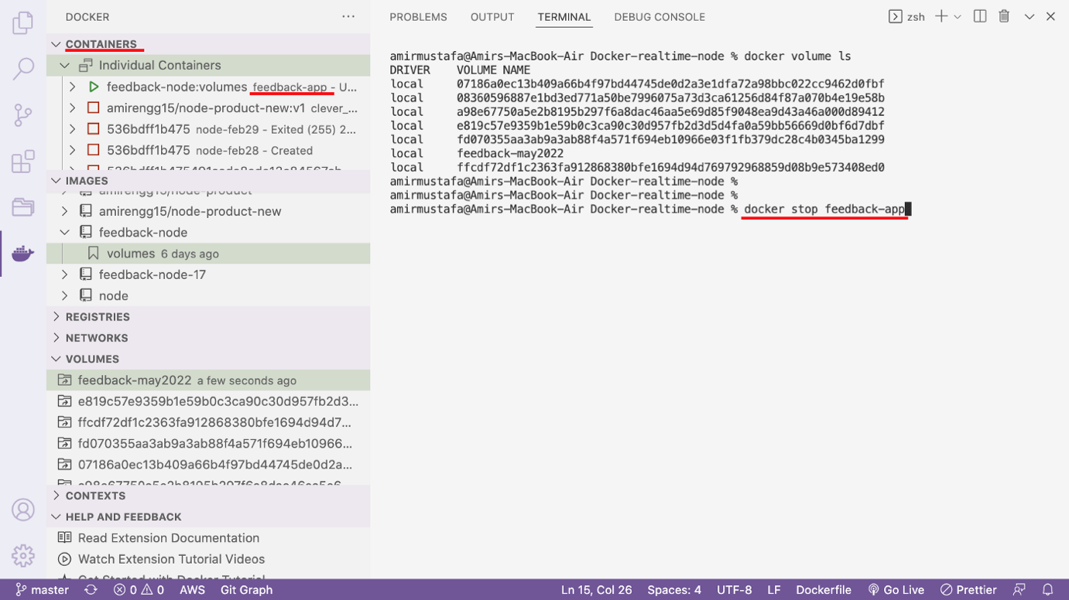

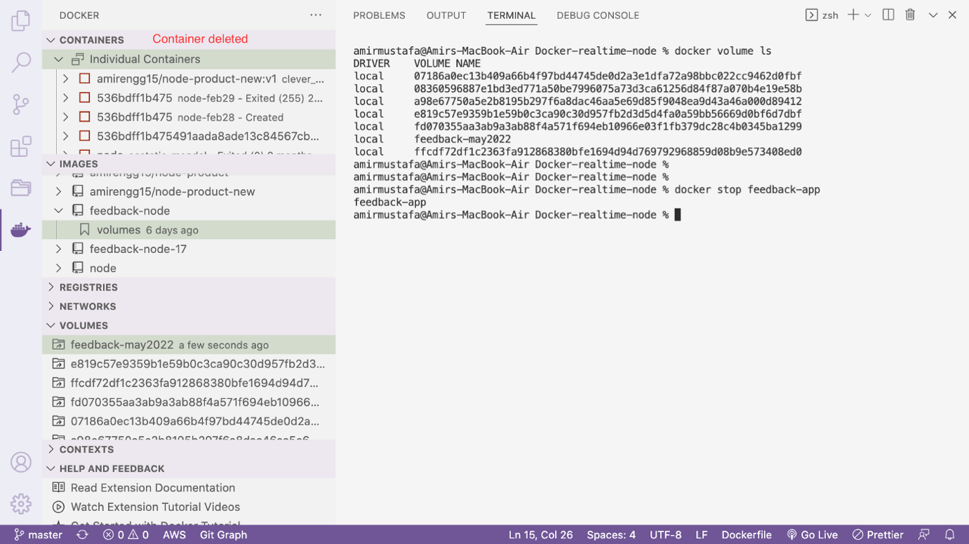

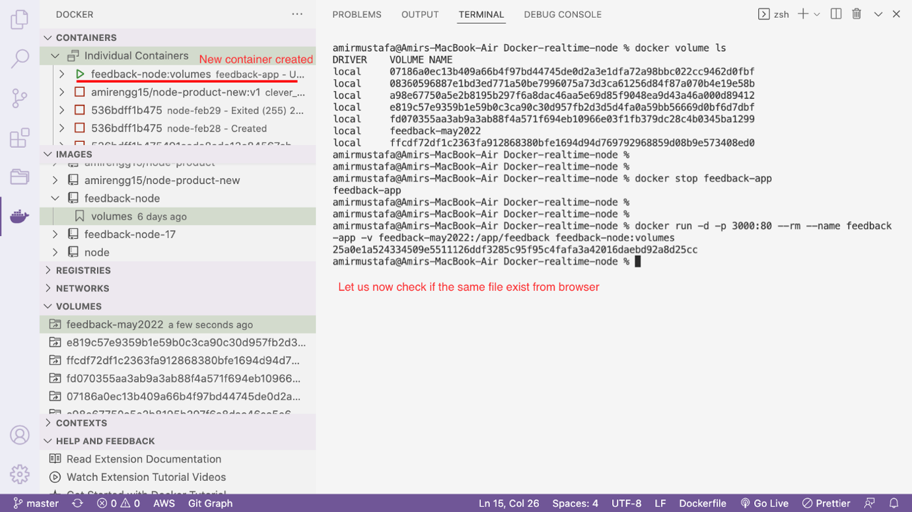

**STEP 7 — Recreating same container**

→ Command is same as previous a new flag is to be added with volume name and path

-v <volume-name>:<volume-path> // ADDITIONAL FLAG

docker run -d -p 3000:80 --rm --name <container-name> -v <volume-name>:<volume-path> <image-name>

eg. docker run -d -p 3000:80 --rm --name feedback-app -v feedback-may2022:/app/feedback feedback-node:volumes

→ Without adding new feedback let us open same file:

<http://localhost:3000/feedback/awesome.txt>

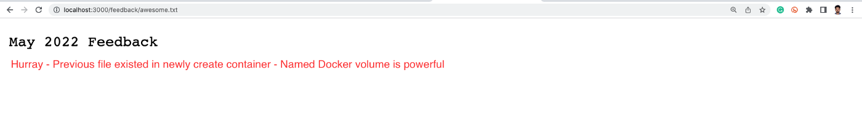

→ So finally we were able to persist data with the help of Named Volume 😀

Remove Anonymous Volume:

docker volume rm VOL_NAME

docker volume prune

### Bind Mounts (Code Sharing):

🡪 Bind mount help us fix different type of problems

🡪 Whenever we make any change in code it is not reflected in code directly. We need to:

build the image 🡪 Create container instance 🡪 Then code reflects

🡪 This happens because we only copy snapshot of the code-base as a docker image

🡪 Therefore subsequent change of the image will not be reflected, and therefore also not there in the container

🡪 During development there should be a pretty way for which our code change is reflected in container, without rebuilding image or container.

🡪 Restarting everytime will be time-taking process. That’s where Bind mount come into picture

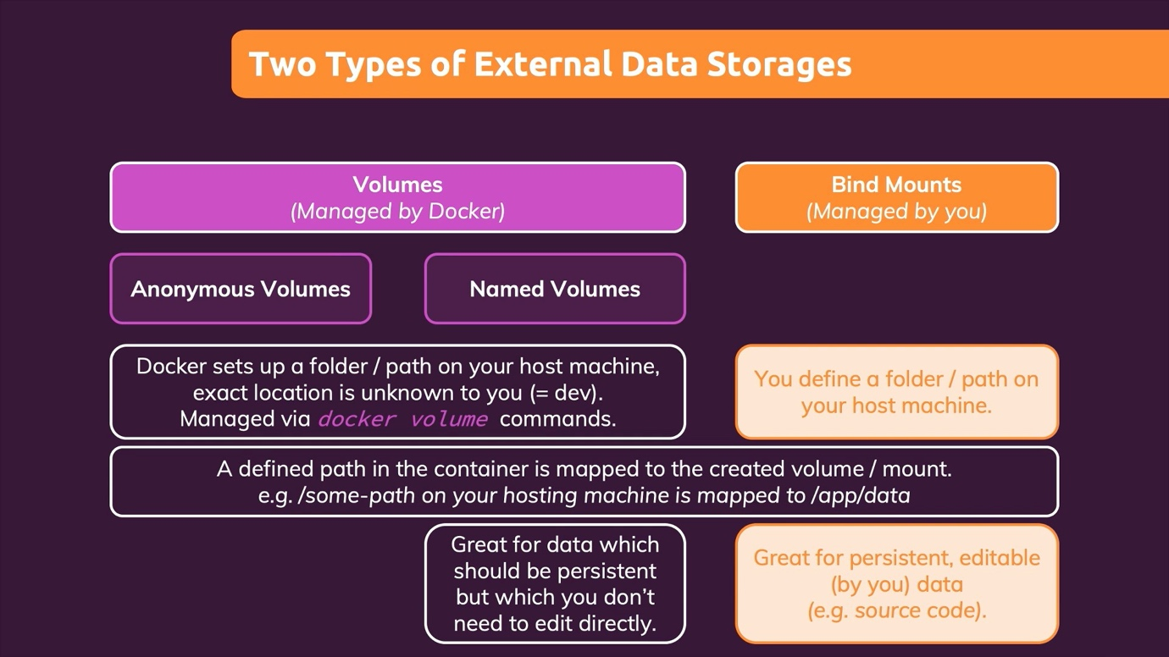

🡪 Bind mounts are somewhere similar to Docker Volumes with one difference:

Volumes – managed by docker. Code kept somewhere in host machine which we as a developer do not know

Bind Mount – managed by us. We define a path

🡪 The path that we will define now for Bind mount is readable + writable from docker container.

🡪 Hence source code will have some connection bind mount path. Any change in code will be instantly reflected

Bind Mount Features:

Persistent, Editable

Volumes:

Persistent, Editing not possible (as we do not know the path)

Implementing Bind Mount inside Node.js Application:

🡪 Bind Mount cannot be set inside image i.e. not in Dockerfile

🡪 It is also set into container (like named volume)

STEP1: We need to give Docker desktop path to our project or parent directory path for using Bind Mount

1. Open Preference setting in Docker Desktop

For Linux and Mac machines:

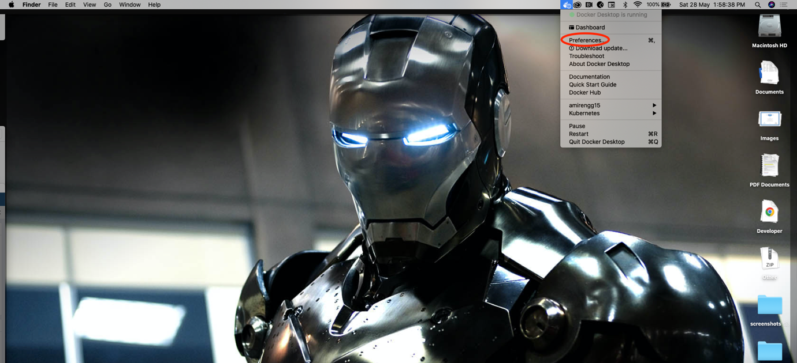

1. Click Resources 🡪 File Sharing

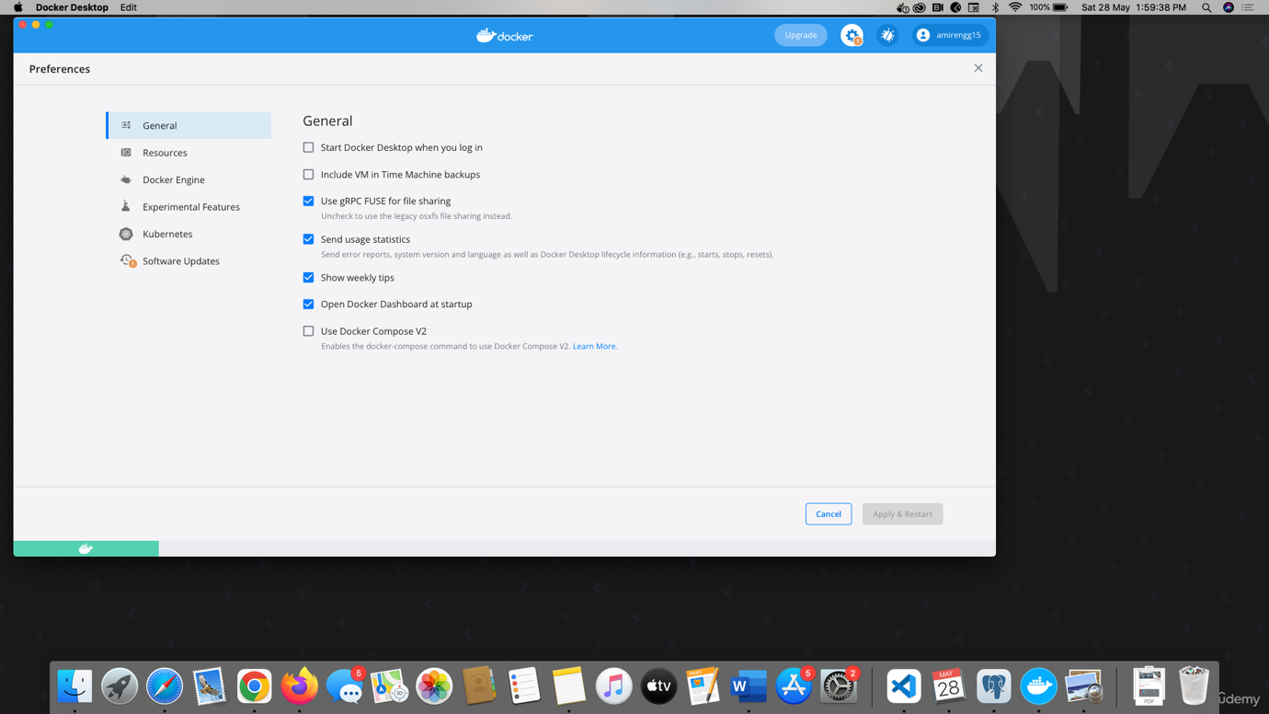

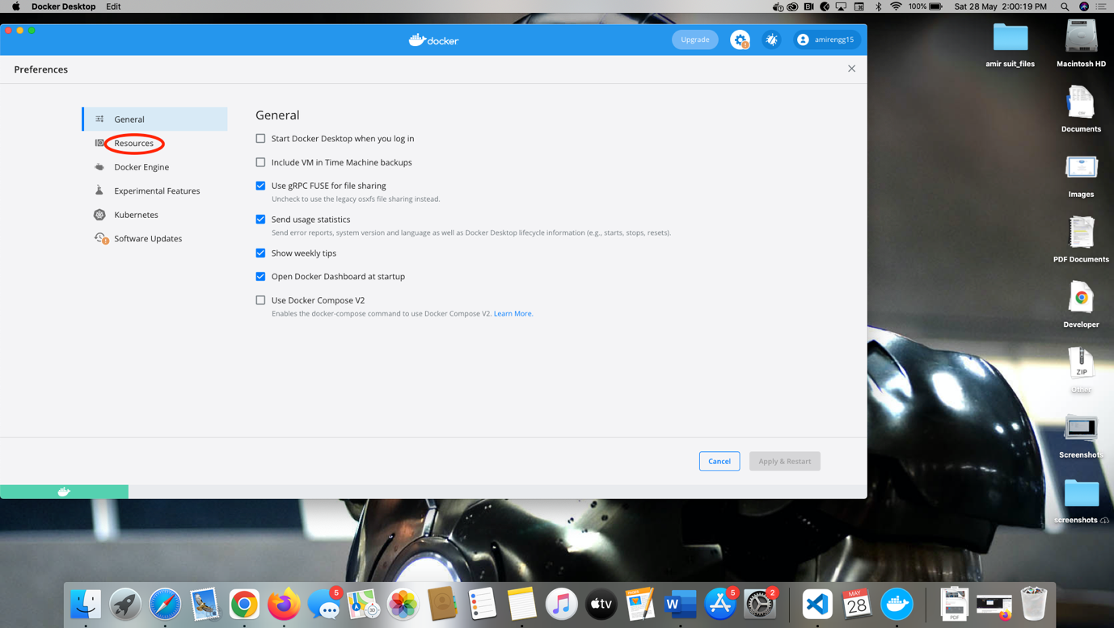

1. Click + sign 🡪 An explorer opens 🡪 Chose project path or root level path of the project

Eg. Users

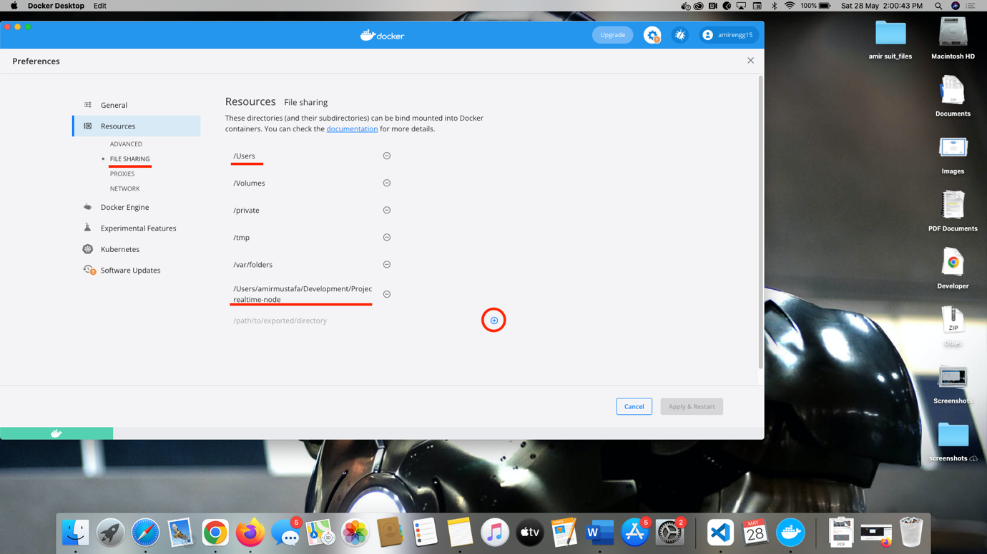

For Windows machines: File sharing is auto on. We need not do this setting.

STEP2: Check current volumes:

docker volumes

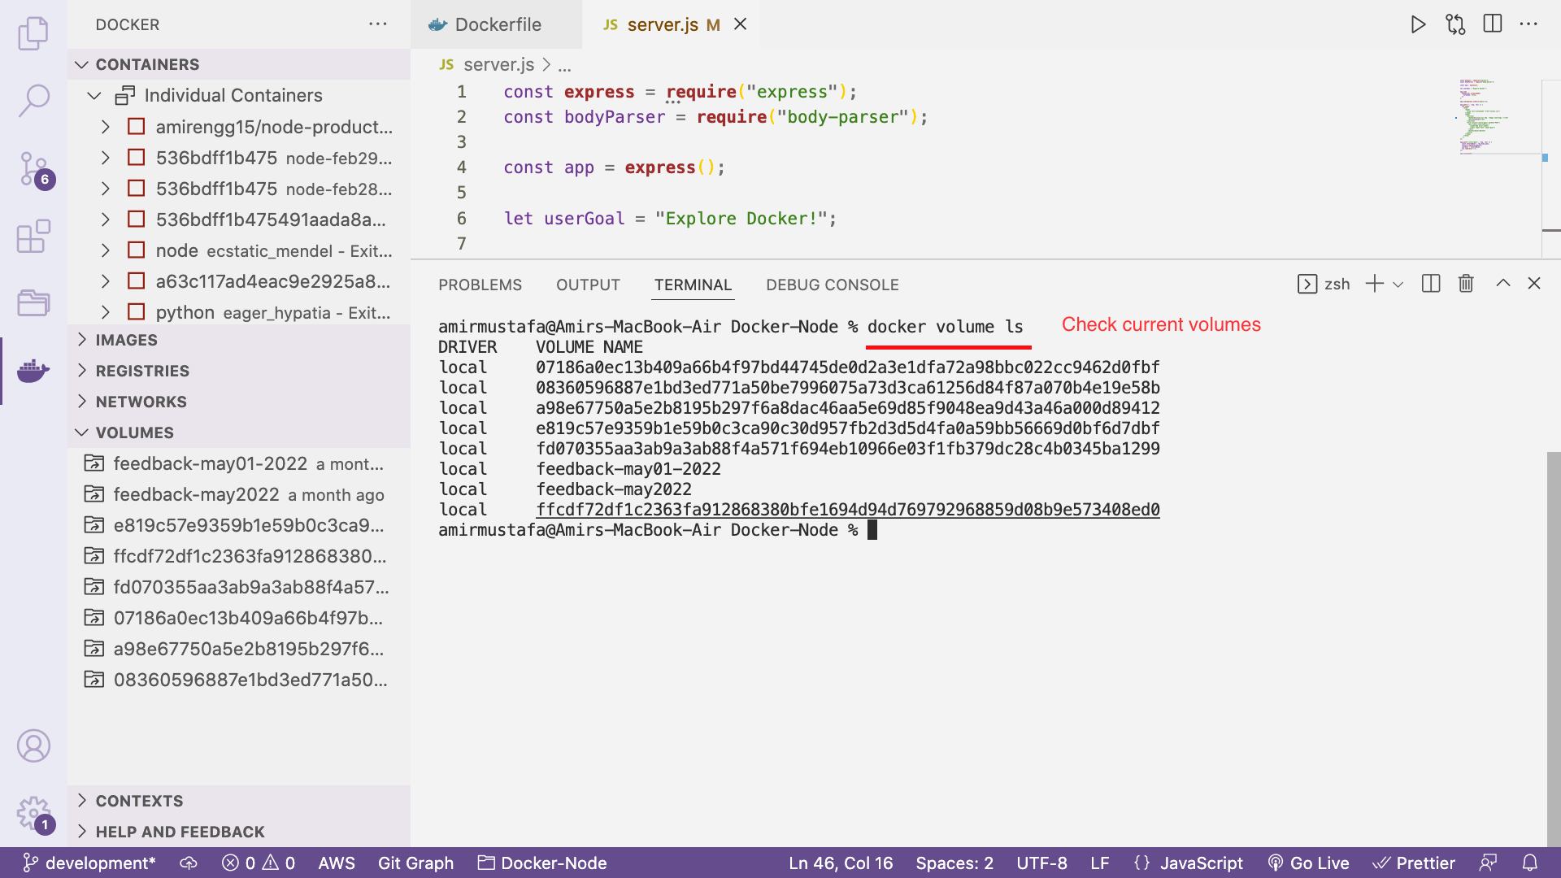

STEP2: Open your code where we will implement Bind mount

This will be somewhat same as Named volume with additional -v flag

docker run -d -p <webport>:<dockerport> --rm --name <container-name> -v <named-volume-name>:<path-for-sharing> -v "<project-root-path>:/<docker-root-path>" <image-name:tag>

docker run -d -p 3000:80 --rm --name feedback-app -v feedback-may28:/app/feedback -v "/Users/amirmustafa/Development/Projects/Docker-Node:/app" feedback-node:volumes

NOTE: We have place in quotes because spaces and other character will also be accepted

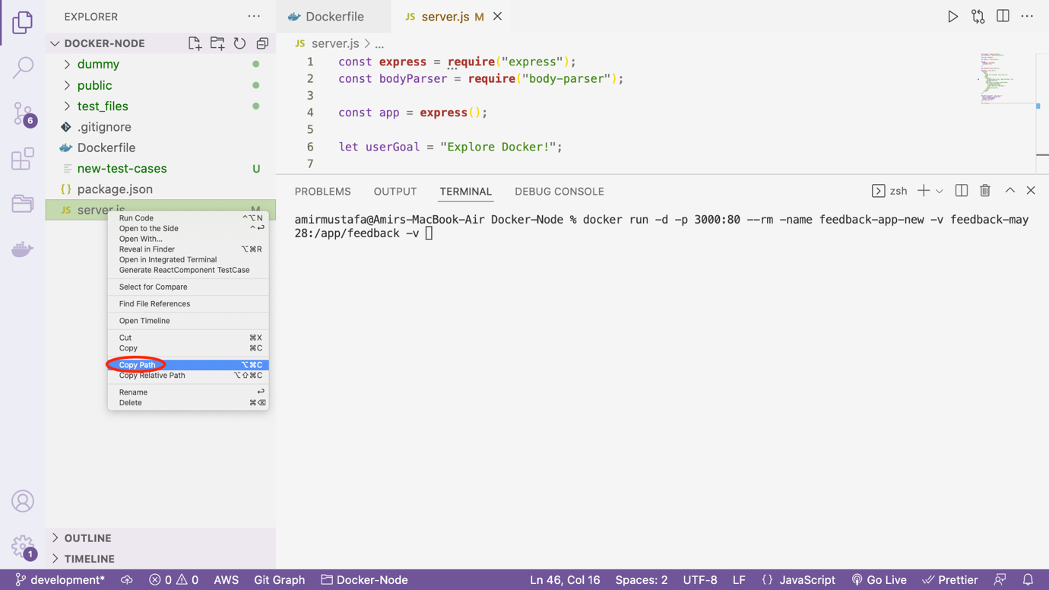

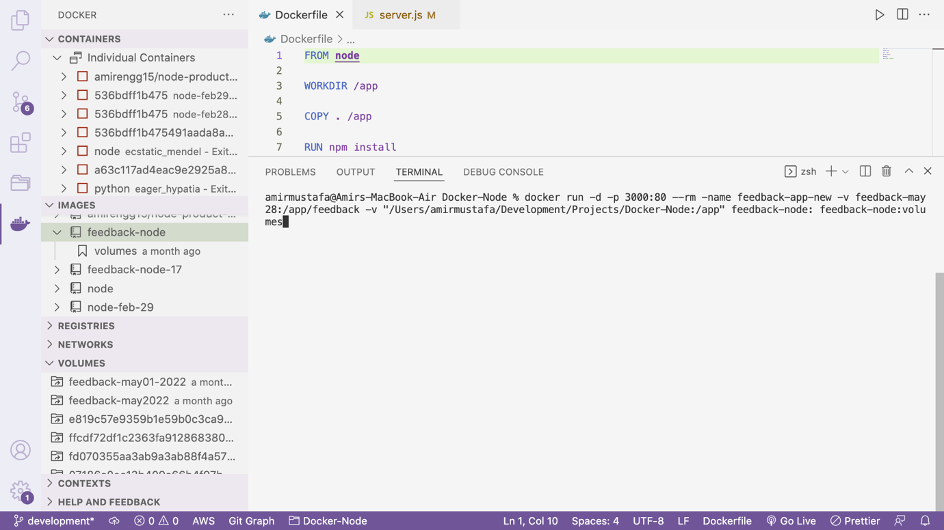

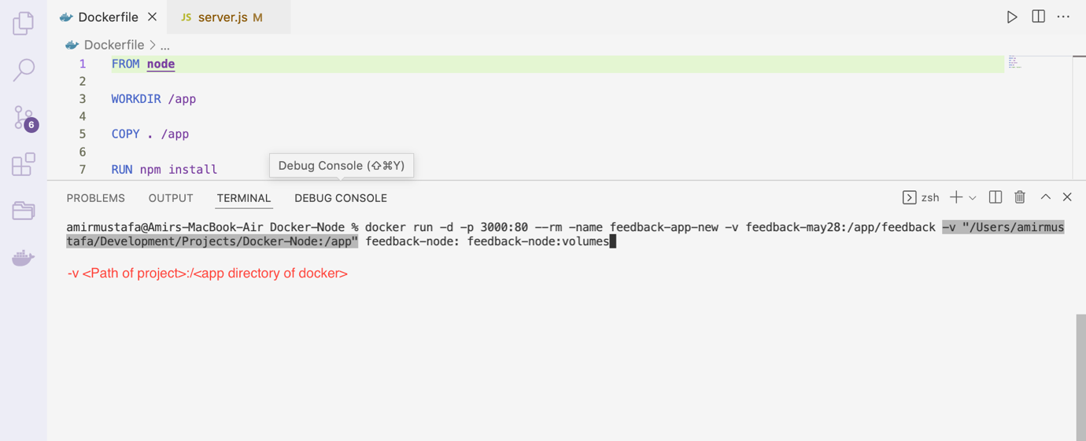

STEP3: Try opening in browser. <http://localhost:3000>

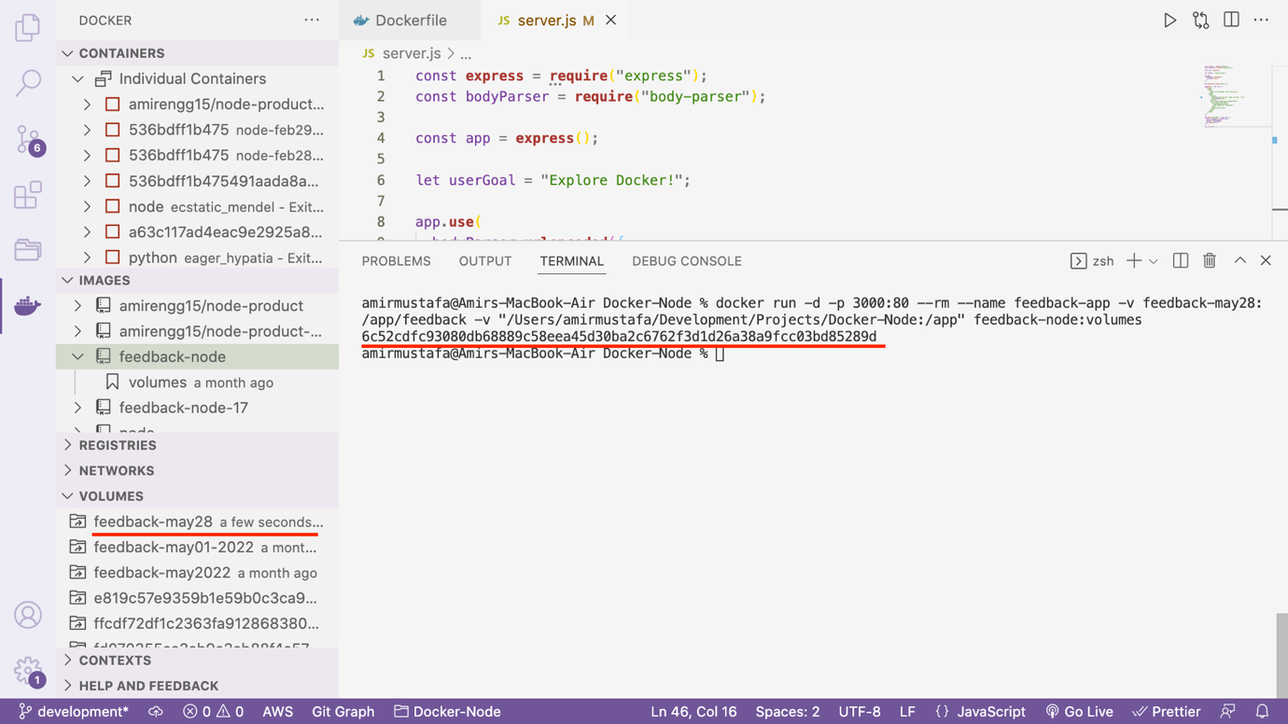

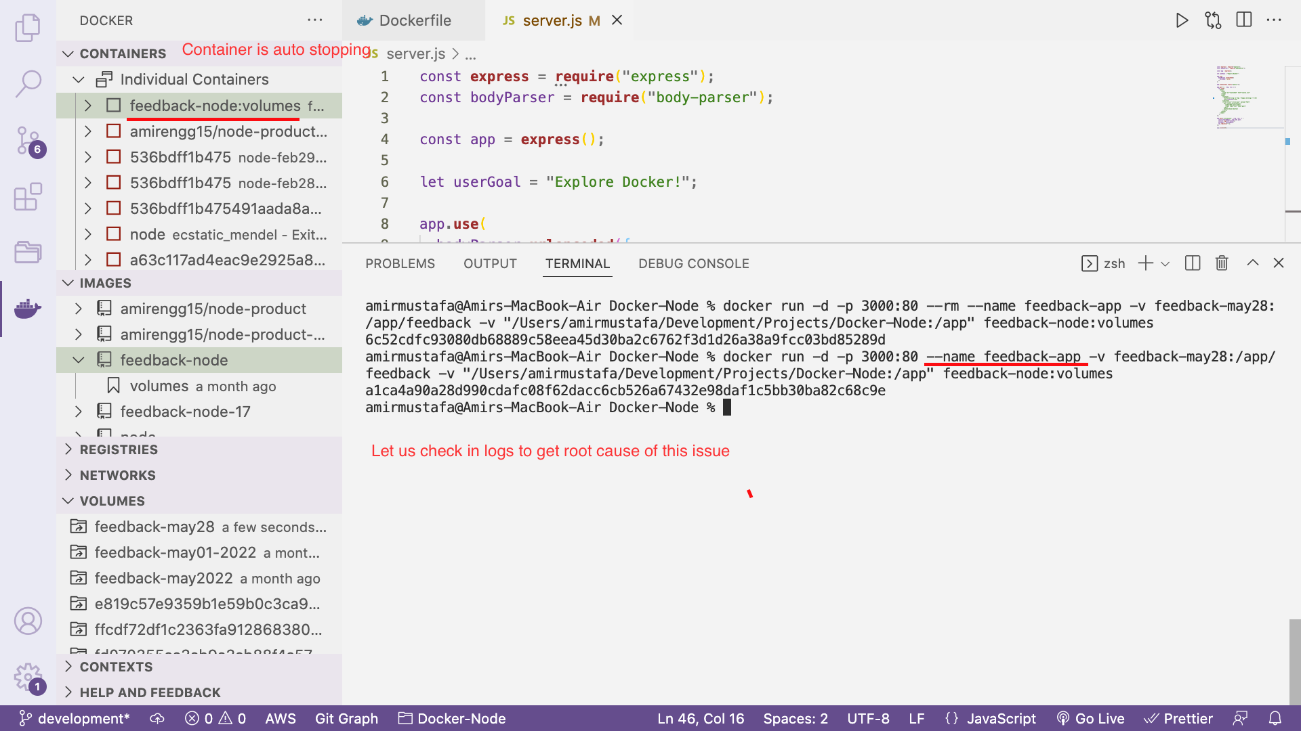

We observe server crashes

STEP4: Observing Error:

Docker logs

Docker logs <container-name-having-error>

Docker logs feedback-app

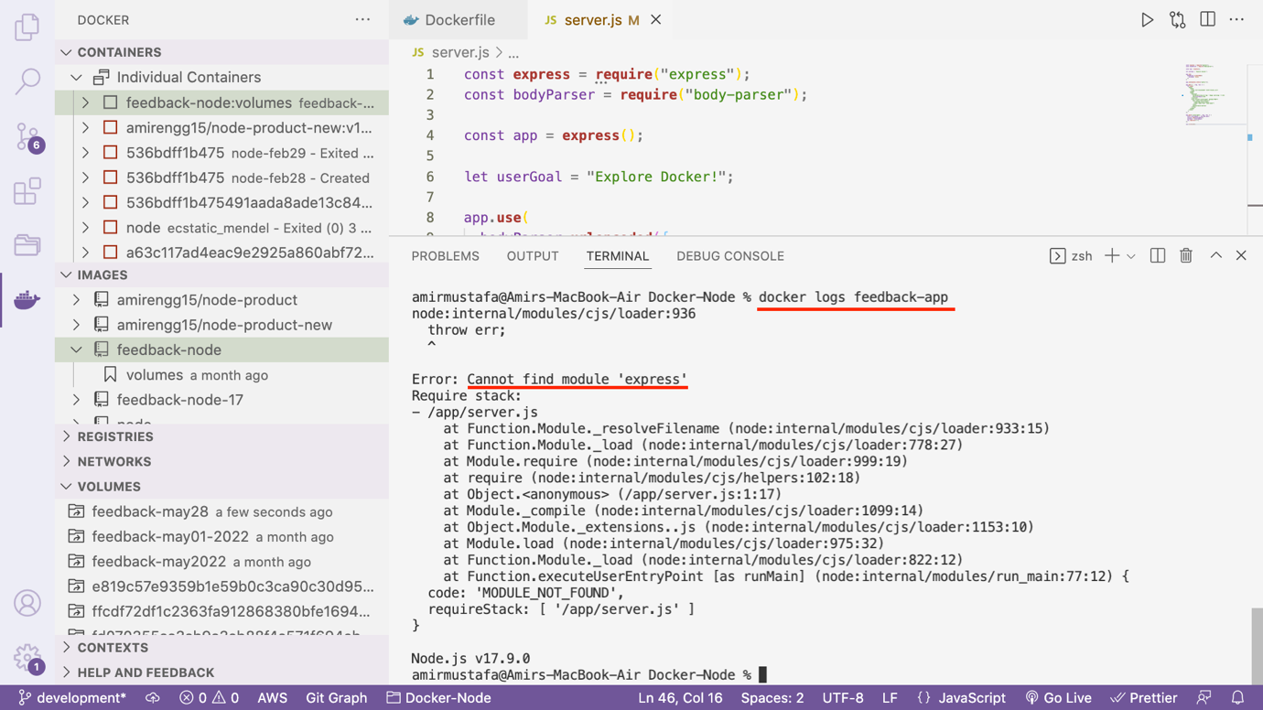

Error found: After implementing Bindmounts express package is not detecting

Just a quick note: If you don't always want to copy and use the full path, you can use these **shortcuts**:

**macOS / Linux**: -v $(pwd):/app

**Windows**: -v "%cd%":/app

Problem for getting this error

docker run -d -p 3000:80 --rm --name feedback-app -v feedback-may28:/app/feedback -v "/Users/amirmustafa/Development/Projects/Docker-Node:/app" feedback-node:volumes

The problem is we have replace whatever we have installed in Docker’s app directory with local file

i.e. "/Users/amirmustafa/Development/Projects/Docker-Node

🡪 Let us first understand how volume and bind mounts is mounted into container

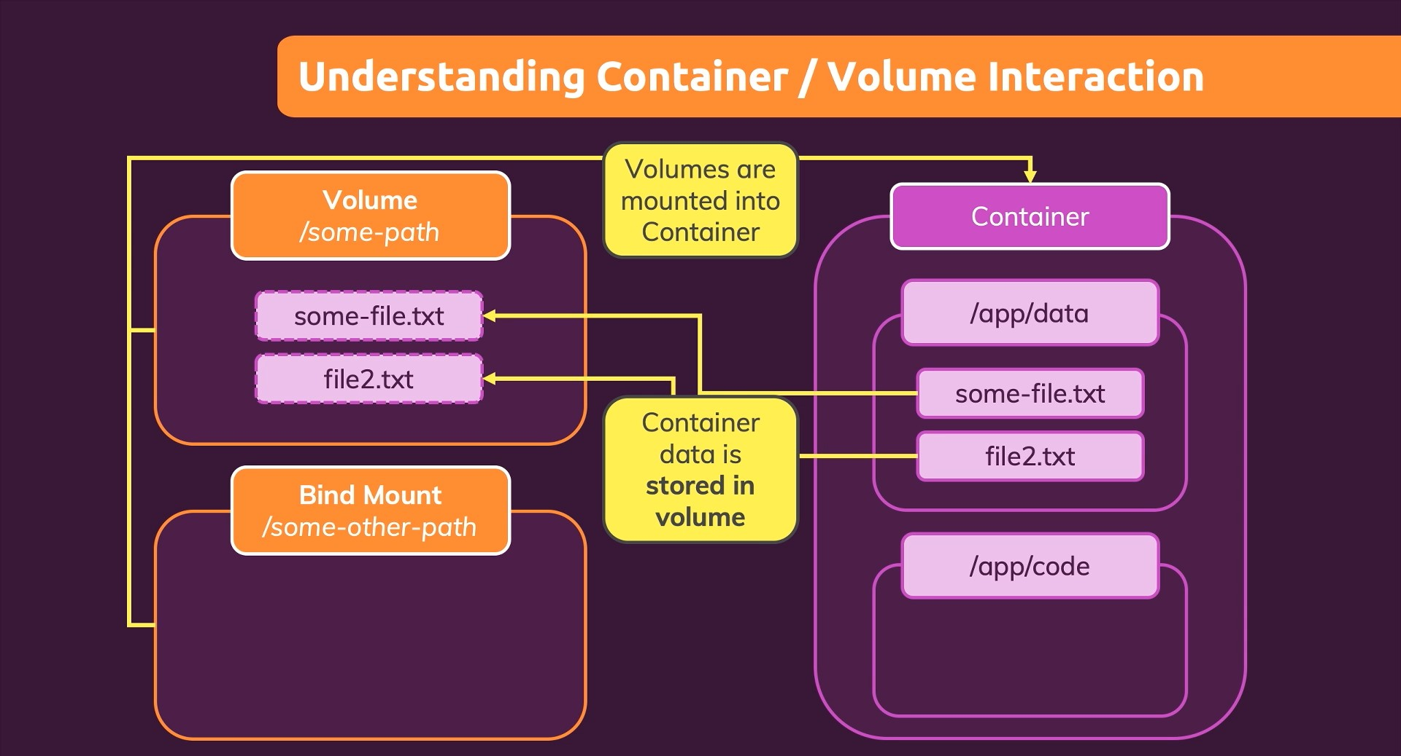

🡪 All the files specified is stored in volume drive and the file is saved

🡪 The same happens in bind mounts:

🡪 Bind mount will never erase local project codebase . Otherwise it is data loss.

🡪 Local drive codebase overwrites in docker codebase and this is the reason we lost npm install folder which we did from Dockerfile

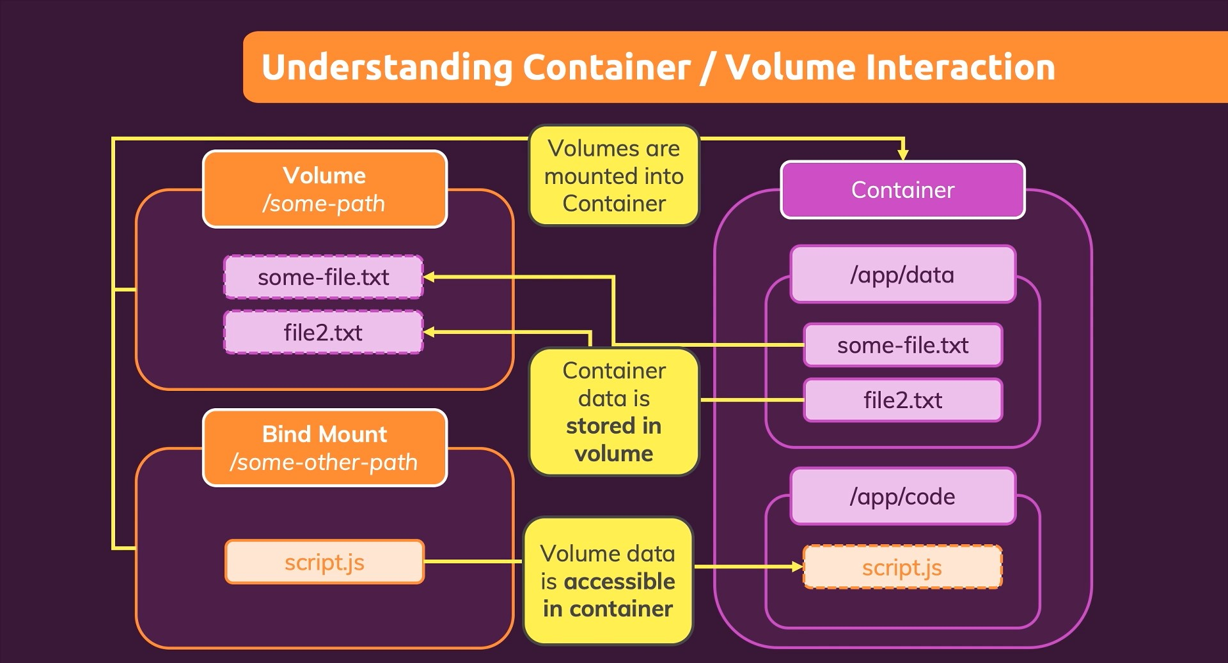

Solution:

We will tell docker not to remove node_modules at the time of replacement

TRICK:

Will add extra anonymous volume with node_modules path

docker run -d -p 3000:80 --rm --name feedback-app -v feedback-may28-2022:/app/feedback -v "/Users/amirmustafa/Development/Projects/Docker-realtime-node/:/app" -v /app/node_modules feedback-node:volumes

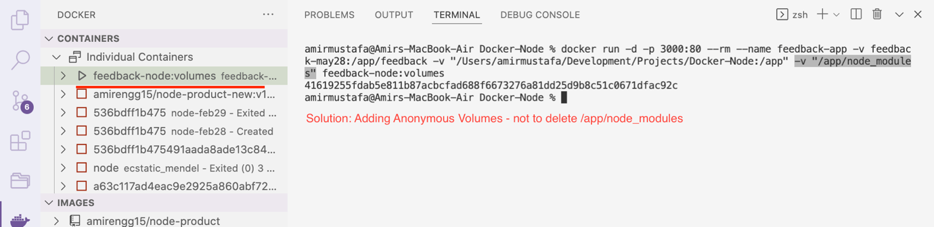

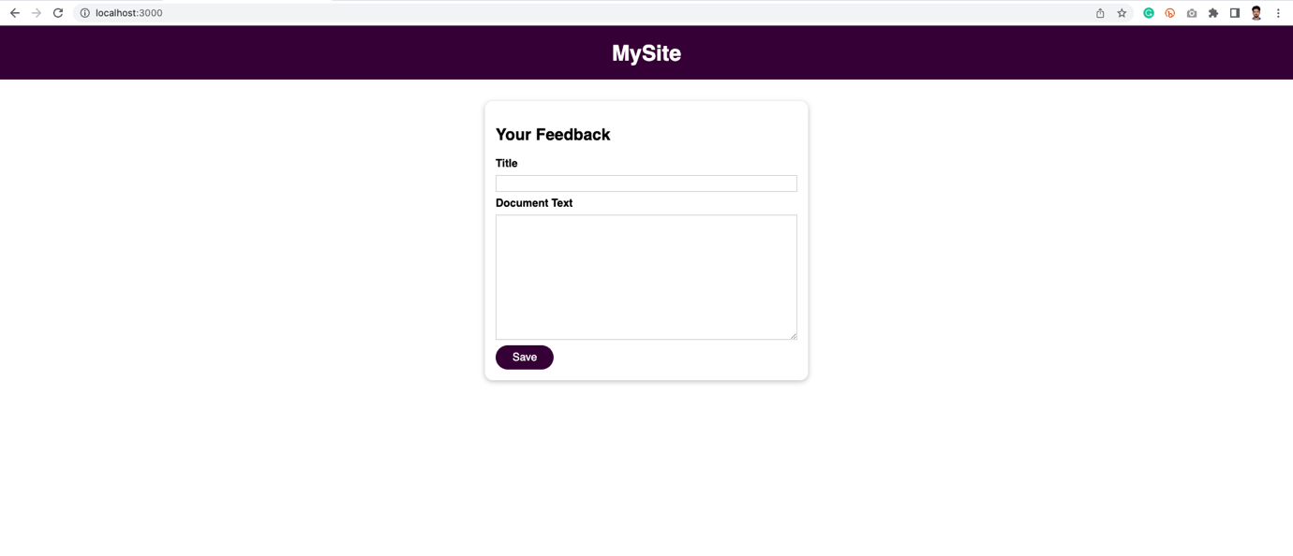

🡪 Let us change something in code.

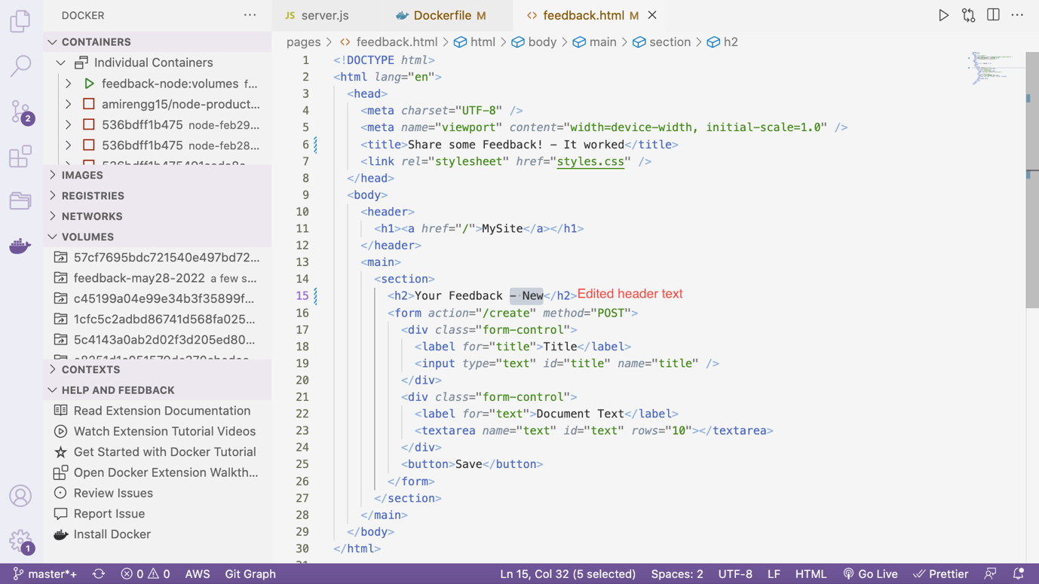

🡪 Without building the new image, our docker app is refreshed with latest code

